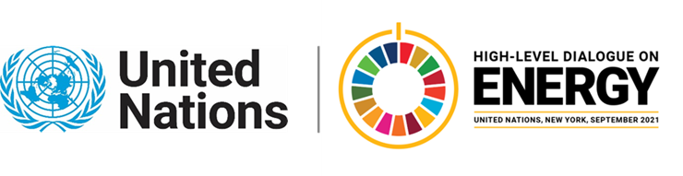

**Ministerial Thematic Forum on Energy Transition:**

**Presentation of the Theme Report on Energy Transition (Side-event)**

**23 June 2021 – 11:30 to 12:45 am EDT (NY Time)**

**Agenda**

1. **Welcome by the Co-Leads**

**Mr. Mark Radka,** Director (OiC), Economy Division, UNEP

1. **Presentation of the Theme Report by the Co-Leads**

**Ms. Elizabeth Press,** Director, Planning and Programme Support, IRENA

1. **Discussion of the Theme Report**
   1. **Interventions from Members of the Technical Working Group on Energy Transitions**

**H.E. Ambassador Rasmus Abildgaard Kristensen**, Head of Department for Green Diplomacy and Climate, Ministry of Foreign Affairs, Denmark

**Mr. Renato Domith Godinho,** Headof Division for Energy Progress, Ministry of Foreign Affairs, Brazil

**Mr. Xiangkun (Elvis) Cao,** Member of the Technical Working Group

* 1. **Open Q & A**

1. **Closing by Co-Leads**

**Mr. Hongpeng Liu,** Director, Energy Division, UN ESCAP

For further information, please contact the HLD on Energy Secretariat at [martin.niemetz@un.org](mailto:martin.niemetz@un.org)