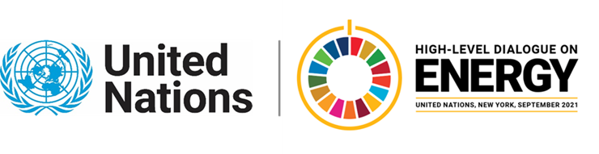
Ministerial Thematic Forum on Enabling SDGs through Inclusive, Just Energy Transitions:
Presentation of the Theme Report on
Enabling SDGs through Inclusive, Just Energy Transitions (Side-event)
24 June 2021 – 11:30 to 12:45 am EDT (NY Time)

Agenda

- Welcome by the Co-Leads
- Mr. Mounir Tabet, Deputy Executive Director, UN ESCWA

- Presentation of the Theme Report by the Co-Leads
- Minoru Takada, Team Leader, Secretariat of the High-level Dialogue on Energy, UN DESA
- Radia Sedaoui, Chief Energy, Climate Change and Natural resource Sustainability Cluster
- Heather Adair-Rohani, Technical Officer, WHO

- Discussion of the Theme Report
  - Interventions from members of the Technical Working Group on Enabling SDGs through Inclusive, Just Energy Transitions
  - Open Q & A

- Closing by Co-Leads

For further information, please contact the HLD on Energy Secretariat at martin.niemetz@un.org

