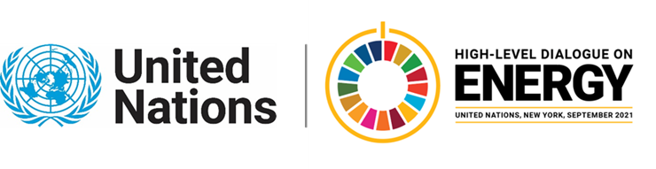
Ministerial Thematic Forum on Energy Access:
Presentation of the Theme Report on Energy Access (Side-event)
23 June 2021 – 12:45 to 14:00 pm EDT (NY Time)

Agenda

Moderator: Martin Niemetz, Secretariat, High-Level Dialogue on Energy

- Welcome by the Co-Leads

- Demetrios Papathanasiou, Global Director, Energy & Extractives, World Bank
- Adriana Dinu, Deputy Director, Bureau for Policy and Program Support, UNDP
- Heidi Schroderus-Fox, Director, UN-OHRLLS

- Presentation of the Theme Report by the Co-Leads and Comments

- Elisa Portale, Senior Energy Specialist, World Bank and Rutu Dave, Senior Energy Specialist, Work Bank

Comments

- Marcel Alers, Head of Energy, Nature, Climate and Energy, UNDP

- Shifaana Thowfeequ, Focal Point for Sustainable Energy, UN-OHRLLS

- Moderated Discussion of the Theme Report
  - Kick off Members of the Technical Working Group on Energy Access
  - Open Q & A

- Closing on behalf of the Co-Leads-Marcel Alers, UNDP

For further information, please contact the HLD on Energy Secretariat at martin.niemetz@un.org

