Third Global Conference on Strengthening Synergies
between the Paris Agreement and the 2030 Agenda for Sustainable Development
Tokyo, Japan / Online
20-21 July 2022
Side Event Summary

Event title
Searching Synergistic SDGs: Securing Food, Nutrition and Livelihood for Agrarian Asians in the Climate Trap.

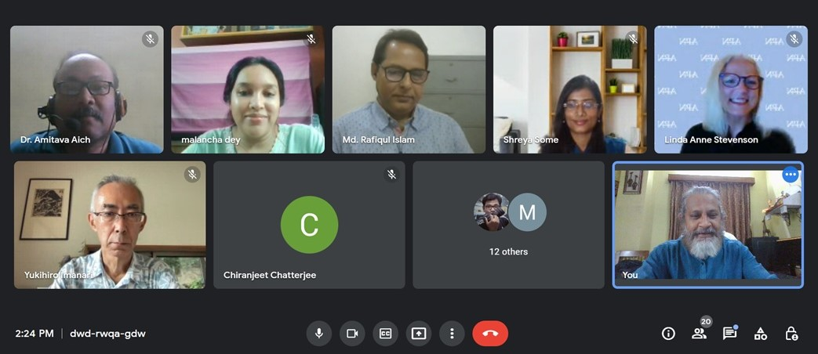
Overview of event and key messages
While adaptation-mitigation policy dichotomy still swirls socioeconomic strategies for climate preparedness, keeping community climate resilience at bay, built capacities in marginal agrarian Asians for boot-strapping adaptive practices, as well technology cooperation for strengthening mitigation measures seems like islandic efforts, rapidly increasing the climate cost. In Asian context, climate resilience is diverse, entailing multistakeholder cross-sectoral approach to engage line departments, overlapping interventions and ghastly conflicting socio-political interests. Gaps in knowledge, information strategies and planning results in discords and apathy in collective resilience building. This is furthered in the post pandemics, wherein the rural-urban breach is topped up with a digital divide in accessibility of resources, amenities and opportunities, putting Asians with highest climate vulnerability. The core issue, therefore, has been the dearth of dialogues in preventing ‘social distancing’ of stakeholders in augmenting systemic efficacy for resilience building in the climate milieu. The remedial measure needs to be a ‘Nexus Approach’ conjoining all levels in open dialogues to search synergies and identify trade-offs between policies and practices, research and implementation, future risks and opportunities.
Session moderated by:
Dr Dipayan Dey, Chair (Research & Innovation) South Asian Forum for Environment.

Speaker notes (including remarks by moderator)
Mr. Charles (Chongguang) Yu, Technical Specialist, Climate Finance and Investment, Bureau for Policy and Programme Support /Global Policy Network UNDP briefly presented the role of UNDP in the Asian context to draw on synergistic areas for climate initiatives through partnership building, regional cooperation and financial inclusion at the community level that can bridge the gaps in implementation and community adoption. He focussed on multistakeholder dialogues, cross sectoral convergence of action and resource management.

Dr. Linda A Stevenson Head of Knowledge Management & Scientific Affairs, Asia-Pacific Network for Global Change Research (APN) briefed about the role of Asia Pacific Network in continuing scientific research for addressing pressing problems owing to climate change at community-ecosystem interface. She stressed about building capacities in various cohorts of stakeholders for augmenting climate resilience and as well accomplishing the SDGs. Commendable research must be translated for action through built capacities and stakeholder coordination, she told.

Mr. Francisco Obino – Director Research & Program, Global Development Network referred to climate resilient action-oriented research and innovations that the Global Development Network supports under the aegis of Japan Social Development Fund. He emphasized in building synergistic approaches to address trivial problems and constraints in disaster resilience and in freeing people from climate-poverty trap.

Dr Rafiqul Islam – Professor, Department of Agronomy, BSMRA. University Bangladesh presented an excellent review on the scenario planning of agro farming in the Asian context and as well the impacts of climate change on it. He shared his research experiences and suggested synergistic congruences in action for climate impact mitigation. He also emphasized on the ‘Nexus Approach’ for remediation.

Dr Shreya Some – Researcher, SMART SERD / Asian Institute of Technology, Thailand presented on the Indian scenario in finding synergies between climate smart agriculture and SDGs, wherein she talked about indexing the SDGs in terms of synergistic efficacy and contingency planning, especially in the primary sector. She also elaborated on the preparedness and infrastructural developments in Indian context that is enabling smoother implementation.

Dr Malancha Dey – Director Progyan Foundation for Research & Innovation, India mainly focussed on adaptive management in synergizing the sustainable development efforts at community-ecosystem interface, She stressed on gender equity and equitable accessibility to resources and opportunities at the community level. She also mentioned about innovations in the socio-ecological production landscapes for resilient local economy.

Dr Amitava Aich – Sr. Scientist in South Asian Forum for Environment [SAFE] presented his research on the application of Information and Communication Technology in Real-time Contingency Planning for climate resilience in the primary productivity sector. He focussed on converging climate knowledge, as through ‘Climate Information Networking (CIN)’ and disseminating it through android applications to bridge the digital divide in the post pandemics that is widening the rural urban divide as well.

Q&A
Mr. Chiranjeet Chatterjee: Question to Dr Shreya Some:
Q: What support the Indian farmers are availing from the Field-Testing labs? Where are these labs in India?
A: https://farmer.gov.in/stl.aspx# Details are available in this website.

Mr Joao Cristo: Question to Dr Amitava Aich:
Q: What is the name of the android app? Is it available for farmers? Can this be used globally?
A: The application is named “Borshamongol” meaning the blessings of monsoon. It is available free in Google App store. Presently farmers in India and Bangladesh can use it.

