United Nations Logo

**United Nations**

**Covid-19 and the rights of people with disabilities**

**Covid-19 is a new illness that many people in the world are getting. It is also called coronavirus.**

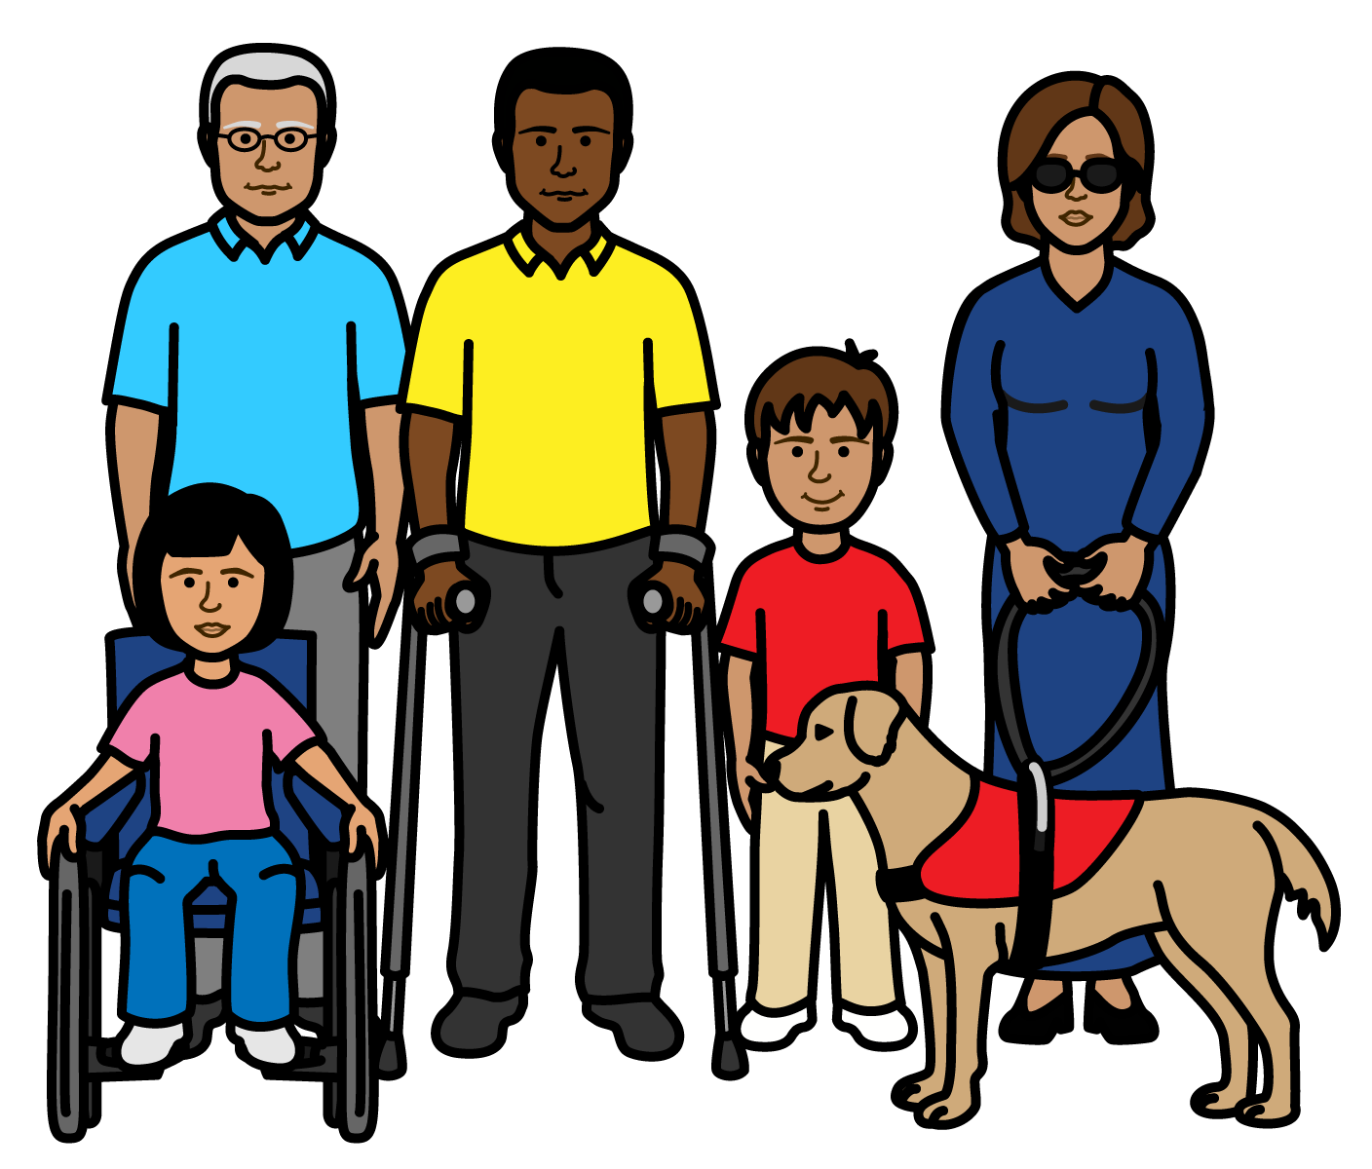

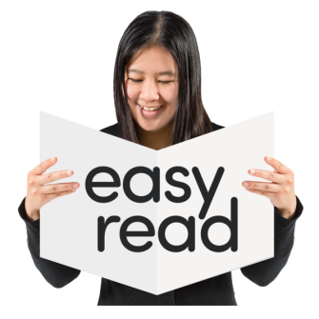

# About us

We are called the United Nations (UN).

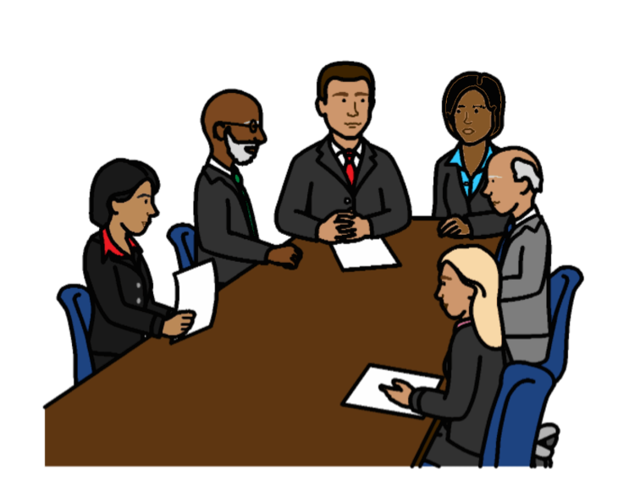

The United Nations is a group of countries that work together to make the world better and safer.



# About this report

This report is about the rights of people with disabilities during and after Covid-19.

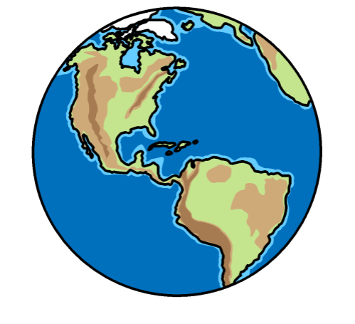

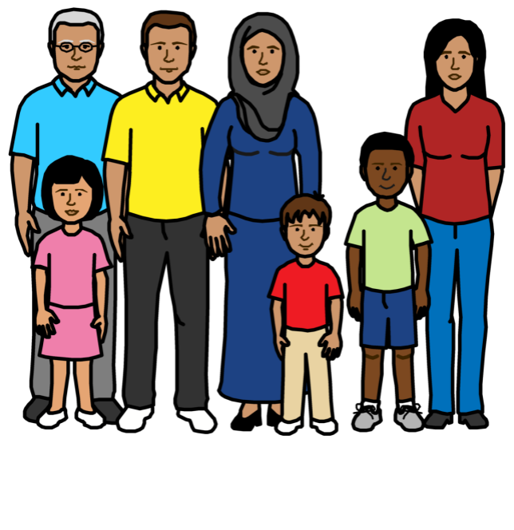

Covid-19 is a new illness that many people in the world are getting. It is also called coronavirus.

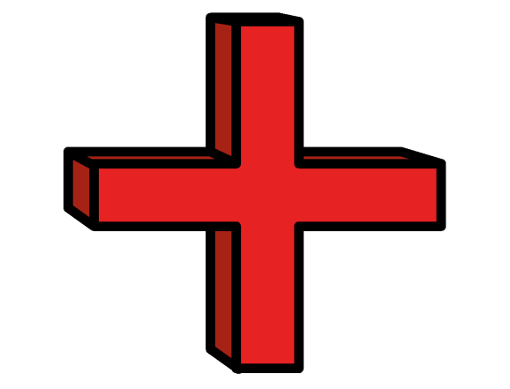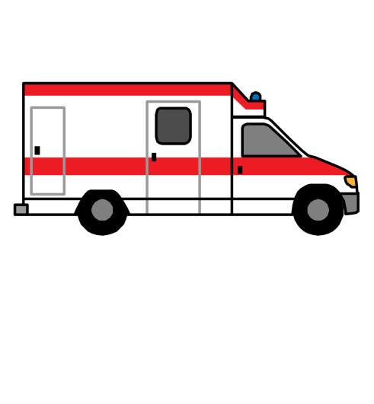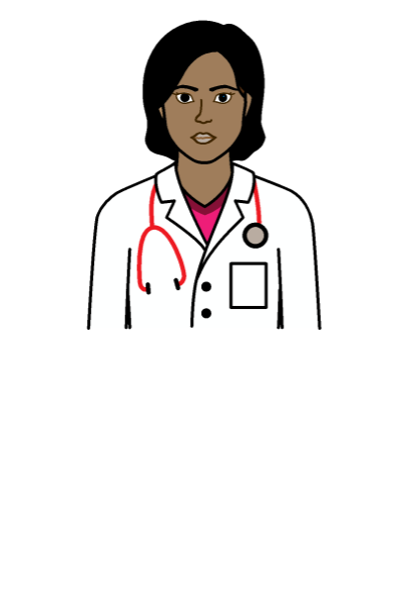Most people get a bit ill from Covid-19.

But some people can get very ill from Covid-19.

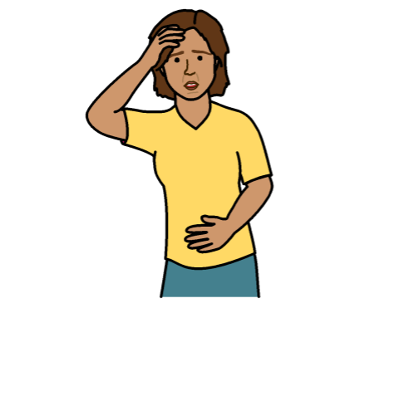

For example:

* Some older people
* Some people with disabilities
* Some people who have been ill for a long time



This report looks at:

* What is happening to people with disabilities during Covid-19

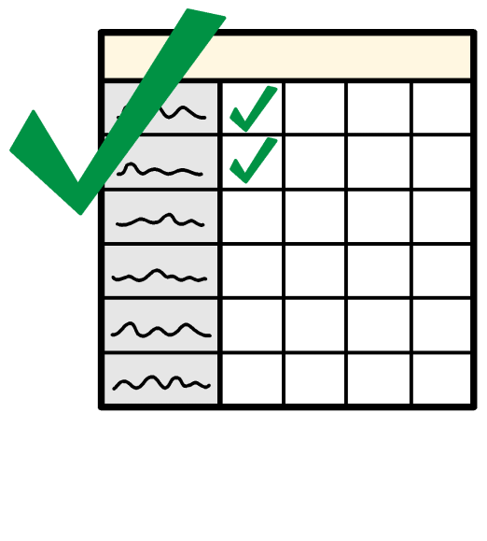

* What countries should be doing to make sure people with disabilities get their rights now and after Covid-19

# What is happening to people with disabilities during Covid-19

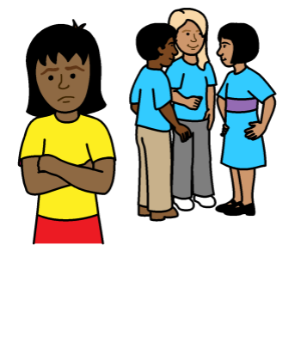

Life is already hard for many people with disabilities in the world.

For example, many people with disabilities are left out and treated unfairly.

Covid-19 is making these problems worse.

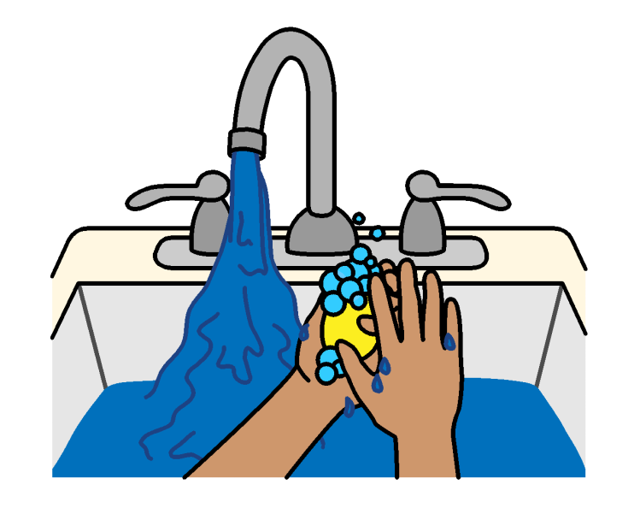Some people with disabilities might be in more danger because of Covid-19.

For example:

* People with disabilities might not have clean water and things they need to wash their hands often.

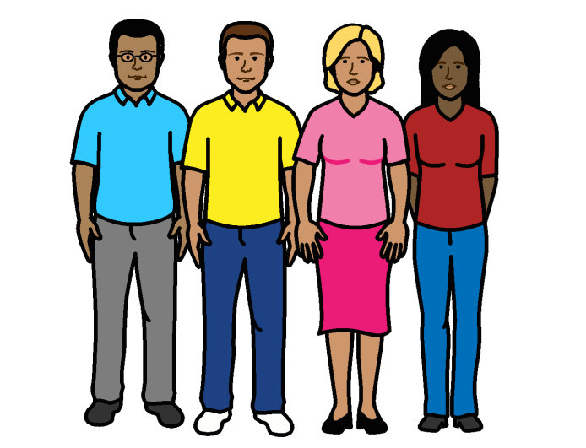

* Covid-19 can spread easily when people are near other people.

Many people with disabilities need to be

near other people to get support.

* 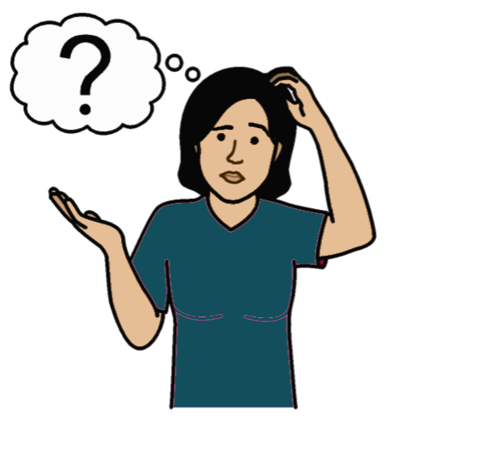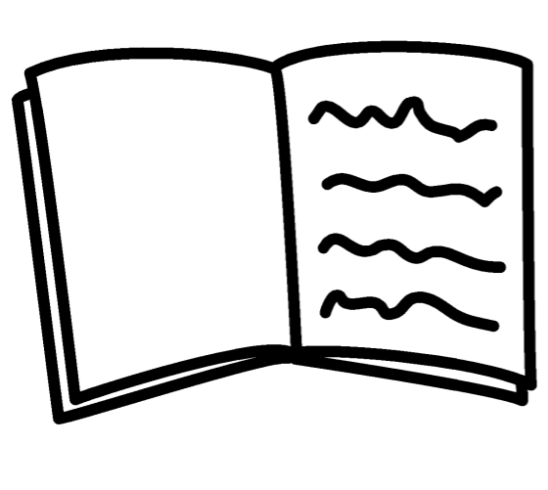Information about how to keep safe from Covid-19 might be hard for people with disabilities to understand.



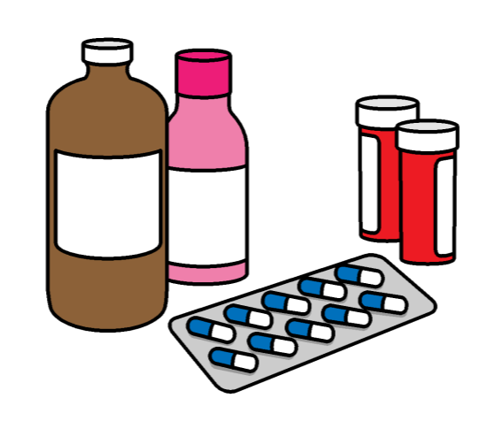

* People with disabilities often need more health care than other people.

But it can be even harder now to get the care and medicines they need.

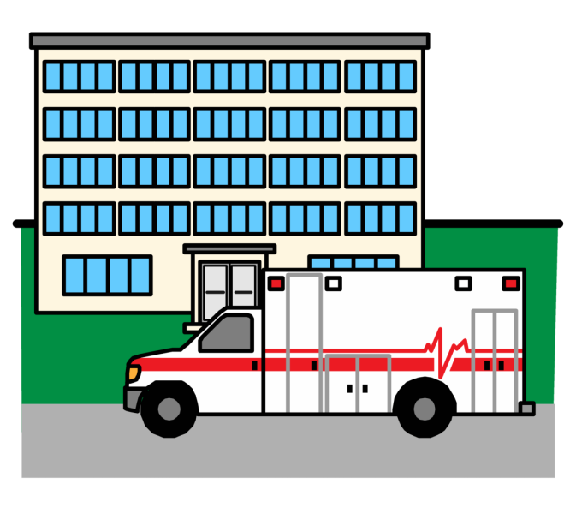



* Some doctors might give better care to people without disabilities if there are many people with Covid-19 in hospital.

## 

## Many people with disabilities do not work. Or they may lose their jobs because of Covid-19.

## Many people with disabilities do not get enough money from the government to live on.

## 

## Many schools have closed because of Covid-19.

## Children and young people with disabilities now have to learn at home.

## 

## But this might be hard for many people with disabilities.

## For example, lessons on the internet might be hard to understand and take part in.

## 

## Many people with disabilities might not get the support or mental health care they need because of Covid-19.

## More violence is happening to people at home and in the family during Covid-19.

## Violence often happens more to

## people with disabilities.

## For example, to women and girls with

## disabilities.

## 

# What should be happening

There are 5 main things that should happen to make sure people with disabilities get their rights now and after Covid-19.

1. **Make sure that people with disabilities have a big say in all plans about Covid-19**

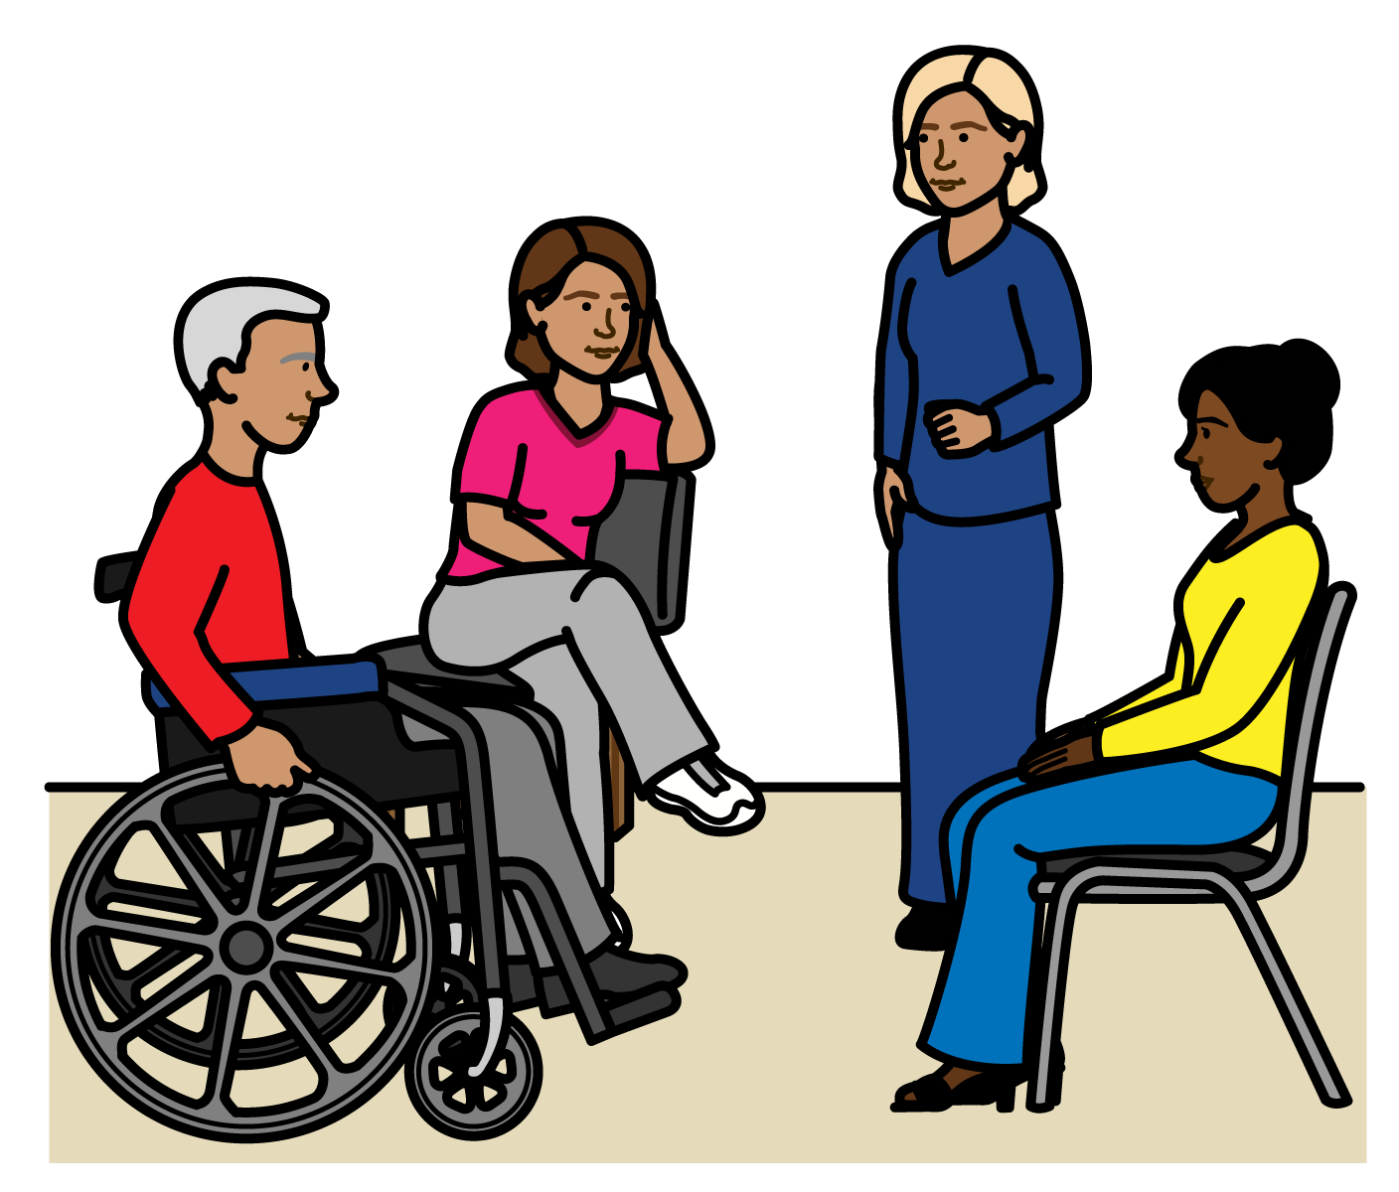

People with disabilities should have a say in all plans about Covid-19 from the start.

This means plans about what happens now and after Covid-19.

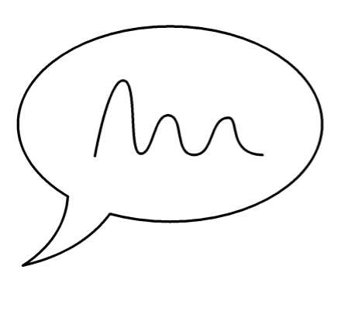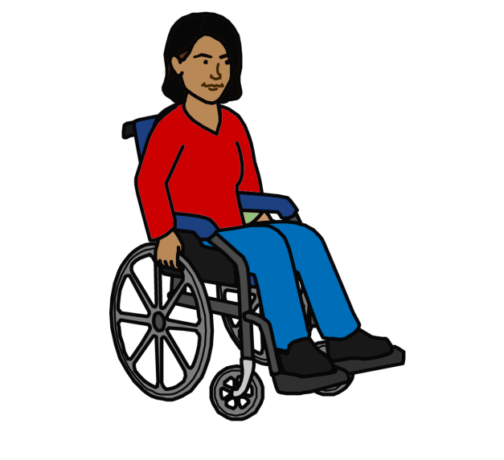People with disabilities can do important work now and after Covid-19.

For example, they can:

* Help people know about people with disabilities and what they need
* Help think of new ideas about how to cope and do well

1. **Make sure all plans about Covid-19 include people with disabilities**

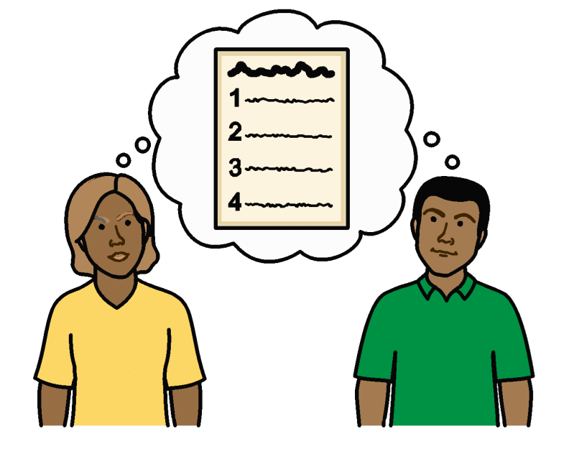

Plans about Covid-19 should talk about people with disabilities and what they need.

This means plans for everyone.

But there might need to be some plans just for people with disabilities.

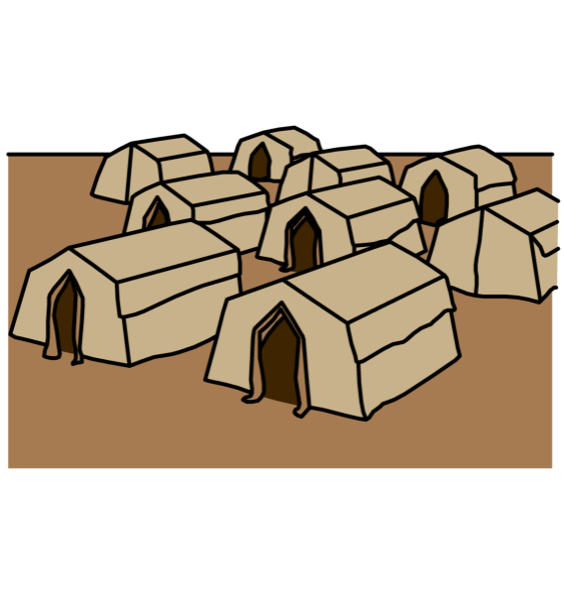

This also includes plans about keeping safe from Covid-19 in an emergency.

For example, if people have to leave home and live in camps with many other people.

1. **Make sure people with disabilities**

**get everything they need now and after Covid-19**

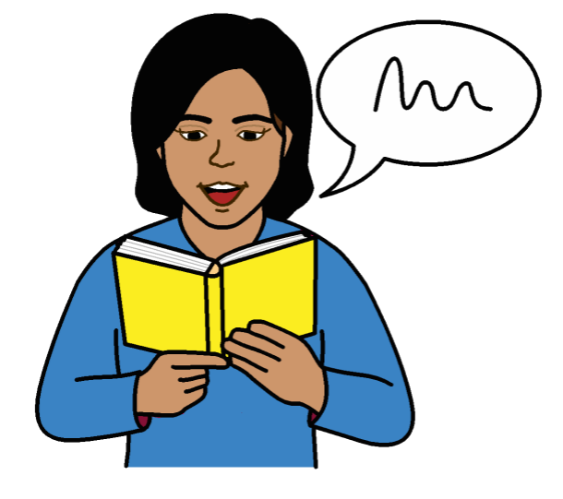

For example:

* Information about Covid-19 should be up to date and easy for people with disabilities to understand.

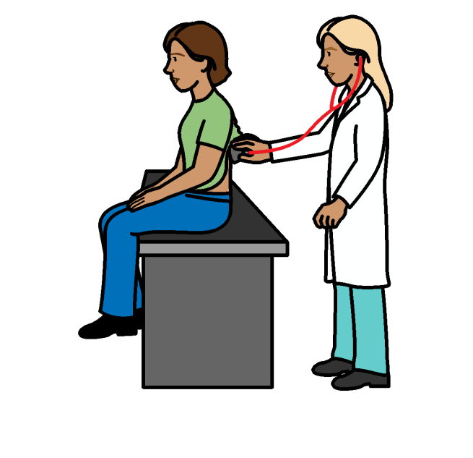

* Services should be easy for people with disabilities to get and use.

For example, health services and transport to health places.



* People with disabilities should get the medicine and equipment they need.

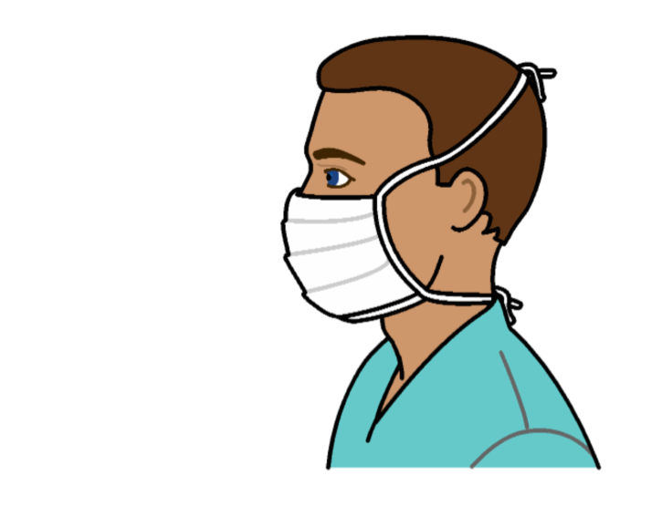This includes clean water and things to wash their hands with.

And equipment that is right for them.

For example, there are special face masks for people who are deaf.

* 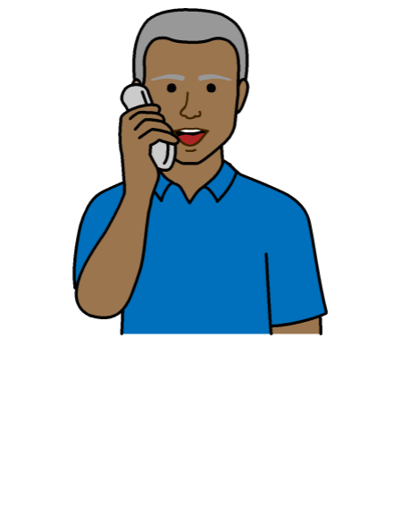People with disabilities should still get the support they need in a safe way during Covid-19.

There should be good plans about support in the community for people with disabilities and their carers.

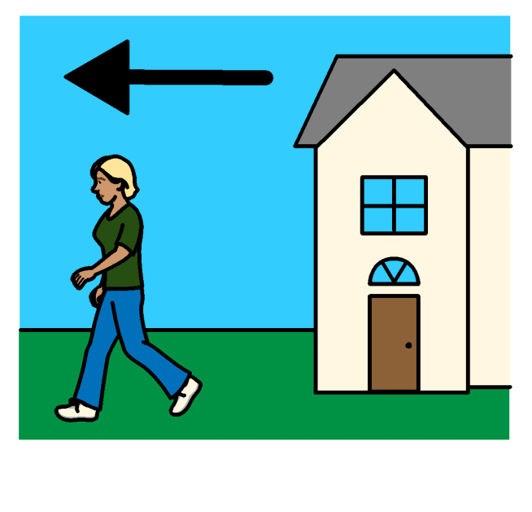

* People with disabilities should be moved out of hospitals and homes for people with disabilities if possible.

This is to keep them safe from Covid-19.

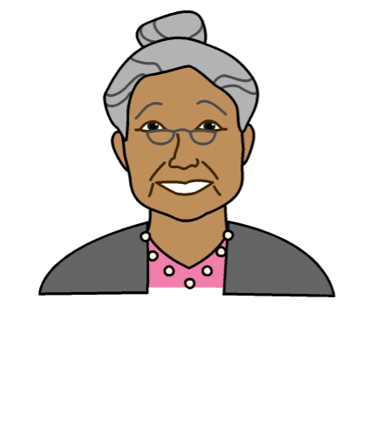

* People with disabilities who must stay in the hospitals and homes should be safe and treated fairly.

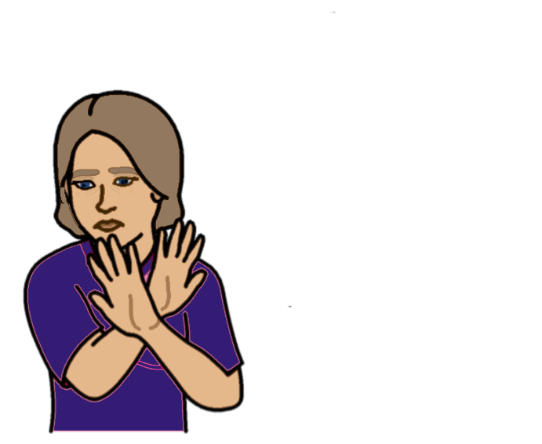

* It should be easy for people with disabilities to get help if someone is violent to them.
* 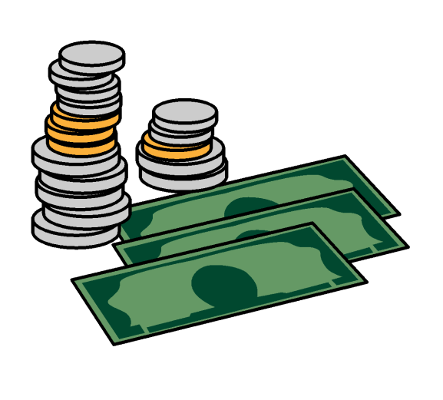Governments should make sure that people with disabilities and their families have enough money to live on now and after Covid-19.

For example, if they cannot work because of Covid-19. Or find it hard to get work after.

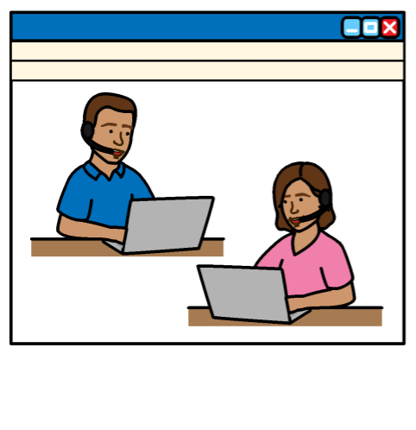

* People with disabilities who still have to work should get the right support.

For example, by making sure people with disabilities can take part in meetings or change the way they work.

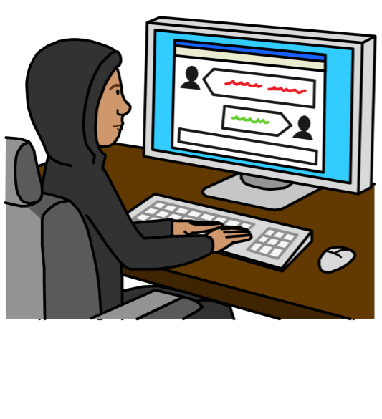

* Students with disabilities must be able to learn at home if their schools have closed.

And they should be able to come back to education after Covid-19.

Students and their families might need extra support and equipment for this.

1. **Make sure that all people with disabilities are treated fairly**

People with disabilities should not be left out or treated badly.

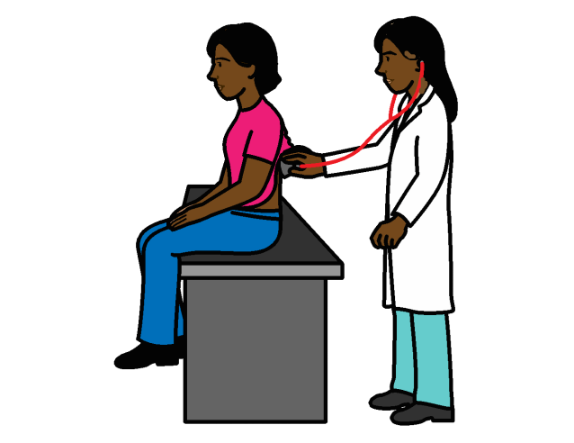

For example:

* They should not get worse health care than other people
* They should get the extra support they need to stay safe and well

1. 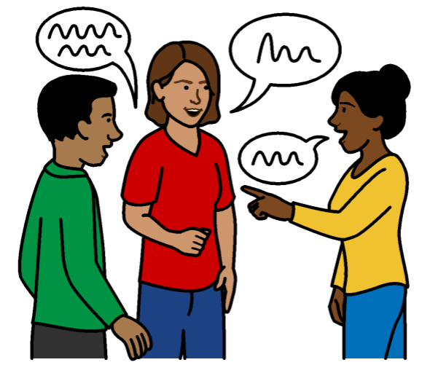**Check to make sure that all plans about Covid-19 include people with disabilities and are working well for them**

Governments and other organizations should check this is happening.

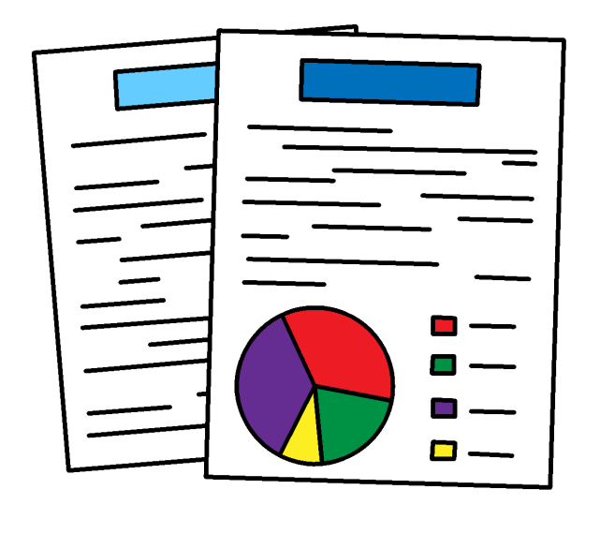

There should be good information to show what is happening to people with disabilities now and after Covid-19.

# After Covid-19

Covid-19 has changed many things.

Now countries have the chance to think about the future and how to make it better for people with disabilities.

# More information

There is some information about Covid-19 in easy words on this website:

<https://www.inclusion-europe.eu/easy-to-read-information-about-coronavirus/>



There is a United Nations plan about

how we will include people with disabilities in our work:

<https://www.un.org/en/content/disabilitystrategy/assets/documentation/Easy_to_Read.pdf>

**Pictures by The Picture Communication Symbols ©1981–2016 by Mayer-Johnson LLC a Tobii Dynavox company. All Rights Reserved Worldwide. Thousands of resources available for free at** [**www.boardmakeronline.com**](http://www.boardmakeronline.com/)

**The Picture Communication Symbols ©1981–2016 by Mayer-Johnson LLC a Tobii Dynavox company. All Rights Reserved Worldwide. Thousands of resources available for free at** [**www.boardmakeronline.com**](http://www.boardmakeronline.com/)