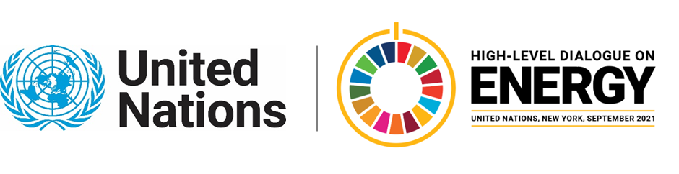

MINISTERIAL THEMATIC FORUMS

Side Event:
From the Ground Up: Translating Compacts to Implementation
Organized by Power for All
11.30 - 12.45 Wednesday 23 June

We all want a Sustainable Planet. Period. With 2030 fast approaching, it is imperative that global The High Level Dialogue on Energy's Technical Working Group (TWG) on Energy Access recognizes that the private sector plays a vital role in supporting the energy access ecosystem, including governments, national utilities, and the communities themselves. In the spirit of supporting HLDE's findings and the call to action to accelerate the end of energy poverty by 2030, Power for All proposes to host a side event on incorporating distributed renewable energy in national energy sector plans. Featuring key sector leadership organizations, c, Power for All and Shortlist, this facilitated discussion would focus both on the key technologies that can help countries achieve compact goals, as well as key aspects critical for sector success, including policy, finance and market activation. By examining the broader value chain of DRE solutions--SHS and rooftop systems, mini-grids, productive use of energy and workforce training and education--this dialogue will help forge partnerships and open conversations about leveraging private sector investments, mitigating risks and market-based approaches that will help energy compacts succeed.
https://us02web.zoom.us/webinar/register/WN_MRN0SYUdSBmffeDyeb2QrQ
Aashna Aggarwal, aashna@powerforall.org

