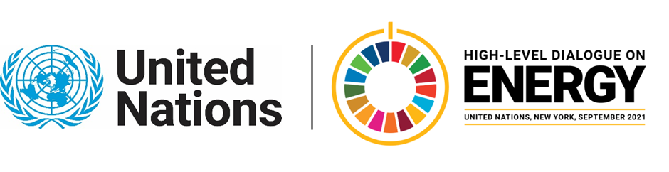

MINISTERIAL THEMATIC FORUMS

Side Event:
Nuclear Power’s Contribution to Sustainable Development and Clean Energy Systems
Organized by IAEA
11.30 - 12.45 Wednesday 23 June

We all want a Sustainable Planet. Period. With 2030 fast approaching, it is imperative that global This virtual event will discuss the contribution of nuclear power to current and future clean energy systems, as well as its contribution to sustainable development objectives.
The IAEA is partnering for this event with the OECD Nuclear Energy Agency. Experts from both agencies will cover the topics of:
- Nuclear energy’s contribution to a net zero world, in particular in the context of decarbonization scenarios, including the recently published Roadmap to Net Zero scenario of the International Energy Agency, and the IPCC 1.5 degree scenario report.
- Contribution of nuclear power and more generally, nuclear technologies, to Sustainable Development Goals
- The importance of nuclear investments in the context of the post-Covid19 recovery.
The economics of nuclear power is often seen as a major challenge for the sector. The event will discuss recently published findings on the economics of Long Term Operation, cost reductions for nuclear new build, and comparison of projected generation cost data among low carbon electricity technologies.
Finally, the event will discuss the potential role of advanced reactor technologies, and in particular Small Modular Reactors. How attractive an option are SMRs, to help meet energy demand and climate objectives, from the point of view of deployability, flexibility, integration in low-carbon energy systems, and economics. In particular, the event will highlight how SMRs and other advanced reactors could address the challenge of decarbonizing hard to abate sectors, by providing low-carbon heat or hydrogen to sectors that currently rely on fossil fuels.
https://iaea.webex.com/iaea/j.php?MTID=ma1714fbc0d16b7e83a22a4e70fd29872
Henri Paillere, h.paillere@iaea.org

