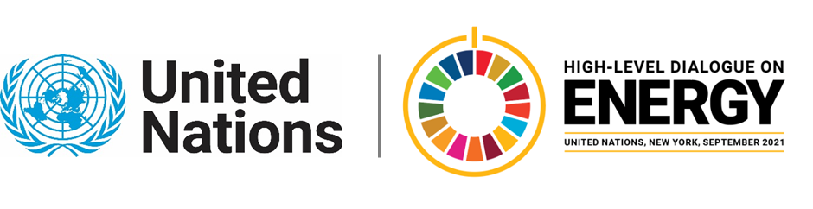

MINISTERIAL THEMATIC FORUMS

Side Event:
Advancing Sustainable Energy (SDG7) and Gender Equality (SDG5)
Organized by Government of Kenya, Ministry of Energy
11.30 - 12.45 Thursday 24 June

Women and female-headed households lag behind in accessing electricity, at home, through community services and in their businesses. Globally, 2.9 billion people lack access to clean cooking, disproportionately affecting women’s health, wellbeing and economic welfare. Women are alarmingly underrepresented in the energy sector at large. Despite the challenges, women are transformation agents and play key roles in delivering sustainable energy solutions to last-mile communities.

The Kenya Ministry of Energy and the Swedish International Development Cooperation Agency in partnership with the ENERGIA are co-hosting a side event during the HLD Ministerial Forum on Energy Access. The event will highlight key messages from the policy brief “Advancing Energy (SDG 7) and Gender Equality (SDG 5)” on SDG7 progress and how to accelerate actions on gender and energy:
- Increase investments in energy services that directly meet poor women’s energy needs for cooking, health, education, water supply and lighting.
- Support women’s entrepreneurship in energy value chains and their productive uses of energy.
- Increase women’s participation, leadership, and agency in the energy sector.
- Increase opportunities for decent jobs and career advancement for women to fulfil their potentials and aspirations in the energy transition.
- Systematically collect, report and use dis-aggregated data and evidence to ensure accountability to commitments on women’s empowerment.
A panel discussion featuring contributors to the brief will be complemented by a dialogue with the audience to exchange views and perspectives. The side event will call for strong political will, international cooperation, and increased funding and investment for closing gender gaps in the energy sector.

https://sida-se.zoom.us/j/85838623342
Password: 87654321

Paul Mbuthi, Paul.Mbuthi@energy.go.ke ; CC Phoebe.makungu@energy.co.ke

