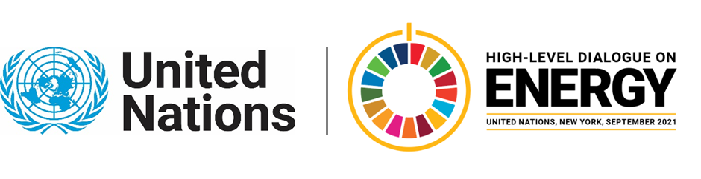

MINISTERIAL THEMATIC FORUMS

Side Event:
Young People Engagement to Accelerate Global Energy Transition and Cross-Sectoral Interlinkages Organized By UNICEF and UNESCWA
11.30 - 12.45 Tuesday 22 June

Successful transition to clean energy will require an intergenerational approach. Hence the recognizing the energy needs of children and young people and their role in accelerating global energy transition is critical. Young people have an important stake in shaping the energy future and stimulate innovative ideas, capacities and inclusiveness. Young people are inspired to act and have expressed their wish to have an active role in green transition (source: recent UNICEF survey with over 78,000 young people). Most of the survey respondents, 98 percent, were from Africa, the region that is home to the largest global population (75%) without access to electricity in 2019. Young people have expressed the need to be supported with the appropriate tools and opportunities to accomplish their endeavor to promote the sustainable energy agenda. This side event will focus on young people engagement in advancing SDG 7, opportunities to support youth leadership in promoting cross sectoral interlinkages between energy and other SDGs, as well as exchange of good practices. The side event, co-organised by UNESCWA and UNICEF, will hear directly from young people and bring a unique and largely untapped perspective into SDG 7 discourse.
https://unicef.zoom.us/j/98005262330
Rakshya R Thapa, rrthapa@unicef.org

