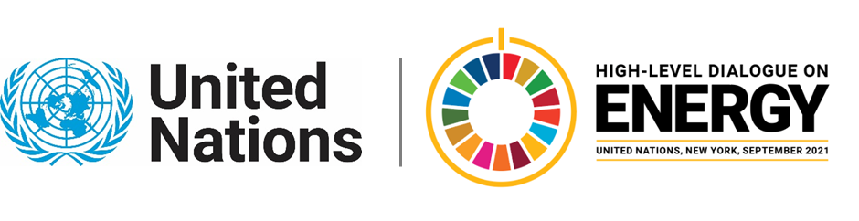

MINISTERIAL THEMATIC FORUMS

Side Event:
Nuclear Energy’s Contribution to Net-Zero and the Sustainable Development Goals
Organized by World Nuclear Association
11.30 - 12.45 Thursday 24 June

This side event will present the important role of nuclear energy, alongside other clean energy technologies, to achieve the Paris Agreement commitments and the UN 2030 Agenda for Sustainable Development, as well as meeting global energy needs.

Nuclear energy is the world’s second-largest source of clean electricity, and the largest in advanced economies. It has delivered reliable 24/7 cost-effective electricity all over the world for more than 50 years, with accumulated CO2 emissions avoided totaling 74 Gt.

To limit the average temperature rise to around 1.5 °C, the world must rapidly transition to a clean, net-zero emissions energy system. Study after study has indicated that the most affordable way to achieve this goal is with a portfolio of clean energy technologies that include nuclear energy.

As the only low-carbon energy that can produce electricity and industrial heat, nuclear energy has the potential to decarbonize other hard to abate sectors beyond the electric power sector. Nuclear energy already supplies district heating and fresh water. Innovative reactor designs are able to supply high-temperature process heat for industrial applications, while nuclear reactors could also produce hydrogen and synthetic fuels for transportation and industrial use.

Nuclear is making important contributions towards achieving the Paris Agreement (SDG 13) and a number of UN Sustainable Development Goals, including the provision of affordable, reliable, sustainable and modern energy to all (SDG 7).

The side event will feature speakers from the private and public sectors, including the International Atomic Energy Agency, to support raising ambition and accelerate action towards the achievement of the SDG7 targets and 2030 Agenda for Sustainable Development.

Virginie Ryan-Taix, virginie.ryan@world-nuclear.org

