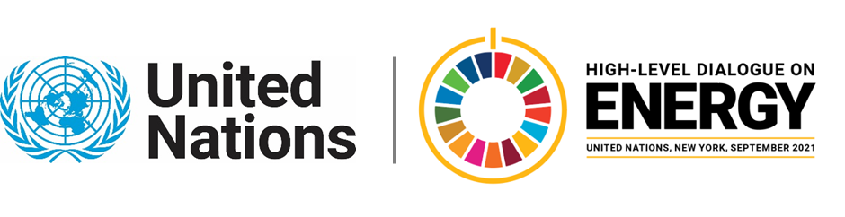

MINISTERIAL THEMATIC FORUMS

Side Event:
Catalysing Private Sector Investments in Decentralised Renewables to Close the Energy Access Gap
Organized by Alliance for Rural Electrification (ARE)
11.30 - 12.45 Monday 21 June

Despite often challenging market conditions, the strong value proposition of decentralised renewable energy (DRE) companies, federated by the Alliance for Rural Electrification (ARE) means that to date at least 470 million people rely on DRE. Private companies in the sector have raised more than USD 2.1 billion in corporate financing and finance from 2010 to the end of 2019 to close the energy access gap.
This is an astonishing achievement - but it is not enough. Efforts to support DRE need to be accelerated and scaled up significantly to reach the Sustainable Development Goals by 2030, as 870 million currently lack access to electricity, while another 1.5 billion suffer from unreliable electricity services.
To achieve this scale-up annual investments need to increase more than threefold to achieve SDG-7 by 2030. The key to achieve radical scale is the private sector.
This session will focus on how to further mobilise private sector investments in energy access and will also shed a light on the need for investment readiness support for DRE companies to absorb investments in the sector.
ARE proposes to involve both public and private sector in this session, including relevant EU initiatives, which may include GET.invest and ElectriFI, as well as private investors from the ARE membership.
https://register.gotowebinar.com/register/3531196357491357187
Jens Jaeger, j.jaeger@ruralelec.org

