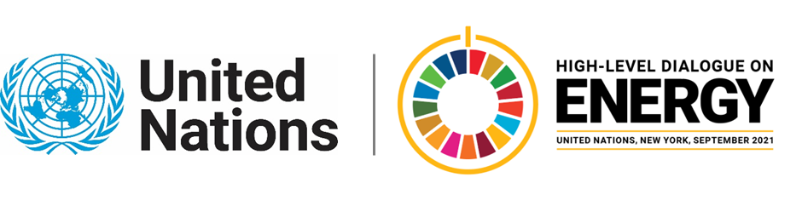

MINISTERIAL THEMATIC FORUMS

Side Event:
Unite Behind the SC1.5NCE
Organized by YOUNGO
15.15 - 16.30 Wednesday 23 June

Unite Behind The SC1.5NCE will amplify the global youth-led campaign SC1.5NCE NOT SILENCE to "unite the world behind the science,” build support for the IPCC 1.5C Special Report (SR 1.5) to be formally welcomed at COP26, and highlight countries and territories who’ve created innovative partnerships to accelerate national energy transitions. After being blocked at COP24 and COP25, SR 1.5 has become a rallying cry within the climate movement. It is critical that governments align their Nationally Determined Contributions with the 1.5C goal and develop partnerships to achieve success.
The SC1.5NCE NOT SILENCE campaign - launched by YOUNGO (official youth constituency of UNFCCC), AOSIS (Alliance of Small Island States), Island Resilience Partnership (IRP) and March For Science (largest science advocacy org in the world) - has secured the support of 19 countries who've pledged to champion SR 1.5 in Glasgow.
This event will build momentum for SC1.5NCE NOT SILENCE and highlight governments who have formed innovative public-private partnerships to achieve climate goals aligned with SR 1.5. From Samoa to Sint Maarten, Unite Behind The SC1.5NCE will demonstrate how public-private partnerships (spearheaded by event co-host IRP) are using artificial intelligence to accelerate and optimize national energy transitions.
If selected, Unite Behind The SC1.5NCE will use the SDG7 Action Zone to livestream the virtual signing of Sint Maarten’s national energy partnership with Prime Minister Silveria Jacobs. This will be a tangible outcome that demonstrates the impact-oriented nature of the SDG7 Action Zone.
http://bit.ly/snseventregistration
Heeta Lakhani, heeta.lakhani@unmgcy.org

