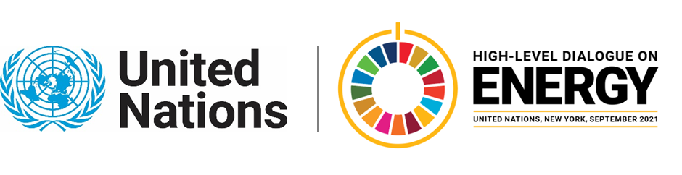

MINISTERIAL THEMATIC FORUMS

Side Event:
All Hands on Deck: Youth and Energy Compacts
Organized by the SDG7 Youth Constituency
11.30 - 12.45 Thursday 24 June

Young people need to be considered as a key stakeholder group in the energy transition: both as a beneficiary and as an agent of change. This side event will build on the ongoing effort across the UN system and by the youth organisations for greater inclusion of youth in the global energy agenda and focus on two key questions:

How can youth benefit from the Energy Compacts?
How can youth contribute to the Energy Compacts?

Segment 1: Energy Compacts for youth
5 min – Presentation about suggested actions for stakeholders to empower youth, with key inputs from the UNDP consultation toward the HLDE and the Global Youth Energy Outlook.
20 min – Open discussion on the suggested actions with 2-3 invited discussants from governments, private sector, nonprofits and interventions from the floor.
5 min – Presentation on next steps and introduction of VEF Call to Action as a platform to commit to actions supporting women and youth.

Segment 2: Youth for Energy Compacts
5 min – Presentation about possible youth contributions to the Energy Compacts, with key inputs from the Youth Sustainable Energy Hub Progress Report.
20 min – Open discussion on the suggested actions with 2-3 invited youth discussants and interventions from the floor.
5 min – Presentation on next steps

The output of the event will be a toolkit on how stakeholders can account for the needs of youth in formulating their Energy Compacts and how youth organisations can participate in the process.

https://zoom.us/webinar/register/WN_YNj1JF6XTM2Ak1zHdOcEPg

Beniamin Strzelecki, beniamin.strzelecki@unmgcy.org

