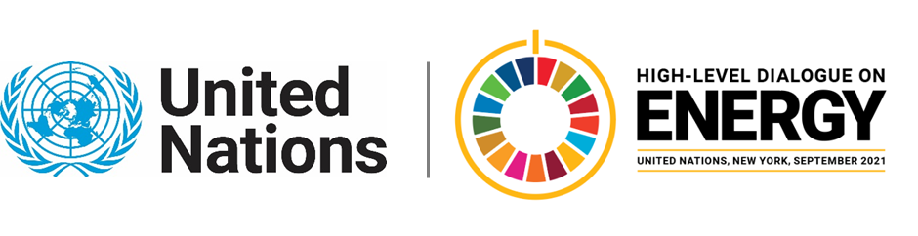

MINISTERIAL THEMATIC FORUMS

Side Event:
Israel’s Energy Innovations
Organized by the Permanent Mission of Israel to the UN
14.00 - 15.15 Tuesday 22 June

The State of Israel is known as the “Start-Up Nation” as it advances innovation, science and technology in all fields. Therefore, the Ministry sees high value in encouraging and investing in technological initiatives, research and development in the Israeli energy sector. The Israeli Ministry of energy, through its Chief Scientist Department, invest in pioneering R&D projects and academic research in the different energy fields: renewable energy, solar technology, alternative fuels, bio-gas, storage, hydrogen and more.
https://forms.gle/G4gsdAj4jKjXWggB8
Moriya Sror, UNDevelopment-Adv@Newyork.mfa.gov.il

