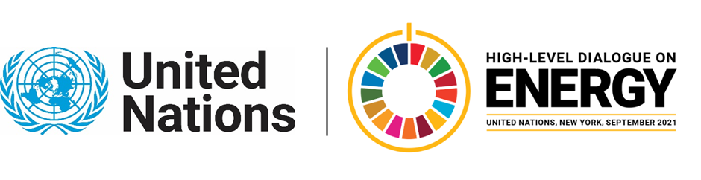

MINISTERIAL THEMATIC FORUMS

Side Event:
Panama’s Energy Transition: Energy Compacts to Enhance Climate Ambition
Organized by Rosilena Lindo
14.00 - 15.15 Thursday 24 June

Present Panama Energy Compacts Portfolio from the Governmental, private sector, civil society and youth.

https://us02web.zoom.us/webinar/register/WN_LDSbTCXESMi6oMs4QeUtxw

Rosilena Lindo, rlindo@energia.gob.pa

