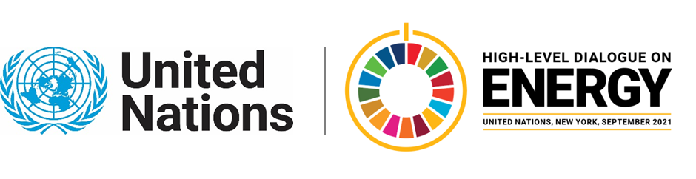

MINISTERIAL THEMATIC FORUMS

Side Event:
High-Level Roundtable on Green Hydrogen
Organized by Denmark
6.00 - 7.00 Wednesday 23 June

The United Nations Marrakech Partnership’s Climate Action Pathway on Green Hydrogen offers guidance on the scope and scale of stakeholder action required to deliver a 1.5 degree compatible energy sector by 2050. In the immediate, this action can aim to achieve the UN Breakthrough Outcome of at least 25 GW Green hydrogen capacity deployed by 2026, toward delivering 500-1000 GW required by 2030. Businesses, countries, and other stakeholders are encouraged to establish Energy Compacts that help to deliver these outcomes through sector-specific and market-enabling targets and measures to accelerate development of a green hydrogen ecosystem and value chain.

This high-level ministerial roundtable will convene stakeholders from different countries and sectors that will address critical gaps, challenges and opportunities in the policy and market environment. It will showcase the work that has been initiated to create a catalogue of Energy Compacts on green hydrogen to establish measurable and actionable bases for individual or collaborative action on key leverage points to accelerate development of end-to-end value chains.

High-level stakeholders will discuss the needed regulatory framework and infrastructure investments needed to support the continued expansion of green hydrogen capacity and capabilities. There will be a particular focus on the role of the private sector and their ambitions for submitting Energy Compacts on green hydrogen

https://zoom.us/webinar/register/WN_cOvbKHXzRPSMWL_Ifpu60g

Mira Bergem, mirber@um.dk

