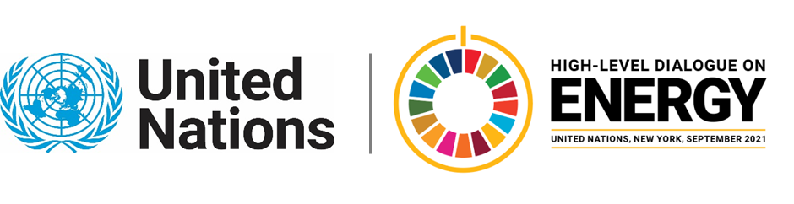

MINISTERIAL THEMATIC FORUMS

Side Event:
Financing Energy Access and Economic Recovery in a Climate Smart Way
Organized by the Rockefeller Foundation, IKEA Foundation, and Sustainable Energy for All
11.30 - 12.45 Monday 21 June

The event will highlight the model approach for integrated energy planning, aligned with integrated resource planning and leveraging quality data, that is focused on outcomes and driving investment.
https://www.seforall.org/events/financing-energy-access-and-economic-recovery-in-a-climate-smart-way
Speakers:
Ashvin Dayal (Rockefeller Foundation), Makhtar Diop (Managing Director, IFC), Per Heggenes (CEO, Ikea Foundation), Damilola Ogunbiyi (CEO/SRSG, SEforALL), Vera Songwe (Executive Secretary of the Economic Commission for Africa (ECA)- tbc.
Moderator: Sonal Bhutra, Anchor and Senior Research Analyst, CNBC TV18
Isabelle Blanc, Isabelle.Blanc@seforall.org

