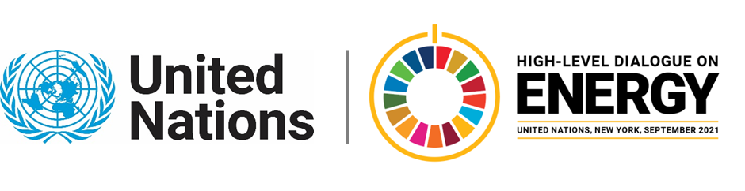

MINISTERIAL THEMATIC FORUMS

Side Event:
Financing Energy Projects in Small Island Developing States
Organized by UNDP - Climate Investment Platform
6.00 - 7.00 Wednesday 23 June

Many SIDS have a large potential for developing and accessing several renewable energy sources, such as solar, wind, geothermal and hydropower. Some SIDS are therefore slowly emerging as frontrunners in the pursuit of renewable-based energy systems, building on the abundant local and natural resources. Furthermore, the declining cost of renewable energy and energy efficiency technologies has opened the door for new opportunities to switch to clean energy, save money and create jobs.
Accelerating the transition can be Utilizing this in SIDS will need to be supported by several different stakeholders. From securing enabling framework conditions, increased investments from the private sector, promotion of attractive project pipelines by developers and provision of targeted support from development partners.

OneA key challenge is to address existing investor risks that affect the financing costs and competitiveness of sustainable energy projects. Despite falling investment costs, SIDS face high financing costs that can dramatically affect the transition and competitiveness of sustainable energy versus deep rooted fossil fuel technologies. Financing costs often reflect several perceived or actual barriers and their associated investment risks.

This event aims to discuss how different, relevant stakeholders can mitigate perceived and actual investor risks when it comes to financing sustainable energy projects in SIDS, by presenting learnings from successful projects SIDS clean energy projects, showing how SIDS can take a project from idea to financial close and operation. And discussing what role different stakeholders can play in that process with an emphasis on very concrete de-risking measures. Participants will include representatives from Small Island Developing States, the CIP Partners, and regional developments banks.

https://undp.zoom.us/webinar/register/WN_UHV4DG6kTv-NAq3wzfUBzA

Anne Marx Lorenzen, anne.marx.lorenzen@undp.org

