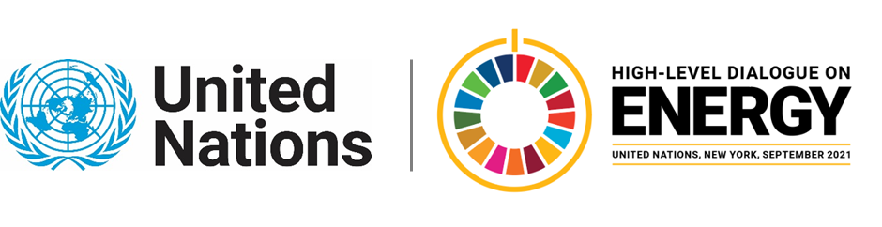

MINISTERIAL THEMATIC FORUMS

Side Event:
Dominican Republic: Towards a Comprehensive Implementation of SDG7
Organized by the Dominican Republic
15.15 - 16.30 Thursday 24 June

Among the goals of SDG 7 is to ensure universal access to affordable, reliable, and modern energy services, leaving no one behind. In this order, through the development of a rural renewable electrification program in communities with difficult access, access to reliable and quality energy to isolated and low-income families is ensured, thus instantly improving their quality of life. Another goal is to double the global rate of improvement of energy efficiency, and with the development and approval of the energy efficiency regulatory framework, it would be possible to impact the entire national population with the rational use of energy and the implementation of energy efficiency in all sectors.

Speaker:
Mr. Alfonso Rodríguez, Vice Minister of Energy Efficiency of the Dominican Republic

Claudia Mansfield LaRue, claudia.larue.un@gmail.com ; npolanco@mem.gob.do

