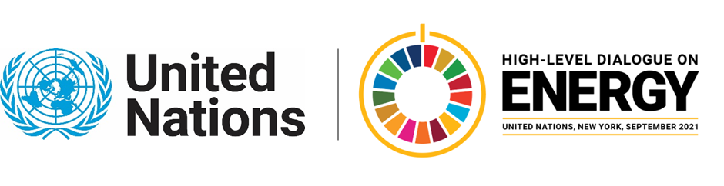

MINISTERIAL THEMATIC FORUMS

Side Event:
The Renewable Energy Revolution: Best Practices for Projects to Achieve Biodiversity Net Gain
Organized by the International Union for Conservation of Nature (IUCN)
14.00 - 15.15 Monday 21 June

The transition to renewable sources of energy is underway. Yet, one fourth of the world’s population still lives without electricity. It is therefore vital to ensure that the needs of billions of people who still lack access to basic energy services are met while transitioning to clean, low carbon energy systems.

However, clean energy sources, like wind and solar, can contribute to the loss of biodiversity through habitat loss and fragmentation, the generation of noise pollution, collision and other indirect impacts, if projects development are not properly managed through appropriate impact assessment and mitigations measures. Furthermore, as deployment of renewables continues at an incremental rate over the next decade there may be several direct, indirect or cumulative impacts on biodiversity that currently are not apparent from the extent of existing developments.

Renewable projects should address the associated risks to biodiversity, from project definition, siting, permitting, construction and operational and decommissioning phases. In particular, the roll-out of renewables, at scale, should proactively deploy the mitigation hierarchy at the project, landscape and national levels to anticipate and address possible impacts on biodiversity, and to achieve Net Gain outcomes.

This session will share and discuss best practices to mitigate biodiversity impacts associated to on-shore and off-shore wind and solar projects building on the work led by IUCN in partnership with Électricité de France, Energias de Portugal, Shell, Fauna & Flora International, BirdLife, Wildlife Conservation Society, The Nature Conservancy, and The Biodiversity Consultancy.
This partnership has launched the IUCN/TBC Guidelines for Mitigating impacts on biodiversity associated to renewable energy projects (solar, onshore and offshore wind).

https://us02web.zoom.us/j/83628854795
Giulia Carbone, giulia.carbone@iucn.org

