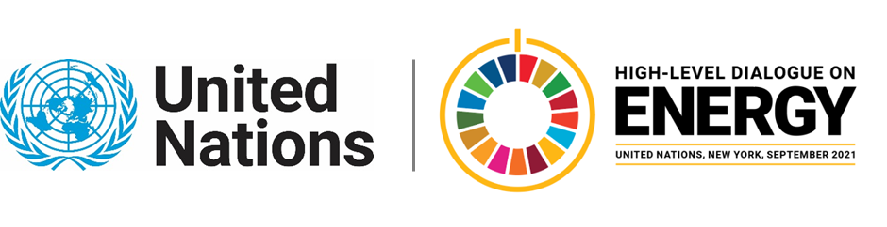

MINISTERIAL THEMATIC FORUMS

Side Event:
Launch of Brazil’s Energy Compact: Hydrogen
Organized by Government of Brazil
15.15 - 16.30 Thursday 24 June

The event will launch Brazil’s energy compact on hydrogen, with high-level messages from the Brazilian Ministry of Mines and Energy, IRENA and IEA and an explanation of the main aspects of the compact (technological bases on hydrogen in Brazil, previous investments and achievements, capacity building and human resources, platform and monitoring), to be followed by Q&A. The event will make use of pre-recorded videos.

https://youtu.be/y9SIaNGI344

Rafael Da Soller, rafael.dasoller@itamaraty.gov.br

