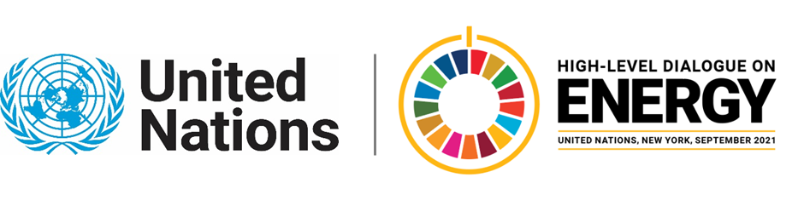

MINISTERIAL THEMATIC FORUMS

Side Event:
Uptake of Port Energy Efficient Technologies and Operations
Organized by State Department for Shipping and Maritime Affairs, Ministry of Transport, Infrastructure, Housing, Urban Development and Public Works, Kenya
6.00 - 7.00 Tuesday 22 June

The aim of taking part in this side event under the Kenyan flag is to ensure that there is focus on the identification of barriers and opportunities for maritime energy efficiency technologies in the developing world (GMN). In addition to this, the other aim is to promote the understanding of the global response to maritime GHG emissions (IMO) inclined to energy efficiency.
Kenya is a Member State of the IMO and host of the MTCC Africa, thus supporting this event will aid in fostering regional and global recognition of measures in sustenance of safety and security of shipping and the prevention of marine and atmospheric pollution by ships. It is imperative to note that IMO's work also supports the UN SDGs.
Kenya Government, IMO, GMN and MTCC Africa look forward to making the side event Forum on Innovation, Technology and Data a success in the best interest of the region.
https://zoom.us/j/93489291221?pwd=OTIrdTljV2NIRkI4YW5aa2o2YmdVUT09
Madam Nancy Karigithu, psmaritimeshipping@gmail.com; CC nlydia@jkuat.ac.ke

