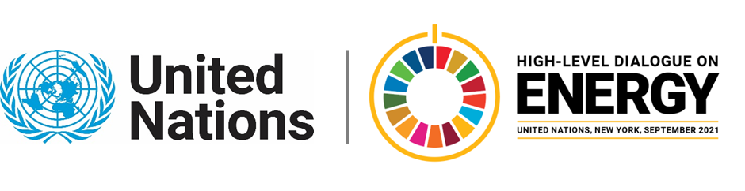

MINISTERIAL THEMATIC FORUMS

Side Event:
Scaling Climate-Positive Development Action from the Global South
Organized by the Council on Energy, Environment and Water
11.30 - 12.45 Wednesday 23 June

A showcase of leading examples from the Global South where climate action and development aspirations are converging together. The aim is to inspire confidence among state actors and the private sector about climate-positive development and market activities and evolve the narrative around climate action in developing countries.

We plan to showcase examples of clean energy applications for economic activities among small and micro-enterprises such as renewables-powered sewing machines and looms that have improved income for thousands of women in India; waste-biomass-based farm-gate cold storages avoiding food loss and increasing farmer incomes, or solar-powered fodder growing stations improving income of cattle rearing communities. We also plan to bring in examples of the impact of clean energy on healthcare and education.

Many actors in developing countries often find climate action inhibiting economic growth and development aspirations. By showcasing real-world examples about climate positive development and market action, we aim to evolve the perspectives and narratives of the stakeholders from the Global South.

Apart from the on-ground scaled-up examples, the session would also bring the spotlight on what kind of conditions and partnerships help bring such examples to life and help them scale.

We intend to collaborate with organisations from a few other continents to showcase globally relevant examples. Partners could include Sustainable Energy for All, Self Employed Women Association (SEWA), Power for ALL, among others.

Abhishek Jain, abhishek.jain@ceew.in

