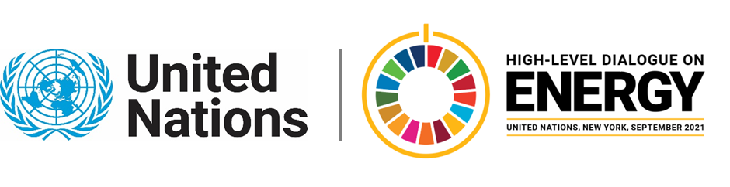

MINISTERIAL THEMATIC FORUMS

Side Event:
Leaving (Really) No One Behind: Energy Access in Fragile and Conflict Affected Areas
Organized by UNITAR
6.00 - 7.00 Thursday 24 June

The need for durable and innovative solutions is particularly great in fragile contexts, such as in situations of displacement, where energy access amongst affected populations is well below SDG7 targets. Humanitarian agencies do not have the means to prioritise energy beyond its direct applicability to addressing the basic needs of the persons of concern, such as, providing food, water and medical assistance. Meanwhile a lack of policy recognition for the displaced people limits their incorporation in national programmes for energy access, which further inhibits longer-term development planning and peacebuilding efforts. In fragile contexts, lack of access to energy and development creates the conditions for the structural instability and persistence of vulnerability.

To bring attention on the energy needs of displacement-affected communities, the Global Platform for Action (GPA) on Sustainable Energy in Displacement Settings hosted at UNITAR will organize an event at the Ministerial Forum to convene governments, UN agencies, and international/national organizations working towards achieving SDG7 in fragile and conflict affected areas. The discussion will focus on policy, advocacy, and strategies for energy interventions, as well as the challenges and opportunities in collaborative approaches, which could also include UN peacekeeping in future solutions. The event is expected to create momentum on this topic and facilitate the discussion during the UN High-level Dialogue on Energy. The organisers will call on all relevant partners to include displaced people in national energy access policies while humanitarian, development and peacebuilding organisations are urged to switch to sustainable energy solutions in their responses.

This side event is proposed on the basis of SDG 7 Policy Brief 3.14 The Interlinkages between Energy and Peaceful and Inclusive Societies.

https://unitar.zoom.us/webinar/register/WN_S9HQi7weQ-uP37d9ISXgIg

Dr. Thomas Fohgrub, thomas.fohgrub@unitar.org

