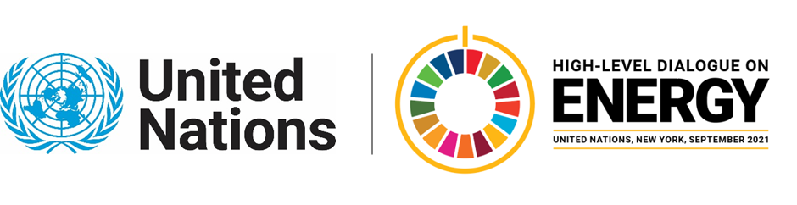

MINISTERIAL THEMATIC FORUMS

Side Event:
RELAC: An Energy Compact to Boost Renewables in Latin America and The Caribbean (LAC)
Organized by the Inter-American Development Bank (IDB)
12.45 - 14.00 Wednesday 23 June

Investment in non-conventional renewable energy has risen sharply in LAC over the past decade. Nonetheless, the share of renewables has remained stable at around 58% during the last decade, mainly explain by a sustained growth in electricity demand. In that challenging context, 10 countries in the region agreed to create the RELAC initiative, during the 2019 United Nations (UN) Secretary General's Climate Action Summit. Its main objective is to achieve a regional target of at least 70% participation of renewable energy sources in the electricity matrix of LAC by 2030. RELAC is the first initiative of its kind in LAC aiming to track and achieve a regional target in terms of sustainable energy.

The objectives of this event are to: (i) discuss how the RELAC collective action platform can better help LAC countries achieve their electricity sector goals by 2030, as well as their long-term climate goals; (ii) attract new countries that are not yet part of RELAC. As part of the agenda, the RELAC initiative will be presented, exploring its mission and medium-term vision, and also how it can contribute to the LAC decarbonization process and green recovery. The event will be also the arena for the countries to discuss about how the process of establishing renewable energy goals has been and the challenges that this entails. The event will have the participation of high-level representatives from energy ministries of the RELAC member countries (Chile, Colombia, Honduras, Dominican Republic), as well as IDB authorities, who will chair the session.

https://us02web.zoom.us/webinar/register/WN_LkVyRv52Q4yv9Mb4TW7Guw

Speakers:
- Miguel Loreto, Vice Minister of Energy, Colombia.
- Rolando Castro, Vice Minister of Energy and Environmental Quality, Costa Rica.
- Alfonso Rodriguez, Vice Minister of Energy Savings, Dominican Republic.
- Maria Florencia Attademo-Hirt, General Manager of the Southern Cone Department at Inter-American Development Bank.
- Ariel Yepez, Energy Division Chief at Inter-American Development Bank.
- Sylvia Larrea, Lead Energy Specialist in Costa Rica at Inter-American Development Bank.
- Alfonso Blanco, Executive Secretary OLADE.
- Representative from IRENA to be confirmed.
- Javiera Aldunate Bengolea, Head International Affairs Office, Energy Ministry, Chile
- Alejandra Bernal Guzmán, Head International Affairs Office, Mines and Energy Ministry, Colombia
- Gustavo A. Mejía-Ricart Del Rosario, Director of International Relations, Energy and Mines Ministry, Dominican Republic
Edwin Malagon, edwinma@iadb.org

