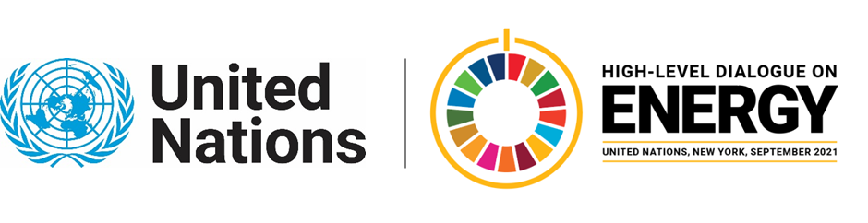

MINISTERIAL THEMATIC FORUMS

Side Event:
The Circular Carbon Economy in Achieving SDG7
Organized by Saudi Arabia & the Russian Federation
11.30 - 12.45 Monday 21 June

Event will broadly cover:
- The Circular Carbon Economy (CCE) as a concept and means of achieving SDG 7
- Implementations nationally and internationally
- CCUS and Hydrogen as examples of CCE technologies (presentations from Saudi Arabia and Russia)
- Q&A to discuss synergies and relationship of CCE concept and technologies with SDG 7
https://moenergy.webex.com/moenergy/j.php?RGID=r3c476e8a275ddad4d54c2309fb03c3f4
Noura Alissa, noura.issa@moenergy.gov.sa

