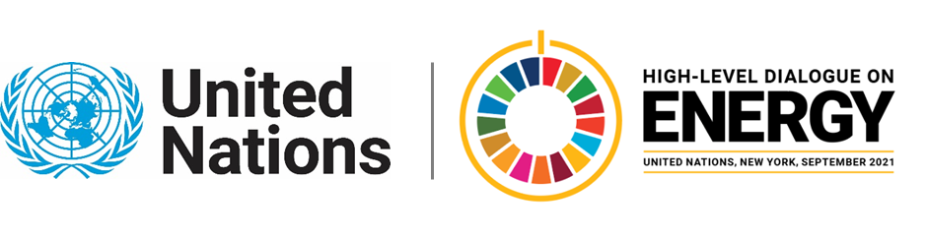

MINISTERIAL THEMATIC FORUMS

Side Event:
Accelerating Energy Access through Technology Innovation
Organized by United Nations Development Programme (UNDP)l
16.30 - 17.45 Tuesday 22 June

The purpose of the event is to showcase new technologies that can simplify energy access: A swarm-based storage system which combines and matches its own battery system and optimizes it. In contrast to conventional systems, which work with battery banks, this concept offers significant advantages and promotes electrification in rural off-grid communities. During the planning process, special software that can automatically create an optimal mini-grid design through an artificial intelligence-based algorithm has been used. The combination of new technologies and artificial intelligence provides a unique opportunity to reach scale faster and also crowd in private sector to reach SDG 7.
Alexandra Soezer, alexandra.soezer@undp.org

