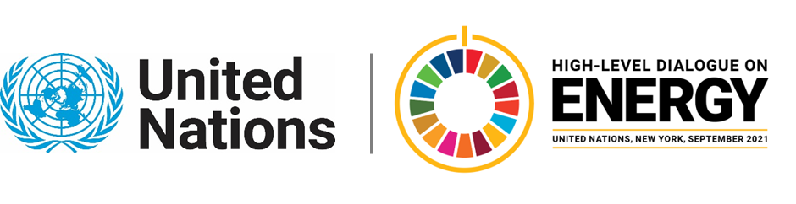

MINISTERIAL THEMATIC FORUMS

Side Event:
Integrated Energy Planning for Driving Outcomes and Investment
Organized by Sustainable Energy for All and the Rockefeller Foundation
14.00 - 15.15 Tuesday 22 June

The event will highlight the model approach for integrated energy planning, aligned with integrated resource planning and leveraging quality data, that is focused on outcomes and driving investment.
https://seforall.zoom.us/webinar/register/WN_s8HWwTU_Q4aMjF_lk_Pf7g
Speakers:
Ministers from Nigeria, Rwanda, Sierra Leone, Malawi and Uganda. World Bank. Damilola Ogunbiyi, CEO/SRSG SEforALL. Moderated by Joseph Nganga, Executive Director, Smart Power Africa.
Isabelle Blanc, Isabelle.Blanc@seforall.org

