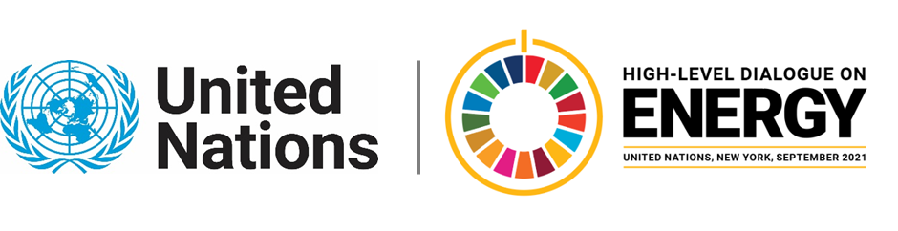

MINISTERIAL THEMATIC FORUMS

Side Event:
Zero Step Warm Data Project
Organized by United Nations Development Programme (UNDP)
14.00 - 15.15 Monday 21 June

In parallel to the formal High-Level Dialogue Technical Working Group process, UNDP as Co-Chair (together with The International Bateson Institute) ran the Zero Step Warm Data Project. This side event will explore the results of this experiment and is an invitation for you into a series of conversations to meet each other in this changing world. We warmly invite and welcome you into a space of care, curiosity and humility to learn together and build relationships, through the 'Warm Data' inspired process called People Need People Online - developed by Nora Bateson and stewarded by the International Bateson Institute (IBI).
People Need People Online (PNP) is a leading-edge systems process and practice that reveals the systemic patterns we are bound by to better perceive the interdependencies and relationships, thereby enabling fresh and new perceiving and thinking within families, communities and society. Thus opening the way of unprecedented possibilities to be explored and pursued as we work together towards achieving SDG7 by 2030.
https://undp.zoom.us/j/8169144188?pwd=dEorMExqYVJiSHVoV25kUG1GeHozUT09
Marcel Alers, marcel.alers@undp.org

