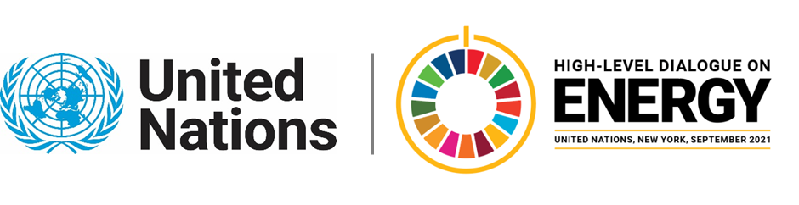

MINISTERIAL THEMATIC FORUMS

Side Event:
The Role of the Finance Sector in Reaching SDG7
Organized by International Institute for Applied Systems Analysis (IIASA)
6.00 - 7.00 Friday 25 June

New global net-zero scenarios have been developed to reach the goals of the Paris Agreement while limiting temperature overshoot and the need for net-negative emissions. Such scenarios thus reduce medium term risks related to climate change and technology uncertainty, but require faster reductions of emissions over the next decade. This has repercussions for the investments that are required during the next decade to reach ambitious climate targets, which will induce shifts in investments between technologies and regions. In this context, recent analyses of climate-related financial risks assessment allow to understand under which conditions investors could affect the feasibility of the low-carbon transition and its societal costs, as well as the role of fiscal and financial policies to enable the role of finance towards the global net-zero targets.
Bas van Ruijven, vruijven@iiasa.ac.at

