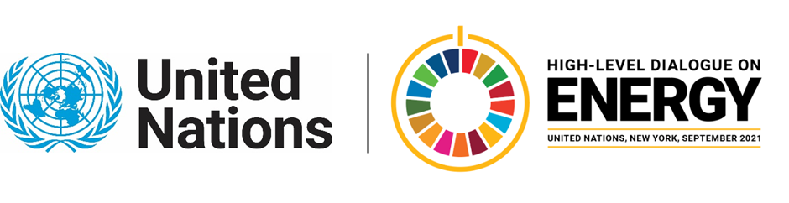

MINISTERIAL THEMATIC FORUMS

Side Event:
Policies and Investment on Energy Efficient Lighting: Models for Success
Organized by UNEP DTU Partnership
12.45 - 14.00 Tuesday 22 June

Lighting, appliances and equipment account for more than 50% of total global electricity demand which is expected to more than double by 2050 in developing countries. However, energy-efficient lighting, appliances and equipment can save energy, emissions and in all global regions more than $60 Billion annually.
Right energy efficiency policies can represent 40% of the emissions reductions to achieve the goals of the Paris Agreement. However, this potential is not being grasped and investment in energy efficiency was even decreasing over the last years. There are many reasons for that, among which are: the lack of right policies, knowledge and capacity, data and the appropriate design of bankable projects.
With this event we aim at presenting the opportunities on market transformation of lighting, appliances and equipment, through policy regulations, green procurement, assessment tools and innovative business models. Best practices will be presented on policy design and a specific focus on a business model adopted by Argentinian municipalities for energy efficiency technology procurement, resulting in evident economies of scale.
Proposed programme:
- Introduction to energy efficiency adoption by countries and municipalities (UNEP DTU Partnership)
- Presentation of the Street Lighting Energy Efficiency Calculator Online Tool (UNEP DTU Partnership and UNEP U4E)
- Opportunities for market transformation of lighting, appliances & Equipment (UNEP - U4E)
- "Fideicomiso" - Argentinian Trust Fund for aggregated municipal procurement of energy efficiency solutions (RAMCC, Argentina).
- Discussion Possible Compact on energy efficiency in lighting may be discussed.

https://c2e2.unepdtu.org/events/policies-and-investment-on-energy-efficient-lighting-models-for-success-webinar/

Gabriela Prata Dias, gdias@dtu.dk

