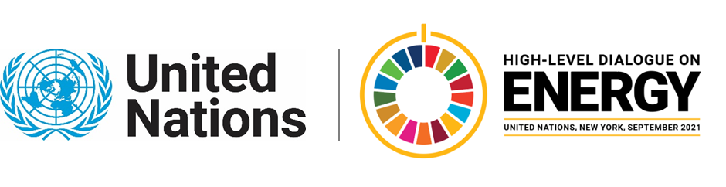

MINISTERIAL THEMATIC FORUMS

Side Event:
Unlocking Renewable Energy Investments through Project Facilitation Climate Investment Platform – Catalysing Concerted Action on the Ground towards Achieving Global Energy Transition
Organized by IRENA
6.00 - 7.00 Friday 25 June

IRENA proposes to host and organise a side event during the Ministerial Thematic Forum on Finance and Investment of the UN High Level Dialogue on 25 June 2021. The event will be organised in the form of a panel discussion where the panellists will comprise of the founding partners of the Climate Investment Platform (CIP).
The CIP was launched as a joint initiative by IRENA, UNDP and SEforALL, in close cooperation with the Green Climate Fund at the Climate Action Summit in September 2019 for the purpose of mobilizing capital towards developing countries to accelerate the scale-up of RE technologies deployment to meet Nationally Determined Contributions (NDCs) targets and achieve compliance with Sustainable Development Goals (SDGs). The CIP aims to support countries and projects in bridging existing gaps when it comes to RE project financing by providing a one-stop-shop where countries can set up ambitious energy and climate targets, including their NDCs under the Paris Agreement, and make use of the platform to create an enabling legal and regulatory environment.
In addition to the CIP’s founding partners, IRENA will invite a panellist from GIZ, a key partner to the CIP, to engage in the discussion that will be centred around the panellists’ individual and collective efforts of working towards the global energy transition through project facilitation, while also addressing the challenges associated with it. The panellists will also uncover the inner workings of the CIP and engage in a dialogue of the potential and current impacts of the platform, while also acknowledging aspects that may need improvement.

https://irena-org.zoom.us/webinar/register/WN_GoGvcZRTT2Smqt7SLTETnw

Speakers:
Panellists: Riad Meddeb (UNDP), Olivia Coldrey (SEforALL), Monica Gullberg (GCF), Michael Franz (GIZ) and Ahmed Badr/Tarig Ahmed TBC (IRENA)

Moderator: Sara Ibrahim Elhag (RCREEE)

Aliz Crowley and Tarig Ahmed, ACrowley@irena.org; TAhmed@irena.org

