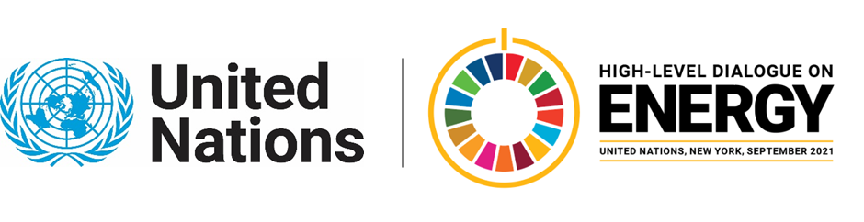

MINISTERIAL THEMATIC FORUMS

Side Event:
Raising Ambitions: New Metrics to End Energy Poverty
Organized by the Payne Institute for Public Policy
11.30 - 12.45 Tuesday 22 June

This event will consider both a new minimum level for energy access as well as a new metric for access reliability.
https://mines.zoom.us/j/96148576044
Morgan Bazilian, mbazilian@mines.edu

