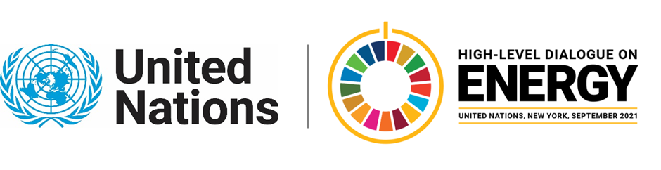

MINISTERIAL THEMATIC FORUMS

Side Event:
Launch of Brazil’s Energy Compact: RenovaBio
Organized by Government of Brazil
15.15 - 16.30 Wednesday 23 June

The event will launch Brazil’s energy compact on bioenergy, with high-level messages at the opening, an explanation of the RenovaBio policy and of the compact itself, a discussion on the role of the private sector and of regulation, monitoring, to be followed by Q&A. The event will make use of pre-recorded videos.

https://youtu.be/8vSCkBw2YCM

Rafael Da Soller, rafael.dasoller@itamaraty.gov.br

