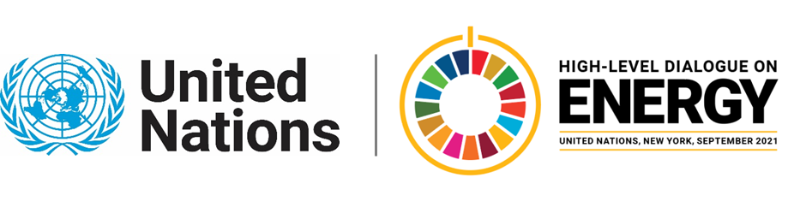

MINISTERIAL THEMATIC FORUMS

Side Event:
2021 Climate Action Pathway for Energy
Organized by IRENA
6.00 - 7.00 Thursday 24 June

The Marrakech Partnership for Global Climate Action (MPGCA) supports implementation of the Paris Agreement by enabling collaboration between governments and the cities, regions, businesses and investors that must act on climate change.

First launched in 2019 the Climate Action Pathways is a vital tool of the MPGCA that set out sectoral visions (Energy, Human Settlements, Industry, Land Use, Oceans and Coastal Zones, Transport and Water) for achieving a 1.5° C resilient world in 2050, with overarching transformational milestones, and key impacts that need to be achieved to realize them.

The Pathways aim to provide a roadmap to help Parties and non-Party stakeholders alike to identify actions needed by 2021, 2025, 2030 and 2040 as steps to get to the 2050 vision. These living documents are updated periodically with the latest information and lessons learned as the state of climate action evolves.

This event will launch the 2021 Climate Action Pathway for Energy (version 2.1) to showcase updates on the milestones to 2050.

Members of the MPGCA group on energy:

- International Energy Agency (IEA)
- International Chamber of Commerce (ICC)
- International Renewable Energy Agency (IRENA)
- Sustainable Energy for All (SEforALL)
- The Climate Group
- World Business Council for Sustainable Development (WBCSD)
https://irena-org.zoom.us/webinar/register/WN_xOQ0u2xOS8a-HsxQP6yotg

Waiman Tsang, WTsang@irena.org

