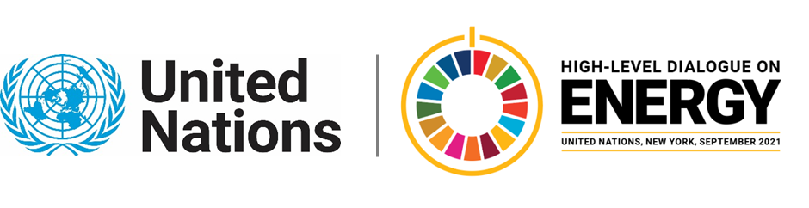

MINISTERIAL THEMATIC FORUMS

Side Event:
NL Energy Compact Initiative
Organized by Ministry of Foreign Affairs of the Netherlands
11.30 - 12.45 Wednesday 23 June

https://teams.microsoft.com/l/meetup-join/19%3ameeting_NzM3MmViYzMtMTcwZS00NDBmLTlkYWQtZDNkYTJiNjkzOTRm%40thread.v2/0?context=%7b%22Tid%22%3a%221321633e-f6b9-44e2-a44f-59b9d264ecb7%22%2c%22Oid%22%3a%2203e7bcf9-8b99-4c04-8eff-6a8b8a93662b%22%7d

