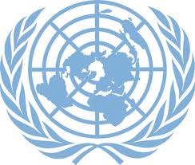 | Regular Process for Global Reporting and Assessment of the State of the Marine Environment, including Socioeconomic Aspects

NOMINATION FORM
Workshop under the Auspices of the United Nations to Assist the Regular Process for Global Reporting and Assessment of the State of the Marine Environment, including Socioeconomic Aspects

Second of two regional workshops for the Indian Ocean (including the Arabian Sea and the Bay of Bengal), the Red Sea and Gulf of Aden and the ROPME/RECOFI area

Doha, State of Qatar
28-29 November 2018

First name as inscribed in Passport:

temnova@un.org with copy to doalos@un.org, and marco.boccia@un.org

