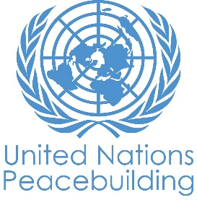
SECRETARY-GENERAL’S PEACEBUILDING FUND

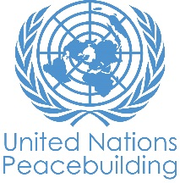
PBF PROJECT CONCEPT NOTE TEMPLATE

PBF PROJECT CONCEPT NOTE

Length : 2-3 pages plus cover page

Country:
Project Title:
PBF project modality:  IRF  PRF | If funding is disbursed into a national or regional trust fund:  Country Trust Fund  Regional Trust Fund  Name of Recipient Fund:
List all proposed direct project recipient organizations (starting with Convening Agency), followed type of organization (UN, CSO etc):
Expected project commencement date:
Project duration in months:
Geographic zones for project implementation:
Does the project fall under one of the specific PBF priority windows below:
Gender promotion initiative
Youth promotion initiative
Transition from UN or regional peacekeeping or special political missions
Cross-border or regional project
Total proposed PBF project budget (by recipient organization):
XXXX: $ XXXXXX
XXXX: $ XXXXXX
XXXX: $ XXXXXX
TOTAL:
Who has been consulted as part of preparing this Concept Note:
Select PBF Focus Areas which best summarizes the focus of the project (select ONLY one): _____
If applicable, UNDAF outcome(s) to which the project contributes:
If applicable, Sustainable Development Goal to which the project contributes:

CONTENT:

- Project rationale:
- What is the sustaining peace issue/problem that the project aims to address?
- Why is it important to act now? What specific opportunities exist?
- How does it align to national priorities/ support national ownership? How does it support the UN political engagement strategy in the country?

- Proposed interventions:
- Proposed project outcomes
- Proposed major interventions to achieve the outcomes / types of support to be provided
- Proposed geographic zones and types of project beneficiaries/ targeting criteria (gender and age sensitive)

- Proposed project budget per outcome and any budget justification/ explanation

- Expected project recipient organizations and partners and any justification:

Note: actual commencement date will be the date of first funds transfer.
Maximum project duration for IRF projects is 18 months, for PRF projects – 36 months.
PBF Focus Areas are: (1.1) SSR, (1.2) Rule of Law; (1.3) DDR; (1.4) Political Dialogue; (2.1) National reconciliation; (2.2) Democratic Governance; (2.3) Conflict prevention/management; (3.1) Employment; (3.2) Equitable access to social services (4.1) Strengthening of essential national state capacity; (4.2) extension of state authority/local administration; (4.3) Governance of peacebuilding resources (including PBF Secretariats)

