Implementation of the DPoA in the State of Eritrea
Generally all the regional and global development initiatives are incorporated together with our national development program. Therefore the DPoA implementation can be reflected in the following points.
- Agricultural Sector; among the many priority of national development; improvement on agricultural sector to insuring food and nutrition security is the priority of the priority of the government of the State of Eritrea. Agriculture is the cornerstone of the Eritrean economy; an estimated 60% of the population is dependent on subsistence agricultural mode of production. The government always need to modernize its agriculture in smart way to maximize productivity, use the product to the maximum and enhance the resilience of farmers and herders. To introduce modern farm, among the many programs initiated by the Ministry of Agriculture called “the Minimum Integrated Household Agricultural Package (MIHAP)” initiated in 2013, that is progressing positively. Therefore, building on the gains of MIHAP, designing appropriate strategic intervention is vital to transform the “Small and medium Scale Commercial Farmers (SMCFs)” across the whole country. In our context comprehensively the SMCFs are including those who are already producing the bulk of vegetables, fruits, milk, eggs, honey and other agricultural products for the markets throughout the country.
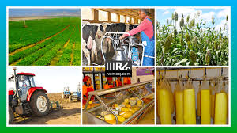
The growing food demand necessitates that a new agricultural transformation strategy that would enable farmers to shift from subsistence oriented production towards more specialized and maximized production.
Technological Support
Technology plays a crucial role in transforming farmers from subsistence to modernized commercial actors. Technology in agriculture is the application of tools, materials and research based knowledge to solve problems and enhance agricultural production and productivity.
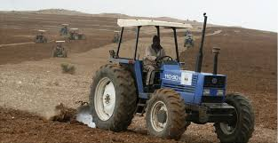
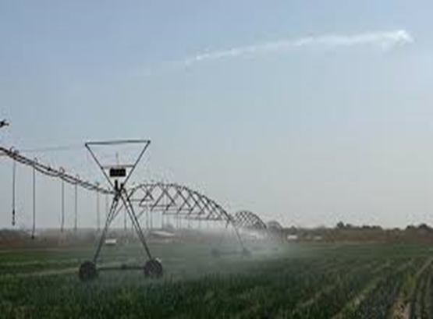

- Use of technologies in agriculture such as mechanization, motorized equipment and energy efficient irrigation technologies efficient and environment friendly renewable energy, crop and livestock production technologies, drought and disease resistant seed varieties and biotechnology provide improvement in agriculture.
- Technology has a positive impact on the way farmers grow and supply food from the farm to the table.
- Transforming from surface or furrow irrigation to pressurized irrigation system.
- Shifting from fossil fuel energy to renewable energy resources mainly soar energy.
- Moving from mono-culture to poly-culture (integrated agricultural system).
- Partial Transformation from outdoors to protected cultivation system.
- Enhancing agricultural value-chain development, food quality and safety.
- Promoting agricultural mechanization.
Vision of SMCFs
The vision of the SMCFs is to ensure the prevalence and development of sustainable and more prosperous SMCFs that in turn contribute to the achievement of the national objective of food and nutrition security. The SMCFs is composed of interrelated components. The main objective is “To transform and modernize on-farm production from subsistence to commercial agriculture serving local and export market demand”.
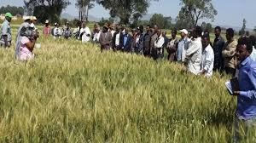
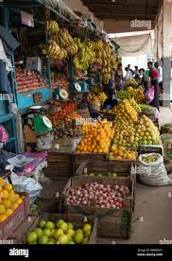

Good practice
1. The Ministry of Agriculture has been an objective that the food and nutrition security will be achieved by the year of 2028 in the country.
2. According of the objective of the government of the State of Eritrea all the food staffs production in the country is organic.
3. The research institutions of the ministry of Agriculture have provided effective natural fertilizer for the majority of the farmers.
4. The Savings and Micro-Credit Programme, which extends loans and credit through 538 village banks, has reached more than 69,000 individuals (66 per cent women) beneficiaries.
Challenges
- Lack of value chain/addition facilities, infrastructure and more sophisticated technology.
- Inadequate or limited financial resources.
- Insufficient access and linkage to global markets.

- Water and Energy sectors
To ensuring access of water;
Eritrea has arid and semi-arid climate. It is not particularly endowed with rich water resources and rainfall continues to be low and erratic, averaging less than 350 mm annually. Rate of evapotranspiration are also relatively high. Against this backdrop, water continues to be one of the country’s leading national priorities, and as a result of made important national investments in water infrastructure and soil conservation a number of important improvements have been registered.
Within rural areas, where the large majority of the country’s people resides, approximately 79% of the total population has access to safely managed drinking water services, while within urban areas it is 95%. Importantly, nationwide access to basic sanitation and hygiene facilities has been steadily expanding in recent years. Following a sustained public campaign that extended to all regions of the country, 93% of the nation’s 2,779 total villages have now been declared and certified as open defecation free. Moreover, about 70% of all public institutions (administrations, health institutions, all level of schools and others) now have improved water, sanitation and hygiene (WASH) facilities. In close cooperation with UNICEF, a longstanding national development partner, Eritrea’s Ministry of Land, Water and Environment and MoH jointly developed and continue to implement the 2019-2030 one WASH strategy and one WASH Implement plan, which aims to substantially bolster and actualize the government’s vision of ensuring universal access to safe drinking water, as well as sanitation and hygiene for all Eritreans by 2030. For Eritrea, the water sector remains critical for promoting sustainable development and it plays a significant role in socioeconomic growth, poverty alleviation, food security, and environmental sustainability. It also assumes great significance in enhancing modernization, industries, tourism, and agricultural activities.
The government has allocated a budget for the water sector’s development, and management with further financing and investment provided through support backing from a range of multilateral partners. As a result of considerable national investments and financial outlays, and the collective efforts of the government, local communities, various other national construction companies and several development partners, the number of large and medium dams in Eritrea has been increased from 138 at independence to nearly 800 at present. Several hundred more small dams have also been built. In addition more dams of varying sizes are currently in different stages of construction and projected to be fully completed across the period 2025 and beyond.

Access of Energy
Regarding of energy; Eritrea has a serious issue of energy. Energy is a cornerstone for all sectors to ensuring progress at all levels. Eritrea has large potential of environmental friendly sources of renewable energies such as solar, wind and geothermal. At the moment energy is bottleneck for our national development; however several initiatives have been taken by the government and cooperation with partners to ensuring demand of the whole country’s on renewable energy. In this regards the African Development Bank is main partner of the government and have been undertaking several projects of solar energy. Solar panel is common in Eritrea, it used in the governmental institutions, public sectors, private stakeholders and in majority household for different purposes.
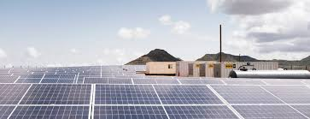
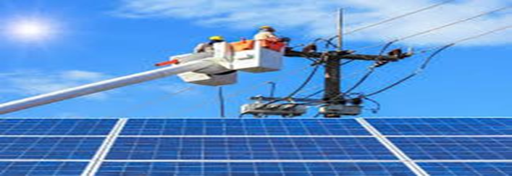
Renewable energy is being prioritized (which will help to minimize the dependence on unsustainable imported fossil fuels and reduce emissions from national power generation), while steps are actively being taken to improve energy efficiency and promote clean alternatives in manufacturing and household consumption. In addition, one unique intervention has been the introduction of improved traditional stoves, locally known as “Adhanet”, which are energy efficient (decreasing consumption by 50%), minimize deforestation, and reduce safety and health hazards. Designed by the Ministry of Energy and Mines and distributed by the MoA.
- Innovation and technology for value adding
Based on our economy majority of the population in Eritrea depend on agricultural sector, however to ensuring the food and nutritional security need to maximizing the quality and quantity of the production by using innovation and technologies for producing, harvesting, processing, storage, and transportation. Introducing of innovation, using technology, manufacturing and chain in different production could be the milestone to create comprehensive and inclusive sustainable development at national level. Therefore encouraged innovation and introducing the modern technology is our national priority. The government of Eritrea invested on education up to the tertiary level without payment and encouraging the innovation by create conducive platform of competitions in different festivals. In addition several TVET centres opened with basic equipment’s for strengthening of the skills and capacity building of the youths. Within the relation of the national development programme of social services such as (in educational, health, water and sanitation, and agriculture sectors) to maximize the services, partners are also strengthening their support base on the framework and using of technology. In the last February the UN-Technology Bank delegation has visited to Eritrea, and conducted very interesting discussion with several Ministers and governmental representatives. Therefore we have a great expectation from the UN-Technology Bank to introduce crucial technology that could to accelerate our national programme of development according to the priority of the government. In this regards we have priority to building up human resource capacity and will take training with collaboration of our partners.

- Social protection during different types of Shocks;
Eritrea has demonstrated extraordinary resilience in the face of several considerable challenges, including regional and global conflicts, sanctions and coercive economic measures, climate-related issues, and pandemic related economic shocks. Social protection from different types of shocks could be one of the many priorities of the government. Eritrea emerged out of a long, bitter struggle, not only for national independence and emancipation, but to bring about social justice, gender equality, shared prosperity and poverty elimination. Therefore, nation building policy in Eritrea depend on the principle of ensuring social justice, equal access of resources and social services, gender equality with the awareness of self-reliance based on integrated programme at the community level with horizontal and vertical relations. Even though our institutional apparatus is in progressing all the systems are very centralized and cultural fabrics of the society is also well established to support each other. One of the good example; due to the semi-arid climate in Eritrea, the desert locust have conducive season to come up and destroyed crops as well as forests every year. The government with international organizations allies particularly FAO and others including the local communities have been working all together to control the locust at early stage effectively before any destruction.
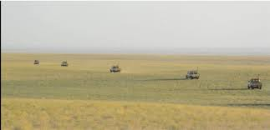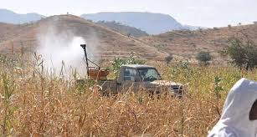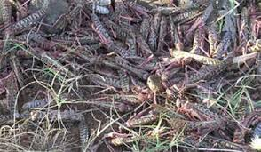
During any pandemic like the COVID-19 pandemic also, if the authorized institutions announced instruction for controlling mechanisms, immediately majority of the society followed it properly. In addition some of our villages close to the borders with Ethiopia and Sudan are having seen a cholera disease; however MoH, with partners immediately controlled such kind of incidents. For any emergency fund could be provided by the authorized institution of the government, partners as well as the communities and Diasporas contribute voluntarily.

