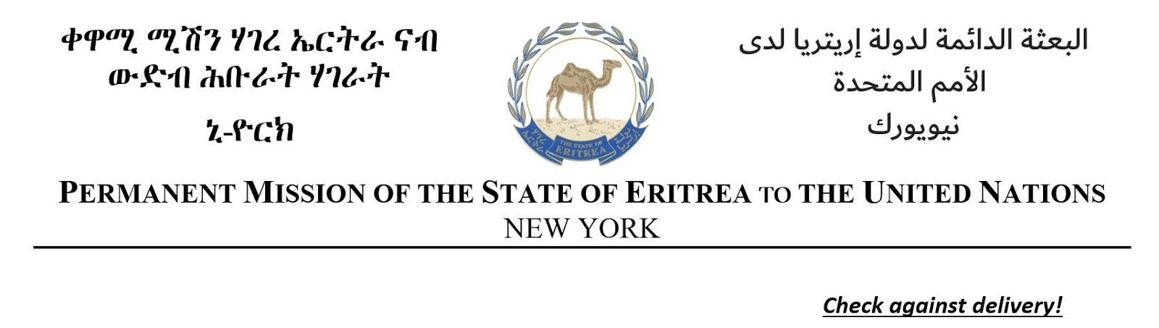
Statement by H.E. Minister Osman Saleh, Foreign Minister of the State of Eritrea
At the Annual Ministerial Meeting of the Least Developed Countries (LDCs)
26 September 2024, New York.
Madam Chair,
Excellencies
Ladies and gentlemen
Let me first express my gratitude to your excellency, Dr. Arzu Rana Deuba, for convening us today to deliberate and exchange views under the timely theme of: “Implementing the Doha program of Actions and its Deliverables to Accelerate the implementation of the 2030 Agenda."
We are in a period of a rapidly evolving global landscape, witnessing unprecedented geopolitical tensions, wars and conflicts, climate change, a record-breaking global warming and biodiversity loss. Countries in special situations, particularly the Least Developed Countries, are those who suffer the most from the repercussions of these cascading policy crisis. Sustainable development report of this year and other relevant reports reveal a bleak picture of the fate of the 2030 Agenda for Sustainable Development. The figures therein attest an even worrying future for the least developed countries.
In Doha, last year, a strong commitment was demonstrated to put the least developed countries on a transformative track from “Potential to Prosperity,” and key deliverables had been identified. While the international solidarity with LDCs is commendable, but the track-record of fulfilling such commitments is not an encouraging one, to say the least.
Implementation of the Doha Programme of Action, and other global commitments are facing multifaceted structural challenges, encompassing financial, technical, infrastructural, environmental and peace and security related issues. Therefore, there is an urgent need for a comprehensive transformation of the global partnership architecture to address the structural fragility of the LDCs and provide a scaled-up support, tailored for the special needs, priorities and challenges of the LDCs. It is crucial to redouble investments in key sectors such as infrastructure and human capital development, which are vital for fostering long-term economic growth and advancing self-sufficiency. We need to further ponder on alternative approaches that complement the efforts of the LDCs and stakeholders in a way that strengthen ownership and leadership of the LDC’s.
Additionally, LDCs need enhanced expertise and know-how to adequately mobilize and effectively utilize domestic resources and align the national, regional and international development initiatives and programs. They also need to bridge the digital divide; address data operationalization challenges and human and institutional capacity deficiencies; build disaster risk reduction and mitigation systems as well as capacities for effective response and recovery.
In pursuit of socio-economic transformation and ensuring societal wellbeing, Eritrea’s developmental trajectory has been registering significant achievements through a policy percept anchored on social justice and self-reliance while identifying key priority areas, mobilizing resources, and advancing community-led programs at every stage.
I welcome in advance the adoption of the Ministerial declaration and assure you of Eritrea’s full commitment to implementing the Doha Program of Action.

I Thank You!

