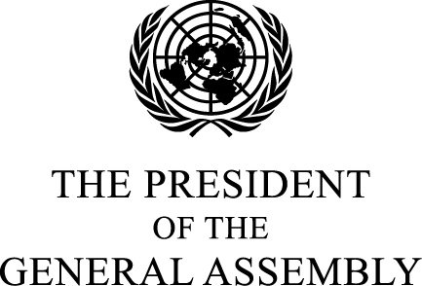 1 August 2006

Excellency,

I am writing to draw your attention to an important element of World Summit follow-up, on which we have an opportunity to complete our work over the coming weeks.

In the World Summit Outcome Document, paragraph 129, our leaders recognized the need for persons with disabilities to be guaranteed full enjoyment of their rights without discrimination, and we affirmed the need to finalize a comprehensive draft convention on the rights of persons with disabilities.

The Eighth session of the Ad Hoc Committee to consider proposals for a comprehensive and integral international convention to promote and protect the rights and dignity of persons with disabilities, mandated by General Assembly resolution 56/168 of 19 December 2001 and chaired by Ambassador Don Mackay, the Permanent Representative of New Zealand to the United Nations in Geneva, will convene here in New York from 14 to 25 August.

I understand that, although there are still a number of issues outstanding, great progress has been made over the previous seven sessions and an agreement is now within reach at the Eighth session.

All the Permanent Representatives and
Permanent Observers to the United Nations
New York

Some 650 million people – one in ten of the world’s population, are believed to be living with some form of disability. Yet until now there has been no international convention on their rights. We therefore have the opportunity to agree a landmark convention which would bring practical improvements to the lives of many people around the world.

I would therefore encourage your delegations to give priority to the upcoming negotiations, and to approach them with maximum flexibility and pragmatism, in order that we can reach agreement on a convention that will be in the common interest of us all.

Please accept, Excellency, the assurances of my highest consideration.

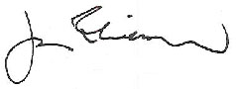

Jan Eliasson

