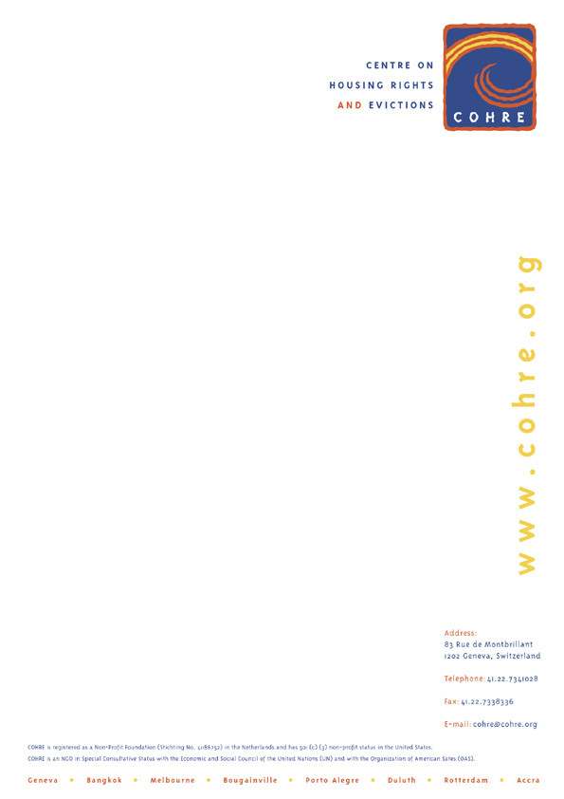

The Rights to Adequate Housing and the Right to Water: A Need for Further Development

COHRE’s Comments on the Draft Convention Text produced by the Working Group for the UN Ad Hoc Committee on a Comprehensive and Integral International Convention on the Protection and Promotion of the Rights and Dignity of Persons with Disabilities.

May 2004

The mere abundance of housing, food and water does not automatically mean that persons with disabilities will enjoy these internationally recognized rights. Such essentials must be affordable and physically accessible, and persons with disabilities suffer a double disadvantage on both fronts.

In General Comment No. 4 on the Right to Adequate Housing, the UN Committee on Economic, Social and Cultural Rights identified certain aspects of the right to housing that must be taken into account in order to determine whether particular forms of shelter can be considered to constitute “adequate housing” for the purpose of the International Covenant on Economic, Social and Cultural Rights.

These elements include availability of services, material, facilities and infrastructure, affordability, accessibility and habitability. Today, the major issues faced by disabled persons in relation to housing relate to these different elements, highlighting the necessity to take their needs into account. With regard to availability of services, person with disabilities often face difficulties with physical access to water, raising similar issues of availability, affordability and accessibility with regard to the enjoyment of the right to water.

Beside these particular elements, discrimination, notably in the realm of housing, often remains a major problem for disabled persons. In that respect, the UN Committee overseeing the International Covenant on Economic, Social and Cultural Rights recognised that the effects of disability-based discrimination have been particularly severe in the field of housing. In that respect, disabled persons are often facing multiple layers of discriminationbased on grounds such as sex, gender, race ethnicity and/or age.

Additionally, when denied housing, disabled persons face greater risk of further violations of their basic rights, in particular women and aged disabled persons. For instance, while women who are homeless face increased risks of violence, disabled homeless women run even greater risks.

Access and Affordability

A billion people worldwide are denied adequate housing and persons with disabilities are disproportionately represented among them. Housing is mostly obtained through the private markets yet persons with disabilities, amongst the poorest in society, cannot compete with higher income buyers and tenants. Indeed, persons with disabilities are likely to pay more than half their incomes on rent. In the USA, there was no single housing market in 2000 where a person with a disability, receiving social security, could afford to rent a one-bedroom apartment. Discriminatory stereotypes amongst landlords only compounds this struggle to find rental housing.

Housing design is often inappropriate – whether it is unreachable water taps, unusable sanitation facilities or the lack of wheelchair ramps – and landlords are often reluctant for simple changes to be made to reasonably accommodate a disability. Many persons with disabilities lack the social services for independent living. While many ‘developed’ countries closed down large institutions for persons with disabilities, they failed to provide the promised community-based alternatives. The result was a massive increase in homelessness. In ‘developing’ countries, persons with disabilities face the worst effects of forced evictions where housing and property laws provide little protection from arbitrary expulsions and almost no alternatives for evicted communities.

Securing other basic necessities of life – food and water – is intricately linked to housing and income. Home is where water is accessed and food is prepared. The price of both goods has significantly risen for the poorer groups with the decline in food subsidies and the liberalization of food and water markets. Persons with disabilities may also have specific food and water needs, and disabled farmers require assistance in growing and marketing their own food crops.

International Human Rights Framework

International law has long acknowledged the particular attention that must be paid to the socio-economic rights of persons with disabilities: from the authoritative UN Standard Rules on the Equalization of Opportunities for Persons with Disabilities 1993 (Rule 5), to the Declaration on the Rights of Disabled Persons 1975 to the binding UN Convention on the Rights of the Child 1990. Regional human rights treaties in Africa, Europe and the Americas likewise recognize the social rights of people with disabilities.

The UN Committee overseeing the International Covenant on Economic, Social and Cultural Rights has emphasized that the right to non-discrimination for persons with disabilities means not only ensuring that laws and practices do not overtly discriminate but that affirmative action is taken to redress the underlying disadvantage.

General Comment 4 gives special emphasis to the obligation of States to provide “a degree of priority consideration in the housing sphere” to the disabled, including the mentally ill. In General Comment No. 5 they state:

In addition to the need to ensure that persons with disabilities have access to adequate food, accessible housing and other basic material needs, it is also necessary to ensure that "support services, including assistive devices" are available "for persons with disabilities, to assist them to increase their level of independence in their daily living and to exercise their rights".

In General Comment No.15 on the Right to Water they noted that “Groups facing difficulties with physical access to water, such as older persons, persons with disabilities, ... are [to be] provided with safe and sufficient water.”

International Convention

Artilce 23 of the current Draft International Convention recognises the right of persons with disabilities to ‘an adequate standard of living, including food, housing, clothing and water’. As such article 23 remains the main reference, in the current draft, to housing as a component of the right to an adequate standard of living.

Other parts of the Draft Convention also bear relevance to the issue of housing, including the provisions on non-discrimination (draft articles 2, 4.1, 7) participation (draft articles 4.2 and 19.2), the fight against stereotypes (draft article 5) and accessibility to services (draft article 19). These elements constitute fundamental prerequisites for the full enjoyment of the right to adequate housing and the right to water by disabled persons.

In addition to these fundamental elements, the following aspects of the rights to adequate housing must be taken into account to guarantee that particular forms of shelter constitute “adequate housing” for disabled persons: availability of services, material, facilities and infrastructure; affordability; accessibility and habitability. As it stands, the current draft, and in particular article 23, fails to take into account these elements.

It should therefore be completed with subsequent sub-paragraphs, reflecting the needs of disabled people, notably in the field of housing and water and the concurrent steps that State Parties should take in that respect.

Proposed amendments to draft article 23 (underlined in the text)

“State Parties recognise the right of all persons with disabilities to an adequate standard of living for themselves and their families, including adequate food, clothing, housing and access to clean water, and to the continuous improvement of living conditions. As such, State Parties will undertake to take appropriate steps to safeguard and promote the realisation of these rights.

(a) With regard to the right to adequate housing, State Parties undertake to engage in no act or practice of discrimination on the grounds of disability in relation to housing policies and programmes and to take all appropriate measures to ensure that all public authorities, public institutions and private entities shall act in conformity with this obligation. In that respect, State Parties shall give particular attention to those persons who face discrimination not only due to their physical or mental disability, but also due to their sex, gender, race, ethnicity and/or age.

(b) State Parties undertake to guarantee the full participation of disabled persons in the elaboration and implementation of housing policies and programmes and to ensure that the development and implementation of housing related legislation reflect their needs.

(c) State Parties shall take all appropriate measures to ensure that persons with disabilities can freely enjoy and exercise their right to housing and can participate fully and equally within society. Steps to be taken by the State Parties should ensure that housing for persons with disabilities:
(i) provides security of tenure and freedom from forced eviction.
(ii) provides for the physical safety of occupants and protection from threats to health, structural hazards and disease vectors.
(iii) is affordable and does not compromise the ability of persons with disabilities to secure other basic needs.
(ii) contains all facilities essential for health, security, comfort and nutrition.
(iv) is located in appropriate proximity to support services, employment options, health care services and other social facilities.

(d) State Parties shall develop special programmes to ensure that persons with disabilities have access to affordable water, including for persons who require additional quantities of water for personal and domestic needs and for those with difficulties in physically accessing sanitation and water supply points and facilities.

See in particular Article 11, International Covenant on Economic, Social and Cultural Rights 1966, General Comment No.15 on the Right to Water of the UN Committee on Economic, Social and Cultural Rigths and Article 27, UN Convention on the Rights of the Child 1990.
General Comment No.15 on the Right to Water of the UN Committee on Economic, Social and Cultural Rigths
‘Poverty Housing...’, Habitat World, Oct-Nov, 2001, www.habitat.org.
A. O’Hara and E. Miller, Priced Out in 2000: The Crisis Continues, June 2001, www.c-c-d.org/Poin2000.html
See Revised European Social Charter (Article 15); Inter-American Convention on the Elimination of All Forms of Discrimination Against Persons with Disabilities (Article III); African Charter on the Rights and Welfare of the Child (Article 13(1) and Article 20).

