Global Survey on
Government Action
on the Implementation of the Standard Rules on the
Equalization of Opportunities for Persons with Disabilities

Administered
November 2004 to June 2005

Acknowledgements

The production of this document could not have been possible without the valuable contributions of a number of people. Therefore, thanks go to the following:

First and foremost, the individuals and organizations around the world who took the time and effort to respond to the Survey questions to the best of their knowledge and ability.

The following individuals for translating the Survey, thereby breaking down the language barrier, without which the rate of return would have been markedly diminished. Those are:
Frida Madanat
for Arabic translation
Abeer Younis
for French translation
Elena Del Bo Cobenas
for Spanish translation

Equally important are the individuals who worked on compiling the lists of government bodies and disabled persons organizations, verifying contact names and addresses, distributing, tracking and following up with the respondents. Those are:
Ala’ Al Sheikh
Amira Johar
Ayman Balsha
Fatma Abdallah
Ma’moun Al Khob
Nawal Al Haddad
Rawda Saadi

For help in photocopying, stuffing envelopes and preparing the Survey for mailing:
Juvi Vilma Soriano
Mariam Cresencia Juloc

For their invaluable help in reaching out to disabled persons organizations in Asia, Africa and Latin America, and for providing access to their network of contacts, the employees of the Center for International Rehabilitation:
Maria Veronica Reina
Anne Hayes
Emmet Regan
Elena Dal Bo Cobenas

For collating and entering data gathered, and producing endless variations of charts and tables:
Mohammad Hashhash

For writing the report:
Thuraya Khalil

For proofreading the final copy:
Alia Abu Nowar

For their constructive comments and review of the Survey draft, and for their inspiration and encouragement, the members of the United Nations Panel of Experts on Disability and their organizations:
World Network of Users and Survivors of Psychiatry
Disabled Persons International
World Federation of the Deaf Blind
World Federation of the Deaf
World Blind Union
Inclusion International
Rehabilitation International

For designing the Survey, reviewing, verifying and ensuring the accuracy of the information contained herein, for managing, directing and supervising the entire process and for keeping all those involved on their toes,
Dr. Sabri Rbeihat

Finally, appreciation and thanks to the Government of the State of Qatar for its continuous and generous financial support of the work of the UN Special Rapporteur on Disability

Forward

In the past thirty years, many initiatives, programmes, schemes and plans of action have been developed with the aim of improving the lives of persons with disabilities. Among these have been the Standard Rules for the Equalization of Opportunities for Persons with Disabilities. Introduced in 1993, it was adopted by all 191 Member States of the United Nations in recognition of the fact that persons with disabilities have been too long marginalized and excluded from both the social development and human rights agendas. It was also a recognition of the fact that the continued marginalization of this group of individuals represents a loss far greater to society than the cost of implementing equalization policies.

However, the adoption of the Standard Rules represents a moral and political commitment on the part of governments rather than a legal obligation. Actions taken by governments in fulfilment of their commitment to equalization, in keeping with the Standard Rules, are voluntary actions. Therefore, monitoring of the implementation of the Rules is not similar to monitoring of other human rights treaty obligations.

This Survey, therefore, was conducted with this fact in mind, and with consideration of what governments have done, with a view to improving implementation. In that sense, the results of this Survey are not seen as a condemnation of government inaction but rather a starting point for cooperation to do better.

Since the adoption of the Standard Rules and the appointment of the first Special Rapporteur on Disability, in fulfilment of the Monitoring requirement of the Rules, assessment of their implementation has taken place through a number of means, ranging from country visits, meetings with governments officials, on-the-ground examinations of the situation of persons with disabilities as well as surveys.

Past Surveys have focused on a select number of Rules (namely, accessibility, education, employment, medical care). This is the first comprehensive Survey of the Standard Rules focusing on process as well as outcome, and concerned with examining the steps and measures involved in reaching full implementation of each of the Rules and assessing how such implementation has effected the lives of persons with disabilities.

For this reason, and after more than 11 years since the adoption of the Rules and based on a full review and understanding of what has been done previously in this respect and making use of the momentum created by the Convention process in mobilizing and galvanizing the world, as never before, to deal with the issues of persons with disabilities as rights—it was time to conduct an assessment of government actions as they relate to the 22 Rules from the perspective of examining all measures expected to be implemented in order to reach the ideal state exemplified by the equalization of opportunities for persons with disabilities.

To this end, the Special Rapporteur on Disability has commissioned the South-North Center for Dialogue and Development to conduct this Survey. This included designing the Survey instrument, disseminating the survey, as well as gathering, collating and entering the data, analyzing the responses and producing this report.

A full review of the existing literature, country experiences in implementation of the Standard Rules, the experiences and reports of the former Special Rapporteur on Disability and the information generated from the activities of the present Rapporteur have informed the design of the Survey. Four-hundred-and-two measures were derived from the Standard Rules themselves, which, if implemented, will constitute an ideal world in which persons with disabilities enjoy the equal opportunity for full participation in society as contributing, productive individuals.

The responses to this Survey resulted in a clear snapshot that shows us whether or not certain actions have been taken by assessing the presence or absence of the measures required to implement the action.

What has been obtained is a generic confirmation from governments with the understanding that there are individual variations resulting from diversity, specificity, cultural differences, as well as differences in understanding.

The objective was to gather this information from governments themselves. However, in order to avoid the problems inherent in self-reporting by governments, the same Survey was sent to two disabled persons organizations in each of the countries. The responses from these organizations constituted a benchmark for comparison as such organizations often possess a better understanding of how actions have impacted the lives of persons with disabilities in a given country.

Included in the Survey were questions on the coverage, scope and inclusiveness of the measures taken. It was also suggested that organizations and governments consult as widely as possible with the relevant agencies and bodies when responding to the survey.

Despite the fact that 77 countries of the 191 did not respond to the Survey, the returns received constitute a wealth of information never before gathered on the issue of equalization of opportunities for persons with disabilities. The information will also serve as the basis for further research and investigation to be used by researchers, advocates and activists.

The aim at this stage, however, is to present a picture regarding the presence or absence of action in 114 countries and to briefly discuss the implication of the observations recorded.

With the completion of the report, we now have a better picture about the world and we are pleased to make this information available to all those who can benefit from it—concerned agencies, organizations, individuals, persons with disabilities—and to encourage further investigation.

This report is only the first phase in a series of further analyses.

Sabri Rbeihat, PhD
President & Founder
South-North Center for Dialogue and Development

Global Survey on
Government Action
on the Implementation of the Standard Rules on the
Equalization of Opportunities for Persons with Disabilities

Administered
November 2004 to June 2005

Chapter I

Executive Summary

Introduction

This is the first Survey on disability which covers each of the Standard Rules on the Equalization of Opportunities for Persons with Disabilities, taking into account all of the measures that need to be implemented in order to achieve the equalization of opportunities for persons with disabilities. Out of the 22 Rules, 402 measures were extracted, listed under 47 questions and organized in an ordinal manner, ranging from the adoption of policies on the particular measure, the passing and enacting of legislations, to the implementation of programmes, the allocation of resources, training of personnel to work with persons with disabilities, raising the awareness of the rights related to the specific rule both at the social level and among persons with disabilities themselves, and involving persons with disabilities in an advisory capacity whether in the decision making process or the implementation of activities and programmes.

Description of the Survey

The design of the Survey took into consideration previous work conducted by the former Rapporteur, the literature generated by various disability organizations worldwide, and relied heavily upon the Scandinavian experience and their work on Agenda 22, using that document in particular as a model to extract the different measures needed for implementation by various government levels in order to achieve equalization and equal participation by persons with disabilities in society.

Recognizing, that although the Supplement to the Standard Rules has not been adopted by the General Assembly, but, that the issues raised in the Supplement were valid and require attention, the Survey also drew on that document and incorporated many of these issues. These include: women and children with disabilities; persons with psychosocial and developmental disabilities; issues related to housing, health, medical care, adequate standards of living and poverty; access to the social environment and communication; and matters relating to the families and care-givers of children and persons with disabilities.

In crafting this instrument, there was strict adherence to the principles of clarity, simplicity, and ease of administration.

Administration of the Survey

The target population was both governments and disabled persons organizations in each of the 191 Member States of the United Nations, all of which had adopted the Standard Rules on the Equalization of Opportunities for Persons with Disabilities, thereby making the moral commitment to its implementation.

In each country, the Survey was given to one government body most relevant to the implementation of the Standard Rules; and to two disabled persons organizations.

A follow up schedule was put in place and adhered to, by which survey recipients were contacted 30 days after receiving the Survey, then 60, then 90 days in order to remind them to fill it out and send it back.

A recommendation was included in the covering letter that accompanied the Survey indicating that disabled persons organizations and government departments concerned with disabilities, hold half to one day workshops to discuss and fill out the survey. This was done to ensure that the responses received are as comprehensive as possible, and to raise awareness of the issues of persons with disabilities and their needs, as well as of the Standard Rules, and as widely as possible.

Objective of the Survey

The overall objective of the Survey was to assess the global situation of persons with disabilities in light of the Standard Rules and to use the momentum of responding to the questions of the survey to raise awareness of the Rules.

In addition, it aimed at establishing a benchmark on the level of implementation of the Standard Rules, which seemed timely, as over 10 years had passed since their adoption by the international community.

This Survey aimed at mapping the global conditions with regard to Government actions and the way in which such actions are reflected on the situation of persons with disabilities and their lives in terms of equal opportunities and full participation. To that end, all 191 Member States of the United Nations were targeted. Additionally, two disabled persons organizations in each of the Member States were identified as respondents to the same questionnaire.

The purpose of this was to diversify the sources of information within the same country; to verify to what degree government actions reflect upon the lives of persons with disabilities; and to create an awareness within the country, among government officials and disabled persons organizations equally, regarding the Standard Rules.

The hope of the Special Rapporteur in administering this Survey in this way was to initiate a debate between governments and disabled persons organizations.

It was also in keeping with the spirit of the Standard Rules which emphasized the involvement of disabled persons organizations, and reflecting the Special Rapporteur’s belief that persons with disabilities are the true experts in the field, and so any endeavour of this kind needs to fully involve them. The intention was also to use the questionnaire as a tool to inform disabled persons organizations of the measures expected to be taken by governments in each area pertaining to the 22 Rules.

In order to achieve this, the Office of the Special Rapporteur, advised governments and disabled persons organizations to hold half-day workshops to review the questions and present their different perspectives, views and suggestions in order to create a common national understanding and provide a momentum for action. A number of countries reported back that they had done so and that the responses to the questionnaire were drafted collectively.

In addition to this, the dissemination of the Survey as widely as possible was meant to serve as a manual or inventory on what ought to be done at the national level, in order to create a universal culture of equalization for persons with disabilities.

Distribution

Five-hundred and seventy-three (573) questionnaires were distributed to 191 Member States of the United Nations, as follows:

191 questionnaires to 191 government bodies in the Member States and
382 questionnaires to disabled persons organizations at the rate of two organizations per country.

The Office of the UN Special Rapporteur on Disability received back 207 questionnaires, containing information about 114 countries at the rate of a 60% return. Seventy-seven (77) countries did not send any responses.

This Survey marks the first time that this much information has been collected from this many countries about so many issues relating to disability.

Three modes of distribution were used to disseminate the Survey:
- through the embassies of countries represented in Doha, Qatar, where the office of the Special Rapporteur is located
- through the Permanent Missions of countries to the United Nations
- through the federations and alliances of disability organizations

The Survey was distributed in a number of ways:
- electronically through e-mail whenever possible
- by hand whenever possible
- by mail with postage-paid envelopes to facilitate returns

Reporting

A report on the preliminary findings was presented to the Commission for Social Development in February 2006. The current report expands on those findings to paint a more global picture of the situation of persons with disabilities around the world.

The findings in this report will reveal that some progress has been made with regard to the recognition of the rights of persons with disabilities to equal participation in society generally. For example, most countries have adopted policies, although not all of those who have done so have passed legislations or implemented programmes. In many cases, when programmes have been planned, no adequate financial resources have been allocated. In general, it is safe to say that there are more good intentions worldwide that are not necessarily backed by a strong political will.

However, we must remember that the Survey has yielded results on only 60% of the countries of the world, and there remains 40% on which there is no information.

Some of the information obtained has been alarming with respect to the prospects for persons with disabilities, particularly, in the area of Education for children with disabilities. Nearly 30 countries reported having taken no measures to enable children to receive education in integrated settings.

Accessibility and Rehabilitation also remain areas that require much attention and need improvement. Considering that these are two areas that are considered pre-requisites to allow persons with disabilities equal participation in society, it means we still have a long way to go before reaching the ideal envisioned by the developers of the Standard Rules for the Equalization of Opportunities for Persons with Disabilities.

Additionally, Awareness Raising is an area still lacking in sufficient measures to achieve the desired goals. Without governmental, societal and individual awareness of the needs and rights of persons with disabilities, there can be little improvement made on the ground with regard to all the other issues.

Some interesting findings revealed that in the area of Medical Care, the situation on the ground was slightly better if we consider the dearth of measures taken by governments with regard to policies and legislations. One explanation could be due to the fact that medical care is a basic human right, which in an overwhelming number of countries is delivered on an as-needed basis regardless of government policies and legislations. However, it is important to remember that legislations are one fundamental way of changing the culture and preventing violations of basic rights.

This report also contains a list of the countries that have taken the least measures (or none at all) on such fundamental issues as awareness raising, accessibility, medical care, education.

Challenges and Limitations

A mailed questionnaire is subject to the interpretation of the person or persons who fill it out, and therefore, to the inflation or deflation of information depending on their perceptions, understanding and biases. This fact should be kept in mind when examining and analyzing the responses. This is why the cover letter accompanying the questionnaire contained a recommendation to hold workshops in the hope of better controlling the responses. Romania and Tanzania are two countries that we know of who implemented this recommendation.

Secondly, in the case of inflated response—such as the countries whose responses showed that they had taken action on all measures∗--it was obvious that the responses referred to the existence of certain policies, legislations, services or measures, but that they did not reflect the comprehensiveness, quality or coverage of such services and or to what degree legislations are implemented or enforced. Such factors, obviously, had to be taken into consideration and would require further investigation.

Additionally, in the absence of a unified definition of disability, and in the case of many countries no definition of disability exists at all—it is natural that there would be variations and variables.

Finally, this questionnaire should not be invested with more importance than what it aims to do—which is to paint a global picture of the situation of persons with disability with all its flaws and diversities, but which, at the end of the day, remains a general and preliminary framework for more detailed research and investigation. Moreover, it is important to remember that although a 60% return on the questionnaire is an impressive one (information about 114 countries on 402 measures) there are 77 countries from which no information could be obtained.

Government Action on the

Implementation of the Standard Rules on

the Equalization of Opportunities for

Persons with Disabilities

Chapter II

Description of the Survey

And

Methodology

Introduction
The Global Survey on Government Action on the Implementation of the Standard Rules for the Equalization of Opportunities for Persons with Disabilities is the first comprehensive assessment of Governments’ moral and political commitment to the implementation of the Standard Rules since its unanimous adoption by the international community. By targeting all Member States and two Disabled Persons Organizations in each country, this Survey differs from it predecessors. It also differs from other Surveys by addressing each of the Standard Rules separately.

Work on the Survey began with designing of the questionnaire in June 2004. At the same time, a number of measures and steps were taken to guarantee the best possible results.

The design of the Survey took into consideration previous work conducted by the former Rapporteur, the literature generated by various disability organizations worldwide, and relied heavily on the Scandinavian experience and their work on Agenda 22 (appendix I), using that in particular as a model to extract the different measures needed for implementation by various government level in order to achieve equalization and equal participation by persons with disabilities in society.

The adoption of the Standard Rules for the Equalization of Opportunities for Persons with Disabilities, showed a commitment on the part of countries to the rights of persons with disabilities. Through the questions, the Survey seeks to respond to the following questions:

- How has this commitment been translated?
- Have policies been drafted?
- Have legislations been passed in order to translate the political will into a legal
framework?
- Have these legislations been followed by programmes which are the only ways to
translate both the policies and legislations into change on the ground?

Furthermore, attention was given as to the type of implementation:

- Have financial resources been allocated?
- Have personnel been trained?
- Have persons with disabilities been included throughout the process?
- Have all types of disabilities been covered or taken into consideration?
- Have persons with disabilities from all socio-economic, religious and cultural backgrounds been reached?
- Has the gender aspect been taken into consideration in the delivery of services and programmes?
- Are immigrants and refugees been considered within the disabled population?

At the practical level, it was necessary to review previous surveys and studies to identify their issues, scope, design, management and the results obtained in order to build on their successes and to learn from the problems they faced. It was also necessary to identify the content of the questions and construct an instrument that validates and assesses the relevance of the responses.

At the logistical level, it was necessary to identify the target groups, their locations and the means by which to communicate with them, and the time frame within which to do so.

- Identifying addresses and locations of target groups,
- translating the questionnaire into several languages along with the guideline for filling out and returning the questionnaire
- obtaining postage-paid envelopes for the questionnaires sent to disabled persons organizations
- encouraging governments to hold seminars with their local organization to discuss the content of the questionnaire and cooperate in filling it out.
- Finding and allocating the financial resources needed to conduct such a Survey.

The Survey was translated into French, Spanish and Arabic to remove any language barriers and allow for a smoother interaction with the contents of the questionnaire.

Objective of the Survey

The overall objective of the Survey was to assess the global situation of persons with disabilities in light of the Standard Rules and to use the momentum of responding to the questions of the survey to raise awareness of the Rules. In addition, it aimed at establishing a benchmark on the level of implementation of the Standard Rules, which seemed timely, as over 10 years had passed since their adoption by the international community.

Distribution
The target population was both governments and disabled persons organizations in each of the 191 Member States of the United Nations, all of whom had adopted the Standard Rules on the Equalization of Opportunities for Persons with Disabilities, thereby making the moral commitment to its implementation.

Therefore, in each country, the Survey was sent to one government body most relevant to the implementation of the Standard Rules and most closely related to the issues of persons with disabilities; and two disabled persons organizations.
Five-hundred and seventy-three (573) questionnaires were distributed to 191 countries, as follows:
- 191 questionnaires to 191 government bodies
(one government body in each country)
- 382 questionnaires to disabled persons organizations,
(at the rate of two disabled persons organizations per country)
- Received back 207 questionnaires,
containing information on 114 countries
(at the rate of a 60% return)

This Survey marks the first time that there has been this much information from this many countries about so many issues relating to disability.

The procedures and conditions on which countries were questioned amounted to 402 measures to be taken by government, which, when put together would constitute the ideal level of adherence to the spirit, letter and philosophy of equalization of opportunities and the Standard Rules. The questions were clearly worded, and followed the order of the Standard Rules themselves beginning with questions relating to the Pre-conditions, then the Target Areas, and finally the Implementation Measures. Each question pertained to a rule and beneath each rule was a checklist of implementation measures listed in an ordinal manner.

Listing

The measures were listed in an ordinal sequence. The first question pertaining to each Rule in the questionnaire listed the measures governments are expected to adopt in an ordinal sequence, staring with the adoption of policies, moving on to passing legislations, then to formulating of programmes, down to the involvement of the disabled persons organizations in a consultative capacity. While the second question for each Rule pertained to the types of disabilities covered and the scope of the coverage.

Two rules were not included in the questionnaire, Rules 14 & 15 pertaining to Policy-making and Planning and to Legislations, respectively. This was due to the fact one question regarding policies adopted and another regarding legislations passed were included for each one of the Rules in question.

Results of the Survey
The aim of the Survey was to paint a global picture of the lives of people with disabilities worldwide in light of the Standard Rules for the Equalization of Opportunities for Persons with Disabilities. This report will present the responses obtained from 114 countries on each of the rules. It will also attempt to analyze the reasons for inaction on the parts of governments, draw conclusions and offer recommendations on what can be done to remedy it.

The responses cannot be considered comprehensive by any means. There remains 77 countries on which there is no information. Additionally there are inescapable issues with bias, over or under-reporting for some of the countries. But the responses and their analysis do constitute a unique framework on which to base further investigation.

Responses
The analysis in this report is based on information collected from 114 countries. It is important to note that the aim was to examine responses from the largest number of countries. The following rule was applied in sorting out the information:

Where a government body and two disabled persons organizations responded, the answers from the government and one disabled persons organization were considered. Therefore, the unit of analysis at this stage is the country. Further analysis is required to identify discrepancies where they exist, or convergence between government responses and disabled persons organizations. This would explain why this report is based on responses from 114 countries although 237 responses were returned to the office of the Special Rapporteur.

Types of responses received from the 114 countries were as follows:
- 15 countries in which the government body and two disabled persons organizations responded;
- 28 countries in which the government body and one disabled persons organization responded;
- 12 countries in which two disabled persons organizations responded and no responses were forthcoming from governments;
- 29 countries in which only one disabled persons organization responded and no responses were forthcoming from the government body or the second disabled persons organization;
- 30 countries in which the only the government body responded and no responses were forthcoming from the disabled persons organizations.

At the regional level, responses were obtained from each region as follows:
- Africa: 23 countries, i.e. 53.48% of the countries in the region
- Asia: 21 countries, i.e. 42.55% of the countries in the region
- Europe: 30 countries, i.e. 65.21% of the countries in the region
- Latin America: 21 countries, i.e. 63.63% of the countries in the region
- Arab States: 19 countries, i.e. 86.36% of the countries in the region
Two responses were obtained from Hong Kong and Palestine.

Limitations

Some of the limitations of the Survey are that it relies exclusively on self-reporting. One of the ways to create guards against that and try to ensure more accuracy was by sending the same questionnaire to both government bodies and disabled persons organizations.

However, in one case, it was found that the government and disabled persons organization copies of the questionnaire were filled out by the same party and therefore only one was taken into consideration.

Another way was to recommend to the receiving countries that they hold half or one-day workshops of all persons concerned with disabilities at the national level in each country and fill out the questionnaire. This was also aimed at raising awareness at the country level of what needs to be done and starting a cooperative process of implementing some of these measures as they are revealed to the respondents in the workshops. Romania and Tanzania both reported to have done so.

The other limitation is the fact that there is no way of verifying the accuracy of the responses. Some factors that may have contributed to the lack of responses from some countries may be the length of the Survey (42 pages), requiring the dedication of time from busy and active people. Additionally, responding to many of the questions required a comprehensive and global knowledge of the situation that no one person or organization could possess. Another reason could be the lack of resources among certain organizations in developing or poor countries.

Chapter III

Survey Results
and
Analysis

Introduction

The Standard Rules for the Equalization of Opportunities for Persons with Disabilities represent a system of ideas, services, guidelines for procedures and measures which, when applied create a society (and by extension a world) that is welcoming and inclusive of all people, primarily persons with disabilities.

The ultimate goal of the Standard Rules is to create an environment in which there can no longer be any discrimination against people based on their ability—that is an environment, in the broadest sense of the word, free of barriers and obstacles. Such an environment, in addition to being inclusive, would also enable and allow individuals to exercise their rights to the fullest extent.

As the aim of the Standard Rules on the Equalization of Opportunities for Persons with Disabilities is equal participation, the drafters of the document divided and ordered the rules in such a way that the implementation of each rule depends on the fulfillment of the one before. They set out the Pre-conditions required for equal participation followed by the Target Areas to be tackled in order to achieve full and equal participation, then the Implementation Measures or the procedures necessary to reach that goal, and finally the necessity of Monitoring implementation of all of the above, as follows:

I. PRECONDITIONS FOR EQUAL PARTICIPATION

Rule 1. Awareness-raising
Rule 2. Medical care
Rule 3. Rehabilitation
Rule 4. Support services

II. TARGET AREAS FOR EQUAL PARTICIPATION

Rule 5. Accessibility
Rule 6. Education
Rule 7. Employment
Rule 8. Income maintenance and social security
Rule 9. Family life and personal integrity
Rule 10. Culture
Rule 11. Recreation and sports
Rule 12. Religion

III. IMPLEMENTATION MEASURES

Rule 13. Information and research
Rule 14. Policy-making and planning
Rule 15. Legislation
Rule 16. Economic policies
Rule 17. Coordination of work
Rule 18. Organizations of persons with disabilities
Rule 19. Personnel training
Rule 20. National monitoring and evaluation
Rule 21. Technical and economic cooperation
Rule 22. International cooperation

IV. MONITORING MECHANISM

Rule 1. Awareness-raising

According to the Standard Rules, raising awareness at all levels of society is a pre-requisite to the implementation of all other measures necessary to achieving equalization of opportunities. In the absence of awareness of the needs and rights of persons with disabilities there can be no real change in their situation.

Therefore, Rule 1 requires that States take measures to raise awareness in society about persons with disabilities, their rights, their needs, their potential and their contributions. In order to fully achieve awareness raising as stated by Rule 1, nine (9) measures in all needed to be taken, and about which the respondents were asked.

The state of the world when it comes to awareness raising, as indicted by the Survey, reveals that two-thirds (2/3) of the countries that responded had taken one or more measure(s) towards the implementation of awareness raising.

With regard to “drafting guidelines for use by the media”, 35 out of 114 stated that they had done so, while 79 out of the 114 countries stated that they had failed to draft guidelines for use by the media in raising awareness about persons with disabilities.

T1-Rule1
Actions taken by government to raise awareness about the rights, needs, potential and contributions of persons w/ disabilities | No | Yes
Adopting policies. | 40 | 74
Passing legislations. | 47 | 67
Adopting programmes. | 45 | 69
Drafting guidelines to be used by the media. | 79 | 35
Training personnel. | 53 | 61
Disseminating materials in the form of brochures, bulletins, posters… | 47 | 67
Introducing awareness raising into school curriculum. | 72 | 42
Educating the public. | 52 | 62
Consulting and cooperating with Organizations of persons w/ disabilities | 28 | 86
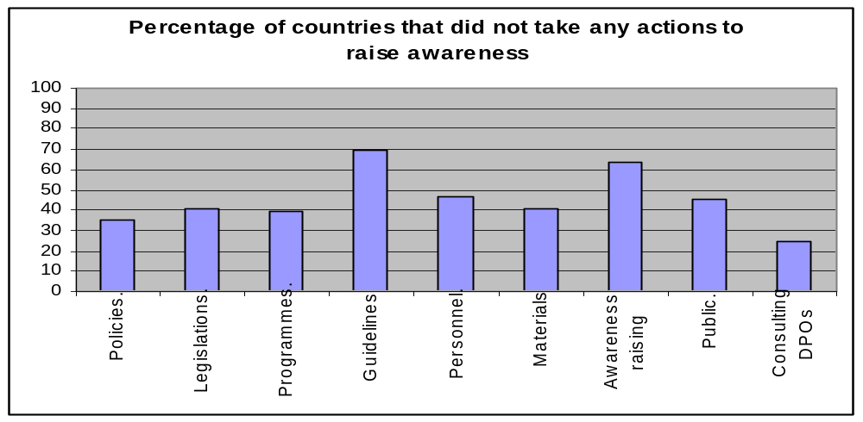

This reveals that in principle all countries have done something in the area of raising awareness, but at the level of substantive action countries have not given the same weight to using the media in awareness raising. Adding this number (79), to the number of countries that did not respond to the Survey (77), indicates that the world generally remains far from fulfilling the requirements for changing attitudes, perceptions, behaviours and knowledge regarding persons with disabilities.

Keeping in mind that awareness raising is a pre-requisite for all other actions, and that much is dependent on it if change is to be effected, these results indicate that much more work still needs to be done on this area and at the following levels:

- completing the global picture by asking the 77 non-responding countries to fill out the questionnaire
- urging all countries to internalize awareness raising efforts and activities into their programmes and give it the priority it deserves

Equally alarming in this respect is that only two-thirds (2/3) of the countries that responded took into consideration the different types of disabilities, the rights, needs, potential and contribution of persons with disabilities when designing awareness raising programmes. This indicates that diversity, rights, needs, potentials and contributions are not fully recognized by policy and decision makers. Awareness raising campaigns remain limited to attitudes and behaviour towards persons with disabilities without exploring the issues rights, potentials and contributions inherent in the concept of equalization. This explains why persons with disabilities, for the most part, remain marginalized in the important areas of education, employment, and other aspects of full participation in society.

T2 Rule 1
Information used in awareness raising about persons w/ disabilities cover | No | Yes
All types of disabilities. | 36 | 78
The rights of persons w/ disabilities. | 34 | 80
The needs of persons w/ disabilities. | 35 | 79
The potential of persons w/ disabilities. | 40 | 74
The contributions of persons w/ disabilities. | 38 | 76
Descriptions of persons w/ disabilities in positive terms | 37 | 77

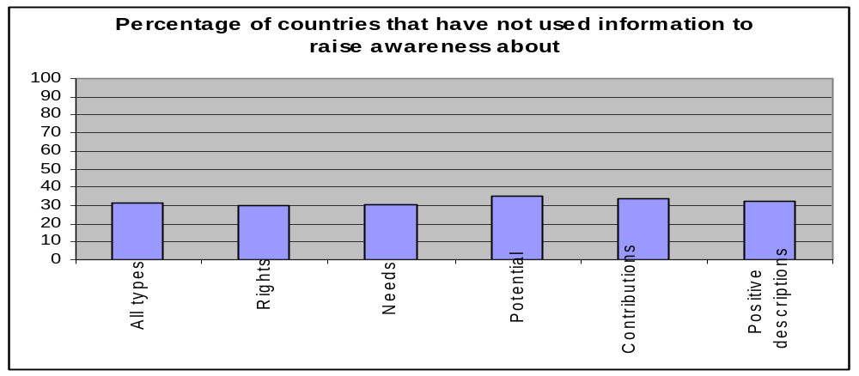
Additionally, knowing that attitudes and perceptions can also be seen as a function of the media’s portrayal of persons with disabilities, and that in two-thirds (2/3) of the responding countries this is not taken into consideration, action needs to be taken at the following levels:

- educating the media about the potentials and contributions of persons with disabilities, as well as their diversity and abilities
- ensuring that the portrayal and description of persons with disabilities in the media is positive, and the exploration of their needs and requirements to achieve equalization is seen as enriching rather than burdensome to society.

It is also important that persons with disabilities themselves be involved in the issues of raising awareness. Not only because they are the true experts, but because it is through their participation itself that awareness of their abilities can be raised.

Rule 2. Medical Care

In order for governments to provide the necessary and effective medical care to persons with disabilities as specified in the Standard Rules, there are eight (8) measures that they are required to take.

All eight (8) actions pertaining to this rule were identified and placed in an ordinal manner by which each action is dependent on the one before it.

In relation to Medical Care data revealed that around two-thirds (2/3) of the countries responding took some measures to ensure that persons with disabilities receive medical care. However, the number of countries that adopted policies, passed legislations, and implemented programmes relating to the provision of medical care was less than the countries that actually provided it.

T1-Rule 2

Actions taken by government to ensure provision of effective medical care for people w/ disabilities | No | Yes | N/A
Adopting policies | 43 | 70 | 1
Passing legislations | 62 | 51 | 1
Adopting programmes | 50 | 63 | 1
Allocating financial resources | 50 | 63 | 1
Training personnel | 48 | 65 | 1
Making medical care accessible | 39 | 74 | 1
Consulting organizations of persons w/ disabilities | 44 | 69 | 1
Informing persons w/ disabilities about the availability of medical services | 50 | 63 | 1
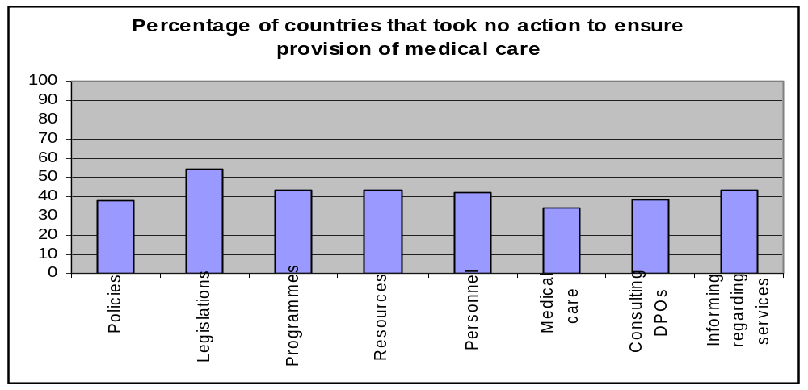

While 70 and 51 countries said that they had adopted policies and passed legislations, respectively, with regard to the provision of medical care for persons with disabilities, 74 countries stated that they actually do provide medical care for persons with disabilities. This indicates that in reality more countries provide medical care for persons with disabilities than the countries that have legislated for such actions.

This might indicate that, health care, being a necessity does not require legislation or does not need to be specific to a certain population within the legislations of a country. The nature of this basic human right, forces the system to respond to it regardless of who the people are receiving the care and whether or not it has been legislated for.

However, less than two-thirds (2/3) of the responding countries indicated that they had taken any actions with regard to medical care.

This is alarming in that it indicates that a large number of persons with disabilities in the world do not have access to proper medical care. In view of the discrepancy explained earlier between the legislation and the actual provision of medical care, it could also mean that medical care is available to persons with disabilities when they need it without it being formally recognized as a right.

In any case, there are still 40 countries in the world in which people with disabilities are deprived of this basic human right.

In relation to the implementation of programmes 63 countries indicated that they do have programmes particularly directed to persons with disabilities, while 50 said they did not.

This indicates that much work still needs to be done to ensure that persons with disabilities have access to appropriate medical care, and the medical sector needs to be sensitized to the needs of persons with disabilities and their requirements from the medical care system; i.e. friendly, accessible, well-equipped, appropriate to the type of disability and offered with the necessary respect to the dignity of persons with disabilities.

In relation to prevention, more countries reported actions taken at the level of awareness raising on the causes of disability, the improvement of pre and post-natal care and maternal health, early detection and treatment at an early age. These ranged between 74 at the low end and 88 at the high end that have implemented such programmes.

T2 Rule2
Has government taken any action to | No | Yes | N/A
Raise awareness on the causes of disability | 31 | 82 | 1
Improve maternal/pre-natal & post-natal health care | 25 | 88 | 1
Detect impairment at an early age | 37 | 76 | 1
Treat impairment at an early age | 39 | 74 | 1
Update medical personnel’s knowledge for persons w/ disabilities | 56 | 57 | 1
Ensure access to treatment and medicine for persons w/ disabilities | 52 | 61 | 1
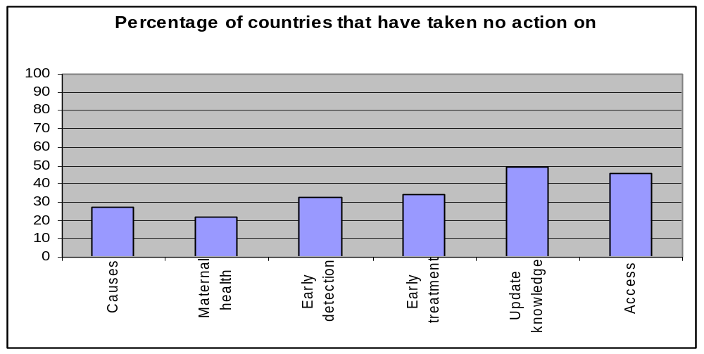

Yet far fewer countries reported having taken measures to update the knowledge and skills of personnel in the medical sector to ensure access to treatment and to medications, (57 to 61 countries respectively). This indicates that even when actions are taken by governments, they are neither comprehensive nor complete. One of the priority issues to be dealt with at this level is to ensure that governments are aware of the importance of accessible, appropriate medical care and that training and updating the knowledge of medical personnel remains a priority.

Considering that medical care is a basic human right and that all human beings are entitled to it, all governments are required to have policies, legislations and programmes to ensure that this right is available to all.

Furthermore, persons with disabilities often require more medical attention and care than non-disabled persons in order to enable them to foster their independence and sustain a life with dignity. Therefore, any measures that fall below the provision of full, comprehensive, medical care is a violation of their rights and requires immediate response and attention by governments.

Rule 3. Rehabilitation
To fulfill their commitment to the provision of rehabilitation to persons with disabilities and in order for them to reach and sustain their optimum level of independence and functioning, governments were required to respond on seven (7) measures that form the core actions for meeting the rehabilitation needs of persons with disability.

Fifty-one (51) out of 114 countries responded positively on all seven (7) measures. This would mean that more than 50% have not taken action on all measures required to provide rehabilitation services. In other words there are no rehabilitation services available to persons with disabilities in 62 countries.

T1-Rule3

Actions government has taken to provide rehabilitation services for persons w/ disabilities | No | Yes | N/A
Adopting policies | 48 | 65 | 1
Passing legislations | 57 | 56 | 1
Adopting programmes | 46 | 67 | 1
Allocating financial resources | 40 | 73 | 1
Training personnel | 37 | 76 | 1
Making rehabilitation services accessible to persons w/ disabilities | 31 | 82 | 1
Consulting organizations of persons w/ disabilities | 32 | 81 | 1
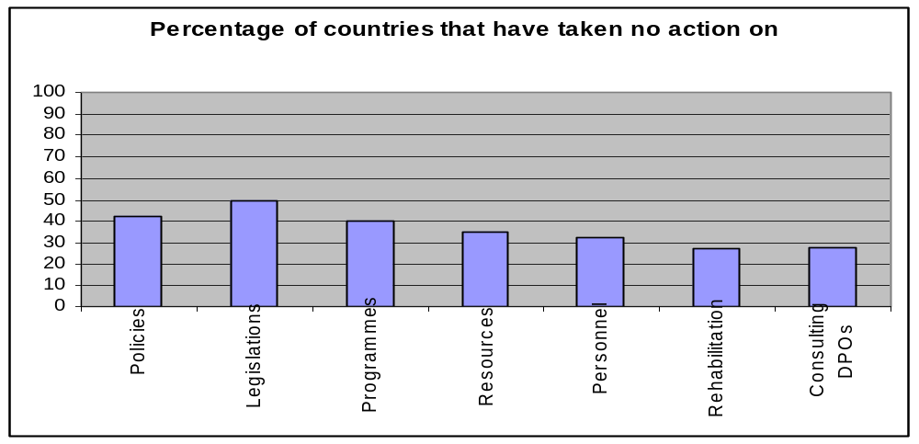
What was perplexing in those results, is that when asked about the inclusiveness of the services, more than 50% of the countries that responded said that they were inclusive, i.e. provided to all persons with disabilities; for all type of disabilities; and from all walks of life and covering all geographical, socio-economic, ethnic and religious backgrounds.

This can be interpreted in two ways. Either that people with disabilities receive all the services they need as a matter of course, regardless of the existence of policies, legislations, specialized programmes, training of personnel and consultation with disabled persons organizations; or that in many countries there is an absence of a formal institutional, governmental and legislative base by which those services are provided.

T2-Rule 2

Are rehabilitation services inclusive of | No | Yes | N/A
All types of disabilities | 44 | 69 | 1
Children with disabilities | 25 | 88 | 1
Women with disabilities | 34 | 79 | 1
Low-income, working class and poor persons w/ disabilities | 36 | 77 | 1
All geographical locations | 48 | 65 | 1
All socio-economic classes and ethnic groups | 42 | 71 | 1
The organizations of persons w/ disabilities | 45 | 68 | 1
The families of persons w/ disabilities | 47 | 66 | 1
The communities in which persons w/ disabilities live | 60 | 53 | 1
The specific/diverse needs of persons w/ disabilities | 59 | 54 | 1
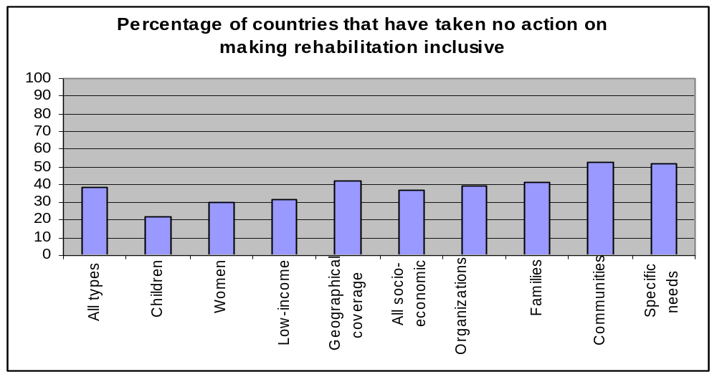
It is important to remember, in explaining these results, that in many countries, services for persons with disabilities are provided by the private sector, charitable organizations, religious foundations or disabled persons organizations in which the role of governments is minimal. This may explain why governments are not aware or not involved in either regulating or legislating rehabilitation services, or in delivering them.

In any case, this is certainly an aspect of rehabilitation that requires further investigation and research. It would also be interesting to see whether disabled persons organizations responded to the existence of services while corresponding governments responded to the lack thereof.

Still from the point of view of disabled persons organizations, there are many shortages in the design and delivery of rehabilitation services generally. With regard to community involvement in the design, implementation and delivery of services, only 46 out of 114 countries stated that they involve persons with disabilities in those actions.

T3-Rule 2
Does planning, design, implementation & evaluation of rehabilitation programmes involve | No | Yes | N/A
Medical personnel | 33 | 81 | 0
Families of persons w/ disabilities | 57 | 57 | 0
Schools, educational institution and teaching staff | 45 | 69 | 0
Communities of persons w/ disabilities | 68 | 46 | 0
Organizations of persons w/ disabilities | 51 | 63 | 0
Percentage of countries where rehabilitation programmes do not involve
0
10
20
30
40
50
60
70
80
90
100
Medical Personnel
Families
Schools
Communities
Organizations

Fifty-seven (57) countries stated that they involve the families of persons with disabilities; while 69 responded that they involve schools and educational institutions; and 81 involve medical staff and personnel. One of the things this reveals is that rehabilitation is still for many a medical issue while overlooking the social dimensions inherent for persons with disabilities themselves, their environment, the community in which they reside, and the people they reside with.

Further research is needed to explore the situation and practices and whether community based rehabilitation (CBR) is delivered but has not been defined as such. Additionally, for disability to be a community issue it requires full community involvement and for that to happen both community and rehabilitation need to be defined broadly, to include more than just the family of a person with disabilities and more than just physical rehabilitation.

There is also a need to work on liberating rehabilitation from the medical model where it still resides in many countries. (Eighty-one (81) countries reported involving medical personnel in rehabilitation while 57 and 68, respectively reported that they do not involve the families of persons with disabilities or the communities in which they live.

There is a need for intensive and comprehensive awareness raising programmes at all levels from the highest levels of government to the grassroots community level, including the medical profession in all its disciplines, and possibly persons with disabilities themselves; and in this respect, governments need to take into consideration that rehabilitation is a process by which persons with disabilities are empowered to participate equally in society. Since rehabilitation in necessary for equalization to be effective, it should be reflected in all policies, legislations and programmes.

Additionally, even where the community, the family and disabled persons organizations are taking an active and pivotal role in rehabilitation, they need to be supported and strengthened by government rather than left to shoulder the responsibility on their own.

Rule 4. Support Services
Support services, include people, assistive devices and technology needed to enable persons with disabilities to lead independent, productive lives with dignity. Governments are expected to take measures in the following areas, and to which countries responded as follows:

T3-Rule 4

Actions by government to develop and supply assistive devices for people w/ disabilities | No | Yes | N/A
Adopting policies | 55 | 59 | 0
Passing legislations | 57 | 57 | 0
Instituting programmes | 61 | 53 | 0
Allocating financial resources | 41 | 73 | 0
Supplying individuals with assistive devices | 35∗ | 79 | 0
Consulting with and involving organizations of persons w/ disabilities | 43 | 71 | 0
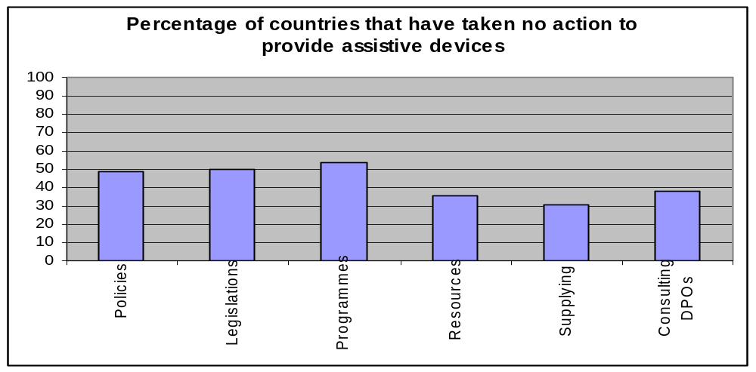

The findings showed that the highest rate of responses was for supplying individuals with assistive devices, to which 79 countries responded positively, while 55, 57 and 61 countries, respectively have neither adopted policies, passed legislations nor instituted programmes.

This means that the response to the needs of persons with disabilities happens on a case by case basis without recourse to legislation. Some countries may respond instinctively, and may act with discretion. It may also be due to the fact that many relate assistive devices to health issues rather than to a right required to achieve equalization. This may indicate that policy makers are not necessarily thinking about disability rights issues when formulating legislations on support services, but rather of health care issues.

It is also an indication that people with disabilities themselves in some countries, are seen and/or view themselves as patients who need these devices, rather than persons with disabilities who require additional help in order to fully participate. Moreover, assistive services, especially in developing countries are provided by agencies, the private sector, donors and international institutions who provide them independently of government legislations and policies

Regarding who receives the support services, the Survey asked about the inclusiveness of these services. Responses were as follows, out of 114 countries that responded the following number of countries provided services to the different groups indicated in the Survey:

T2-Rule4

Does government provide support needed by persons w/ disabilities with regard to assistive technology, personal assistance to | No | Yes | N/A
Children with disabilities | 43 | 71 | 0
Women with disabilities | 51 | 63 | 0
Low-income, working class and poor persons w/ disabilities | 51 | 63 | 0
Persons w/ disabilities in all geographical locations | 63 | 51 | 0
All socio-economic classes | 63 | 51 | 0
All ethnic groups | 60 | 54 | 0
All religious groups | 59 | 54 | 1
All types of disabilities | 54 | 60 | 0
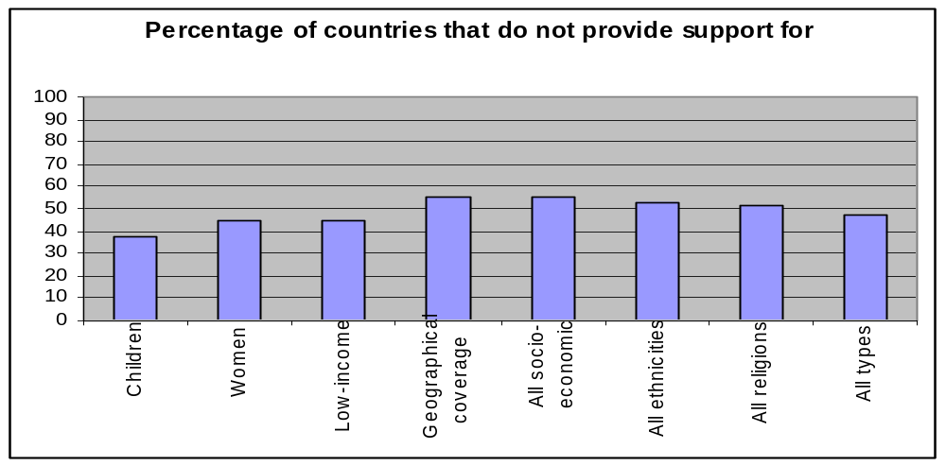
Inclusiveness of services and coverage remains a problem. Almost half the countries that responded indicated that socio-economic, geographical, ethnic and religious factors formed one kind of barrier to services, while women and children fared slightly better.

Supportive services and assistive devices enable persons with disabilities to participate fully in society and constitute a basic right. The absence of such devices means unequivocally the deprivation of persons with disabilities from full participation.

The reality of the world today as revealed by the results of the survey, is that in 35 countries support services and assistive technology are not available to persons with disabilities. Therefore, in those countries, persons with disabilities require the recognition of their rights and the translation of those rights into implementable actions that will support, assist and enable them to participate equally in society.

Throughout the Survey the figure of one-third (1/3) is consistent, particularly where the pre-conditions are concerned. One-third of the countries of the world have not fulfilled their moral commitment towards persons with disabilities at the levels of adopting policies, passing legislations and implementing programmes, which has been clearly reflected in the lives of persons with disabilities and the actual situations in which they live.

Rule 5. Accessibility
States were required to recognize the overall importance of accessibility in the process of the equalization of opportunities in all spheres of life, and were therefore, required to provide programmes of action to make the physical environment accessible, and to undertake measures to provide access to information and communication.

At the level of the environment, eight (8) types of action were required.

Results revealed that accessibility at all levels world wide falls short of expectations. In the areas of policies, legislations and consulting with disabled persons organizations, more than half the responding countries answered positively. The shortfall was observed at the level of implementation of programmes and awareness- raising where only 40 to 49 countries responded positively.

T1-Rule5

Actions taken by government to make the physical environment accessible to all persons w/ disabilities | No | Yes | N/A
Adopting policies | 49 | 65 | 0
Passing legislations | 54 | 60 | 0
Introducing programmes | 65 | 49 | 0
Allocating financial resources | 66 | 48 | 0
Training architects and construction engineers | 74 | 40 | 0
Raising public awareness | 51 | 63 | 0
Implementing accessibility programmes | 67 | 47 | 0
Consulting with and involving organizations of persons w/disabilities | 43 | 71 | 0
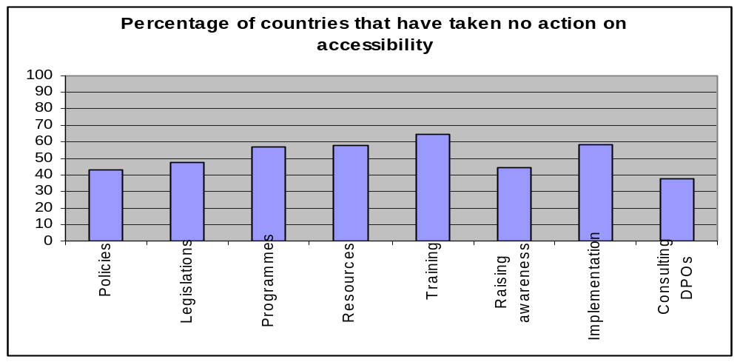

This shows that the intention is present in most of the responding countries to make the physical environment accessible and that many do understand the importance of this aspect in effecting equalization of opportunities for persons with disabilities.

Responses relating to policies were higher than those relating to change on the ground in accordance with these policies. The fact that the intention is clearly present seems to indicate that the obstacle to implementation could be the availability of financial resources which is responsible for the gap between theory (intention) and practice (implementation).

While accessibility is expressed as a priority by governments in all discussions about disability at international fora, it is obvious that when it comes to implementation at the national level—which requires the spending of resources—it is a priority that competes with many others. Education, health, security…etc. often take precedence over disability issues where governments are concerned.

Therefore, the alarming number of 49 countries that have taken no action on accessibility for persons with disabilities is a serious matters that requires awareness raising and advocacy.

Regarding the existence of codes and standards of accessibility for different physical locations the results were as follows:

T2-Rule 5

Do legislations and regulations provide codes and standards of accessibility for | No | Yes | N/A
Schools, hospitals, clinics, community centers, public libraries, theatres, rehabilitations centers | 50 | 64 | 0
Public buildings and government agencies & offices | 49 | 65 | 0
Outdoor environment ( sidewalks, pedestrian crossing …) | 62 | 52 | 0
Land, sea and air transportation | 75 | 39 | 0
Housing | 72 | 42 | 0
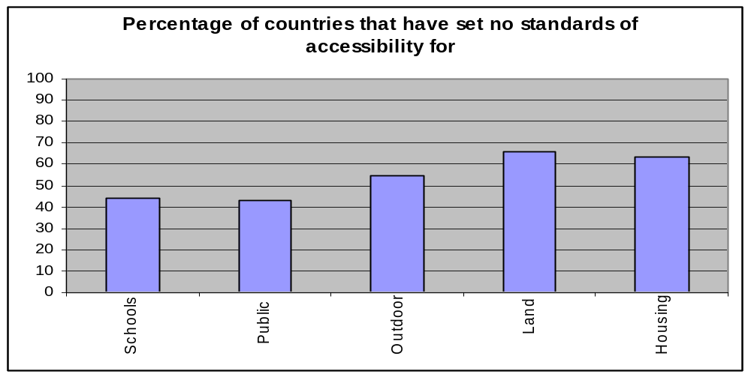

In effect, this means that the physical environment is not as accessible as it should be. Even in the countries that stated they have accessibility, not all spaces are accessible and in only 64 of them the spaces related to services, which may or may not be legislated for, are accessible, such as government buildings. On the whole both housing and transportation remain major issues of concern in terms of accessibility in most of the responding countries.

This means that social commitment is not widely shared or backed by the necessary resources in order to restructure the environment to suit the needs of all persons with disabilities.

Considering that more than 10 years have passed since the adoption of the Standard Rules at the time of the administration of this questionnaire, the responses given to the issue of accessibility are far from satisfactory. Political commitments need to be translated into actions, and the community at every level needs to be involved in this because communities are where people spend their lives and interact, and where the equalization of opportunities counts the most.

Regarding accessibility of information, two aspects are required by the Standard Rules and covered in this Survey:

- Information about accessibility; and
- Information in an accessible form

On the first, information about accessibility targeting specific segments, responses were as follows:

T3-Rule 5

Does government provide information regarding accessibility to | No | Yes | N/A
Persons w/ disabilities only | 73 | 41 | 0
Families of persons w/ disabilities | 74 | 40 | 0
Representatives of persons w/ disabilities & their organizations | 63 | 51 | 0
Society as a whole | 58 | 56 | 0
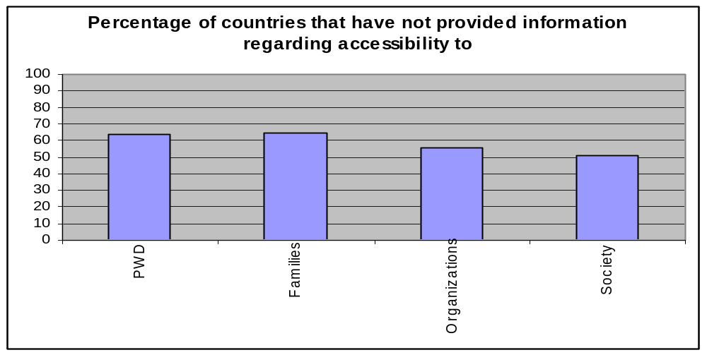

These responses indicate that not all countries have information regarding accessibility and that where it is provided it is general in nature and scope and does not target specific populations of concern.

As for the accessibility of information and communication, countries were expected to take eight (8) measures ranging from policy adoption to consulting with disabled persons organizations.

T4-Rule 5
Has government taken actions to ensure accessibility  of information to persons w/ disabilities | No | Yes | N/A
Adopting policies | 61 | 53 | 0
Passing legislations | 71 | 43 | 0
Introducing programmes | 61 | 53 | 0
Allocating financial resources | 61 | 53 | 0
Training interpreter for all disability needs | 74 | 40 | 0
Raising public awareness | 59 | 55 | 0
Implementing accessibility programmes | 71 | 43 | 0
Consulting with and involving organizations of persons w/ disabilities | 52 | 62 | 0
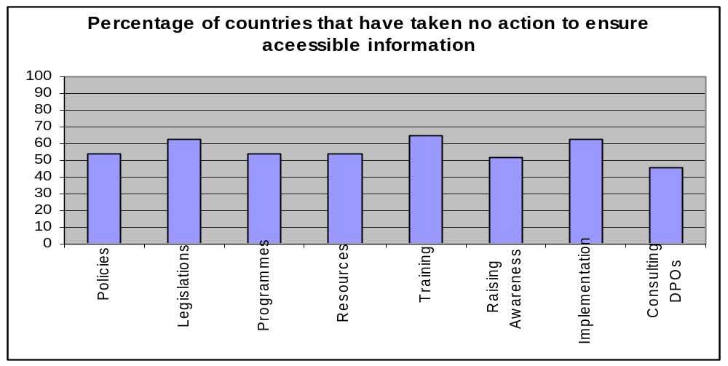

On all eight measures, more than half the countries reported that they had taken no measures at all in that respect. The numbers range from 50 countries that had taken action on training sign language interpreters to 55 countries that had taken action on raising awareness. While the numbers were even less on all the other measures.

This indicates that there is a serious problem where accessible information and communication for persons with disabilities is concerned, which inevitably contributes to their continued marginalization as they do not receive the information necessary for equal participation in society. Additionally, persons with disabilities are being deprived of their basic human rights to enjoy all activities related to the enhancement of a person’s well being—cultural, educational, recreational, professional—in integrated settings where their communication needs are being met. Governments’ failure in this respect required further and concentrated efforts in order to improve the situation.

Concerning accessibility of information with regard to types of disabilities, of the 114 responding countries, most indicated the presence of accessible information for blind persons, while other types of disabilities did not fare so well.

T5-Rule 5

Is information accessible to | No | Yes | N/A
Blind persons or visually impaired | 44 | 70 | 0
Deaf/blind people | 59 | 55 | 0
Deaf or hearing impaired | 52 | 62 | 0
People with developmental disabilities | 68 | 46 | 0
People with psycho social disabilities | 76 | 38 | 0
Percentage of countries that have not provided accessible
information to types of disabilities
0
10
20
30
40
50
60
70
80
90
100
Blind
Deaf/Blind
Deaf
Developmental
Psychosocial
This shows that accessible information is far from being inclusive or complete even in countries where accessibility measures are better and more broadly implemented than others.

However, even though countries may not have official policies and have not passed legislation, and where governments have not taken explicit measures or actions on accessibility, persons with disabilities still receive information and communication from sources other than their governments or official institutions.

This means that the needs of persons with disabilities in this respect, are being met to some extent by disabled persons organizations, non-governmental and/or charitable organizations; indicating that with the lack of adequate services at the macro level, and the marked absence of policies, legislations and programmes, non-governmental organizations and local authorities are obliged to fill the gap. In spite of that, the shortfall is still beyond acceptable levels.

With regard to specific services relating to information and communication for persons with disabilities 79 countries indicated that they provide literature in Braille to blind persons; while 71 indicated literature on tape and 34 also indicated magazines on tape and Braille. Seventy-three (73) countries indicated providing public information in sign language, and only 24 indicated they provide easy readers for persons with developmental disabilities.

T6-Rule 5

Are any of the following services available to persons w/ disabilities | No | Yes | N/A
Literature on Braille | 35 | 79 | 0
Literature on tape | 43 | 71 | 0
News magazines on tape/in Braille | 80 | 34 | 0
Sign language interpretation | 41 | 73 | 0
Easy reader for persons w/ developmental disabilities | 90 | 24 | 0
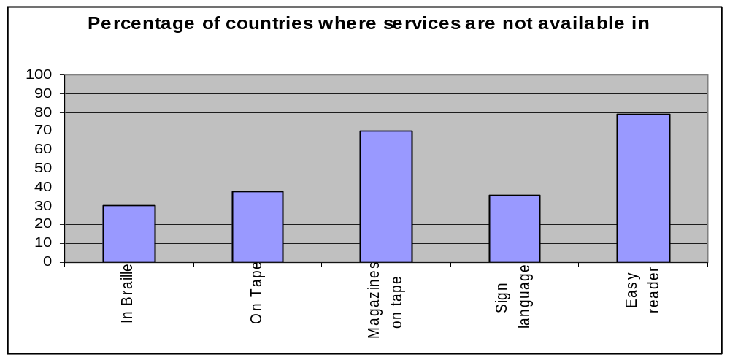

Although this shows the availability of such services in the countries that responded, we have no way of knowing to what extent these services fulfill the information and communication needs of all persons with disabilities. In other words, is the information provided for them sufficient to fulfill the goal of full participation and to create a culture of equalization.

Therefore, more efforts need to be exerted on the part of government and disabled persons organizations to develop materials and widen the base of coverage. It is also only through the active participation and involvement of disabled persons organizations can we know whether what is being provided is sufficient and what more needs to be done both qualitatively and quantitatively. This brings us once again to an issue that cuts across all the Standard Rules—which is the importance of involving disabled persons organizations as advisors and consultants in all matters pertaining to their issues.

In view of these responses—and considering that accessibility is one of the most discussed of the Standard Rules, and that it effects all aspects of life of persons with all types of disabilities—there are still many shortcomings in both understanding and implementing it. Many still associate accessibility with only the physical environment giving far less attention to other aspects of accessibility. Therefore, the needs of blind and deaf persons in public spaces do not seem to be fully realized; the information and communication needs of persons with psychosocial disabilities remain largely unrecognized.

With regard to the measures taken by governments to monitor accessibility and address the issues relating to it, the following measures have been implemented:

T7-Rule5

What measures has government taken to monitor accessibility of environment & information for persons w/ disabilities | No | Yes | N/A
Ombudsman | 89 | 25 | 0
Governmental bodies set up for the purpose | 63 | 51 | 0
Independent expert bodies | 87 | 27 | 0
Special arbitration/conciliation bodies | 101 | 13 | 0
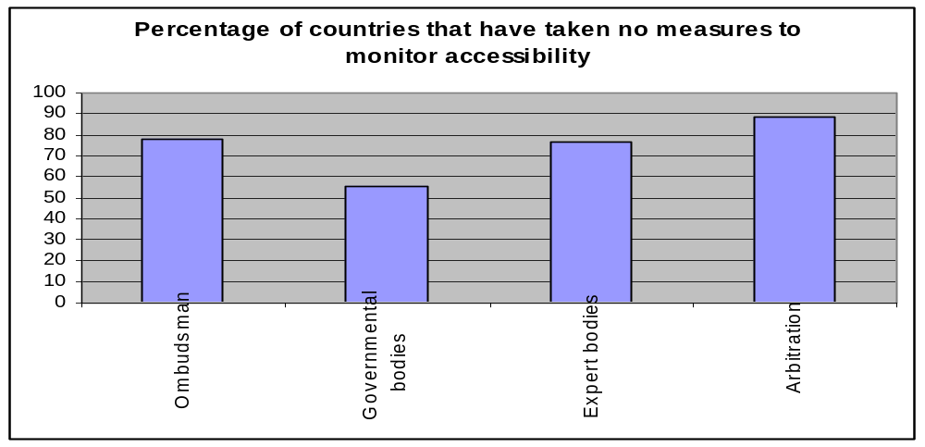

While monitoring bodies on accessibility do exist in one form or another in many countries, little is known at this time about their programmes and methodology, or their levels of coverage and whether they are related to government policies and legislations or whether they provide information to governments leading to change.

Monitoring and reporting without an effective mechanism that translates into real change, remain intellectual exercises that have little effect on the actual lives of persons with disabilities.

It is also obvious that there is a need for greater involvement on the part of disabled persons organizations in assessing the accessibility situation in their countries, identifying the needs, and advising governments on the best course of action to achieve full accessibility and thereby move one step closer to full participation in society for persons with disabilities.

Rule 6. Education
Equalization of opportunities in relation to education requires that governments take certain measures to ensure the right of persons with disabilities to receive education in integrated settings. Rule 6 identifies integrated education as a need for children, youth and adults and at all levels of the educational system.

The set of measures expected to be taken in order to achieve this goal, range from adopting policies and enacting legislations to involving the organizations of persons with disabilities in an advisory and consultative capacity. There were eight (8) measures in all identified by the questionnaire in order to assess governments’ compliance with Rule 6.

More than half of the countries responding (out of 114) said that they had taken one or more measure(s) to ensure integration in education for persons with disabilities.

The highest responses were with regard to teacher training, with 84 countries responding positively; and the lowest was with regard to adopting legislation, at 63 countries. As for implementing programmes to ensure integrated education, 79 countries responded positively.

While these numbers do not indicate full compliance with the provisions of Rule 6 in all countries, the relatively high numbers can be explained by the existence of compulsory education in most countries, whereby children with disabilities are accommodated within the physical school environment. In other words, children with disabilities attend regular schools along with non-disabled children simply by virtue of education being compulsory. However, there are no legislations particular to the provision of education suitable to children with disabilities within integrated settings. If we take into consideration World Bank estimates that 40 million of the world’s 115 million children who are out of school have disabilities, then the numbers revealed by the Survey fall very short of fulfilling the educational needs of children and adults with disabilities, let alone quality education in integrated settings.

When focusing on the measures needed to make the school environment accessible to children with disabilities through the allocation of financial resources, the adoption of programmes, modification and adaptation of the physical environment, responses ranged between 70 and 72 countries that have adopted these measures.

T1-Rule 6
Action government has taken to ensure the education of persons w/ disabilities in integrated settings | No | Yes
Adopting policies | 38 | 76
Passing legislations | 51 | 63
Adopting programmes | 35 | 79
Allocating financial resources | 36 | 78
Modifying and adapting schools to the needs of children w/ disabilities | 44 | 70
Training teachers and school administrators | 30 | 84
Providing accessible schools, classrooms & educational materials | 45 | 69
Involving organizations of PWD in planning and implementing | 47 | 67
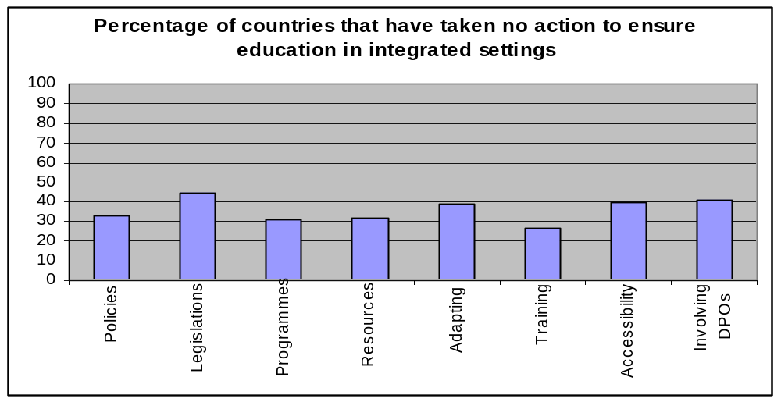

Considering that education is the process by which children become socialized, and the means by which individuals are enabled to participate in society, gain the necessary skills and qualifications to find employment, and are therefore, empowered to lead productive and independent lives, the denial of the right to education to children and adults with disabilities in integrated settings, is a serious violation of their human rights and needs to be addressed urgently by international, regional and national human rights and United Nations bodies concerned with education.

It should also constitute a major advocacy challenge facing disabled persons organizations in all countries of the world—because anything less than full implementation of the measures of this rule should be considered an unacceptable state of affairs.

However, on the issue of involving the organizations of persons with disabilities in a consultative capacity in making decisions about education for children with disabilities, only 67 countries responded positively.

This may be explained by the lack of adequate or effective disabled persons organizations in many developing countries or the lack of government commitment in considering the valuable contribution that disabled persons organizations are able to make in the areas of adopting policies and implementing appropriate programmes and ensuring coverage and delivery.

The following number of countries responded with regard to the availability of education to persons with different types of disabilities:

T2-Rule 6
Is education available to | No | Yes | N/A
Children with disabilities | 13* | 101 | 0
Women with disabilities | 37 | 77 | 0
Low-income, working class and poor persons w/ disabilities | 37 | 77 | 0
Disabled persons all ethnic groups | 38 | 75 | 1
Disabled persons all religious groups | 35 | 78 | 1
Disabled persons all communities | 46 | 67 | 1
All types of disabilities | 46 | 68 | 0
Percentage of countries that have not made
education available to
0
10
20
30
40
50
60
70
80
90
100
Children
Women
Low-income
All ethnicities
All religions
All communities
All types

It must be remembered, that these numbers out of 114, (the countries that responded), indicate a great lack world wide, and that there remains 77 countries from which there were no responses at all. These results indicate that there are problems in education in general worldwide, and that there are grave violations to the right to education of children with disabilities.

More alarming is that 13* of the 114 responding countries indicated that no education whatever is provided to children with disabilities. There are also 37 countries in which education is not available to low income persons with disabilities or to women with disabilities, thereby condemning them to eternal marginalization, and increased poverty.

Also alarming are the number of countries that reported not having taken any measures to provide special accommodations and/or facilities for children with disabilities whose needs cannot be met in integrated settings, as well as the number of countries that have taken no action with regard to education of children with different types of disabilities.

T3-Rule 6

Does education for persons w/disabilities include the use of | No | Yes | N/A
Sign language interpreters | 35 | 79 | 0
Educational materials in Braille | 23 | 91 | 0
Lessons on tape | 45 | 68 | 1
Educational material & teaching methods for children w/ intellectual disabilities | 36 | 77 | 1
Programmes for children whose needs cannot be met in integrated settings | 41 | 72 | 1
Percentage of countries where education does not include
0
10
20
30
40
50
60
70
80
90
100
Sign
language
Braille
Tape
Intellectual
disabilities
Special
programmes
It is safe to say that the quality of life of persons with disabilities is greatly dependent on his/her ability to communicate and interact with the world. In order to fully participate in society, there are certain skills that are needed which only quality education can provide. Therefore, the absence or shortage of measures relating to the provision of education for children and adults with disabilities cannot be overlooked or taken lightly and must be considered a violation of basic human rights.

It is crucial that the world community focus on the issues of education for children and adults with disabilities, and do whatever is needed to urge governments to fulfill this right and meet their obligations towards the Standard Rules for the Equalization of Opportunities for Persons with Disabilities—to which it publicly committed more than 10 years ago.

Additionally, considering the number of countries in which children and adults with disabilities receive no education, it is safe to assume that this contributes greatly to increasing the level of illiteracy in the world. If the Millennium Development Goal, Education for All initiative hopes to cut the level of illiteracy and increase enrolment in schools, then greater efforts must be made to include children with disabilities in all education initiatives. There is also a need to support the Education Flagship Programme by helping, encouraging, urging governments to make the Flagship goals part of their National Action Plans on education and providing governments with the resources to implement them.

Essentially, these numbers indicate that education, in a great number of countries, does not fulfill its basic function of preparing children and adults with disabilities by providing them with the necessary life skills and adaptation methods, or the equal opportunity to gain the abilities necessary for full participation. This is also clear from the number of countries that do not involve anyone (parents, persons with disabilities, disabled persons organizations, communities) in making educational decisions for children with disabilities.

T4-Rule6

Are the following groups involved in the educational process for children & adults with disabilities | No | Yes
Parents of children with disabilities | 27 | 87
Organizations of persons w/ disabilities | 25 | 89
NGOs dealing with children | 33 | 81
The community | 64 | 50
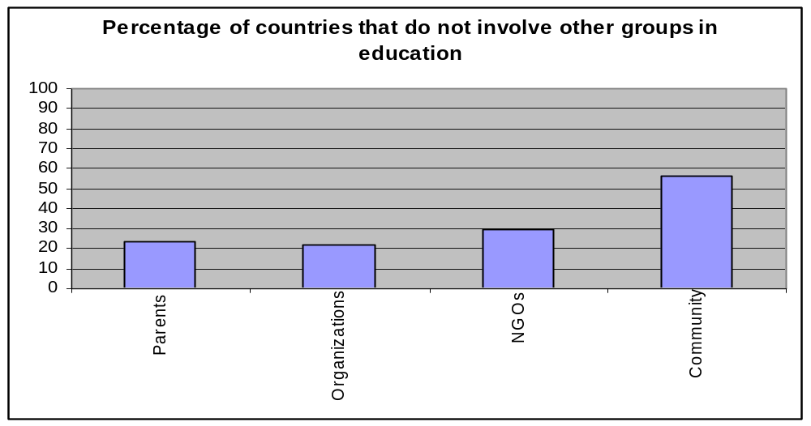

Also at the national level, there is a need to review all educational policies and legislations pertaining to education to ensure that they incorporate the educational needs of children and adults with disabilities—including accessibility of the school environment, teaching methods, learning materials, delivery methods, and trained teachers.

Rule 7. Employment

In order to ensure the integration of persons with disabilities within the labour market, governments are required to take nine (9) actions to implement Rule 7 regarding the right to work for persons with disabilities.

Responses to the Survey revealed that the right to employment is neither fully recognized nor is it considered a priority.

Seventeen countries responded that they have taken no measures with regard to this rule.

In terms of the recognition of the right of persons with disabilities to employment, 47 countries have taken no action in the area of adoption of policies; while 43 countries have not taken any action on legislations. With regard to the implementation of measures and programmes to ensure integrated employment for persons with disabilities, the following table paints a bleak picture:

49 countries no measures on programme implementation
51 countries no resources into implementing integrated employment
38 countries no training for employment for persons with disabilities
69 countries no action to adapt the physical environment
59 countries no action to raise the awareness of management regarding the needs of persons with disabilities
83 countries no action on accessible transportation or work stations for persons with disabilities
57 countries no action on cooperating with disabled persons organizations with regard to employment

These figures indicate a serious lack. It is obvious that these measures are necessary in order to shape the positive legal, cultural, attitudinal and physical environment that would enable persons with disabilities to participate in the labour market as productive, contributing citizens. Moreover, gainful employment and a productive life are a source of dignity for all persons and a necessity for psychological well being and social adjustment. The figures above go a long way in explaining why persons with disabilities are not visible in the labour market and remain, throughout the world, economically marginalized.

T1-Rule 7

Actions government has taken to encourage the integration of persons w/ disabilities into open employment. | No | Yes | N/A
Adopting policies | 47 | 67 | 0
Passing legislations | 43 | 71 | 0
Adopting programmes | 49 | 65 | 0
Allocating financial resources | 51 | 63 | 0
Training person w/ disabilities | 38 | 76 | 0
Modifying and adapting the physical, social and administrative environment. | 69 | 45 | 0
Raising awareness among management and administration on disability issues. | 51 | 63 | 0
Providing accessible transportation and work station | 83 | 31 | 0
Cooperating with organizations of persons w/ disabilities on all measures relating to the labour market | 57 | 56 | 1
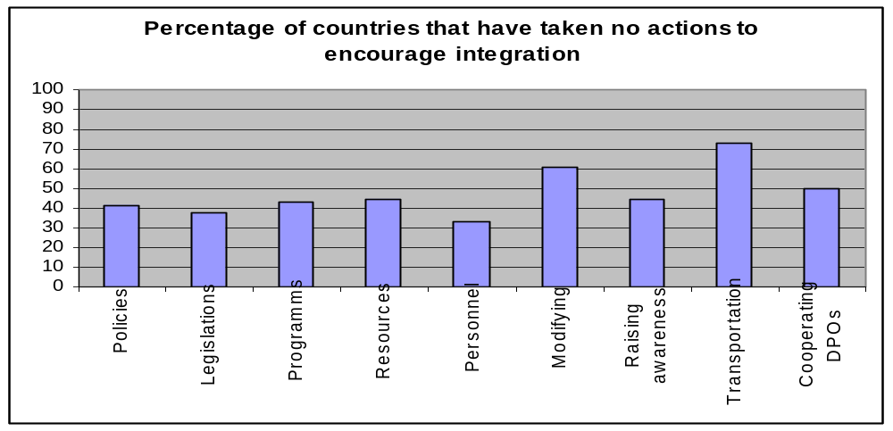

With respect to hiring and promotion of persons with disabilities more than half the countries responding to the questionnaire stated that persons with disabilities do not have the same opportunities or prospects as non-disabled persons.

Considering the opportunities available to persons with disabilities in the areas of hiring, promotion, pay increases, training and skills upgrading, only 51 countries reported that persons with disabilities have the same prospects as others in terms of being hired. This number increases only slightly to 57 when it comes to the chances of persons with disabilities already employed of being promoted. While 62 and 63 countries, respectively, indicated that persons with disabilities have the same chances of receiving pay increases and enrolling in training programmes; and 64 countries indicated that persons with disabilities are entitled to work benefits.

T2-Rule 7
Do persons w/ disabilities have same prospects as others with regard to | No | Yes | N/A
Hiring | 59 | 51 | 4
Promotion | 54 | 57 | 3
Work benefits | 47 | 64 | 3
Pay increases | 49 | 62 | 3
Participation in training programmes | 48 | 63 | 3
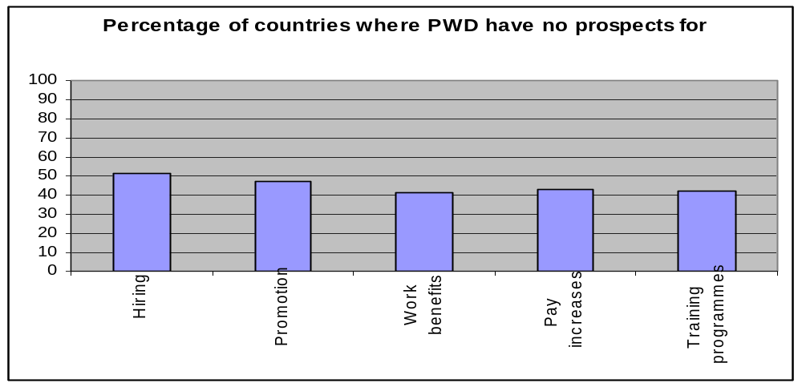

Considering the under-representation of persons with disabilities in the labour market, even those who are employed are not always entitled to the same privileges as non-disabled persons.

This indicates that discrimination is still a major problem for persons with disabilities with regard to employment. Considering that education and gainful employment are a recognized source of dignity for all people, the Survey has shown that for persons with disabilities those two conditions are in very short supply worldwide regardless whether countries are developed or developing.

There is a need for new and innovative ways to fulfill the rights of persons with disabilities in those areas, and that despite the conventions, covenants and treaties that guarantee the right to education and employment—and most recently the Convention on the Rights of Persons with Disabilities—there has not been full recognition of those rights in practice and not enough has been done to enforce their implementation.

Rule 8. Income Maintenance and Social Security
Rule 8 calls upon countries to ensure social security and maintain the income of persons with disabilities. The measures required leading to full realization range from the adoption of policies to consulting with the organizations of persons with disabilities.

The state of the world, as revealed by the Survey, shows that less than half the countries that responded have taken some action of this matter, while more than half have taken no action on the provision of income maintenance for persons with disability.

T1-Rule 8
Actions government has taken to ensure income maintenance and support for persons w/ disabilities | No | Yes | N/A
Adopting policies | 57 | 56 | 1
Passing legislations | 67 | 47 | 0
Adopting programmes | 60 | 53 | 1
Allocating financial resources | 51 | 62 | 1
Providing persons w/ disabilities with info on income maintenance | 61 | 52 | 1
Consulting organizations of persons w/ disabilities | 60 | 53 | 1
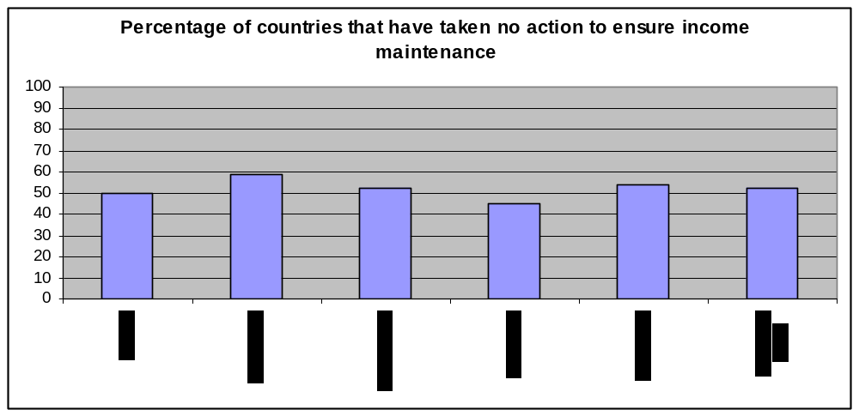
The survey asked about 10 categories of persons with disabilities who are entitled to the provision of income and social security, ranging from people with temporary disabilities to persons with disabilities from all walks of life, socio-economic classes and ethnic and religious backgrounds. Responses revealed that more than half the countries that responded lack a comprehensive scheme for maintaining income and providing social security for persons with disabilities regardless of the category they fall in—this is true at the levels of policy, legislation, programmes and implementation.

These responses, along with those on education and employment reveal that persons with disabilities across the board and the world over are economically marginalized and explains why persons with disabilities are the poorest of poor.

When income maintenance and social security are examined in relation to the categories of persons with disabilities, the number of countries that have taken no action is even higher, thus indicating several layers of discrimination:

Persons temporarily disabled | 54 countries
Persons disabled by on-the-job accidents | 80 countries
People with physical disabilities | 45 countries
People with sensory disabilities | 54 countries
People with intellectual disabilities | 49 countries
People with psycho-social disabilities | 62 countries
Women with disabilities | 50 countries
Families of children with disabilities | 64 countries
Care-givers of people with disabilities | 71 countries
Persons with disabilities from all social, economic, religious, ethnic backgrounds | 60 countries

It is difficult to know whether governments do not view income maintenance as a priority for persons with disabilities because of the lack of resources, or because there is simply no recognition of their part that income and social security are necessary to maintain a certain standard of self-reliance and dignity for persons with disabilities, or because the financial support of persons with disabilities is considered the responsibility of their families rather than society at large or the government in particular.

Whatever the reason for this shortcoming, it is important to raise awareness at all levels of the need to support persons with disabilities financially. In the case of the absence of resources, governments at all levels need to recognize that the concept of equalization of opportunities means that people with disabilities need to maintain a standard of living compatible to the general standard enjoyed by the community in which they live. Providing them with an income and social security is not meant to elevate persons with disabilities above the level of their community, but rather to allow them to live within their communities with a degree of dignity.

In considering the responses to Rule 8, one of the most controversial was the number of governments that do not provide social security and income to persons who have become disabled as the result of an on-the-job accident or a work-related injury. The fact that 80 out of 114 countries responded negatively to this question is requires further investigation and research, especially when some of those are highly industrialized countries.

Additionally, on the question of income maintenance for families and care-givers of persons with disabilities, there seems to be little recognition of the loss of income that care givers of persons with disabilities suffer, and therefore, the economic burden on the family. If governments consider persons with disabilities the sole responsibility of their families financially, then they are not doing much to support those families in providing care.

Often caring for a family member with a disability—particularly in the absence of adequate services outside the home—will deprive one, and at times, two members of the family from earning an income or acquiring an education, thereby further impoverishing the family. Research has shown that along with persons with disabilities, the families of persons with disabilities also live in poverty below that of their communities.

Rule 9. Family Life and Personal Integrity

In Rule 9 governments are called upon to promote and protect the right of persons with disabilities to their personal integrity, including their right to marriage, parenthood, family and sexual relations. This may be the most difficult rule to assess, perhaps due to the difficulty in regulating and legislating the personal lives of people. However, it is important to remember that family life is crucial to the psychological well being of every person. It is even more so for persons with disabilities who require the supportive presence of family. This Rule also makes the link between family life and personal integrity.

It goes without saying that most people live in families, and in some cultures it is unheard of for people to live away from their families before they have formed families of their own. And even then, the family remains the basic and primary social unit. Additionally, in many countries, family life and personal status laws are governed not by mainstream civil policies and legislations, but by religious laws or tradition. In all cases, family life, in all its aspects, is a right, and as necessary to persons with disabilities as it is to non-disabled persons. Any deprivation of this right is considered a violation which must be redressed.

Actions pertaining to this rule range from adopting policies to involving and consulting with disabled persons organizations. On all eight (8) measures, 69 countries indicated that they have taken no actions to implement provisions of Rule 9.

T1-Rule9

Action government has taken to ensure full participation of persons w/disabilities in family life, & protecting & promoting rights & personal integrity | No | Yes | N/A
Adopting policies | 69 | 45 | 0
Passing legislations | 67 | 47 | 0
Adopting programmes | 73 | 41 | 0
Allocating financial resources | 79 | 35 | 0
Raising social awareness of rights of persons w/ disabilities | 65 | 49 | 0
Raising awareness among persons w/ disabilities regarding their rights | 67 | 47 | 0
Establishing mechanisms for reporting discrimination and handling violations | 79 | 35 | 0
Involving organizations of persons w/ disabilities | 55 | 59 | 0
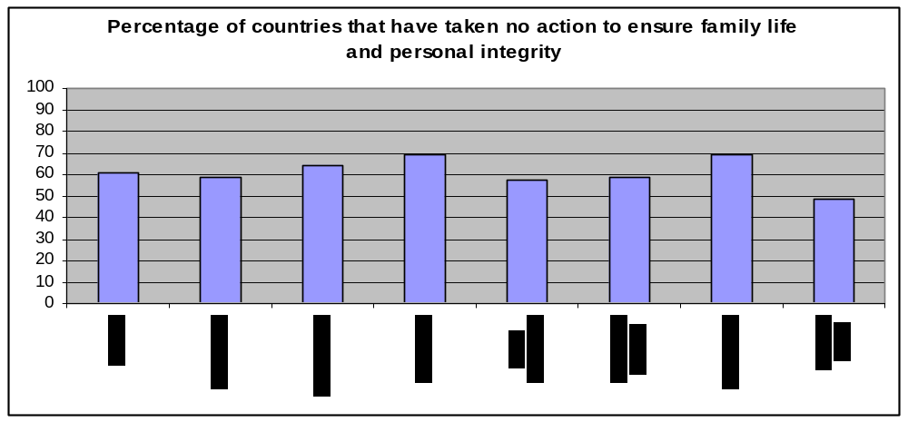
When it came to involving and consulting with persons with disabilities 55 out of 114 countries stated that they have taken no action.

This may be attributed to one or more factors, among which is that personal life cannot be regulated by the state and people, at the personal level people will do what they will without seeking government approval or permission.

T2-Rule9

Do persons w/ disabilities enjoy the right to | No | Yes | N/A
Full participation in family life | 22 | 92 | 0
Sexual relationships | 28 | 86 | 0
Marriage | 21 | 93 | 0
Parenthood | 23 | 91 | 0
Privacy | 29 | 85 | 0
Consulting services | 38 | 76 | 0
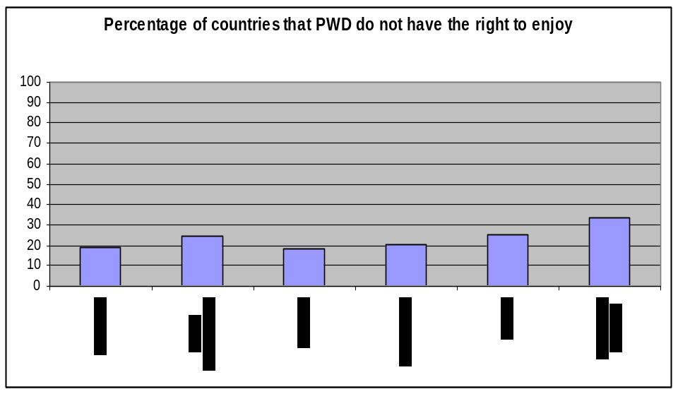

A second factor, closely related, may be the reluctance on the part of the state to regulate people’s personal lives. One possible explanation may be that governments consider such matters personal and dependent on the persons themselves.

Rule 10. Culture
In the same way that persons with disabilities have been marginalized from most social participation due to shame, lack of accessibility, discrimination and any number of other factors, they have also been excluded from participation in cultural life. Therefore, Rule 10 of the Standard Rules elaborated 11 measures that governments ought to take to ensure integration of persons with disabilities into cultural life in accordance with their commitment to equalization of opportunities for persons with disabilities. The first three (3) measures have to do with stating the right to cultural participation, and the remaining eight (8) are aimed at implementation of the Rule.

Responses revealed that of the 114 countries that responded to the Survey, a large number have taken no action on all 11 measures. Participation in cultural life for persons with disabilities does not seem to be a priority for most countries. This may stem from factors similar to provisions on Family Life, in that governments are reluctant to regulate matters of culture, preferring to leave it up to individual preference.

T1-Rule 10

Actions government has taken to ensure that persons w/ disabilities are integrated into and can participate in cultural activities on an equal basis | No | Yes
Adopting policies | 67 | 47
Passing legislations | 76 | 38
Adopting programmes | 66 | 48
Allocating financial resources | 63 | 51
Raising social awareness of the rights of persons w/ disabilities | 58 | 56
Raising awareness among PWD regarding their rights | 57 | 57
Providing venues for persons w/ disabilities to participate in cultural activities | 59 | 55
Providing venues for persons w/ disabilities to contribute to cultural life | 64 | 50
Providing accessible information about cultural activities | 73 | 41
Making cultural performance accessible to all types of disabilities | 70 | 44
Involving organizations of persons w/ disabilities | 44 | 70
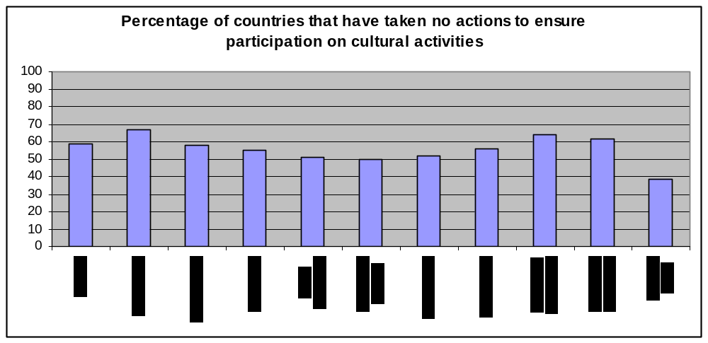

Additionally, the measures pertaining to this rule may be used to check against the responses given in many of the other rules. As is evident in this rule, the participation of persons with disabilities in the cultural life of their community is dependent of accessibility of the physical space; the accessibility of information with regard to culture; the availability of appropriate and accessible information; sufficient awareness regarding the right of persons with disabilities to participate in cultural life; education for persons with disabilities to enable them to participate. In other words, participation in culture requires a change in the culture of the community and society towards persons with disabilities to guarantee their inclusion, and allow for their participation and contribution. It also requires changes in the physical environment in order to make cultural events and venues accessible for their participation.

Regarding the types of disabilities, the gender of persons with disabilities, the socio-economic, cultural, ethnic and religious backgrounds of persons with disabilities, measures taken by governments were insufficient to ensure participation by all persons with disabilities to participate equally in cultural life, the response were as follows:

T2-Rule 10

Do persons w/ disabilities participate equally in cultural activities, including | No | Yes | N/A
Children with disabilities | 43 | 69 | 2
Women with disabilities | 50 | 62 | 2
Low-income, working class and poor persons w/ disabilities | 53 | 58 | 3
Disabled persons from all ethnic groups | 53 | 58 | 3
Disabled persons from all religious groups | 50 | 61 | 3
Disabled persons in all communities | 55 | 56 | 3
All type of disabilities | 53 | 58 | 3
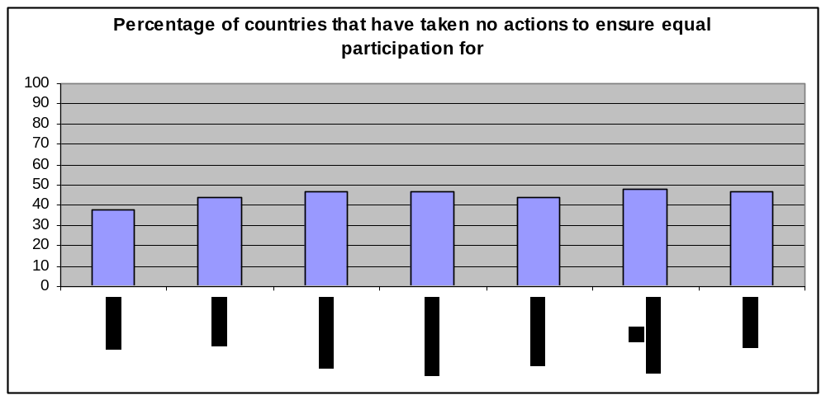
It is clear that women, children and low-income persons with disabilities are still excluded from fully participating in cultural life, and remain unrecognized in the eyes of policy and decision makers.

Rule 11. Recreation and Sport
Sports and recreation are crucial to both physical and psychological well being, and to the growth, fulfilment and socialization of a person. They create opportunities for people to explore their abilities, stretch their potential, test their limits, compete and interact as part of a team and feel pride in themselves and their abilities.

This is equally true for non-disabled persons as for persons with disabilities. Whether amateur or professional, disabled athletes are role models for children—particularly children with disabilities, and highlight the strengths, abilities, aptitudes and potentials of persons with disabilities to society as a whole. In many countries athletes with disabilities are a major source of national pride.

Rule 11 requires governments to take measures to broaden the base of participation in sports and recreation to include persons with disabilities. Countries were required to take 10 measures to ensure implementation of measures translating the spirit of the Rule, as follows.

T1-Rule 11

Actions government has taken to ensure the persons w/ disabilities have the opportunity to equally participate in sports and recreational activities | No | Yes | N/A
Adopting policies | 55 | 58 | 1
Passing legislations | 70 | 43 | 1
Adopting programmes | 44 | 69 | 1
Allocating financial resources | 40 | 73 | 1
Raising social awareness of the rights of persons w/ disabilities | 50 | 63 | 1
Raising awareness among persons w/ disabilities regarding their rights | 52 | 61 | 1
Providing venues for persons w/ disabilities to participate | 46 | 67 | 1
Providing accessible information re sporting and recreational activities | 53 | 60 | 1
Making sports and recreational activities accessible to all disabilities | 56 | 57 | 1
Involving organizations of persons w/ disabilities | 39 | 74 | 1
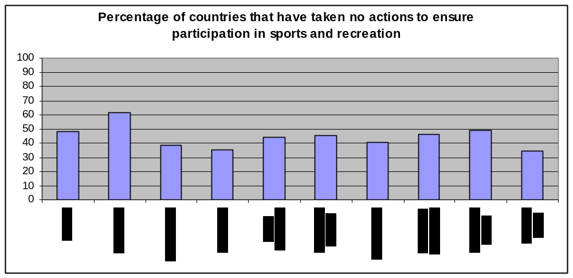

Assessment of the results of government actions as revealed by the Survey, indicated that 1/3 or more of the 114 countries responding have taken no measures necessary to enable persons with disabilities to enjoy the right to sports and recreation.

However, when examining the participation of persons with disabilities in sports and recreational activity whether at the community, national or international levels, we find the number of countries that responded positively regarding that participation exceeds the number of countries that reported having taken no formal measures (adopting policies, passing legislations…) to ensure it, as shown by the table below:

T2-Rule 11

Do persons w/ disabilities participate in sports & recreational activities at the | No | Yes | N/A
Community level | 39 | 74 | 1
National level | 30 | 81 | 3
International level | 34 | 77 | 3
As amateur athletes | 57 | 54 | 3
As professional athletes | 83 | 28 | 3
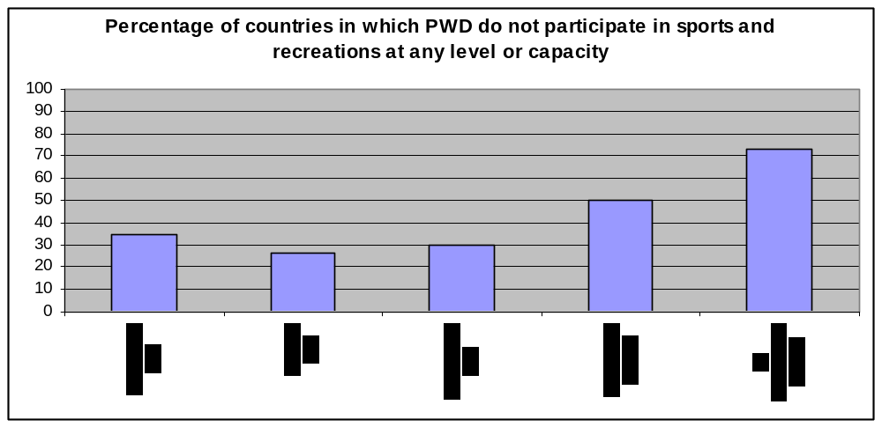
This is indicative of a discrepancy between what governments have actually done (or not done, as is the case) and conditions on the ground independently of government actions. It may be due to personal and community initiatives in training persons with disabilities, planning and holding sports and recreational events that involve them. It is also due to the involvement of the organizations of persons with disabilities in initiating/sustaining these activities—as evident in T1-Rule 11, where 55, 70, 50 countries, respectively, responded that they had taken no action on policies, legislations, and awareness raising, while T2-Rule 11 indicates that in 81 and 77 countries respectively persons with disabilities participate in sports and recreational activities at the community, national and international levels.

This was also the case in Rule 2 on Medical Care, Rule 4 on Support Services, where the reality on the ground was slightly better than what government inaction at the administrative and legislative levels would otherwise have produced.

One must, however, keep in mind that the participation of some is not indicative that this right is available to all. The aim of the Standard Rules in to enable all persons to participate, making it necessary to have policies and legislations that would ensure this right.

As for accessibility of sports and recreation venues, 63 countries responded that they were accessible to persons with disabilities; while 49 answered that they were not.

Rule 12. Religion
Religion represents a particular set of ideas, beliefs, convictions, rituals and behaviours that are shared by a community. The right to religion is a right guaranteed by UN human rights instruments. Governments are required to enable people to freely exercising this right without constraints, obstacles or barriers. This applies equally to non-disabled persons and persons with disabilities. In order to implement this Rule, a set of 10 measures were required, ranging from adoption of policies to involving disabled persons organizations.

Survey results revealed that there are major shortcomings in the implementation of this rule across the board. As T1-Rule 12 reveals, governments that took one or more action(s) do not exceed 40 out of 114, while only 24 countries allocated financial resources to enable persons with disabilities to exercise this right.

What is particularly striking regarding the responses is that it is one of the highest to which no responses were available, perhaps indicating that countries did not know how to respond to the question.

T1-Rule12

Action government has taken to encourage equal participation by persons w/ disabilities in religious life | No | Yes | N/A
Adopting policies | 77 | 34 | 3
Passing legislations | 83 | 27 | 4
Adopting programmes | 83 | 27 | 4
Allocating financial resources | 86 | 24 | 4
Raising social awareness of the rights of persons w/ disabilities | 71 | 39 | 4
Raising awareness among persons w/ disabilities regarding their rights | 78 | 32 | 4
Providing accessible venues for persons w/ disabilities to participate in religious events and services | 78 | 32 | 4
Providing accessible information about religious events & services | 79 | 30 | 5
Making religious events and services accessible to all types of disabilities | 70 | 40 | 4
Involving organizations of persons w/ disabilities | 78 | 33 | 3
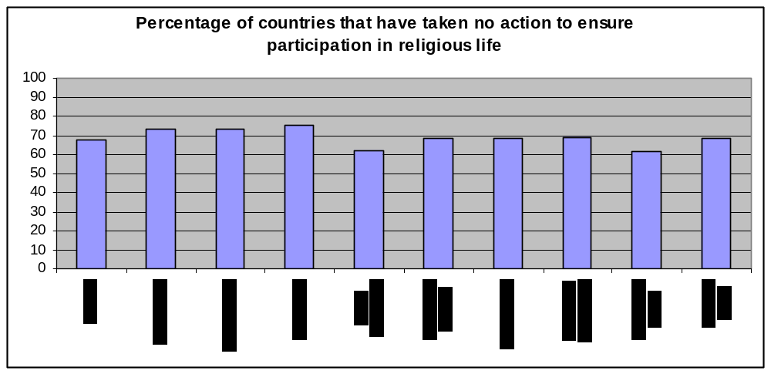
On whether religious events and services are accessible to persons with disabilities, 49 countries indicated that they are not while 63 countries answered that they were.

Rule 13. Information and Research

The availability of information regarding any given issue is an indication of whether and how much this issues is part of the collective consciousness; and whether this issue constitutes a priority for government and society alike. The type of information available is also a function of society’s readiness to address and respond to the issue. It is no coincidence that Rule 13 is the first rule within the Procedures beginning with existence of a definition to the compilation and analysis of data, transforming such data into information for publication and dissemination.

Responses to this question have revealed that there is a direct correlation between the degree of development in a country and the availability of information on disability and in turn the existence of policies and programmes.

This is also borne out by an examination of the United Nations Statistics on Disability—where many developing countries indicated that the percentage of disability in their countries did not exceed 1% or even 0.5%, while industrialized countries put the percentage at the two-digit mark. Information, therefore, is very much a function of the level of awareness.

It is also important to keep in mind that information given by a country about itself should be examined for biases—including the information in this Survey which is highly dependent on government self-reporting.

Rule 13 required governments to take nine (9) measures to ensure the collection and dissemination of information and the promotion of research on issues affecting the lives of persons with disabilities.

T1-Rule 13

Actions government has taken to collect, disseminate information & promote research on disability | No | Yes | N/A
Adopting policies | 65 | 47 | 2
Passing legislations | 81 | 32 | 1
Adopting programmes | 64 | 48 | 2
Allocating financial resources | 64 | 48 | 2
Raising social awareness | 61 | 51 | 2
Collecting statistics | 33 | 79 | 2
Involving disabled persons organizations | 44 | 68 | 2
Disseminating statistical information to all pertinent users | 59 | 52 | 3
Updating statistical information regularly and periodically | 59 | 52 | 3
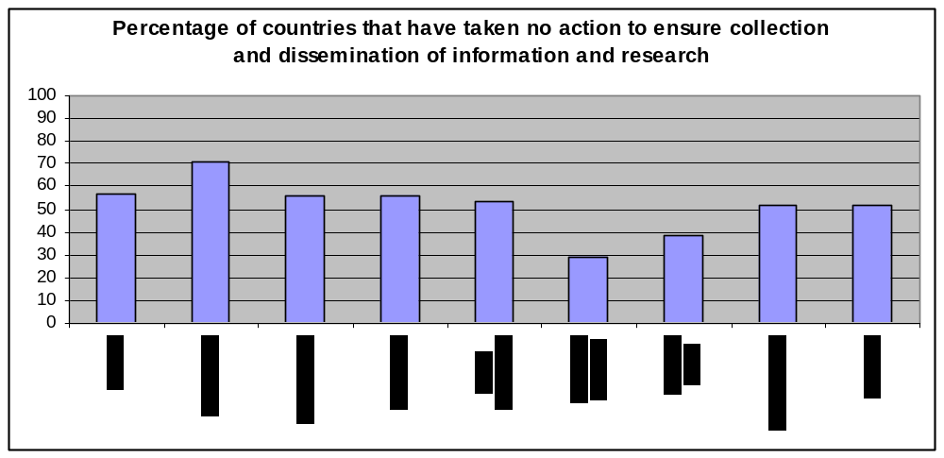
With the exception of involving disabled persons organizations and the collecting of statistics—(an activity that in most countries can be done through national census), less than half the countries reported adopting measures relating to the installation of an information and research system relating to disability. When in fact such a system is a pre-requisite for the compilation of the necessary data and crucial in enabling policy and decision makers adopt and implement the necessary policies and programmes; it is also necessary in developing a clearer understanding of the variables effecting the size, scope, magnitude, availability of services and the effectiveness of the responses to the issues.

In considering the coverage of the information system, the survey revealed that only 84 countries covered types of disabilities, while 66 and 61 countries gathered information pertaining to the situation of students with disabilities and the services and programmes available. T2-Rule13 lists 15 issues countries were asked about:

T2-Rule 13

Does statistical information cover | No | Yes | N/A
Prevalence and incidence of disabilities | 46 | 66 | 2
Types of disabilities | 28 | 84 | 2
Disaggregate data by gender, age, socio-economic background, geographical location | 49 | 63 | 2
Needs of persons w/ disabilities | 58 | 54 | 2
Services and programmes for persons w/ disabilities | 51 | 61 | 2
Availability, coverage and scope of services | 64 | 48 | 2
Living conditions for persons w/ disabilities | 54 | 58 | 2
Educational situation for pupils with disabilities | 46 | 66 | 2
Conditions in the workplace for persons w/ disabilities | 79 | 33 | 2
Employment opportunities for persons w/ disabilities | 67 | 45 | 2
Expenditure entailed by disability | 84 | 27 | 3
The impact of social policies on persons w/ disabilities | 88 | 24 | 2
The type of research available and parties undertaking it | 93 | 19 | 2
Organizations of persons w/ disabilities their programmes, services, coverage and location | 64 | 48 | 2
Local, national, regional and international disability issues | 86 | 26 | 2
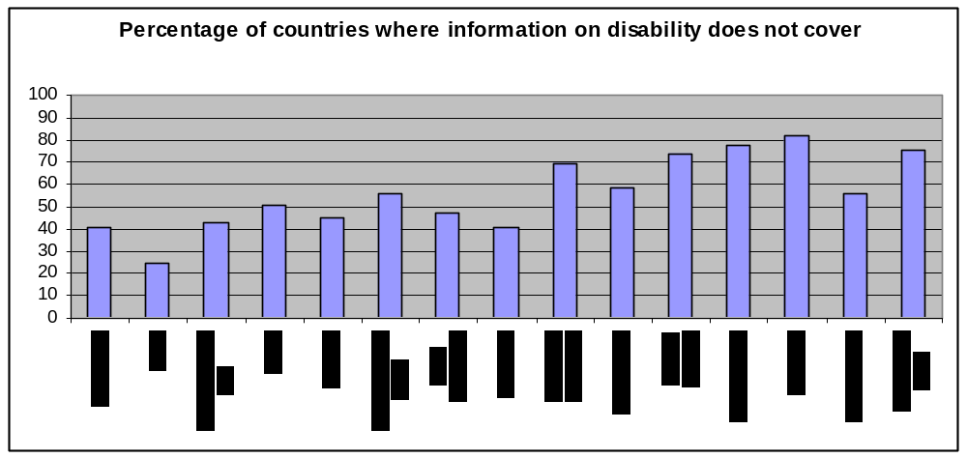

With regard to information about disability, therefore, there is much variation and discrepancy among countries. A large number of countries have some sort of research or information; however, as large a number have no research or any information on specific issues relating to disability.

Therefore, in terms of the comprehensibility of such information, almost all responding countries fall short of the desired actions to enable them to adopt policies appropriate to the needs and provide the services. Without the statistical framework, it is extremely difficult to persuade policy and decision makers of the need to create a comprehensive and integrated response through the adopting policies, passing legislations and implementing programmes that would achieve the equalization of opportunities for persons with disabilities.

Rule 16. Economic Policies
Economic policies are necessary to the implementation of all measures specified in each of 22 Rules of the Standard Rules for the Equalization of Opportunities for Persons with Disabilities. Recognizing the importance of economic policies, “allocation of financial resources” was included in each of the survey questions as a measure inherent in every action to be taken by governments.

Countries were expected to take measures securing national resources in order to implement programmes that would achieve the equalization of opportunities for persons with disabilities.

The survey asked about five (5) such measures that would ensure equal opportunities for the full participation of persons with disabilities in society. The responses revealed that the issues of persons with disabilities are still not a priority on the list of government funding.

T1-Rule16
Economic policies government has undertaken to create equal opportunities for persons w/ disabilities | No | Yes | N/A
Adopting financial policies specific to persons w/ disabilities | 64 | 47 | 3
Passing legislations | 64 | 47 | 3
Providing support to projects and measures relevant to persons w/ disabilities | 39 | 72 | 3
Allocating special disability fund to support grassroots projects and programmes | 58 | 53 | 3
Involving disabled persons organizations in financial planning | 61 | 50 | 3
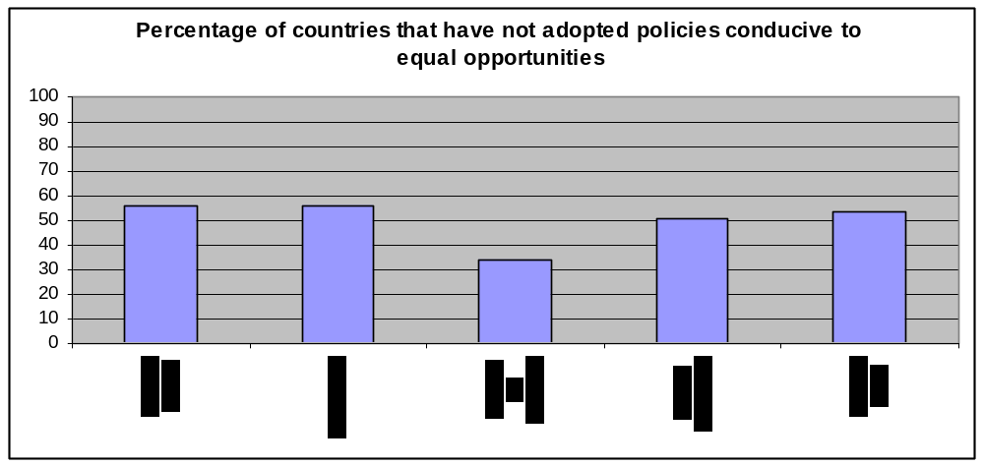
It is evident that disability is not considered a priority by fiscal planners for which resources need to be allocated.

Rule 17. Coordination of Work
In accordance with this rule, countries were expected to establish and strengthen national coordinating committees, or similar bodies, to serve as national focal points on disability matters. In this respect countries were asked whether they had taken five (5) measures considered crucial to the implementation of this Rule.

T1-Rule 17

Actions taken by government to establish & strengthen national coordinating bodies | No | Yes | N/A
Forming permanent coordinating committees | 39 | 72 | 3
Giving national coordinating committees clear legal mandate | 54 | 57 | 3
Allocating resources to support national coordinating committees | 61 | 50 | 3
Involving organizations of persons w/ disabilities in their composition and activities | 34 | 77 | 3
Ensuring balanced representation of all disabilities and both genders in the coordinating committees | 60 | 51 | 3
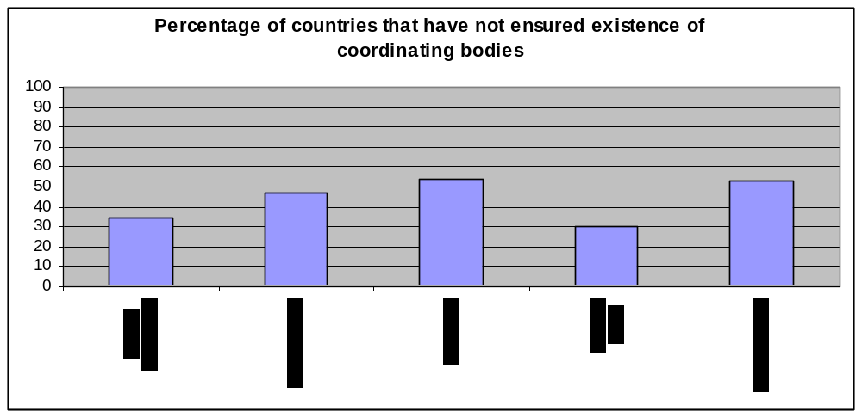
With regard to the nature and representation of these national bodies and coordination committees on disabilities, responses were as follows:

T2-Rule 17

Are there national committees (or similar bodies) on disability with | No | Yes | N/A
Representation by persons w/ disabilities | 31 | 80 | 3
Enjoying legal and political status | 42 | 69 | 3
Balanced representation of types of disability | 53 | 58 | 3
Balanced gender representation | 72 | 39 | 3
Adequate financial resources | 74 | 37 | 3
Percentage of countries that have not ensured that national committees
are representative
0
10
20
30
40
50
60
70
80
90
100
Representation
Legal status
Disability types
Gender
Resources

Regardless of the level of commitment displayed by governments and the effectiveness of their policies, coordination of work is pivotal to the success of any initiative. This is even more relevant to the equalization of opportunities since it involves changes in the culture, attitudes, and legal frameworks. People with disabilities would become part of the system which is working to make changes that would make the environment in all its aspects suitable for all.

Experience has shown that coordinating bodies differ in their roles from country to country. They play an advocacy role on the issues of persons with disabilities, and become the liaison between the disabled persons organizations and the authorities—they monitor conditions, situations, receive complaints, mobilize efforts for change and monitor improvement. They can also play the role of being the gateway between the international treaty bodies and the governments in their country. They have the political, moral and technical authority.

They act on behalf of persons with disabilities to create the conditions conducive to their full participation. Therefore, the involvement of persons with disabilities in these bodies is crucial in an advisory capacity, an advocacy capacity and as the experts on living with disability. They also need to play a role in developing policies and legislations, and be a resource on information on disability at the national, regional and international level where monitoring of the violations of the rights of persons with disabilities takes place.

Even though 72 out of 114 countries have taken action on the formation of coordinating bodies, many of those have not invested these bodies with a clear mandate. Additionally, forming and mandating coordinating bodies is not sufficient to achieve the desired goal in the absence of financial resources and support.

Rule 18. Organizations of Persons with Disabilities
This rule is what fully demonstrates the participatory spirit of the Standard Rules and the philosophy of equalization that permeates them—and which is the overall aim of their full implementation. The participation of persons with disabilities in every aspect of the implementation of the rules, as persons who understand the issues at an intimate and personal level, who are able to identify barriers and obstacles and point out ways by which they can be removed. They can also be closely involved in drafting policies and specifying the measures needed to be taken by governments to make the environment in the broadest sense accessible. It is for this reason that the survey asked about the involvement of disabled persons organizations in relation to every measure in the questionnaire.

The strength and capacities of disabled persons organizations varies from one country and even one region to another. In some they can be the driving force behind change, while in others they have no power. More than half the countries responding said they do not have such organizations. Observation has shown that even where available, they may not have a either a role or the means to effect change and influence policy.

States are expected to recognize the right of persons with disabilities to be represented at all levels in all issues concerning their rights and needs by organizations playing an advisory role.

With regard to the measures expected in fulfilment of their obligation to encourage the formation of organizations of persons with disabilities and ensure their full participation, countries responded as follows:

T1-Rule 18

Actions taken by government to ensure & encourage formation & participation of organizations to represent persons w/ disabilities at national regional and local levels | No | Yes | N/A
Adopting policies | 58 | 53 | 3
Passing legislations | 59 | 52 | 3
Setting up programmes to strengthen and support organizations | 58 | 53 | 3
Setting administrative guidelines | 70 | 41 | 3
Allocating financial resources | 47 | 64 | 3
Empowering organizations with advisory capacity | 60 | 51 | 3
Cooperating with organizations on all matters concerning persons w/ disabilities | 40 | 71 | 3
Granting organizations legal and representational status | 47 | 64 | 3
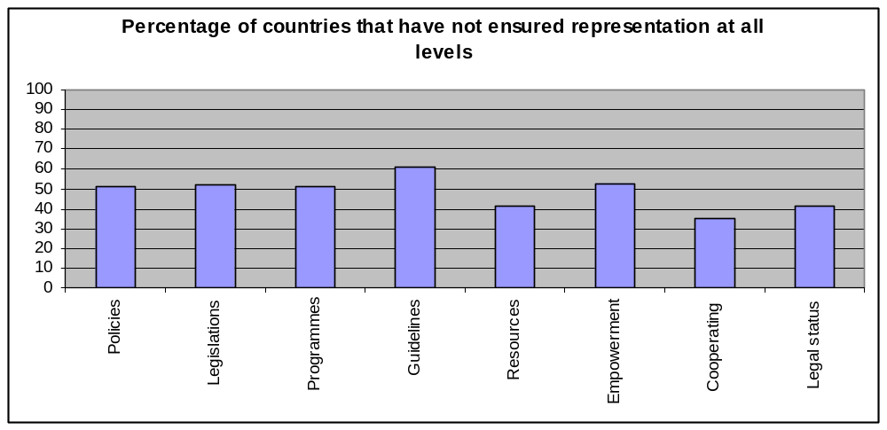
However, even though the numbers indicate that government do not provide support, there is an independent NGO movement in most countries that is involved in the issues of persons with disabilities. With regard to the role of the organizations of persons with disabilities:

T2-Rule 18
What role do organizations of persons w/ disabilities play with regard to | No | Yes | N/A
Advising on general policy and specific measures | 33 | 78 | 3
Identifying needs and priorities | 23 | 88 | 3
Participating in the planning of measures | 39 | 72 | 3
Participating in the implementation of measures | 42 | 69 | 3
Participating in monitoring and evaluation | 50 | 61 | 3
Contributing actively towards increasing public awareness | 22 | 89 | 3
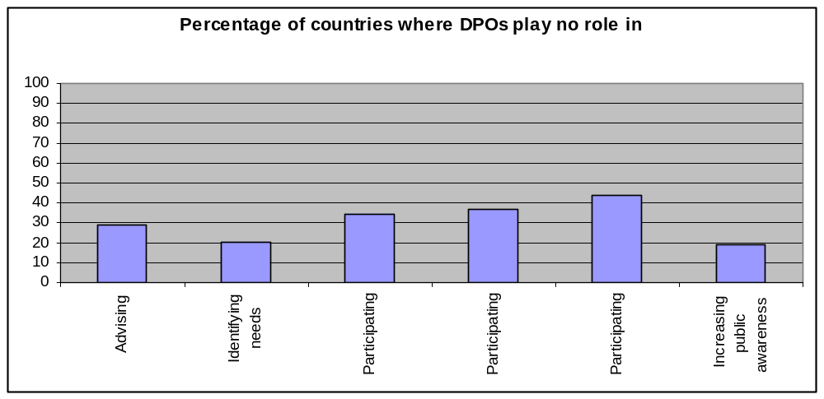

The responses indicate that while in two-thirds (2/3) of the countries that responded, disabled persons organizations participate in the planning and implementation of measures to improve the quality of life for persons with disabilities, their roles have not been fully defined and realized in a large number of countries. Therefore, there is a need to encourage the establishment of partnerships and cooperative relationships between the government and the organizations representing persons with disabilities.

Rule 19. Personnel Training
When it comes to the implementing the Standard Rules on the Equalization of Opportunities for Persons with Disabilities trained personnel are change agents, their role exceeds the technical know-how to a more comprehensive role of managing change. In the many required target areas, effecting change rests upon the existence of well trained, qualified personnel who are able to understand the needs of persons with disabilities and fulfill them, and who are able to recognize that the ultimate goal in fulfilling those needs is the full participation of persons with disabilities in all aspects of life. Therefore, the training of personnel is one of the important aspects of the life of persons with disabilities dealt with in rule 19.

Actions expected from governments and leading to this objective ranged from the adoption of policies to the involvement of organizations of persons with disabilities.
The responses to this question revealed that more than half the countries responding to the survey have not taken any measures relating to this area.

T1-Rule 19

Actions taken by government to ensure adequate training of personnel at all levels of the planning and provision of programmes and services | No | Yes | N/A
Adopting policies | 64 | 47 | 3
Passing legislations | 84 | 27 | 3
Adopting training programmes | 47 | 64 | 3
Setting professional standards | 67 | 44 | 3
Allocating financial resources to training programmes | 56 | 55 | 3
Building the capacities of personnel | 60 | 51 | 3
Involving organizations of persons w/ disabilities | 58 | 53 | 3
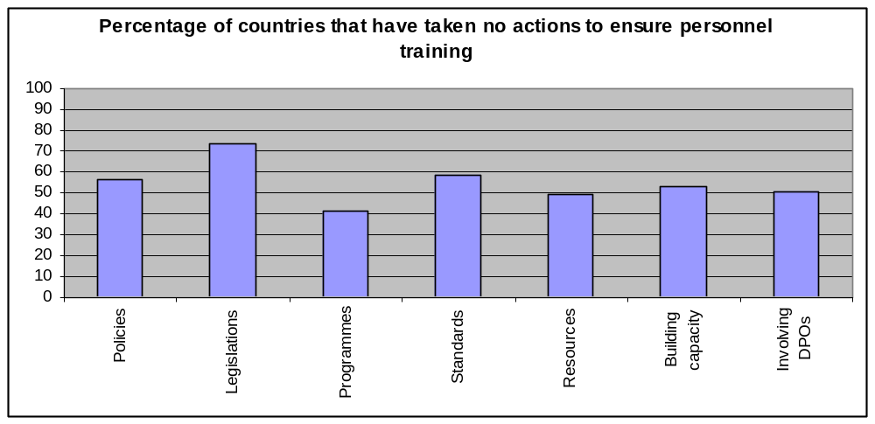

In terms of the training of personnel to work with persons with disabilities, 83 of the 114 countries said that they provided training, while 57 responded that they involved the organizations of persons with disabilities in designing and planning training programmes for such personnel. In 62 countries, persons with disabilities themselves were used resource persons in acquiring information about the needs of disabled persons in this respect.

T2-Rule 19

In your country | No | Yes | N/A
Do personnel working with persons w/ disabilities receive training | 27 | 83 | 4
Are organizations of persons w/ disabilities involved in planning training programmes | 53 | 57 | 4
Are PWD involved as resource persons in training of persons w/ disabilities | 48 | 62 | 4

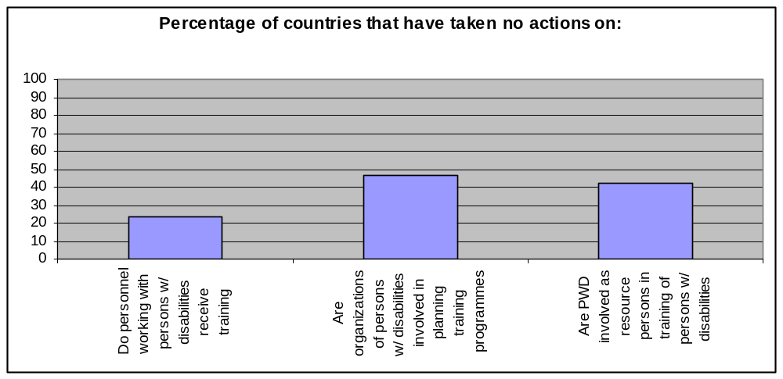

Rule 20. Monitoring

In any given country, the existence of monitoring bodies and mechanisms is the ultimate expression of the country’s commitment to the concept of equalization. Establishing such bodies and mechanisms reflects the level of awareness of the measures needed to be taken and the end to which they are put, and the willingness to assess their success in arriving at their goals.

This is the basic principle inherent in the Standard Rules for the Equalization of Opportunities for Persons with Disabilities. This Survey is in itself a manifestation to the implementation of this rule. Monitoring is one way of re-energizing the vision and detecting the lacks and needs, and assuring that programmes stay their course, as well as ensuring their cost effectiveness and the quality of service delivery scheme.

Monitoring bodies and mechanisms inform stakeholders of the coherence of the policies, and the ability of the measures to achieve the national goals. This can be spelled out through full and accurate knowledge of precisely who service recipients are, how many, where they are, what their needs are? Which would inform the assessment and guide the revision of programmes, services and financial allocations.

In this sense, monitoring, both self-assessment by governments and monitoring through independent bodies becomes, not a punitive and blame-laying exercise, but a means of understanding how to reach the desired goal of equalization of opportunities most effectively.

Basic to all of the above is knowing who the people are for whom the service should be delivered. The responses below (T1-Rule 20) reveal that 50% of the respondents have not established a clear and workable definition of disability, which would constitute the basic component for developing policies on services and expenditure.

One of the main challenges for the disability movement worldwide is the absence of a universal definition. Although the World Health Organization (WHO) has developed an International Classification of Functioning (ICF), few countries seem to have formally adopted it.

T1-Rule 20

Actions taken to ensure monitoring & evaluation of implementation of national programmes and services concerning the equalization of opportunities for persons w/ disabilities | No | Yes | N/A
Establishing a formal definition of disability | 54 | 55 | 5
Creating a specialized monitoring body | 67 | 43 | 4
Collecting census data | 54 | 56 | 4
Conducting a sample Survey | 63 | 46 | 4
Using records from service providers ( ministries, hospitals, educational institutions) | 83 | 27 | 4
Using information gathered by organizations of people w/ disabilities | 54 | 56 | 4
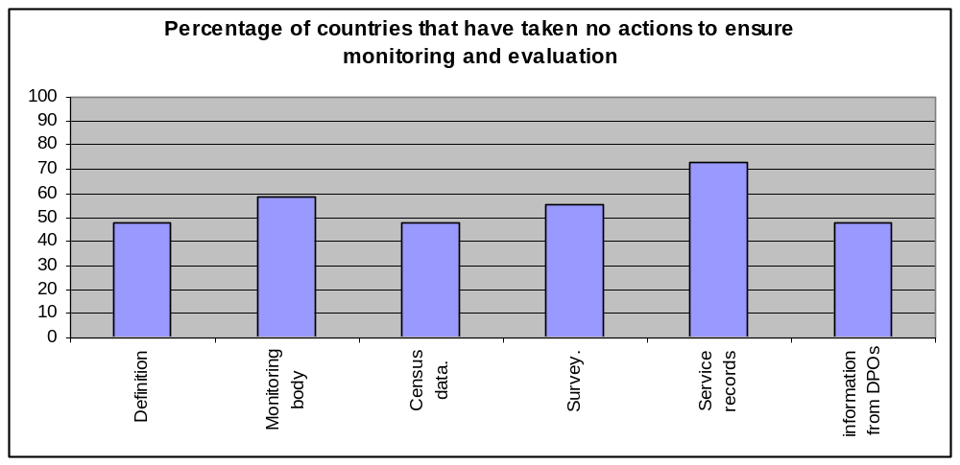

T2-Rule 20

Do monitoring and evaluation cover | No | Yes | N/A
Size, scope and prevalence of disability | 59 | 51 | 4
Types of disability | 48 | 62 | 4
Age distribution | 54 | 56 | 4
Gender distribution | 58 | 52 | 4
Geographic distribution | 59 | 51 | 4
Organizations of persons w/ disability | 66 | 43 | 5
Programmes for persons w/ disability | 65 | 44 | 5
Service provision organizations | 73 | 38 | 3
Service provision personnel | 82 | 29 | 3
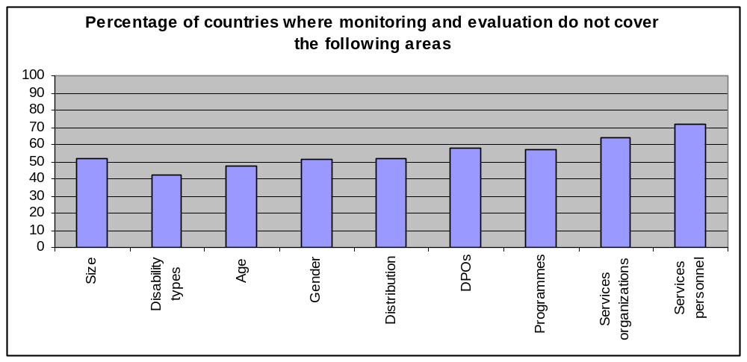
This would explain why in many countries (59 out of 114), monitoring activities do not include a firm knowledge of the size, scope, prevalence of disability and little knowledge of the programmes being delivered to persons with disabilities.

It goes without saying that when it is not known who is meant to receive services, it cannot be clear whether these services are reaching their intended targets. Additionally, this would make it difficult to construct the appropriate policies and to legislate them.

Is information from monitoring and evaluation used in | No | Yes | N/A
Policy making | 48 | 64 | 2
Adaptation and improvement of services | 53 | 58 | 3
Revision and restructuring of programmes | 55 | 56 | 3
Public dissemination | 71 | 41 | 3
Awareness raising programmes | 57 | 54 | 3
Annual and periodic national development reports | 56 | 55 | 3
Research | 69 | 42 | 3
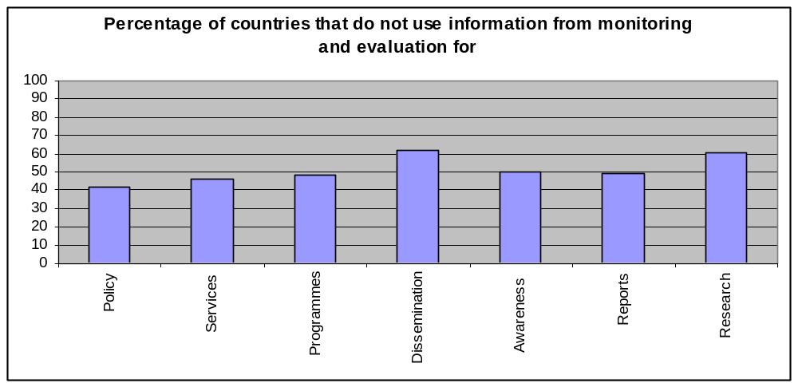

Rule 21. Technical & Economic Cooperation

All United Nations initiatives, treaties, conventions, are aimed at establishing a universal, shared culture in which the rights of all persons are promoted and the most vulnerable are protected from violations. The signing of such agreements indicates a belief on the part of Member States in the importance of creating such a culture. However, implementing the requirements for compliance with these agreements is an indication of international responsibility that goes beyond verbal commitment to action on the ground.

International cooperation, both at the technical and economic level, is exemplified by giving and receiving assistance, sharing and exchanging expertise and disseminating best practices.

The means to create a world in which all people enjoy the right to live in dignity are available. Through the implementation of the measures identified by the Standard Rules for the Equalization of Opportunities for Persons with Disabilities, the opportunity to create a world free of barriers and obstacles is possible. Country responses show, however, that not many have taken advantage of opportunity presented.

Measures taken to ensure the improvement of living conditions of persons with disabilities | No | Yes | N/A
Signing relevant international treaties and conventions | 33 | 79 | 2
Being party to bi-lateral aid agreements | 53 | 59 | 2
Providing or receiving financial aid | 42 | 70 | 2
Providing or receiving technical assistance | 45 | 67 | 2
Exchanging information, experience, expertise, best practices | 40 | 72 | 2
Disseminating or receiving technological cooperation project | 52 | 60 | 2
Participating in international development cooperation project | 47 | 65 | 2
Taking part in regional activities ( decades, declarations … etc) | 37 | 75 | 2
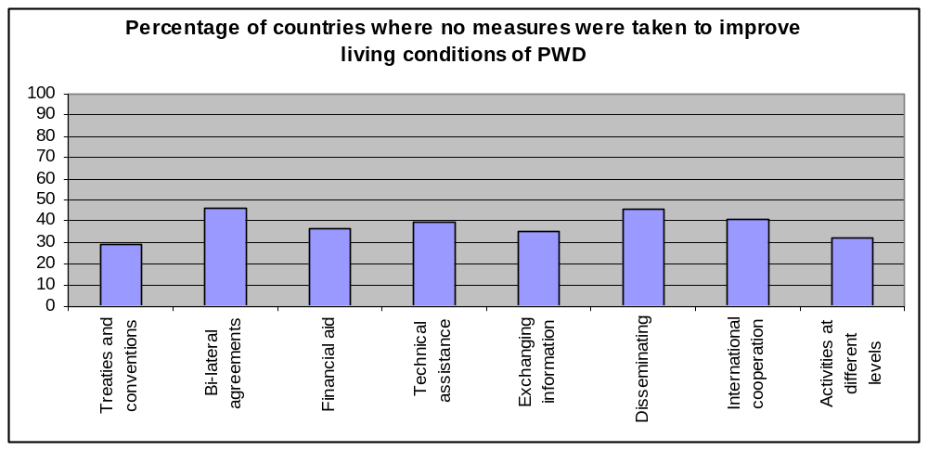

The nature of international cooperation is that it takes place at the macro level, and the presence of technical cooperation in a country does not reveal the magnitude or scope of that cooperation, or to what degree it actually affects persons with disabilities and their organizations. The fact that countries responded positively to many of these measures, does not indicate whether these have impacted change on the ground.

The findings of the survey reveal that bi-lateral cooperation does not often cut across cultural and geographical boundaries to create a global environment where equalization of opportunities for persons with disabilities is the ultimate goal. There is a need for governments and disabled persons organizations to recognize that right to equalization of opportunities needs to extend to all persons with disabilities regardless of national identity and political status.

Measures taken to improve the life conditions of immigrants and refugees with disabilities | No | Yes | N/A
Including them in policy plans and programmes | 73 | 38 | 3
Tailoring programmes specific to their needs | 87 | 24 | 3
Supporting their families | 82 | 29 | 3
Ensuring their access to services | 82 | 29 | 3
Ensuring disabled persons organizations represent their interests | 64 | 47 | 3
Ensuring access to education | 64 | 47 | 3
Ensuring gainful employment | 84 | 27 | 3
Ensuring access to adequate housing | 80 | 31 | 3
Protecting vulnerable segments such as women, children | 78 | 33 | 3
Allocating resources | 84 | 27 | 3
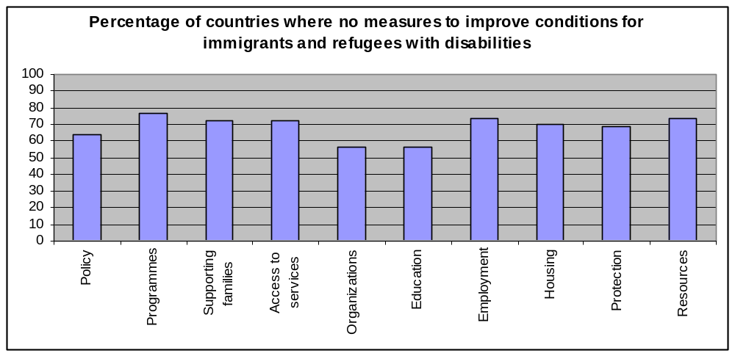

International cooperation and responsibility is a way of upholding the concept of universality upon which all human rights treaties rest. Attention to migrant populations is a real test to the ability of the international community to live up to the commitment they made in becoming party to these agreements.

However, the results have indicated less than satisfactory numbers in this respect where no more that 38 countries out of 114 have included these populations in their programmes and their policies.

End Note

This report constitutes the central activity of the Special Rapporteur on Disabilities in monitoring the state of the world in relation to the implementation of the Standard Rules on the Equalization of Opportunities for Persons with Disabilities. It is by no means the definitive word on the situation of persons with disabilities in the world, however. It has raised as many questions as it has answered. To date it remains the most comprehensive survey on the Standard Rules that has been produced. It has also opened the door to further investigation based on the information gathered here.

Based on the analysis of information collected from 114 countries regarding the existence of policies, legislations, programmes, their reach and coverage, awareness raising and the involvement of disabled persons organizations, it is evident that the implementation of the Standard Rules is far from comprehensive. On all the rules, less than 80% of the countries that responded reported having taken one or more measures in implementing the Standard Rules. However, this still leaves 20% of the countries that have implemented no measures. Additionally, there are still 77 countries about which there is no information, despite repeated requests for responses.

The next step in the monitoring work of the Special Rapporteur is to seek out the 77 countries and attempt to obtain the information needed in order to complete the global picture that the survey is intended to portray. Furthermore, there is also a need to investigate the gaps that have presented themselves in implementation that appeared in many of the countries.

The findings of this survey as they stand now, however, can prove to be a powerful tool to be used by disabled persons organizations, disability activists and human rights advocates in awareness raising campaigns and advocacy work.

Generally speaking, work needs to be done on strengthening awareness raising campaigns and including the media as the conduit for a more positive image of persons with disabilities in society. Sensitizing the media to the issues and rights of persons with disabilities is the first step in beginning to change attitudes and negative stereotypes about disabled persons.

In most countries, there is an urgent need to give a stronger voice and firmer presence to the organizations of persons with disabilities and to ensure that these organizations are represented by the persons with disabilities themselves—governments need to recognize that the true experts are people living and dealing with disabilities on a daily basis. Along with the organizations, it is also imperative to involve the families—particularly in dealing with children with disabilities. Parents form another layer of knowledge, experience and expertise that could prove useful to governments in meeting the needs. In order to do this, there must be recognition that disabled persons organizations in many parts of the world lack the resources necessary for their work. Disabled persons organizations from some African and Latin American countries, lacked the meagre funds needed to mail the questionnaire back to the Office of the Special Rapporteur. This should be an unacceptable state of affairs for any government.

Disabled persons organizations along with the Special Rapporteur on Disability need to work together to promote the importance and utility of the Standard Rules and the actions and measures specified as guiding tools on what needs to be done to achieve the equalizations of opportunities. And the concept of equalization of opportunities should be disseminated worldwide in such a way that societies understand that it represents a right and not a privilege for persons with disabilities.

It is important to note that in a few cases persons with disabilities fared better in reality than was reported by the survey. For example, in countries where no policies, legislations or programmes existed with regard to Medical Care, Support Services and Rehabilitation, persons with disabilities still received those services at a higher rate than was expected. This is an issue that governments need to take note of and establish a more cooperative and supportive relationship with those service providers to ensure more efficient and effective service delivery.

In countries where there exists an adversarial relationship between the governments and disabled persons organizations, measures should be taken to give organizations the space, status, and resources they need as well as the value they deserve for their expertise.

At the regional and international levels, the importance of cooperation and collaboration, exchange and sharing cannot be overstressed. It is imperative the world, collectively, starts to put more efforts into strengthening and deepening the culture of equalization of opportunities, and creating a world free of all obstacles and barriers to participation.

As Special Rapporteur on Disabilities, I believe that the Standard Rules on the Equalization of Opportunities for Persons with Disabilities is a unique document that can be used as a base for equalization across board and a blue print for participation for all marginalized groups in all societies.

Hissa Al Thani
UN Special Rapporteur on Disabilities

Responses received from governments and disabled persons organizations by country

Response from government & two Disabled persons organizations | Response from government and one Disabled persons organization | Response from two Disabled persons organizations | Response from government only | Response from one Disabled persons organization only
- Argentina | - Algeria | - Burundi | - Armenia | - Albania
- Azerbaijan | - Austria | - Cambodia | - Bahrain | - Australia
- Colombia | - Belize | - Chile | - Brazil | - Bangladesh
- Gambia | - Botswana | - Costa Rica | - Brunei Darussalam | - Belgium
- Guinea | - El Salvador | - Fiji | - Comoros | - Bosnia & Herzegovina
- México | - Eritrea | - Honduras | - Croatia | - Bulgaria
- Peru | - Finland | - Iraq | - Cyprus | - Cameroon
- Philippines | - Guyana | - Lebanon | - Czech republic | - Cape Verde
- Qatar | - Italy | - Serbia and  Montenegro | - Denmark | - Ethiopia
- Sudan | - Jordan | - Serbia and  Montenegro | - Dominica | - Ghana
- Macedonia | - Malta | - Zimbabwe | - Ecuador | - Guatemala
- Tunisia | - Mongolia |  | - Egypt | - India
- UAE | - Morocco |  | - Haiti | - Kenya
- UAE | - Morocco |  | - Hungary | - Malawi
 | - Namibia |  | - Iran | - Myanmar
 | - Nepal |  | - Kuwait | - Nigeria
 | - Netherlands |  | - Libya | - Papua New Guinea
 | - Norway |  | - Libya | - Papua New Guinea
 | - Portugal |  | - Luxembourg | - Paraguay
 | - Portugal |  | - Marshall islands | - Rwanda
 | - republic of Korea |  | - Marshall islands | - Rwanda
 | - republic of Korea |  | - New Zealand | - Saint Vincent & the Grenadines
 | - Russian Federation |  | - New Zealand | - Saint Vincent & the Grenadines
 | - Samoa |  | - New Zealand | - Saint Vincent & the Grenadines
 | - Samoa |  | - Oman | - Sierra Leon
 | - Slovakia |  | - Romania | - Syria
 | - Slovakia |  | - Saudi Arabia | - Thailand
 | - Sweden |  | - South Africa | - Uganda
 | - Tanzania |  | - Spain | - Uruguay
 | - Yemen |  | - Swaziland | - Zambia
 | - Palestine |  | - Switzerland | - Hong Kong
 | - Palestine |  | - Trinidad & Tobago
 | - Palestine |  | - Turkey
 | - Palestine |  | - UK

country | Gov’t + 2 DPOs | Gov+1DPo | DPO1+2 | Gov only | 1 DPO
Afghanistan
Albania |  |  |  |  | X
Algeria |  | X
Andorra
Angola
Antigua & Barbuda
Argentina | X
Armenia |  |  |  | X
Australia |  |  |  |  | X
Austria |  | X
Azerbaijan | X
Bahamas
Bahrain |  |  |  | X
Bangladesh |  |  |  |  | X
Barbados
Belarus
Belgium |  |  |  |  | X
Belize |  | X
Benin
Bhutan
Bolivia |  |  |  |  | X
Bosnia-Herzegovina |  |  |  |  | X
Botswana |  | X
Brazil |  |  |  | X
Brunei Darussalam |  |  |  | X
Bulgaria |  |  |  |  | X
Burkina Faso
Burundi |  |  | X
Cambodia |  |  | X
Cameroon |  |  |  |  | X
Canada
Cape Verde |  |  |  |  | X
Central African Republic
Chad
Chile |  |  | X
China |  |  |  |  | X
Colombia | X
Comoros |  |  |  | X
Congo
Costa Rica |  |  | X
Côte
Croatia |  |  |  | X
Cuba
Cyprus |  |  |  | X
Czech Republic |  |  |  | X
Korea
Congo Zaire |  | X
Denmark |  |  |  | X
Djibouti
Dominica |  |  |  | X
Dominican Republic |  |  | X
Ecuador |  |  |  | X
Egypt |  |  |  | X
El Salvador |  | X
Equatorial Guinea
Eritrea |  | X
Estonia
Ethiopia |  |  |  |  | X
Fiji |  |  | X
Finland |  | X
France
Gabon
Gambia | X
Georgia | X
Germany
Ghana |  |  |  |  | X
Greece
Grenada
Guatemala |  |  |  |  | X
Guinea | X
Guinea-Bissau
Guyana |  | X
Haiti |  |  |  | X
Honduras |  |  | X
Hungary |  |  |  | X
Iceland
India |  |  |  |  | X
Indonesia
Iran |  |  |  | X
Iraq |  |  | X
Ireland |  | X
Israel
Italy |  | X
Jamaica
Japan
Jordan |  | X
Kazakhstan
Kenya |  |  |  |  | X
Kiribati
Kuwait |  |  |  | X
Kyrgyzstan
Laos
Latvia
Lebanon |  |  | X
Lesotho
Liberia
Libya |  |  |  | X
Liechtenstein
Lithuania
Luxembourg |  |  |  | X
Madagascar
Malawi |  |  |  |  | X
Malaysia
Maldives
Mali
Malta |  | X
Marshall Islands |  |  |  | X
Mauritania
Mauritius |  |  | X
Mexico | X
Micronesia
Monaco
Mongolia |  | X
Morocco |  | X
Mozambique
Myanmar |  |  |  |  | X
Namibia |  | X
Nauru
Nepal |  | X
Netherlands |  | X
New Zealand |  |  |  | X
Nicaragua
Niger
Nigeria |  |  |  |  | X
Norway |  | X
Oman |  |  |  | X
Pakistan
Palau
Panama
Papua New Guinea |  |  |  |  | X
Paraguay |  |  |  |  | X
Peru
Philippines | X
Poland | X
Portugal |  | X
Qatar | X
Republic of Korea |  | X
Republic of Moldova
Romania |  |  |  | X
Russian Federation |  | X
Rwanda |  |  |  |  | X
Saint Kitts and Nevis
Saint Lucia
Saint Vincent Grenadines |  |  |  |  | X
Samoa |  | X
San Marino
Sao Tome & Principe
Saudi Arabia |  |  |  | X
Senegal
Serbia & Montenegro |  |  | X
Seychelles
Sierra Leone |  |  |  |  | X
Singapore
Slovakia |  | X
Slovenia
Solomon Islands
Somalia
South Africa |  |  |  | X
Spain |  |  |  | X
Sri Lanka
Sudan | X
Suriname
Swaziland |  |  |  | X
Sweden |  | X
Switzerland |  |  |  | X
Syria |  |  |  |  | X
Tajikistan
Thailand |  |  |  |  | X
Macedonia | X
Timor-L’este
Togo
Tonga
Trinidad & Tobago |  |  |  | X
Tunisia | X
Turkey |  |  |  | X
Turkmenistan
Tuvalu
Uganda |  |  |  |  | X
Ukraine
United Arab Emirates | X
UK , Northern Ireland |  |  |  | X
Tanzania |  | X
United States
Uruguay |  |  |  |  | X
Uzbekistan
Vanuatu
Venezuela
Viet Nam
Yemen |  | X
Zambia |  |  |  |  | X
Zimbabwe |  |  | X
Palestine |  | X
Hong Kong |  |  |  |  | X

APPENDIX I

Government Actions on Equalization of Opportunities
for
People with Disabilities

A Global Survey

Office of the Special Rapporteur on Disability
September 2004

Rule 1
Awareness-raising
“States should take action to raise awareness in society about persons with disabilities, their rights, their needs and their potential and their contribution.”

Q 1. What action was taken by your government to raise awareness about the rights, needs, potential and contributions of persons with disability?

( ) Adopting policies
( ) Passing legislation (Please, attach copy)
( ) Adopting programmes
( ) Drafting guidelines to be used by the media
( ) Training personnel
( ) Disseminating materials in the form of brochures, bulletins, posters...etc.
( ) Introducing awareness raising into the school curriculum
( ) Educating the public
( ) Consulting and cooperating with organizations of persons with disabilities
( ) Other (specify) ______________________________________________

Please briefly describe the nature of actions taken: _______________

________________________________________________________

________________________________________________________
( ) None

Q 2. Does information used in awareness-raising about persons with disabilities cover:

( ) All types of disabilities (including psycho-social & developmental disabilities)
( ) The rights of people with disabilities (including civic, social & political, & the right to development)
( ) The needs of people of with disabilities (services, full participation, enjoyment of all aspects of life, accessibility…etc.)
( ) The potential of people with disabilities (abilities, capabilities, talents)
( ) The contributions of people with disabilities (social, cultural, scientific, economic…etc.)
( ) Descriptions of persons with disabilities in positive terms (diversity, dignity, rights, equality…etc)
( ) Other (specify) _____________________________________________
( ) None

Rule 2
Medical care

“States should ensure the provision of effective medical care to persons with disabilities.”

Q 3. What actions has your government taken to ensure the provision of effective medical care for persons with disabilities?

( ) Adopting policies
( ) Passing legislation (Please, attach copy)
( ) Adopting programmes
( ) Allocating financial resources
( ) Training personnel
( ) Making medical care accessible to persons with disabilities
( ) Consulting with organizations of persons with disabilities
( ) Informing persons with disabilities about the availability of medical services
( ) Other (specify) ___________________________________________________

Please describe programmes: _______________________________________

_______________________________________________________________

______________________________________________________________

( ) None

Q 4. Has your government taken any action to:

( ) Raise awareness on the causes of disability (inter-familial marriages, hereditary factors, war, drugs, HIV/AIDS, road accidents…etc.)
( ) Improve maternal/pre-natal & post-natal health care
( ) Detect impairment at an early age
( ) Treat impairment at an early stage
( ) Train personnel in detecting & treating impairment at an early stage
( ) Update medical personnel’s knowledge in methods and technologies
( ) Ensure access to treatment and medicine for persons with disabilities (including financial accessibility for all types of disabilities)
( ) Other (specify) ___________________________________________________
( ) None

Rule 3
Rehabilitation
“States should ensure the provision of rehabilitation services to persons with disabilities in order for them to reach and sustain their optimum level of independence and functioning”.

Q 5. What action has your government taken to provide rehabilitation services for persons with disabilities?

( ) Adopting policies
( ) Passing legislation (Please, attach copy)
( ) Adopting programmes
( ) Allocating financial resources
( ) Training personnel
( ) Making rehabilitation services accessible to persons with disabilities
( ) Consulting and cooperating with organizations of persons with disabilities
( ) Other (specify) ____________________________________________________

Please describe programmes: ________________________________________

________________________________________________________________

________________________________________________________________
( ) None

Q 6. In your country, are rehabilitation services inclusive of:

( ) All types of disabilities (including psycho-social & developmental disabilities)
( ) Children with disabilities
( ) Women with disabilities
( ) Low-income, working class and poor persons with disabilities
( ) All geographical locations, (rural, urban, agricultural, tribal…etc.)
( ) All socio-economic classes and ethnic groups
( ) The organizations of persons with disabilities
( ) The families of people with disabilities
( ) The communities in which people with disabilities live
( ) The specific/diverse needs of persons with disabilities
( ) Other ____________________________________________________

Please describe _____________________________________________

__________________________________________________________
( ) None

Q 7. In your country, does the planning, design, implementation and evaluation of rehabilitation programmes involve:

( ) Medical personnel
( ) Families of persons with disabilities
( ) Schools, educational institutions and teaching staff
( ) Communities of persons with disabilities
( ) Organizations of persons with disabilities
( ) Describe the nature and activities of rehabilitation programmes, including rate of coverage and percentage ____________________________________________

________________________________________________________________

________________________________________________________________

( ) Other (specify) ____________________________________________________
( ) None

Rule 4
Support services
“States should ensure the development and supply of support services, including assistive devices for persons with disabilities, to assist them to increase their level of independence in their daily living and to exercise their rights.”

Q 8. What action has your government taken to develop and supply assistive devices for persons with disabilities?

( ) Adopting policies
( ) Passing legislation (Please, attach copy)
( ) Instituting programmes
( ) Allocating financial resources
( ) Supplying individuals with assistive devices
( ) Consulting with and involving organizations of persons with disabilities
( ) Other (specify) ___________________________________________________

Please, describe programmes _________________________________________

__________________________________________________________________

__________________________________________________________________
( ) None

Q 9. In your country, does the government provide the support which persons with disabilities need with regard to assistive technology, personal assistance, interpreter services…etc., to:

( ) Children with disabilities
( ) Women with disabilities
( ) Low-income, working class and poor persons with disabilities
( ) Persons with disabilities in all geographical locations, (rural, urban, agricultural, tribal, migrant, refugee, illegal aliens…etc.)
( ) All socio-economic classes
( ) All ethnic groups
( ) All religious groups
( ) All types of disabilities
( ) Other (specify)____________________________________________________
( ) None

Rule 5
Accessibility
“States should recognise the overall importance of accessibility in the process of the equalisation of opportunities in all spheres of society.
For persons with disabilities of any kind, States should
(a) introduce programmes of action to make the physical environment accessible; and
(b) undertake measures to provide access to information and communication.”

Q 10. What actions has your government taken to make the physical environment accessible to all persons with disabilities?

( ) Adopting policies
( ) Passing legislation (Please, attach copy)
( ) Introducing programmes
( ) Allocating financial resources
( ) Training architects and construction engineers
( ) Raising public awareness
( ) Implementing accessibility programmes
( ) Consulting organizations of persons with disabilities
( ) Other (specify) _____________________________________________________

Please describe programmes ____________________________________

___________________________________________________________

___________________________________________________________
( ) None

Q 11. In your country, do legislations and regulations provide codes and standards of accessibility for:

( ) Schools, hospitals, clinics, community centers, public libraries, theatres, rehabilitation centers
( ) Public buildings and government agencies & offices
( ) Outdoor environment (sidewalks, pedestrian crossings, parking spaces…etc)
( ) Land, sea and air transportation
( ) Housing
( ) Other (specify) ____________________________________________________
( ) None

Q 12. Does government provide information regarding accessibility to:

( ) Persons with disabilities only
( ) Families of persons with disabilities
( ) Representatives of persons with disabilities and their organizations
( ) Society as a whole
( ) Other (specify) _____________________________________________________
( ) None

Q 13. What actions has your government taken to ensure accessibility of information to persons with disabilities?

( ) Adopting policies
( ) Passing legislation (Please, attach copy)
( ) Introducing programmes
( ) Allocating financial resources
( ) Training interpreters for all disability needs
( ) Raising public awareness
( ) Implementing accessibility programmes
( ) Consulting organizations of persons with disabilities
( ) Other (specify) _________________________________________________

Please describe programmes _______________________________________

_______________________________________________________________

_______________________________________________________________
( ) None

Q 14. In your country, is information accessible to:

( ) Blind persons or visually impaired
( ) Deaf/blind people
( ) Deaf or hearing-impaired
( ) People with developmental disabilities
( ) People with psycho-social disabilities
( ) Other (specify) _________________________________________________
( ) None

Q 15. In your country, are any of the following services available to persons with disabilities:

( ) Literature in Braille
( ) Literature on tape
( ) News magazines on tape/in Braille
( ) Sign language interpretation
( ) Easy reader for persons with mental disabilities
( ) Other ___________________________________________________
( ) None

Q 16. What measures does your government take to monitor the accessibility of the environment and of information for persons with disabilities?

( ) Ombudsman
( ) Governmental bodies set up for the purpose
( ) Independent expert bodies
( ) Special arbitration/conciliation bodies
( ) Others ___________________________________________________

Please describe the measures __________________________________

__________________________________________________________

___________________________________________________________
( ) None

Rule 6
Education
“States should recognize the principle of equal primary, secondary and tertiary educational opportunities for children, youth and adults with disabilities, in integrated settings. They should ensure that the education of persons with disabilities is an integral part of the educational system.”

Q 17. What actions has your government taken to ensure the education of persons with disabilities in integrated settings?

( ) Adopting policies
( ) Passing legislation (Please attach copy)
( ) Adopting programmes
( ) Allocating financial resources
( ) Modifying and adapting schools to the needs of children with disabilities
( ) Training teachers & school administrators
( ) Providing accessible schools, classrooms & educational materials
( ) Involving organizations of persons with disabilities in planning & implementing
( ) Other (specify) ___________________________________________________

Please describe programmes __________________________________________

________________________________________________________________

________________________________________________________________
( ) None

Q 18. In your country, is education available to:

( ) Children with disabilities
( ) Women with disabilities
( ) Low-income, working class and poor persons with disabilities
( ) Disabled persons from all ethnic groups
( ) Disabled persons from all religious groups
( ) Disabled persons in all communities (urban, rural, agricultural, tribal, indigenous, migrant, refugee, illegal aliens)
( ) All types of disabilities (including psycho-social & developmental disabilities)
( ) Other (specify) ____________________________________________________
( ) None

Q 19. In your country, does education for persons with disabilities include the use of:

( ) Sign language interpreters
( ) Educational materials in Braille
( ) Lessons on tape
( ) Educational materials & teaching methods appropriate to children with intellectual disabilities
( ) Programmes for children whose needs cannot be met in integrated settings
( ) Other (specify) ________________________________________________
( ) None

Q 20. Other than educational authorities, are the following groups involved in the educational process for children & adults with disabilities:

( ) Parents of children with disabilities
( ) Organizations of persons with disabilities
( ) NGOs dealing with children
( ) The community
( ) Other groups (specify) _____________________________________________
( ) None

Rule 7
Employment
“States should recognize the principle that persons with disabilities must be empowered to exercise their human rights, particularly in the field of employment. In both rural and urban areas they must have equal opportunities for productive and gainful employment in the labor market.”

Q 21. What actions has your government taken to encourage the integration of persons with disabilities into open employment?

( ) Adopting policies
( ) Passing legislation (Please attach copy)
( ) Adopting programmes
( ) Allocating financial resources
( ) Training people with disabilities
( ) Modifying and adapting the physical, social and administrative environment
( ) Raising awareness among management and administration on disability issues
( ) Providing accessible transportation and work stations
( ) Cooperating with organizations of persons with disabilities on all measures relating to the labour market
( ) Other (specify) ____________________________________________________

Please describe programmes __________________________________________

_________________________________________________________________

__________________________________________________________________
( ) None
Q 22. In your country, do persons with disabilities have the same prospects as others with regard to:

( ) Hiring
( ) Promotion
( ) Work benefits
( ) Pay increases
( ) Participation in training programmes

Rule 8
Income maintenance and social security
“States are responsible for the provision of social security and income maintenance for persons with disabilities.”

Q 23. What actions has your government taken to ensure income maintenance and support for persons with disabilities?

( ) Adopting policies
( ) Passing legislation (Please attach copy)
( ) Adopting programmes
( ) Allocating financial resources
( ) Providing persons with disabilities with information regarding income maintenance and support
( ) Consulting organizations of persons with disabilities
( ) Other (specify) _________________________________________________

Please describe programmes _______________________________________

______________________________________________________________

_______________________________________________________________
( ) None

Q 24. In your country, does the financial support provided for persons with disabilities include:

( ) Persons who have temporarily lost their income due to disability
( ) Only people with disability due to on-the-job accidents
( ) People with physical disabilities
( ) People with sensory disabilities
( ) People with intellectual disabilities
( ) People with psycho-social disabilities
( ) Women with disabilities
( ) Families of children with disabilities
( ) Care-givers of people with disabilities
( ) All persons with disabilities regardless of social, economic, religious, national, ethnic, backgrounds
( ) Other (specify) ______________________________________________
( ) None

Rule 9
Family life and personal integrity
“States should promote the full participation of persons with disabilities in family life. They should promote their right to personal integrity and ensure that laws do not discriminate against persons with disabilities with respect to sexual relationships, marriage and parenthood.”

Q 25. What actions has your government taken to ensure the full participation of persons with disabilities in family life, including protecting and promoting their rights and personal integrity?

( ) Adopting policies
( ) Passing legislation (Please attach copy)
( ) Adopting programmes
( ) Allocating financial resources
( ) Raising social awareness of the rights of persons with disabilities, (including reproductive and parental rights)
( ) Raising awareness among persons with disabilities regarding their rights
( ) Establishing mechanisms for reporting discrimination and handling violations and abuse
( ) Involving organizations of persons with disabilities
( ) Other (specify) __________________________________________________

Please describe programmes ________________________________________

________________________________________________________________

________________________________________________________________

( ) None

Q 26. In your country, do persons with disabilities enjoy the right to:

( ) Full participation in family life
( ) Sexual relationships
( ) Marriage
( ) Parenthood
( ) Privacy
( ) Counseling services
( ) Other (specify)_______________________________________________
( ) None

Rule 10
Culture
“States will ensure that persons with disabilities are integrated into and can participate in cultural activities on an equal basis.”

Q 27. What actions has your government taken to ensure that persons with disabilities are integrated into and can participate in cultural activities on an equal basis?

( ) Adopting policies
( ) Passing legislation (Please attach copy)
( ) Adopting programmes
( ) Allocating financial resources
( ) Raising social awareness of the rights of persons with disabilities
( ) Raising awareness among persons with disabilities regarding their rights
( ) Providing venues for persons with disabilities to participate in cultural activities
( ) Providing venues for persons with disabilities to contribute to cultural life
( ) Providing accessible information about cultural activities
( ) Making cultural performances accessible to all types of disabilities
( ) Involving organizations of persons with disabilities
( ) Other (specify) ______________________________________________

Please describe programmes ____________________________________

___________________________________________________________

___________________________________________________________
( ) None

Q 28. In your country, do persons with disabilities participate equally in cultural activities, including:

( ) Children with disabilities
( ) Women with disabilities
( ) Low-income, working class and poor persons with disabilities
( ) Disabled persons from all ethnic groups
( ) Disabled persons from all religious groups
( ) Disabled persons in all communities (urban, rural, agricultural, tribal, indigenous, migrant, refugee, illegal aliens)
( ) All types of disabilities
( ) Other (specify) _______________________________________
( ) None

Rule 11
Recreation and sports
“States will take measures to ensure that persons with disabilities have equal opportunities for recreation and sports.”

Q 29. What actions has your government taken to ensure that persons with disabilities have the opportunity to equally participate in sports and recreational activities?

( ) Adopting policies
( ) Passing legislation (Please attach copy)
( ) Adopting programmes
( ) Allocating financial resources
( ) Raising social awareness of the rights of persons with disabilities
( ) Raising awareness among persons with disabilities regarding their rights
( ) Providing accessible venues for persons with disabilities to participate in sports and recreational activities
( ) Providing accessible information about sporting events and recreational activities
( ) Making sports and recreational activities accessible to all types of disabilities
( ) Involving organizations of persons with disabilities
( ) Other (specify) ______________________________________________

Please describe programmes _______________________________________

______________________________________________________________

________________________________________________________________
( ) None

Q 30. In your country do people with disabilities equally participate in sports and recreational activities at the:

( ) Community level
( ) National level
( ) International level
( ) As amateur athletes
( ) As professional athletes
( ) Not at all

Q 31. In your country are sports and recreational venues accessible to people with disabilities?

( ) Yes
( ) No

If Yes, please provide details ______________________________________________

_______________________________________________________________________

________________________________________________________________________

Rule 12
Religion
“States will encourage measures for equal participation by persons with disabilities in the religious life of their communities.”

Q 32. What actions has your government taken to encourage equal participation by persons with disabilities in the religious life of their communities?

( ) Adopting policies
( ) Passing legislation (Please attach copy)
( ) Adopting programmes
( ) Allocating financial resources
( ) Raising social awareness of the rights of persons with disabilities to participate
( ) Raising awareness among persons with disabilities regarding their right to participate
( ) Providing accessible venues for persons with disabilities to participate in religious events and services
( ) Providing accessible information about religious events and services
( ) Making religious events and services accessible to all types of disabilities
( ) Involving organizations of persons with disabilities in ensuring equal participation
( ) Other (specify) ______________________________________________

Please describe programmes ____________________________________

___________________________________________________________

___________________________________________________________
( ) None

Q 32. In your country, are religious events and services accessible to all people with disabilities?

( ) Yes
( ) No

If Yes, please provide details ______________________________________________

______________________________________________________________________

______________________________________________________________________

Rule 13
Information and research
“States assume the ultimate responsibility for the collection and dissemination of information on the living conditions of persons with disabilities and promote comprehensive research on all aspects, including obstacles that affect the lives of persons with disabilities.”

Q 33. What actions has your government taken to collect and disseminate information, promote research on all issues affecting the lives of persons with disabilities?

( ) Adopting policies
( ) Passing legislation (Please attach copy)
( ) Adopting programmes
( ) Allocating financial resources
( ) Raising social awareness
( ) Collecting statistics
( ) Involving the organizations of persons with disabilities
( ) Disseminating statistical information to all pertinent users
( ) Updating statistical information regularly and periodically
( ) Other (specify) ________________________________________________

Please describe programmes ____________________________________

____________________________________________________________

____________________________________________________________
( ) None

Q 34. In your country, is there a system for collecting, processing, analyzing and publishing data about disability?

( ) Yes
( ) No

If Yes, please specify and describe type of system used ___________________________

________________________________________________________________________

________________________________________________________________________

Q 35. In your country does the statistical information cover:

( ) Prevalence and incidence of disabilities
( ) Types of disabilities
( ) Disaggregate data by gender, age, socio-economic backgound, geographical location
( ) Needs of persons with disabilities
( ) Services and programmes for persons with disabilities
( ) Availability, coverage and scope of services
( ) Living conditions for persons with disabilities
( ) Educational situation for pupils with disabilities
( ) Conditions in the workplace for persons with disabilities
( ) Employment opportunities for persons with disabilities
( ) Expenditure entailed by a disability
( ) The impact of social policies on persons with disabilities
( ) The type of research available and parties undertaking it
( ) Organizations of persons with disabilities, their programmes, services, coverage and location
( ) Local, national, regional, international disability issues, events, studies…etc.
( ) Other (specify) _____________________________________________________

Rule 16
Economic policies
“States have the financial responsibility for national programmes and measures to create equal opportunities for persons with disabilities.”

Q 36. What economic policies has your government undertaken to create equal opportunities for persons with disabilities?

( ) Adopting financial policies specific to persons with disabilities
( ) Passing legislation (Please attach copy)
( ) Providing support to projects and measures relevant to persons with disabilities
( ) Allocating special disability fund to support grassroots projects and programmes
( ) Involving organizations of persons with disabilities in financial planning
( ) Other (specify) _____________________________________________________
( ) None

Rule 17
Co-ordination of work
“States are responsible for the establishment and strengthening of national coordinating committees, or similar bodies, to serve as a national focal point on disability matters.”

Q 37. What action has your government taken to establish and strengthen national coordinating bodies on disability?

( ) Forming permanent coordinating committees
( ) Giving national coordinating committees clear legal mandate
( ) Allocating resources to support national coordinating committees
( ) Involving organizations of persons with disabilities in their composition and activities
( ) Ensuring balanced representation of all disabilities and both genders in the coordinating committees
( ) Other (specify) ____________________________________________________
( ) None

Q 38. In your country, are there a national committees (or similar bodies) on disability with:

( ) Representation by persons with disabilities
( ) Enjoying legal and political status
( ) Balanced representation of types of disabilities
( ) Balanced gender representation
( ) Adequate financial resources

Rule 18
Organizations of persons with disabilities
“States should recognize the right of the organizations of persons with disabilities to represent persons with disabilities at national, regional and local levels. States should also recognize the advisory role of organizations of persons with disabilities in decision-making on disability matters.”

Q 39. What actions has your government taken to ensure and encourage the formation and participation of organizations to represent persons with disabilities at national, regional and local levels?

( ) Adopting policies
( ) Passing legislation (Please attach copy)
( ) Setting up programmes to strengthen and support organizations
( ) Setting administrative guidelines
( ) Allocating financial resources
( ) Empowering organizations with advisory capacity
( ) Cooperating with organizations on all matters concerning persons with disabilities
( ) Granting organizations legal and representational status
( ) Other (specify)___________________________________________________

Please describe programmes ________________________________________

________________________________________________________________

________________________________________________________________
( ) None

Q 40. In your country, what role do organizations of persons with disabilities play with regard to:

( ) Advising on general policy and specific measures
( ) Identifying needs and priorities
( ) Participating in the planning of measures
( ) Participating in the implementation of measures
( ) Participating in monitoring and evaluation
( ) Contributing actively towards increasing public awareness
( ) Other (specify) _____________________________________________________
( ) None

Rule 19
Personnel training
“States are responsible for ensuring the adequate training of personnel at all levels, involved in the planning and provision of programmes and services concerning persons with disabilities.”

Q 41. What actions has your government taken to ensure adequate training of personnel at all levels involved in the planning and provision of programmes and services to persons with disabilities?

( ) Adopting policies
( ) Passing legislation (Please attach copy)
( ) Adopting training programmes
( ) Setting professional standards
( ) Allocating financial resources to training programmes
( ) Building the capacities of personnel
( ) Involving organizations persons with disabilities
( ) Other (specify) _____________________________________________________

Please describe programmes __________________________________________

__________________________________________________________________

__________________________________________________________________
( ) None
Q 42. In your country…

( ) Do personnel working with persons with disabilities receive training
( ) Are organization of persons with disabilities involved in planning training programmes
( ) Are persons with disabilities involved as resource persons in training of personnel
( ) None

Rule 20
National monitoring and evaluation of disability programmes in the implementation of the Rules

“States are responsible for the continuous monitoring and evaluation of the implementation of national programmes and services concerning the equalisation of opportunities for persons with disabilities.”

Q 43. What actions has your government taken to ensure monitoring and evaluation of the implementation of national programmes and services concerning the equalisation of opportunities for persons with disabilities?

( ) Establishing a formal definition of disability
( ) Creating a specialized monitoring body
( ) Collecting census data
( ) Conducting a sample survey
( ) Establishing a national registrar
( ) Using records from service providers (ministries, hospitals, educational institutions, social welfare, doctors)
( ) Using information gathered by organizations of people with disabilities
( ) Other (specify) _______________________________________________
( ) None

Q 44. Does monitoring and evaluation cover…

( ) Size, scope and prevalence of disability
( ) Types of disability
( ) Age distribution
( ) Gender distribution
( ) Geographic distribution
( ) Organizations of persons with disability (including number, size, type, scope, coverage, activities)
( ) Programmes for persons with disabilities (including nature, number, capacity, scope, activities, effectiveness)
( ) Service provision organizations (number, type, capacity, scope, location, specialty, coverage, cost, issues and problems)
( ) Service provision personnel (number, type, training, specialization, turn over, gender, age)

Q 45. Is information from monitoring and evaluation used in…

( ) Policy making
( ) Adaptation and improvement of services
( ) Revision and restructuring of programmes
( ) Public dissemination
( ) Awareness raising programmes
( ) Annual and periodic national development reports
( ) Research
( ) Other (specify) __________________________________________

Rule 21
Technical and economic co-operation
“States, both industrialised and developing, have the responsibility to co-operate in and take measures for the improvement of the living conditions of persons with disabilities in developing countries.”

Q 46. What measures has your government taken to ensure the improvement of the living conditions of persons?

( ) Signing relevant international treaties and conventions
( ) Being party to bi-lateral or multi-lateral aid agreements
( ) Providing or receiving financial aid
( ) Providing or receiving technical assistance
( ) Exchanging information, experience, expertise, best practices
( ) Disseminating or receiving technological know-how, equipment
( ) Participating in international development cooperation project
( ) Taking part in regional initiative (Decades, Declarations, allocating awareness raising days)
( ) Other (specify) _________________________________________________
( ) None

Q 47. In your country, what measures has your government taken to improve the life conditions of immigrants and refugees with disabilities:

( ) Including them in policy plans and programmes
( ) Tailoring programmes specific to their needs
( ) Supporting their families
( ) Ensuring their access to services
( ) Ensuring organizations for persons with disabilities represent their interests
( ) Ensuring access to education
( ) Ensuring access to gainful employment
( ) Ensuring access to adequate housing
( ) Protecting vulnerable segments such as women, children
( ) Allocating resources
( ) Other (specify) _____________________________________________________
( ) None

Comments

Please use this space to provide any additional comments and information relevant to the issues detailed in this questionnaire.

________________________________________________________________________

________________________________________________________________________

________________________________________________________________________

APPENDIX II

Reaching the most vulnerable: proposed supplement to the
Standard Rules on the Equalization of Opportunities for
Persons with Disabilities
E/CN.5/2004/4

I. Introduction
1. The 1990s brought more progress in disability policy and legislation than earlier decades. This development was initiated through the activities in connection with the observance of the International Year of Disabled Persons (1981), the adoption of the World Programme of Action concerning Disabled Persons (A/37/351/Add.1 and Add.1/Corr.1, annex, sect. VIII) and the activities during the International Decade of Disabled Persons (1983-1992).
2. Since the adoption of the Standard Rules on the Equalization of Opportunities for Persons with Disabilities by the General Assembly in its resolution 48/96 (annex) of 20 December 1993, and the establishment of its monitoring mechanism in 1994, the Rules have played a significant role worldwide in the elaboration of national policies and legislation in the disability field. This active and practical application of the Rules has provided new and valuable experience on how to use the Rules in the future. At the same time, it has revealed certain weaknesses and omissions in the present text.
3. Throughout the entire Standard Rules text, the term “persons with disabilities” is used to refer to persons of all ages with disabilities. In the text of the proposed supplement the term should always be understood as meaning “girls, boys, women and men with disabilities” when no other qualifying term is indicated.
4. The purpose of preparing the proposed supplement to the United Nations Standard Rules is to complement and develop the text in certain areas. The work is based on the analysis of gaps and shortcomings presented by the Special Rapporteur on Disability in his report to the thirty-sixth session of the Commission for Social Development (E/CN.5/2000/3, annex). In that analysis the following were pointed out: gender concerns; housing and communication issues; the needs of children and older persons; the needs of persons with developmental and psychiatric disabilities; and the needs of persons with disabilities in poverty situations.
5. In the process of elaborating this supplement, several international organizations and individual experts have contributed, particularly those representing the interests of persons with developmental and psychiatric disabilities and children. The panel of experts, attached to the Standard Rules monitoring mechanism, has worked with the text and made many valuable suggestions. Finally, the outcome of the global Conference on Rethinking Care (Oslo, 22-25 April 2001), organized by the World Health Organization in cooperation with the Government of Norway, has been taken into account.
6. The text of this supplement does not follow the structure of the Standard Rules. The order of sections has been chosen to avoid unnecessary repetition. The mode of presentation combines a commentary and explanation of the text with a set of recommendations, presented in the same way as in the Rules.
7. The most obvious common feature of the comments and recommendations in this supplement is that they bring into focus the needs of the most vulnerable among children and adults with disabilities.

II. Proposed supplement to the Standard Rules
A. Fundamental concepts
8. The Standard Rules include a presentation of the International Classification of Impairment, Disabilities and Handicaps, which was adopted by the World Health Assembly of the World Health Organization (WHO) in 1980. This classification has now been revised. In 2001 the World Health Assembly endorsed the International Classification of Functioning, Disability and Health, in which functioning and disability are understood to occur in a context characterized by personal and environmental factors: physical, social and attitudinal. Functioning and disability are classified at the levels of the body, the person and the society. The Classification can be used to describe an individual’s capacity to execute simple and complex actions, which can be employed to determine appropriate health interventions and other changes to the person. In addition, the Classification can be used to describe actual performance in an individual’s current environment. It is then possible to identify the environmental factors that facilitate or hinder that performance so as to determine appropriate environmental modifications or health-related interventions to improve it. In this supplement, however, the terminology used in the Standard Rules has been retained in order to avoid confusion.
9. It should be noted that considerable confusion has arisen concerning the use of the word “handicap”. Even if the term is established in many languages, it has acquired a derogatory, negative and even insulting connotation in several languages, and should therefore be used with great care.
10. It should also be emphasized that the term “prevention”, as outlined in the Standard Rules, must never be used to justify the denial of the right to life or to equal participation in society for persons who have disabilities.

B. Adequate standard of living and poverty alleviation
11. It is obvious that in developing countries, as in more developed areas, persons with disabilities and their families are more likely than the rest of the population to live in poverty. It is a two-way relationship: disability adds to the risk of poverty, and conditions of poverty increase the risk of disability. Prejudice and social stigma affect the lives of both children and adults with disabilities and lead to isolation and exclusion from the life of their communities.
12. The attainment of an adequate standard of living by persons with disabilities is implied in the principle of equal rights for all and in the process of equalization of opportunities for persons with disabilities.
13. States should ensure that persons with disabilities receive the support they need within the ordinary systems of society, such as education, health, employment and social services.
14. When taking measures to combat poverty, States should include programmes to support empowerment of persons with disabilities and promote their active participation in society.
15. As part of their development programmes, States should also ensure access to adequate and safe housing, food and nutrition, water and clothing for persons with disabilities.
16. In the framework of community-based services, States should provide education, rehabilitation, assistive devices and employment services to persons with disabilities.
17. States should encourage the collection and dissemination of information on the living conditions of persons with disabilities and promote comprehensive research on all conditions affecting the lives of persons with disabilities.
18. In cooperation with local and regional authorities, the Office of the United Nations High Commissioner for Refugees (UNHCR) and other actors, States should provide the necessary assistance to homeless persons, displaced persons and refugees with disabilities, enabling them to attain self-sufficiency and promoting sustainable solutions to their problems.
19. Organizations of persons with disabilities should be consulted at all levels in programmes affecting the standard of living of persons with disabilities.

C. Housing, including the issue of residential institutions
20. A prerequisite for full participation and equality is that persons with disabilities can grow up, live and develop their potential in the community they belong to. In this context the provision of suitable housing is crucial.
21. States should ensure safe, habitable, accessible, affordable housing and shelter
for all persons with disabilities, adequate for their health and well-being. Such housing conditions, including the social and physical infrastructure, should enable children with disabilities to grow up with their parents and should enable adults with disabilities to be part of the community.
22. Measures should also include awareness-raising campaigns to combat negative attitudes among neighbours as well as the local population.
23. In countries where the policy has been to house many groups of persons with disabilities in separate and large institutions States should reorient their policies towards community-based services and family support. In this way it should be possible to initiate programmes to stop admissions to such facilities as well as plan for their ultimate closure.
24. For orphans with disabilities and for other groups of disabled children without family or other personal support, substitute families should be found. For adults in the same situation, small family-like facilities (group homes), situated in the community, should replace large institutions.
25. States should ensure that appropriate support is provided for residents with disabilities when they leave their residential institutions to rejoin the community, and that the support services continue for as long as required.
26. With regard to persons still living in institutions, States must ensure that their basic needs are met, and ensure respect for their right to a private space where they may receive visitors as well as keep their files, correspondence and other personal belongings. The treatment of every person should be directed to preserving and enhancing personal autonomy. States must also ensure that opportunities for meaningful participation and involvement in community life occur.

D. Health and medical care
27. Recognizing that health is a human right, States must ensure access to high quality and safe medical services and facilities for all people, regardless of the nature and/or severity of impairment, age, gender, race, ethnicity and sexual orientation. States should recognize that persons with disabilities have the same right to self-determination as other citizens, including the right to accept or refuse treatment. States must ensure that the right to life is paramount in the delivery of medical and health services.
28. States should ensure that persons with disabilities get the same level of medical care within the same system as other members of society, and do not face discrimination on the grounds of presumptions of their quality of life and potential.
29. States should ensure that all medical, paramedical and related personnel are adequately trained and equipped to give medical care to persons with disabilities and that they have access to relevant treatment methods and technology. To understand fully what it means to live with a disability, future professionals should meet and learn from persons with disabilities.
30. Medical and paramedical personnel should give full and balanced information and advice concerning diagnosis and treatment to persons with disabilities. This is particularly important in the situation of prenatal diagnosis. In the case of children, information should be given to parents and, when appropriate, to other family members.
31. States should design and implement programmes with the full involvement of women and men with disabilities to give them appropriate and fully accessible education, information and services to address their reproductive and sexual health needs.
32. States should raise awareness of, prevent and treat sexually transmitted infections, including HIV/AIDS.
33. States should ensure that medical facilities and personnel inform people with disabilities of their right to self-determination, including the requirement of informed consent, the right to refuse treatment and the right not to comply with forced admission to institutional facilities. States should also prevent unwanted medical and related interventions and/or corrective surgeries from being imposed on persons with disabilities.
34. States should develop national rehabilitation programmes for all groups of persons with disabilities. Such programmes should be based on the actual individual needs of persons with disabilities. The training should be based on the principles of full participation and equality, and aim at the removal of barriers for their participation in the mainstream of community life.

E. Emergency situations
35. It has often been recognized that the needs of persons with disabilities are forgotten or neglected in general relief programmes.
36. In cooperation with concerned United Nations agencies such as UNHCR and the United Nations Development Programme (UNDP), States should develop policies and guidelines for the inclusion of support measures with regard to persons with disabilities in emergency situations. Their emergency services should be adequately equipped and prepared to provide medical treatment and support to persons with disabilities and their families.
37. Special attention should be paid to the fact that persons with disabilities are particularly vulnerable to abuse in emergency situations.

F. Access to the social environment
38. Two dimensions of accessibility are pointed out in Rule 5 of the Standard Rules: access to the physical environment and access to information and communication. Experience has shown that it is necessary to include a third dimension — access to the social environment — in national disability programmes.
39. States should encourage measures to remove all obstacles resulting from ignorance and negative attitudes towards persons with disabilities.
40. Measures to combat prejudice should be taken through public education and information campaigns, awareness-raising and encouragement of a positive portrayal of persons with disabilities in the media. Particular emphasis should be given to the gender dimension, to persons with developmental and psychiatric disabilities, to children with disabilities and to persons with multiple or invisible disabilities.
41. When planning measures to combat social prejudice, it is of particular importance for States to ensure the involvement of organizations of persons with disabilities.

G. Communication issues
1. Information and communication technology
42. Information and communication technologies and infrastructures are rapidly growing in importance in the provision of information and services to the population. These technologies must therefore be made accessible and their great potential to assist and support persons with disabilities must be utilized.
43. States should ensure that information and communication technologies and service systems offered to the general public are either made initially accessible or adapted to be made accessible to persons with disabilities. It is also important to create opportunities for special training courses as well as access to affordable equipment and software and to distance learning through these technologies for persons with disabilities.
44. States should consider presenting accessibility and usability standards and guidelines as a precondition for public funding and recognize public procurement as a tool to achieve accessibility.
45. States should initiate the development and use of special technical and legal arrangements to make information and communication technologies accessible to persons with disabilities.

2. Sign language
46. During the 1990s an increasing number of States recognized sign language as the main means of communication for deaf people. In view of the decisive importance of sign language in the personal development of deaf people, such recognition must be encouraged worldwide.
47. States should recognize sign language as a natural language and as the medium of communication among deaf people. It should be used in the education of deaf children, in their families and in the communities.
48. Sign language interpretation services should be provided to facilitate communication between deaf persons and others.

3. Other communication needs
49. Consideration should be given to the needs of people with other communication disabilities, such as the speech-impaired, the hard-of-hearing, the deaf-blind and persons with developmental and psychiatric disabilities, who require specific forms of assistance.
50. In addition to information and communication technologies, special assistive devices and interpreter services may be needed.

H. Personnel training
51. A key element in all programmes and services for persons with disabilities is to have well-trained and informed personnel. Furthermore, information on disability and the living conditions of persons with disabilities should be provided to professional groups serving the general population, such as medical doctors, teachers and social workers as part of their basic training. In addition to technical information, professionals should have knowledge of the prevailing attitudes towards persons with disabilities.
52. States should ensure that all authorities providing services in the disability field give adequate training to their personnel and that an understanding of the substance of the United Nations Standard Rules is an outcome of such training.
53. States should ensure that personnel are educated to recognize acts of discrimination based on gender, ethnicity, race, age and/or sexual orientation against children and adults with disabilities.
54. States should facilitate training for persons with various types of disabilities so they may work as professionals in the disability field and serve as role models.
55. Access to continuing education on a regular basis should be available and encouraged for all persons, groups and institutions concerned with disabilities.

I. Gender
56. Women with disabilities are often exposed to double, or even triple, discrimination. They suffer discrimination as women, as disabled persons and on the grounds of their economic status.
57. In many cultures, the status of women with disabilities is negatively affected by the fact that they less frequently get married and have children. They are often exposed to discrimination in medical care and rehabilitation, education, vocational rehabilitation and employment.
58. The initial sentence of every Rule in the Standard Rules document contains the term “persons with disabilities”. This should always be understood as referring to “girls, boys, women and men with disabilities”. It is important to emphasize both gender equality and the inclusion of children and youth, wherever appropriate.
59. In gender-sensitive development programmes, women and girls with disabilities should be identified as target beneficiaries.
60. Organizations of persons with disabilities should take action to get the concerns of women and girls with disabilities onto their agenda, and onto the agendas of women’s organizations and organizations representing children.

J. Children with disabilities and the family
61. In some cultures, a disability is often seen as a punishment and is connected with feelings of fear and shame. Owing to this, children with disabilities may be hidden away or neglected by the rest of the community. As a consequence it is not possible for them to live a decent life, and they are sometimes even denied the right to survival.
62. Children with disabilities are often neglected by the school system. Obstacles in the physical environment prevent the children from moving around freely, from playing and from sharing the company of other children.
63. States should initiate programmes for early detection and intervention and ensure that children with disabilities, including children with severe and/or multiple disabilities, have access to medical care and rehabilitation services. These services should be provided without any bias based on gender, age or other status.
64. Training and rehabilitation programmes should not disrupt the disabled child’s right to family life and social interaction with their non-disabled peers.
65. All children with disabilities, including those with severe disabilities, should have access to education. Special attention should be given to very young children, girls and young women with disabilities.
66. States should encourage measures that enable children with disabilities to play and to be together with other children in the community.
67. States should ensure that children, adolescents and youth with disabilities are entitled freely to express their views on matters of concern to them and to have their views taken seriously in accordance with their age and maturity.
68. States should develop adequate support to families who have children with disabilities, including disability-specific assistance and information, access to mainstream parent support and possibilities for parent-to-parent exchanges.
69. States should encourage employers to make reasonable adjustments to accommodate family members responsible for the care of children and adults with disabilities.
70. States should support women and men with disabilities wanting to pursue a separation or a divorce owing to abuse or violence.

K. Violence and abuse
71. Studies during recent years have shown that experience of sexual abuse and of other forms of violence and abuse are frequent among persons with disabilities. Owing to the special circumstances, such problems are often difficult to discover, as they may occur in closed environments and are sometimes committed against children and adults who have difficulty explaining what has happened.
72. States should develop programmes to recognize and eradicate abuse and violations of girls, boys, women and men with disabilities. It may occur in the family, in the community, in institutions and/or in emergency situations.
73. Persons with disabilities need to be educated about how to avoid the occurrence of abuse, how to recognize when abuse has occurred and how to report it.
74. States should provide information to persons with disabilities and their families about ways to take precautions against sexual and other forms of abuse.
75. Professionals should be trained how to identify conditions leading to possible victimization, how to avoid such situations, how to recognize when abuse has occurred, how to support a victim with a disability and how to report on such acts.
76. Police and judicial authorities should be trained to work with persons with disabilities so that they can receive testimonies from such persons and treat instances of abuse seriously. Perpetrators of abuse should be identified and brought to justice.
77. Special legislative measures may be needed to protect the right to personal integrity and privacy for children and adults with disabilities, in order to avoid their exploitation and abuse.

L. Older persons
78. There are two main categories of older persons with disabilities. For those who experienced their disabilities earlier in life, the needs may change with advancing age. The other group consists of people who lose physical, sensory or mental functions due to ageing. With the increase in life expectancy, owing to the general improvement in the standard of living, this group is growing in number.
79. The Standard Rules do not make any age distinctions. The term “persons with disabilities” refers to persons of all ages. However, experience has shown that the needs of older persons with disabilities are often not included in national disability policies and programmes, and therefore some clarification may be appropriate.
80. States should ensure that the needs of older persons with disabilities are included in the policies, programmes and services designed to meet the needs of persons with disabilities.
81. Special attention should be paid to the needs of older persons with disabilities in the provision of health and medical care services, rehabilitation, assistive devices and other forms of support services.
82. The situation of older persons with disabilities should be included in research, in the collection of statistics and in the general monitoring of the living conditions of persons with disabilities.
83. Public information and awareness-raising campaigns should pay attention to the situation of older persons with disabilities.

M. Developmental and psychiatric disabilities
84. The two groups of persons, those with developmental and those with psychiatric disabilities, are different in regard to both the origin and the character of their problems. However, both groups belong to the most vulnerable among citizens of society. Their disabilities are surrounded with more negative attitudes and prejudice than most other groups of persons with disabilities. Particularly in developing regions and in countries with economies in transition, the voice of persons with developmental and psychiatric disabilities is seldom heard. Consequently, their needs are often forgotten or neglected when plans are made to improve the living conditions of persons with disabilities.
85. One of the more serious weaknesses of the Standard Rules is that the needs of persons with developmental and psychiatric disabilities are not dealt with in a satisfactory way. Areas such as health and medical care, rehabilitation, support services, housing conditions, family life and personal integrity are of vital importance for both these groups. Their needs constituted an important perspective when these policy areas were elaborated for this supplement.
86. States should ensure that the special needs of persons with developmental and psychiatric disabilities are respected in health and medical care, and in rehabilitation and support services. Particular emphasis should be given to issues of selfdetermination.
87. States should develop forms of support for families who have children or adult family members with developmental or psychiatric disabilities. Such support may be necessary to make it possible for the disabled person to live with the family.
88. Many adults with developmental or psychiatric disabilities need special housing arrangements to be able to cope with their situation. Small family-like facilities (group homes) with sufficient support services, sometimes provided within the framework of independent living schemes, may be useful alternatives.
89. States should ensure that the situation of persons with developmental and psychiatric disabilities is included in research, data collection and general monitoring of the disability field.
90. States should encourage and support the development of organizations representing the interests of persons with developmental and psychiatric disabilities, including self-advocacy groups and parent action groups.

N. Invisible disabilities
91. An important group of persons with disabilities are those who have disabilities that are not easily discovered by others. This often leads to misunderstandings and wrong conclusions. Among such groups with invisible disabilities, the following may be mentioned: persons with psychiatric or developmental disabilities; those with disabilities from chronic diseases; and those who are hard of hearing or deaf.
92. In public awareness programmes, it is important to include information about persons with invisible disabilities and the special problems they may experience.
93. It is also important to include the unique characteristics of invisible disabilities when taking measures towards full participation and equal opportunities for persons with disabilities.

O. Suggested further initiatives in national policy and legislation
94. As a result of the experience gained in the use of the Standard Rules for a number of years and as a consequence of the development in the human rights area, the following general recommendations concerning governmental policy can be made:
(a) States should introduce comprehensive mandatory anti-discrimination laws to secure the removal of obstacles to equal participation in mainstream community life by persons with disabilities. They should ensure the inclusion of persons with disabilities among indigenous peoples and other minorities in this process;
(b) States should consider the introduction of mandatory legislation to ensure the provision of assistive technologies, personal assistance and interpreter services, according to the needs of persons with disabilities, and those of their family caregivers, as important measures to achieve equal opportunities;
(c) States should consider the use of public procurement as a tool to obtain accessibility. Accessibility requirements should be included in the design and construction of the physical environment from the beginning of the designing process;
(d) Legislative measures should also be considered to encourage and support the development of accessibility in transportation systems, housing, and information and communication services;
(e) States should support and promote the international exchange of research findings and experiences and the dissemination of best practices in all sectors of society;
(f) States should take action to include reporting on the situation regarding persons with disabilities in their periodic reports to the committees of the various human rights conventions to which they are parties. Information should be gathered and submitted whether or not articles in each convention refer specifically to persons with disabilities. States should support the participation of organizations of persons with disabilities and encourage them to express their views during the review process;
(g) Before making decisions on policies, programmes and legislation that affect the lives of the population generally, consequence analyses concerning the effects on persons with disabilities should be made.

Standard Rules on the Equalization of Opportunities for Persons with Disabilities, A/RES/48/96, 85th Plenary Meeting 20 December 1993.

The General Assembly,
Recalling Economic and Social Council resolution 1990/26 of 24 May 1990, in which the Council authorized the Commission for Social Development to consider, at its thirty-second session, the establishment of an ad hoc open-ended working group of government experts, funded by voluntary contributions, to elaborate standard rules on the equalization of opportunities for disabled children, youth and adults, in close collaboration with the specialized agencies, other intergovernmental bodies and non-governmental organizations, especially organizations of disabled persons, and requested the Commission, should it establish such a working group, to finalize the text of those rules for consideration by the Council in 1993 and for submission to the General Assembly at its forty-eighth session,
Also recalling that in its resolution 32/2 of 20 February 1991 the Commission for Social Development decided to establish an ad hoc open-ended working group of government experts in accordance with Economic and Social Council resolution 1990/26,
Noting with appreciation the participation of many States, specialized agencies, intergovernmental bodies and non-governmental organizations, especially organizations of disabled persons, in the deliberations of the working group,
Also noting with appreciation the generous financial contributions of Member States to the working group,
Welcoming the fact that the working group was able to fulfil its mandate within three sessions of five working days each,
Acknowledging with appreciation the report of the ad hoc open-ended working group to elaborate standard rules on the equalization of opportunities for persons with disabilities,
Taking note of the discussion in the Commission for Social Development at its thirty-third session on the draft standard rules contained in the report of the working group,
- Adopts the Standard Rules on the Equalization of Opportunities for Persons with Disabilities, set forth in the annex to the present resolution;
- Requests Member States to apply the Rules in developing national disability programmes;
- Urges Member States to meet the requests of the Special Rapporteur for information on the implementation of the Rules;
- Requests the Secretary-General to promote the implementation of the Rules and to report thereon to the General Assembly at its fiftieth session;
- Urges Member States to support, financially and otherwise, the implementation of the Rules.

ANNEX
Standard Rules on the Equalization of Opportunities for Persons with Disabilities

INTRODUCTION
- Background and current needs
- Previous international action
- Towards standard rules
- Purpose and content of the Standard Rules on the Equalization of Opportunities for Persons with Disabilities
- Fundamental concepts in disability policy

PREAMBLE
I. PRECONDITIONS FOR EQUAL PARTICIPATION
Rule 1. Awareness-raising
Rule 2. Medical care
Rule 3. Rehabilitation
Rule 4. Support services
II. TARGET AREAS FOR EQUAL PARTICIPATION
Rule 5. Accessibility
Rule 6. Education
Rule 7. Employment
Rule 8. Income maintenance and social security
Rule 9. Family life and personal integrity
Rule 10. Culture
Rule 11. Recreation and sports
Rule 12. Religion
III. IMPLEMENTATION MEASURES
Rule 13. Information and research
Rule 14. Policy-making and planning
Rule 15. Legislation
Rule 16. Economic policies
Rule 17. Coordination of work
Rule 18. Organizations of persons with disabilities
Rule 19. Personnel training
Rule 20. National monitoring and evaluation of disability programmes in the implementation of the Rules
Rule 21. Technical and economic cooperation
Rule 22. International cooperation
IV. MONITORING MECHANISM
INTRODUCTION
Background and current needs
- There are persons with disabilities in all parts of the world and at all levels in every society. The number of persons with disabilities in the world is large and is growing.
- Both the causes and the consequences of disability vary throughout the world. Those variations are the result of different socio-economic circumstances and of the different provisions that States make for the well-being of their citizens.
- Present disability policy is the result of developments over the past 200 years. In many ways it reflects the general living conditions and social and economic policies of different times. In the disability field, however, there are also many specific circumstances that have influenced the living conditions of persons with disabilities. Ignorance, neglect, superstition and fear are social factors that throughout the history of disability have isolated persons with disabilities and delayed their development.
- Over the years disability policy developed from elementary care at institutions to education for children with disabilities and rehabilitation for persons who became disabled during adult life. Through education and rehabilitation, persons with disabilities became more active and a driving force in the further development of disability policy. Organizations of persons with disabilities, their families and advocates were formed, which advocated better conditions for persons with disabilities. After the Second World War the concepts of integration and normalization were introduced, which reflected a growing awareness of the capabilities of persons with disabilities.
- Towards the end of the 1960s organizations of persons with disabilities in some countries started to formulate a new concept of disability. That new concept indicated the close connection between the limitation experienced by individuals with disabilities, the design and structure of their environments and the attitude of the general population. At the same time the problems of disability in developing countries were more and more highlighted. In some of those countries the percentage of the population with disabilities was estimated to be very high and, for the most part, persons with disabilities were extremely poor.

Previous international action
6. The rights of persons with disabilities have been the subject of much attention in the United Nations and other international organizations over a long period of time. The most important outcome of the International Year of Disabled Persons, 1981, was the World Programme of Action concerning Disabled Persons, adopted by the General Assembly by its resolution 37/52 of 3 December 1982. The Year and the World Programme of Action provided a strong impetus for progress in the field. They both emphasized the right of persons with disabilities to the same opportunities as other citizens and to an equal share in the improvements in living conditions resulting from economic and social development. There also, for the first time, handicap was defined as a function of the relationship between persons with disabilities and their environment.
7. The Global Meeting of Experts to Review the Implementation of the World Programme of Action concerning Disabled Persons at the Mid-Point of the United Nations Decade of Disabled Persons was held at Stockholm in 1987. It was suggested at the Meeting that a guiding philosophy should be developed to indicate the priorities for action in the years ahead. The basis of that philosophy should be the recognition of the rights of persons with disabilities.
8. Consequently, the Meeting recommended that the General Assembly convene a special conference to draft an international convention on the elimination of all forms of discrimination against persons with disabilities, to be ratified by States by the end of the Decade.
9. A draft outline of the convention was prepared by Italy and presented to the General Assembly at its forty-second session. Further presentations concerning a draft convention were made by Sweden at the forty-fourth session of the Assembly. However, on both occasions, no consensus could be reached on the suitability of such a convention. In the opinion of many representatives, existing human rights documents seemed to guarantee persons with disabilities the same rights as other persons.

Towards standard rules
10. Guided by the deliberations in the General Assembly, the Economic and Social Council, at its first regular session of 1990, finally agreed to concentrate on the elaboration of an international instrument of a different kind. By its resolution 1990/26 of 24 May 1990, the Council authorized the Commission for Social Development to consider, at its thirty-second session, the establishment of an ad hoc open-ended working group of government experts, funded by voluntary contributions, to elaborate standard rules on the equalization of opportunities for disabled children, youth and adults, in close collaboration with the specialized agencies, other intergovernmental bodies and non-governmental organizations, especially organizations of disabled persons. The Council also requested the Commission to finalize the text of those rules for consideration in 1993 and for submission to the General Assembly at its forty-eighth session.
11. The subsequent discussions in the Third Committee of the General Assembly at the forty-fifth session showed that there was wide support for the new initiative to elaborate standard rules on the equalization of opportunities for persons with disabilities.
12. At the thirty-second session of the Commission for Social Development, the initiative for standard rules received the support of a large number of representatives and discussions led to the adoption of resolution 32/2 of 20 February 1991, in which the Commission decided to establish an ad hoc open-ended working group in accordance with Economic and Social Council resolution 1990/26.

Purpose and content of the Standard Rules on the Equalization of Opportunities for Persons with Disabilities
13. The Standard Rules on the Equalization of Opportunities for Persons with Disabilities have been developed on the basis of the experience gained during the United Nations Decade of Disabled Persons (1983-1992). The International Bill of Human Rights, comprising the Universal Declaration of Human Rights, the International Covenant on Economic, Social and Cultural Rights and the International Covenant on Civil and Political Rights, the Convention on the Rights of the Child and the Convention on the Elimination of All Forms of Discrimination against Women, as well as the World Programme of Action concerning Disabled Persons, constitute the political and moral foundation for the Rules.
14. Although the Rules are not compulsory, they can become international customary rules when they are applied by a great number of States with the intention of respecting a rule in international law. They imply a strong moral and political commitment on behalf of States to take action for the equalization of opportunities for persons with disabilities. Important principles for responsibility, action and cooperation are indicated. Areas of decisive importance for the quality of life and for the achievement of full participation and equality are pointed out. The Rules offer an instrument for policy-making and action to persons with disabilities and their organizations. They provide a basis for technical and economic cooperation among States, the United Nations and other international organizations.
15. The purpose of the Rules is to ensure that girls, boys, women and men with disabilities, as members of their societies, may exercise the same rights and obligations as others. In all societies of the world there are still obstacles preventing persons with disabilities from exercising their rights and freedoms and making it difficult for them to participate fully in the activities of their societies. It is the responsibility of States to take appropriate action to remove such obstacles. Persons with disabilities and their organizations should play an active role as partners in this process. The equalization of opportunities for persons with disabilities is an essential contribution in the general and worldwide effort to mobilize human resources. Special attention may need to be directed towards groups such as women, children, the elderly, the poor, migrant workers, persons with dual or multiple disabilities, indigenous people and ethnic minorities. In addition, there are a large number of refugees with disabilities who have special needs requiring attention.

Fundamental concepts in disability policy
16. The concepts set out below appear throughout the Rules. They are essentially built on the concepts in the World Programme of Action concerning Disabled Persons. In some cases they reflect the development that has taken place during the United Nations Decade of Disabled Persons.

Disability and handicap
17. The term 'disability' summarizes a great number of different functional limitations occurring in any population in any country of the world. People may be disabled by physical, intellectual or sensory impairment, medical conditions or mental illness. Such impairments, conditions or illnesses may be permanent or transitory in nature.
18. The term 'handicap' means the loss or limitation of opportunities to take part in the life of the community on an equal level with others. It describes the encounter between the person with a disability and the environment. The purpose of this term is to emphasize the focus on the shortcomings in the environment and in many organized activities in society, for example, information, communication and education, which prevent persons with disabilities from participating on equal terms.
19. The use of the two terms 'disability' and 'handicap', as defined in paragraphs 17 and 18 above, should be seen in the light of modern disability history. During the 1970s there was a strong reaction among representatives of organizations of persons with disabilities and professionals in the field of disability against the terminology of the time. The terms 'disability' and 'handicap' were often used in an unclear and confusing way, which gave poor guidance for policy-making and for political action. The terminology reflected a medical and diagnostic approach, which ignored the imperfections and deficiencies of the surrounding society.
20. In 1980, the World Health Organization adopted an international classification of impairments, disabilities and handicaps, which suggested a more precise and at the same time relativistic approach. The International Classification of Impairments, Disabilities, and Handicaps makes a clear distinction between 'impairment', 'disability' and 'handicap'. It has been extensively used in areas such as rehabilitation, education, statistics, policy, legislation, demography, sociology, economics and anthropology. Some users have expressed concern that the Classification, in its definition of the term 'handicap', may still be considered too medical and too centred on the individual, and may not adequately clarify the interaction between societal conditions or expectations and the abilities of the individual. Those concerns, and others expressed by users during the 12 years since its publication, will be addressed in forthcoming revisions of the Classification.
21. As a result of experience gained in the implementation of the World Programme of Action and of the general discussion that took place during the United Nations Decade of Disabled Persons, there was a deepening of knowledge and extension of understanding concerning disability issues and the terminology used. Current terminology recognizes the necessity of addressing both the individual needs (such as rehabilitation and technical aids) and the shortcomings of the society (various obstacles for participation).

Prevention
22. The term 'prevention' means action aimed at preventing the occurrence of physical, intellectual, psychiatric or sensory impairments (primary prevention) or at preventing impairments from causing a permanent functional limitation or disability (secondary prevention). Prevention may include many different types of action, such as primary health care, prenatal and postnatal care, education in nutrition, immunization campaigns against communicable diseases, measures to control endemic diseases, safety regulations, programmes for the prevention of accidents in different environments, including adaptation of workplaces to prevent occupational disabilities and diseases, and prevention of disability resulting from pollution of the environment or armed conflict.

Rehabilitation
23. The term 'rehabilitation' refers to a process aimed at enabling persons with disabilities to reach and maintain their optimal physical, sensory, intellectual, psychiatric and/or social functional levels, thus providing them with the tools to change their lives towards a higher level of independence. Rehabilitation may include measures to provide and/or restore functions, or compensate for the loss or absence of a function or for a functional limitation. The rehabilitation process does not involve initial medical care. It includes a wide range of measures and activities from more basic and general rehabilitation to goal-oriented activities, for instance vocational rehabilitation.

Equalization of opportunities
24. The term 'equalization of opportunities' means the process through which the various systems of society and the environment, such as services, activities, information and documentation, are made available to all, particularly to persons with disabilities.
25. The principle of equal rights implies that the needs of each and every individual are of equal importance, that those needs must be made the basis for the planning of societies and that all resources must be employed in such a way as to ensure that every individual has equal opportunity for participation.
26. Persons with disabilities are members of society and have the right to remain within their local communities. They should receive the support they need within the ordinary structures of education, health, employment and social services.
27. As persons with disabilities achieve equal rights, they should also have equal obligations. As those rights are being achieved, societies should raise their expectations of persons with disabilities. As part of the process of equal opportunities, provision should be made to assist persons with disabilities to assume their full responsibility as members of society.

PREAMBLE
States,
Mindful of the pledge made, under the Charter of the United Nations, to take joint and separate action in cooperation with the Organization to promote higher standards of living, full employment, and conditions of economic and social progress and development,
Reaffirming the commitment to human rights and fundamental freedoms, social justice and the dignity and worth of the human person proclaimed in the Charter,
Recalling in particular the international standards on human rights, which have been laid down in the Universal Declaration of Human Rights, the International Covenant on Economic, Social and Cultural Rights and the International Covenant on Civil and Political Rights,
Underlining that those instruments proclaim that the rights recognized therein should be ensured equally to all individuals without discrimination,
Recalling the Convention on the Rights of the Child, which prohibits discrimination on the basis of disability and requires special measures to ensure the rights of children with disabilities, and the International Convention on the Protection of the Rights of All Migrant Workers and Members of Their Families, which provides for some protective measures against disability,
Recalling also the provisions in the Convention on the Elimination of
All Forms of Discrimination against Women to ensure the rights of girls and women with disabilities,
Having regard to the Declaration on the Rights of Disabled Persons, the Declaration on the Rights of Mentally Retarded Persons, the Declaration on Social Progress and Development, the Principles for the Protection of Persons with Mental Illness and for the Improvement of Mental Health Care and other relevant instruments adopted by the General Assembly,
Also having regard to the relevant conventions and recommendations adopted by the International Labour Organisation, with particular reference to participation in employment without discrimination for persons with disabilities,
Mindful of the relevant recommendations and work of the United Nations Educational, Scientific and Cultural Organization, in particular the World Declaration on Education for All, the World Health Organization, the United Nations Children's Fund and other concerned organizations,
Having regard to the commitment made by States concerning the protection of the environment,
Mindful of the devastation caused by armed conflict and deploring the use of scarce resources in the production of weapons,
Recognizing that the World Programme of Action concerning Disabled Persons and the definition therein of equalization of opportunities represent earnest ambitions on the part of the international community to render those various international instruments and recommendations of practical and concrete significance,
Acknowledging that the objective of the United Nations Decade of Disabled Persons (1983-1992) to implement the World Programme of Action is still valid and requires urgent and continued action,
Recalling that the World Programme of Action is based on concepts that are equally valid in developing and industrialized countries,
Convinced that intensified efforts are needed to achieve the full and equal enjoyment of human rights and participation in society by persons with disabilities,
Re-emphasizing that persons with disabilities, and their parents, guardians, advocates and organizations, must be active partners with States in the planning and implementation of all measures affecting their civil, political, economic, social and cultural rights,
In pursuance of Economic and Social Council resolution 1990/26, and basing themselves on the specific measures required for the attainment by persons with disabilities of equality with others, enumerated in detail in the World Programme of Action,
Have adopted the Standard Rules on the Equalization of Opportunities for Persons with Disabilities outlined below, in order:
(a) To stress that all action in the field of disability presupposes adequate knowledge and experience of the conditions and special needs of persons with disabilities;
(b) To emphasize that the process through which every aspect of societal organization is made accessible to all is a basic objective of socio-economic development;
(c) To outline crucial aspects of social policies in the field of disability, including, as appropriate, the active encouragement of technical and economic cooperation;
(d) To provide models for the political decision-making process required for the attainment of equal opportunities, bearing in mind the widely differing technical and economic levels, the fact that the process must reflect keen understanding of the cultural context within which it takes place and the crucial role of persons with disabilities in it;
(e) To propose national mechanisms for close collaboration among States, the organs of the United Nations system, other intergovernmental bodies and organizations of persons with disabilities;
(f) To propose an effective machinery for monitoring the process by
which States seek to attain the equalization of opportunities for persons with disabilities.

I. PRECONDITIONS FOR EQUAL PARTICIPATION

Rule 1. Awareness-raising
States should take action to raise awareness in society about persons with disabilities, their rights, their needs, their potential and their contribution.
1. States should ensure that responsible authorities distribute up-to-date information on available programmes and services to persons with disabilities, their families, professionals in the field and the general public.
Information to persons with disabilities should be presented in accessible form.
2. States should initiate and support information campaigns concerning persons with disabilities and disability policies, conveying the message that persons with disabilities are citizens with the same rights and obligations as others, thus justifying measures to remove all obstacles to full participation.
3. States should encourage the portrayal of persons with disabilities by the mass media in a positive way; organizations of persons with disabilities should be consulted on this matter.
4. States should ensure that public education programmes reflect in all their aspects the principle of full participation and equality.
5. States should invite persons with disabilities and their families and organizations to participate in public education programmes concerning disability matters.
6. States should encourage enterprises in the private sector to include disability issues in all aspects of their activity.
7. States should initiate and promote programmes aimed at raising the level of awareness of persons with disabilities concerning their rights and potential. Increased self-reliance and empowerment will assist persons with disabilities to take advantage of the opportunities available to them.
8. Awareness-raising should be an important part of the education of children with disabilities and in rehabilitation programmes. Persons with disabilities could also assist one another in awareness-raising through the activities of their own organizations.
9. Awareness-raising should be part of the education of all children and should be a component of teacher-training courses and training of all professionals.

Rule 2. Medical care
States should ensure the provision of effective medical care to persons with disabilities.
- States should work towards the provision of programmes run by multidisciplinary teams of professionals for early detection, assessment and treatment of impairment. This could prevent, reduce or eliminate disabling effects. Such programmes should ensure the full participation of persons with disabilities and their families at the individual level, and of organizations of persons with disabilities at the planning and evaluation level.
- Local community workers should be trained to participate in areas such as early detection of impairments, the provision of primary assistance and referral to appropriate services.
- States should ensure that persons with disabilities, particularly infants and children, are provided with the same level of medical care within the same system as other members of society.
- States should ensure that all medical and paramedical personnel are adequately trained and equipped to give medical care to persons with disabilities and that they have access to relevant treatment methods and technology.
- States should ensure that medical, paramedical and related personnel are adequately trained so that they do not give inappropriate advice to parents, thus restricting options for their children. This training should be an ongoing process and should be based on the latest information available.
- States should ensure that persons with disabilities are provided with any regular treatment and medicines they may need to preserve or improve their level of functioning.

Rule 3. Rehabilitation*
States should ensure the provision of rehabilitation services to persons with disabilities in order for them to reach and sustain their optimum level of independence and functioning.
- States should develop national rehabilitation programmes for all groups of persons with disabilities. Such programmes should be based on the actual individual needs of persons with disabilities and on the principles of full participation and equality.
- Such programmes should include a wide range of activities, such as basic skills training to improve or compensate for an affected function, counselling of persons with disabilities and their families, developing self-reliance, and occasional services such as assessment and guidance.
- All persons with disabilities, including persons with severe and/or multiple disabilities, who require rehabilitation should have access to it.
- Persons with disabilities and their families should be able to participate in the design and organization of rehabilitation services concerning themselves.
- All rehabilitation services should be available in the local community where the person with disabilities lives. However, in some instances, in order to attain a certain training objective, special time-limited rehabilitation courses may be organized, where appropriate, in residential form.
- Persons with disabilities and their families should be encouraged to involve themselves in rehabilitation, for instance as trained teachers, instructors or counsellors.
- States should draw upon the expertise of organizations of persons with disabilities when formulating or evaluating rehabilitation programmes.

Rule 4. Support services
States should ensure the development and supply of support services, including assistive devices for persons with disabilities, to assist them to increase their level of independence in their daily living and to exercise their rights.
- States should ensure the provision of assistive devices and equipment, personal assistance and interpreter services, according to the needs of persons with disabilities, as important measures to achieve the equalization of opportunities.
- States should support the development, production, distribution and servicing of assistive devices and equipment and the dissemination of knowledge about them.
- To achieve this, generally available technical know-how should be utilized. In States where high-technology industry is available, it should be fully utilized to improve the standard and effectiveness of assistive devices and equipment. It is important to stimulate the development and production of simple and inexpensive devices, using local material and local production facilities when possible. Persons with disabilities themselves could be involved in the production of those devices.
- States should recognize that all persons with disabilities who need assistive devices should have access to them as appropriate, including financial accessibility. This may mean that assistive devices and equipment should be provided free of charge or at such a low price that persons with disabilities or their families can afford to buy them.
- In rehabilitation programmes for the provision of assistive devices and equipment, States should consider the special requirements of girls and boys with disabilities concerning the design, durability and age-appropriateness of assistive devices and equipment.
- States should support the development and provision of personal assistance programmes and interpretation services, especially for persons with severe and/or multiple disabilities. Such programmes would increase the level of participation of persons with disabilities in everyday life at home, at work, in school and during leisure-time activities.
- Personal assistance programmes should be designed in such a way that the persons with disabilities using the programmes have a decisive influence on the way in which the programmes are delivered.

II. TARGET AREAS FOR EQUAL PARTICIPATION

Rule 5. Accessibility
States should recognize the overall importance of accessibility in the process of the equalization of opportunities in all spheres of society. For persons with disabilities of any kind, States should (a) introduce programmes of action to make the physical environment accessible; and (b) undertake measures to provide access to information and communication.
(a) Access to the physical environment
- States should initiate measures to remove the obstacles to participation in the physical environment. Such measures should be to develop standards and guidelines and to consider enacting legislation to ensure accessibility to various areas in society, such as housing, buildings, public transport services and other means of transportation, streets and other outdoor environments.
- States should ensure that architects, construction engineers and others who are professionally involved in the design and construction of the physical environment have access to adequate information on disability policy and measures to achieve accessibility.
- Accessibility requirements should be included in the design and construction of the physical environment from the beginning of the designing process.
- Organizations of persons with disabilities should be consulted when standards and norms for accessibility are being developed. They should also be involved locally from the initial planning stage when public construction projects are being designed, thus ensuring maximum accessibility.
(b) Access to information and communication
5. Persons with disabilities and, where appropriate, their families and advocates should have access to full information on diagnosis, rights and available services and programmes, at all stages. Such information should be presented in forms accessible to persons with disabilities.
6. States should develop strategies to make information services and documentation accessible for different groups of persons with disabilities. Braille, tape services, large print and other appropriate technologies should be used to provide access to written information and documentation for persons with visual impairments. Similarly, appropriate technologies should be used to provide access to spoken information for persons with auditory impairments or comprehension difficulties.
7. Consideration should be given to the use of sign language in the education of deaf children, in their families and communities. Sign language interpretation services should also be provided to facilitate the communication between deaf persons and others.
8. Consideration should also be given to the needs of people with other communication disabilities.
9. States should encourage the media, especially television, radio and newspapers, to make their services accessible.
10. States should ensure that new computerized information and service systems offered to the general public are either made initially accessible or are adapted to be made accessible to persons with disabilities.
11. Organizations of persons with disabilities should be consulted when measures to make information services accessible are being developed.

Rule 6. Education
States should recognize the principle of equal primary, secondary and tertiary educational opportunities for children, youth and adults with disabilities, in integrated settings. They should ensure that the education of persons with disabilities is an integral part of the educational system.
- General educational authorities are responsible for the education of persons with disabilities in integrated settings. Education for persons with disabilities should form an integral part of national educational planning, curriculum development and school organization.
- Education in mainstream schools presupposes the provision of interpreter and other appropriate support services. Adequate accessibility and support services, designed to meet the needs of persons with different disabilities, should be provided.
- Parent groups and organizations of persons with disabilities should be involved in the education process at all levels.
- In States where education is compulsory it should be provided to girls and boys with all kinds and all levels of disabilities, including the most severe.
- Special attention should be given in the following areas:
(a) Very young children with disabilities;
(b) Pre-school children with disabilities;
(c) Adults with disabilities, particularly women.
6. To accommodate educational provisions for persons with disabilities in the mainstream, States should:
(a) Have a clearly stated policy, understood and accepted at the school level and by the wider community;
(b) Allow for curriculum flexibility, addition and adaptation;
(c) Provide for quality materials, ongoing teacher training and support teachers.
7. Integrated education and community-based programmes should be seen as complementary approaches in providing cost-effective education and training for persons with disabilities. National community-based programmes should encourage communities to use and develop their resources to provide local education to persons with disabilities.
8. In situations where the general school system does not yet adequately meet the needs of all persons with disabilities, special education may be considered. It should be aimed at preparing students for education in the general school system. The quality of such education should reflect the same standards and ambitions as general education and should be closely linked to it. At a minimum, students with disabilities should be afforded the same portion of educational resources as students without disabilities. States should aim for the gradual integration of special education services into mainstream education. It is acknowledged that in some instances special education may currently be considered to be the most appropriate form of education for some students with disabilities.
9. Owing to the particular communication needs of deaf and deaf/blind persons, their education may be more suitably provided in schools for such persons or special classes and units in mainstream schools. At the initial stage, in particular, special attention needs to be focused on culturally sensitive instruction that will result in effective communication skills and maximum independence for people who are deaf or deaf/blind.

Rule 7. Employment
States should recognize the principle that persons with disabilities must be empowered to exercise their human rights, particularly in the field of employment. In both rural and urban areas they must have equal opportunities for productive and gainful employment in the labour market.
- Laws and regulations in the employment field must not discriminate against persons with disabilities and must not raise obstacles to their employment.
- States should actively support the integration of persons with disabilities into open employment. This active support could occur through a variety of measures, such as vocational training, incentive-oriented quota schemes, reserved or designated employment, loans or grants for small business, exclusive contracts or priority production rights, tax concessions, contract compliance or other technical or financial assistance to enterprises employing workers with disabilities. States should also encourage employers to make reasonable adjustments to accommodate persons with disabilities.
- States' action programmes should include:
(a) Measures to design and adapt workplaces and work premises in such
a way that they become accessible to persons with different disabilities;
(b) Support for the use of new technologies and the development and production of assistive devices, tools and equipment and measures to facilitate access to such devices and equipment for persons with disabilities to enable them to gain and maintain employment;
(c) Provision of appropriate training and placement and ongoing
support such as personal assistance and interpreter services.
4. States should initiate and support public awareness-raising campaigns designed to overcome negative attitudes and prejudices concerning workers with disabilities.
5. In their capacity as employers, States should create favourable conditions for the employment of persons with disabilities in the public sector.
6. States, workers' organizations and employers should cooperate to ensure equitable recruitment and promotion policies, employment conditions, rates of pay, measures to improve the work environment in order to prevent injuries and impairments and measures for the rehabilitation of employees who have sustained employment-related injuries.
7. The aim should always be for persons with disabilities to obtain employment in the open labour market. For persons with disabilities whose needs cannot be met in open employment, small units of sheltered or supported employment may be an alternative. It is important that the quality of such programmes be assessed in terms of their relevance and sufficiency in providing opportunities for persons with disabilities to gain employment in the labour market.
8. Measures should be taken to include persons with disabilities in training and employment programmes in the private and informal sectors.
9. States, workers' organizations and employers should cooperate with organizations of persons with disabilities concerning all measures to create training and employment opportunities, including flexible hours, part-time work, job-sharing, self-employment and attendant care for persons with disabilities.

Rule 8. Income maintenance and social security
States are responsible for the provision of social security and income maintenance for persons with disabilities.
- States should ensure the provision of adequate income support to persons with disabilities who, owing to disability or disability-related factors, have temporarily lost or received a reduction in their income or have been denied employment opportunities. States should ensure that the provision of support takes into account the costs frequently incurred by persons with disabilities and their families as a result of the disability.
- In countries where social security, social insurance or other social welfare schemes exist or are being developed for the general population, States should ensure that such systems do not exclude or discriminate against persons with disabilities.
- States should also ensure the provision of income support and social security protection to individuals who undertake the care of a person with a disability.
- Social security systems should include incentives to restore the income-earning capacity of persons with disabilities. Such systems should provide or contribute to the organization, development and financing of vocational training. They should also assist with placement services.
- Social security programmes should also provide incentives for persons with disabilities to seek employment in order to establish or re-establish their income-earning capacity.
- Income support should be maintained as long as the disabling conditions remain in a manner that does not discourage persons with disabilities from seeking employment. It should only be reduced or terminated when persons with disabilities achieve adequate and secure income.
- States, in countries where social security is to a large extent provided by the private sector, should encourage local communities, welfare organizations and families to develop self-help measures and incentives for employment or employment-related activities for persons with disabilities.

Rule 9. Family life and personal integrity
States should promote the full participation of persons with disabilities in family life. They should promote their right to personal integrity and ensure that laws do not discriminate against persons with disabilities with respect to sexual relationships, marriage and parenthood.
- Persons with disabilities should be enabled to live with their families. States should encourage the inclusion in family counselling of appropriate modules regarding disability and its effects on family life. Respite-care and attendant-care services should be made available to families which include a person with disabilities. States should remove all unnecessary obstacles to persons who want to foster or adopt a child or adult with disabilities.
- Persons with disabilities must not be denied the opportunity to experience their sexuality, have sexual relationships and experience parenthood. Taking into account that persons with disabilities may experience difficulties in getting married and setting up a family, States should encourage the availability of appropriate counselling. Persons with disabilities must have the same access as others to family-planning methods, as well as to information in accessible form on the sexual functioning of their bodies.
- States should promote measures to change negative attitudes towards marriage, sexuality and parenthood of persons with disabilities, especially of girls and women with disabilities, which still prevail in society. The media should be encouraged to play an important role in removing such negative attitudes.
- Persons with disabilities and their families need to be fully informed about taking precautions against sexual and other forms of abuse. Persons with disabilities are particularly vulnerable to abuse in the family, community or institutions and need to be educated on how to avoid the occurrence of abuse, recognize when abuse has occurred and report on such acts.

Rule 10. Culture
States will ensure that persons with disabilities are integrated into and can participate in cultural activities on an equal basis.
- States should ensure that persons with disabilities have the opportunity to utilize their creative, artistic and intellectual potential, not only for their own benefit, but also for the enrichment of their community, be they in urban or rural areas. Examples of such activities are dance, music, literature, theatre, plastic arts, painting and sculpture. Particularly in developing countries, emphasis should be placed on traditional and contemporary art forms, such as puppetry, recitation and story-telling.
- States should promote the accessibility to and availability of places for cultural performances and services, such as theatres, museums, cinemas and libraries, to persons with disabilities.
- States should initiate the development and use of special technical arrangements to make literature, films and theatre accessible to persons with disabilities.

Rule 11. Recreation and sports
States will take measures to ensure that persons with disabilities have equal opportunities for recreation and sports.
- States should initiate measures to make places for recreation and sports, hotels, beaches, sports arenas, gym halls, etc., accessible to persons with disabilities. Such measures should encompass support for staff in recreation and sports programmes, including projects to develop methods of accessibility, and participation, information and training programmes.
- Tourist authorities, travel agencies, hotels, voluntary organizations and others involved in organizing recreational activities or travel opportunities should offer their services to all, taking into account the special needs of persons with disabilities. Suitable training should be provided to assist that process.
- Sports organizations should be encouraged to develop opportunities for participation by persons with disabilities in sports activities. In some cases, accessibility measures could be enough to open up opportunities for participation. In other cases, special arrangements or special games would be needed. States should support the participation of persons with disabilities in national and international events.
- Persons with disabilities participating in sports activities should have access to instruction and training of the same quality as other participants.
- Organizers of sports and recreation should consult with organizations of persons with disabilities when developing their services for persons with disabilities.

Rule 12. Religion
States will encourage measures for equal participation by persons with disabilities in the religious life of their communities.
- States should encourage, in consultation with religious authorities, measures to eliminate discrimination and make religious activities accessible to persons with disabilities.
- States should encourage the distribution of information on disability matters to religious institutions and organizations. States should also encourage religious authorities to include information on disability policies in the training for religious professions, as well as in religious education programmes.
- They should also encourage the accessibility of religious literature to persons with sensory impairments.
- States and/or religious organizations should consult with organizations of persons with disabilities when developing measures for equal participation in religious activities.

III. IMPLEMENTATION MEASURES

Rule 13. Information and research
States assume the ultimate responsibility for the collection and dissemination of information on the living conditions of persons with disabilities and promote comprehensive research on all aspects, including obstacles that affect the lives of persons with disabilities.
- States should, at regular intervals, collect gender-specific statistics and other information concerning the living conditions of persons with disabilities. Such data collection could be conducted in conjunction with national censuses and household surveys and could be undertaken in close collaboration, inter alia, with universities, research institutes and organizations of persons with disabilities. The data collection should include questions on programmes and services and their use.
- States should consider establishing a data bank on disability, which would include statistics on available services and programmes as well as on the different groups of persons with disabilities. They should bear in mind the need to protect individual privacy and personal integrity.
- States should initiate and support programmes of research on social, economic and participation issues that affect the lives of persons with disabilities and their families. Such research should include studies on the causes, types and frequencies of disabilities, the availability and efficacy of existing programmes and the need for development and evaluation of services and support measures.
- States should develop and adopt terminology and criteria for the conduct of national surveys, in cooperation with organizations of persons with disabilities.
- States should facilitate the participation of persons with disabilities in data collection and research. To undertake such research States should particularly encourage the recruitment of qualified persons with disabilities.
- States should support the exchange of research findings and experiences.
- States should take measures to disseminate information and knowledge on disability to all political and administration levels within national, regional and local spheres.

Rule 14. Policy-making and planning
States will ensure that disability aspects are included in all relevant policy-making and national planning.
- States should initiate and plan adequate policies for persons with disabilities at the national level, and stimulate and support action at regional and local levels.
- States should involve organizations of persons with disabilities in all decision-making relating to plans and programmes concerning persons with disabilities or affecting their economic and social status.
- The needs and concerns of persons with disabilities should be incorporated into general development plans and not be treated separately.
- The ultimate responsibility of States for the situation of persons with disabilities does not relieve others of their responsibility. Anyone in charge of services, activities or the provision of information in society should be encouraged to accept responsibility for making such programmes available to persons with disabilities.
- States should facilitate the development by local communities of programmes and measures for persons with disabilities. One way of doing this could be to develop manuals or check-lists and provide training programmes for local staff.

Rule 15. Legislation
States have a responsibility to create the legal bases for measures to achieve the objectives of full participation and equality for persons with disabilities.
1. National legislation, embodying the rights and obligations of citizens, should include the rights and obligations of persons with disabilities.
States are under an obligation to enable persons with disabilities to exercise their rights, including their human, civil and political rights, on an equal basis with other citizens. States must ensure that organizations of persons with disabilities are involved in the development of national legislation concerning the rights of persons with disabilities, as well as in the ongoing evaluation of that legislation.
2. Legislative action may be needed to remove conditions that may adversely affect the lives of persons with disabilities, including harassment and victimization. Any discriminatory provisions against persons with disabilities must be eliminated. National legislation should provide for appropriate sanctions in case of violations of the principles of non-discrimination.
3. National legislation concerning persons with disabilities may appear in two different forms. The rights and obligations may be incorporated in general legislation or contained in special legislation. Special legislation for persons with disabilities may be established in several ways:
(a) By enacting separate legislation, dealing exclusively with disability matters;
(b) By including disability matters within legislation on particular topics;
(c) By mentioning persons with disabilities specifically in the texts
that serve to interpret existing legislation.
A combination of those different approaches might be desirable. Affirmative action provisions may also be considered.
4. States may consider establishing formal statutory complaints mechanisms in order to protect the interests of persons with disabilities.

Rule 16. Economic policies
States have the financial responsibility for national programmes and measures to create equal opportunities for persons with disabilities.
- States should include disability matters in the regular budgets of all national, regional and local government bodies.
- States, non-governmental organizations and other interested bodies should interact to determine the most effective ways of supporting projects and measures relevant to persons with disabilities.
- States should consider the use of economic measures (loans, tax exemptions, earmarked grants, special funds, and so on) to stimulate and support equal participation by persons with disabilities in society.
- In many States it may be advisable to establish a disability development fund, which could support various pilot projects and self-help programmes at the grass-roots level.

Rule 17. Coordination of work
States are responsible for the establishment and strengthening of national coordinating committees, or similar bodies, to serve as a national focal point on disability matters.
- The national coordinating committee or similar bodies should be permanent and based on legal as well as appropriate administrative regulation.
- A combination of representatives of private and public organizations is most likely to achieve an intersectoral and multidisciplinary composition. Representatives could be drawn from concerned government ministries, organizations of persons with disabilities and non-governmental organizations.
- Organizations of persons with disabilities should have considerable influence in the national coordinating committee in order to ensure proper feedback of their concerns.
- The national coordinating committee should be provided with sufficient autonomy and resources to fulfil its responsibilities in relation to its decision-making capacities. It should report to the highest governmental level.

Rule 18. Organizations of persons with disabilities
States should recognize the right of the organizations of persons with disabilities to represent persons with disabilities at national, regional and local levels. States should also recognize the advisory role of organizations of persons with disabilities in decision-making on disability matters.
- States should encourage and support economically and in other ways the formation and strengthening of organizations of persons with disabilities, family members and/or advocates. States should recognize that those organizations have a role to play in the development of disability policy.
- States should establish ongoing communication with organizations of persons with disabilities and ensure their participation in the development of government policies.
- The role of organizations of persons with disabilities could be to identify needs and priorities, to participate in the planning, implementation and evaluation of services and measures concerning the lives of persons with disabilities, and to contribute to public awareness and to advocate change.
- As instruments of self-help, organizations of persons with disabilities provide and promote opportunities for the development of skills in various fields, mutual support among members and information sharing.
- Organizations of persons with disabilities could perform their advisory role in many different ways such as having permanent representation on boards of government-funded agencies, serving on public commissions and providing expert knowledge on different projects.
- The advisory role of organizations of persons with disabilities should be ongoing in order to develop and deepen the exchange of views and information between the State and the organizations.
- Organizations should be permanently represented on the national coordinating committee or similar bodies.
- The role of local organizations of persons with disabilities should be developed and strengthened to ensure that they influence matters at the community level.

Rule 19. Personnel training
States are responsible for ensuring the adequate training of personnel, at all levels, involved in the planning and provision of programmes and services concerning persons with disabilities.
- States should ensure that all authorities providing services in the disability field give adequate training to their personnel.
- In the training of professionals in the disability field, as well as in the provision of information on disability in general training programmes, the principle of full participation and equality should be appropriately reflected.
- States should develop training programmes in consultation with organizations of persons with disabilities, and persons with disabilities should be involved as teachers, instructors or advisers in staff training programmes.
- The training of community workers is of great strategic importance, particularly in developing countries. It should involve persons with disabilities and include the development of appropriate values, competence and technologies as well as skills which can be practised by persons with disabilities, their parents, families and members of the community.

Rule 20. National monitoring and evaluation of disability programmes in the implementation of the Rules
States are responsible for the continuous monitoring and evaluation of the implementation of national programmes and services concerning the equalization of opportunities for persons with disabilities.
- States should periodically and systematically evaluate national disability programmes and disseminate both the bases and the results of the evaluations.
- States should develop and adopt terminology and criteria for the evaluation of disability-related programmes and services.
- Such criteria and terminology should be developed in close cooperation with organizations of persons with disabilities from the earliest conceptual and planning stages.
- States should participate in international cooperation in order to develop common standards for national evaluation in the disability field. States should encourage national coordinating committees to participate also.
- The evaluation of various programmes in the disability field should be built in at the planning stage, so that the overall efficacy in fulfilling their policy objectives can be evaluated.

Rule 21. Technical and economic cooperation
States, both industrialized and developing, have the responsibility to cooperate in and take measures for the improvement of the living conditions of persons with disabilities in developing countries.
- Measures to achieve the equalization of opportunities of persons with disabilities, including refugees with disabilities, should be integrated into general development programmes.
- Such measures must be integrated into all forms of technical and economic cooperation, bilateral and multilateral, governmental and non-governmental. States should bring up disability issues in discussions on such cooperation with their counterparts.
- When planning and reviewing programmes of technical and economic cooperation, special attention should be given to the effects of such programmes on the situation of persons with disabilities. It is of the utmost importance that persons with disabilities and their organizations are consulted on any development projects designed for persons with disabilities. They should be directly involved in the development, implementation and evaluation of such projects.
- Priority areas for technical and economic cooperation should include:
(a) The development of human resources through the development of skills, abilities and potentials of persons with disabilities and the initiation of employment-generating activities for and of persons with disabilities;
(b) The development and dissemination of appropriate disability-related technologies and know-how.
5. States are also encouraged to support the formation and strengthening of organizations of persons with disabilities.
6. States should take measures to improve the knowledge of disability issues among staff involved at all levels in the administration of technical and economic cooperation programmes.

Rule 22. International cooperation
States will participate actively in international cooperation concerning policies for the equalization of opportunities for persons with disabilities.
- Within the United Nations, the specialized agencies and other concerned intergovernmental organizations, States should participate in the development of disability policy.
- Whenever appropriate, States should introduce disability aspects in general negotiations concerning standards, information exchange, development programmes, etc.
- States should encourage and support the exchange of knowledge and experience among:
(a) Non-governmental organizations concerned with disability issues;
(b) Research institutions and individual researchers involved in disability issues;
(c) Representatives of field programmes and of professional groups in the disability field;
(d) Organizations of persons with disabilities;
(e) National coordinating committees.
4. States should ensure that the United Nations and the specialized agencies, as well as all intergovernmental and interparliamentary bodies, at global and regional levels, include in their work the global and regional organizations of persons with disabilities.

IV. MONITORING MECHANISM
- The purpose of a monitoring mechanism is to further the effective implementation of the Rules. It will assist each State in assessing its level of implementation of the Rules and in measuring its progress. The monitoring should identify obstacles and suggest suitable measures that would contribute to the successful implementation of the Rules. The monitoring mechanism will recognize the economic, social and cultural features existing in individual States. An important element should also be the provision of advisory services and the exchange of experience and information between States.
- The Rules shall be monitored within the framework of the sessions of the Commission for Social Development. A Special Rapporteur with relevant and extensive experience in disability issues and international organizations shall be appointed, if necessary, funded by extrabudgetary resources, for three years to monitor the implementation of the Rules.
- International organizations of persons with disabilities having consultative status with the Economic and Social Council and organizations representing persons with disabilities who have not yet formed their own organizations should be invited to create among themselves a panel of experts, on which organizations of persons with disabilities shall have a majority, taking into account the different kinds of disabilities and necessary equitable geographical distribution, to be consulted by the Special Rapporteur and, when appropriate, by the Secretariat.
- The panel of experts will be encouraged by the Special Rapporteur to review, advise and provide feedback and suggestions on the promotion, implementation and monitoring of the Rules.
- The Special Rapporteur shall send a set of questions to States, entities within the United Nations system, and intergovernmental and non-governmental organizations, including organizations of persons with disabilities. The set of questions should address implementation plans for the Rules in States. The questions should be selective in nature and cover a number of specific rules for in-depth evaluation. In preparing the questions the Special Rapporteur should consult with the panel of experts and the Secretariat.
- The Special Rapporteur shall seek to establish a direct dialogue not only with States but also with local non-governmental organizations, seeking their views and comments on any information intended to be included in the reports. The Special Rapporteur shall provide advisory services on the implementation and monitoring of the Rules and assistance in the preparation of replies to the sets of questions.
- The Department for Policy Coordination and Sustainable Development of the Secretariat, as the United Nations focal point on disability issues, the United Nations Development Programme and other entities and mechanisms within the United Nations system, such as the regional commissions and specialized agencies and inter-agency meetings, shall cooperate with the Special Rapporteur in the implementation and monitoring of the Rules at the national level.
- The Special Rapporteur, assisted by the Secretariat, shall prepare reports for submission to the Commission for Social Development at its thirty-fourth and thirty-fifth sessions. In preparing such reports, the Rapporteur should consult with the panel of experts.
- States should encourage national coordinating committees or similar bodies to participate in implementation and monitoring. As the focal points on disability matters at the national level, they should be encouraged to establish procedures to coordinate the monitoring of the Rules. Organizations of persons with disabilities should be encouraged to be actively involved in the monitoring of the process at all levels.
- Should extrabudgetary resources be identified, one or more positions of interregional adviser on the Rules should be created to provide direct services to States, including:
(a) The organization of national and regional training seminars on the content of the Rules;
(b) The development of guidelines to assist in strategies for implementation of the Rules;
(c) Dissemination of information about best practices concerning implementation of the Rules.
11. At its thirty-fourth session, the Commission for Social Development should establish an open-ended working group to examine the Special Rapporteur's report and make recommendations on how to improve the application of the Rules. In examining the Special Rapporteur's report, the Commission, through its open-ended working group, shall consult international organizations of persons with disabilities and specialized agencies, in accordance with rules 71 and 76 of the rules of procedure of the functional commissions of the Economic and Social Council.
12. At its session following the end of the Special Rapporteur's mandate, the Commission should examine the possibility of either renewing that mandate, appointing a new Special Rapporteur or considering another monitoring mechanism, and should make appropriate recommendations to the Economic and Social Council.
13. States should be encouraged to contribute to the United Nations Voluntary Fund on Disability in order to further the implementation of the Rules.

The South-North Center for Dialogue and Development is a forum founded on the conviction that all people are entitled to exercise their human rights to the fullest. It upholds dialogue and the exchange of ideas, knowledge as the basic principles through which it implements its conviction. Research, data collection, policy review analysis are some of the means by which the Center achieves this.
http://www.hso.se/fileserver/Alvesta_Disab_policy_plan%5B1%5D.pdf Agenda 22 is a disability policy plan developed as a handbook or manual based on the Standard Rules by the Swedish Disability Federation. (appendix I)
The Supplement to the Standard Rules was drafted 10 years after the adoption of the Standard Rules with the aim of overcoming the shortcomings identified in the Standard Rules by the disability movement and the former Rapporteur Mr. Bengt Lindqvist. (appendix II) It was subject to international debate regarding whether to include it in the issues within the Rules.
http://www.un.org/esa/socdev/enable/rapporteur.htm
 Jordan, UK, Croatia, Mongolia, Kuwait, Austria, Yemen, Czech Republic, Ireland, Philippines
Two responses were received from non-Member States, Hong Kong and Palestine; however all the results analyzed in this report pertain to the 191 Member States.
A contributing factor to the high rate of response from the Arab region, could be the growing awareness in the region of disability issues, generated by the adoption of an Arab Decade for Persons with Disabilities (May 2004), and the establishment of a Parliamentary Committee on Disability within the Union of Arab Parliaments together with the accompanying awareness raising efforts. It is indeed possible to speculate that translating the questionnaire into Arabic and having a Special Rapporteur from the region may also have contributed to this.
Yemen, China
Adopting policies Passing legislation Adopting programmes Drafting guidelines to be used by the media Training personnel Disseminating materials in the form of brochures, bulletins, posters Introducing awareness raising into the school curriculum Educating the public Consulting and cooperating with organizations of persons with disabilities
What actions has your government taken to ensure the provision of effective medical care for persons with disabilities? ( ) Adopting policies ( ) Passing legislation ( ) Adopting programmes ( ) Allocating financial resources ( ) Training personnel ( ) Making medical care accessible to persons with disabilities ( ) Consulting with organizations of persons with disabilities ( ) Informing persons with disabilities about the availability of medical services
What action has your government taken to provide rehabilitation services for persons with disabilities? ( ) Adopting policies ( ) Passing legislation ( ) Adopting programmes ( ) Allocating financial resources ( ) Training personnel ( ) Making rehabilitation services accessible to persons with disabilities ( ) Consulting and cooperating with organizations of persons with disabilities
( ) all types of disabilities (including psycho-social & developmental disabilities) ( ) children with disabilities ( ) women with disabilities ( ) low-income, working class and poor persons with disabilities ( ) all geographical locations (rural, urban, agricultural, tribal…etc.) ( ) all socio-economic classes and ethnic groups ( ) the organizations of persons with disabilities ( ) the families of people with disabilities ( ) the communities in which people with disabilities live ( ) the specific/diverse needs of persons with disabilities
In your country, does the planning, design, implementation and evaluation of rehabilitation programmes involve: ( ) medical personnel ( ) families of persons with disabilities ( ) schools, educational institutions and teaching staff ( ) communities of persons with disabilities ( ) organizations of persons with disabilities
 Albania Dominica Malawi Argentina Dominican Republic Eritrea Marshall Islands South Africa Spain Armenia Nigeria Macedonia Bangladesh Papua New Guinea Turkey Burundi Paraguay Zambia Cambodia Peru India Comoros Rwanda Kenya Congo (Zaire) Saint Vincent & Grenadines Haiti Hungary Honduras Guatemala Ghana Ethiopia Samoa Sierra Leone Ecuador
( ) Adopting policies ( ) Passing legislation ( ) Introducing programmes ( ) Allocating financial resources ( ) Training architects and construction engineers ( ) Raising public awareness ( ) Implementing accessibility programmes ( ) Consulting organizations of persons with disabilities
Albania, Argentina, Bangladesh, Bolivia, Botswana, Brunei Darussalam, Burundi, Cambodia, Cameroon, Cape Verde, Chile, Colombia, Comoros, Democratic Republic of the Congo Zaire, Dominica, Dominican Republic, Fiji, Ghana, Guatemala, Guinea, Guyana, India, Iraq, Kenya, Lebanon, Malawi, Marshall Islands, Myanmar, Nepal, Nigeria, Oman, Papua New Guinea, Paraguay, Peru, Republic of Korea, Rwanda, Saint Vincent & the Grenadines, Sierra Leone, Slovakia, Spain, Swaziland, Thailand, Turkey, Uganda, United Republic of Tanzania, Uruguay, Zambia, Palestine, Hong Kong
Experience has shown that in some countries having persons with disabilities in policy making and service provision areas works to ensure the implementation of the measures required to effect equalization of opportunities, has yielded remarkable results in terms of compliance with the provisions of the Standard Rules. One such country is Sweden.
It is important to remember, throughout this report that 114 countries only responded to the questionnaire, and that there were no responses forthcoming from 77 countries, most of which are developing countries, add to those the countries that responded negatively to the questions, we can safely conclude that two-thirds (2/3) of the world countries have not yet taken the appropriate measures and actions required to achieve equalization of opportunities for persons with disabilities and effect equal participation in society. Countries that reported having taken action on all 402 measures relating to the equalization of opportunities for persons with disabilities were only 10 countries
Adopting policies ( ) Passing legislation ( ) Adopting programmes ( ) Allocating financial resources ( ) Modifying and adapting schools to the needs of children with disabilities ( ) Training teachers & school administrators ( ) Providing accessible schools, classrooms & educational materials ( ) Involving organizations of persons with disabilities in planning & implementing
http://web.worldbank.org/WBSITE/EXTERNAL/TOPICS/ Education and Disability
Countries that reported no action taken on education for persons with disabilities: Argentina, Bolivia, Burundi, Cambodia, Comoros, Dominica, Dominican Republic, Guatemala, Oman, Peru, Rwanda, Slovakia, Zambia
30 of the 114 countries reported that they do not provide sign language instruction for deaf children; 23 do not provide Braille instruction or educational material in Braille; 45 countries do not provide lessons on tape; 36 countries do not have teaching materials or use teaching methodologies specific for children with developmental disabilities; 41 countries do not provide special educational programmes for children who cannot be included in integrated educational settings; 27 countries do not involve the parents of children with disabilities in their education; 25 countries do not involve persons with disabilities themselves in making educational choices; 33 countries do not involve disabled persons organizations in an advisory or consultative capacity in the educational decisions for persons with disabilities; 64 countries do not involve communities in which children with disabilities live, in making educational decisions.
MDG 2: Achieve Universal Primary Education Target 3. Ensure that, by 2015, children everywhere, boys and girls alike, will be able to complete a full course of primary schooling.
Education for All Goal # 2 ii) ensuring that by 2015 all children, particularly girls, children in difficult circumstances and those belonging to ethnic minorities, have access to and complete free and compulsory primary education of good quality;
Education Flagship aims to: - Have the full participation of persons with disabilities and families in the design of all Flagship activities. - Promote the full participation of persons with disabilities and families in the development of policies and guidelines related to the education of persons with disabilities at local, national, regional, and global levels. - Seek to ensure that all governmental entities, donors, and NGOs endorse the universal right to education for all children, youth and adults with a disability.
In Argentina, Botswana, Burundi, Cambodia, Comoros, Congo Zaire, Dominica, Haiti, Malawi, Marshall islands, Nigeria, Papua New Guinea, Peru, Rwanda, Saint Vincent and the Grenadines, Sierra Leon, Uruguay no enabling measures have been taken to make employment accessible to persons with disabilities
74% of the countries that responded have taken no action on transportation while over 50% have done nothing in terms of providing an accessible environment.
Does financial support provided for persons w/ disabilities includeYes Persons who have temporarily lost their income due to disability59Only persons w/ disabilities due to on-the-job accidents33People with physical disabilities68People with sensory disabilities59People with intellectual disabilities64People with psycho-social disabilities51Women with disabilities63Families of children with disabilities49Care-givers of persons w/ disabilities42Persons w/ disabilities of social, economic, religious, national, ethnic, backgrounds53
Argentina, Australia, Austria, Azerbaijan, Bahrain, Bangladesh, Belgium, Bolivia, Bosnia & Herzegovina, Brazil, Brunei, Bulgaria, Cameroon, Cape Verde, China, Comoros, Croatia, Cyprus, Democratic Republic of the Congo, Denmark, Dominica, Dominican Republic, Ecuador, Egypt, El Salvador, Eritrea, Ethiopia, Fiji, Finland, Ghana, Guatemala, Haiti, Honduras, India, Islamic Republic of Iran, Iraq, Ireland, Italy, Kenya, Lebanon, Libyan Arab Jamahiriya, Luxembourg, Malawi, Malta, Marshall Islands, Mauritius, Morocco, Myanmar, Netherlands, New Zealand, Nigeria, Norway, Oman, Papua New Guinea, Peru, Portugal, Republic of Korea, Romania, Russian Federation, Rwanda, Saint Vincent & the Grenadines, Samoa, Saudi Arabia, Serbia & Montenegro, Slovakia, South Africa, Spain, Sudan, Sweden, Switzerland, The former Yugoslav Republic of Macedonia, Trinidad & Tobago, Tunisia, Uganda, United Arab Emirates, United Republic of Tanzania, Yemen, Zaire, Zimbabwe, Palestine, Hong Kong
? ( ) Adopting policies ( ) Passing legislation ( ) Adopting programmes ( ) Allocating financial resources ( ) Raising social awareness of the rights of persons with disabilities, (including sexual, reproductive and parental rights) ( ) Raising awareness among persons with disabilities regarding their rights ( ) Establishing mechanisms for reporting discrimination and handling violations and abuse ( ) Involving organizations of persons with disabilities
Number of countries that have taken no action on: Full participation in family life 92 countries Sexual relations 86 countries Marriage 93 countries Parenthood 91 countries Privacy 85 countries Consulting services re all of the above 76 countries
( ) Adopting policies ( ) Passing legislation ( ) Adopting programmes ( ) Allocating financial resources ( ) Raising social awareness of the rights of persons with disabilities ( ) Raising awareness among persons with disabilities regarding their rights ( ) Providing venues for persons with disabilities to participate in cultural activities ( ) Providing venues for persons with disabilities to contribute to cultural life ( ) Providing accessible information about cultural activities ( ) Making cultural performances accessible to all types of disabilities ( ) Involving organizations of persons with disabilities
( ) Adopting policies ( ) Passing legislation ( ) Adopting programmes ( ) Allocating financial resources ( ) Raising social awareness of the rights of persons with disabilities to participate ( ) Raising awareness among persons with disabilities regarding their right to participate ( ) Providing accessible venues for persons with disabilities to participate in religious events and services ( ) Providing accessible information about religious events and services ( ) Making religious events and services accessible to all types of disabilities
( ) Adopting policies ( ) Passing legislation ( ) Adopting training programmes ( ) Setting professional standards ( ) Allocating financial resources to training programmes ( ) Building the capacities of personnel ( ) Involving organizations persons with disabilities
ICF is a classification of health and health related domains that describe body functions and structures, activities and participation. The domains are classified from body, individual and societal perspectives. Since an individual's functioning and disability occurs in a context, ICF also includes a list of environmental factors.

