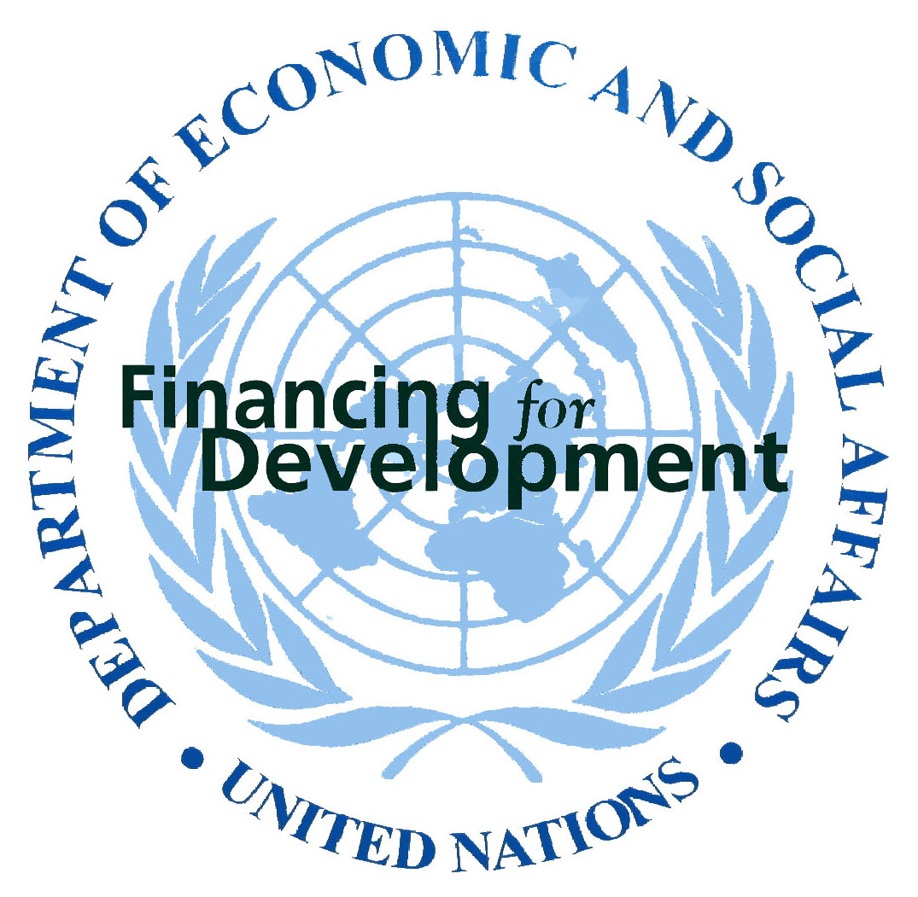

Working agenda
Seminar on Regional Financial Arrangements

(United Nations Headquarters, Conference Room 1
New York, 14–15 July, 2004)

Wednesday, 14 July 2004

Morning session 9:30 a.m. – 1:00 p.m.:

Welcome and opening remarks
Mr. José Antonio Ocampo, Under-Secretary-General, DESA
Mr. José Luis Machinea, Executive Secretary, ECLAC
Mr. Bradford Smith, Vice President for Peace and Social Justice, Ford Foundation
Chair: Mr. José Luis Machinea, Executive Secretary, ECLAC

Presenters: Roy Culpeper, President, The North-South Institute
“Theoretical arguments for regional financial arrangements”

Francisco Sagasti, President of FORO Nacional/Internacional
“A comparative vision of regional development banks”
George Corm, Former Minister of Finance, Lebanon
“The Arab experience in regional financial arrangements”

Facilitator: Ms. Mervat M. Tallawy, Executive Secretary, ESCWA

Afternoon Session 3:00 p.m. – 6:00 p.m.

Chair: Mr. José Antonio Ocampo, Under-Secretary-General, DESA

Presenters: Charles Wyplosz, Professor, Graduate Institute of International Studies, Geneva
“Drawing lessons from the history of European financial institutions”

Stephany Griffith-Jones, Research Fellow and Professor at the Institute of Development Studies, University of Sussex
Alfred Steinherr, Chief Economist, European Investment Bank
“The role of the European Investment Bank in European integration: lessons for developing countries”

José Luis Machinea, Executive Secretary, ECLAC
Guillermo Rozenwurcel,
“Macroeconomic policy coordination in Latin America”

Andras Uthoff, Coordinator of the Unit of Special Studies, ECLAC
Daniel Titelman, Economist, ECLAC
“Subregional financial institutions in Latin America”

Facilitator: Ms. Brigita Schmögnerová, Executive Secretary, ECE

Thursday, 14 July 2004

Morning session 9:30 a.m. – 1:30 p.m.:

Chair: Mr. José Luis Machinea, Executive Secretary, ECLAC

Presenters: Ernest Aryeetey, Professor, Institute of Statistical, Social and Economic Research, University of Ghana
“The African experience in regional financial arrangements”
Slide presentation: PDF / Power Point

Facilitator: Mr. K. Y. Amoako, Executive Secretary, ECA

Presenters: Yung Chul Park, Professor, Korea University
“Regional Financial Integration in East Asia: Challenges and Prospects”
Slide presentation: PDF / Power Point

Yung Chul Park, Professor, Korea University
Julia Leung, Executive Director, Hong Kong Monetary Authority
Kanit Sangsubhan, Director, Fiscal Policy Research Institute, Ministry of Finance, Thailand
Jae Ha Park, Senior Fellow, Korea Institute of Finance
“The development of a regional Asian bond market”

Facilitator: Mr. Kim Hak-Su, Executive Secretary, ESCAP

Summary and closing remarks by ECLAC and DESA

