Putting in place a national coalition of civil society organizations
A National Voice for Civil Society
“Civil society organizations are in the best position to really know the realities and aspirations of the Malagasy people in all sectors at all levels,” says Lalao Randriamampionona, the president of a national association of women’s organizations. These organizations should have no political agenda and should not make money or be part of the government. They should consist of community leaders and strive to improve quality of life. There have been several attempts since the early 1990’s to put in place a national coalition of civil society organizations in Madagascar. But many were politically motivated, and they failed. USAID decided to help steer the country’s efforts at developing a strong, independent, and apolitical civil society
Imbe Venance, left, from northern Madagascar’s Antsiranana province, and Perilina, from the northeastern area of Sambava, celebrate the creation of a national civil society coalition in Antananarivo
Photo Credit: Pact Madagascar
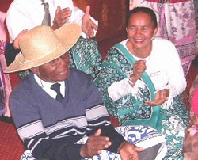
“We see our words and ideas in the charter, our ideas in the discussions. We chose the leaders and they are people that have the interests of civil society at heart, not a political agenda” said Maria Zafitsara, a civil society representative from Toamasina.

Read more ….

