UN Enable Newsletter
Oct-Nov2017

The UN Enable Newsletter is prepared by the Secretariat for the Convention on the Rights of Persons with Disabilities (DSPD/DESA) with input from UN offices, agencies, funds and programmes, as well as from civil society organizations, including organizations of persons with disabilities. It is also available online at: www.un.org/disabilities.

In this issue:
- Status of the CRPD
- In the Spotlight
- News from UN Headquarters
- News from other UN entities
- Calendar of international disability events
- Other news

STATUS OF THE CRPD
175 ratifications/accessions and 160 signatories to the CRPD
92 ratifications/accessions and 92 signatories to its Optional Protocol (OP)
More on the CRPD at: http://bit.ly/UN_crpd

IN THE SPOTLIGHT

International Day of Persons with Disabilities
Proclaimed by the UN General Assembly resolution 47/2 in 1992, the International Day of Persons with Disabilities (IDPD) has been commemorated on 3 December every year to raise the awareness and promote the rights and well-being of persons with disabilities in society and development.
Under the theme “Transformation towards sustainable and resilient society for all”, the observance of the 2017 IDPD at UN Headquarters in New York City will be organized by UN DESA on 1 December 2017 in Conference Room 4 from 10am to 6pm, in collaboration with Member States, the UN system, academic institutions, civil society, and the private sector. There will be an opening session attended by the Secretary-General (tbc), the President of the UN General Assembly, six Ambassadors to the UN, and a representative of civil society. In addition, there will be three panel discussions, two side events, an exhibition, and artistic performances throughout the Day. More information can be found at: http://bit.ly/IDPD2017
If you want to know how the world is commemorating the International Day of Persons with Disabilities, visit: http://bit.ly/2jK5ClB

NEWS FROM UN HEADQUARTERS

UN General Assembly adopted a new resolution on the implementation of the Convention with a focus on Women and Girls with Disabilities
The General Assembly of the United Nations at its 72nd session adopted the resolution entitled “Implementation of the Convention on the Rights of Persons with Disabilities and the Optional Protocol thereto: situation of women and girls with disabilities” through its Third Committee on 21st of November (A/C.3/72/L.18/Rev.1 with oral amendments). The adopted resolution recognizes that women and girls with disabilities are faced with multiple and intersecting forms of discrimination which poses barriers in all aspects of life, and therefore focuses on a number of key issues that are critical to realizing their rights on the equal basis with others, namely (1) multiple and intersecting forms of discrimination; (2) education and employment; (3) access to health services, including sexual and reproductive health; (4) access to justice and equal recognition before the law; and (5) participation in public and political life. More information on the draft resolution can be found at: http://bit.ly/2AuiuUc

UN-DESA: Regional capacity building workshops on disability in Addis Ababa and Dushanbe
The Division for Social Policy and Development of the United Nation Department of Economic and Social Affairs organised two regional workshops on capacity building for ratification and implementation of the Convention on the Rights of Persons with Disabilities. The workshop held in Addis Ababa, Ethiopia from 7-9 November 2017 offered training on the CRPD by using Disability Toolkit for Africa. The participants including government officials and representatives of Disabled People’s Organizations from Eastern African sub-regional countries discussed best practices and lessons learned in promoting inclusive development policies and developing programmes for persons with disabilities for the implementation of the CRPD. The other workshop was held in Dushanbe, Tajikistan from 13-17 November 2017 in close collaboration with the Government of Tajikistan, UN country team, and other partners including disability organisations from the Central Asian region. The participants from the region discussed national experiences in signing and ratifying the CRPD, as well as effective implementation, monitoring and evaluation of the Convention.
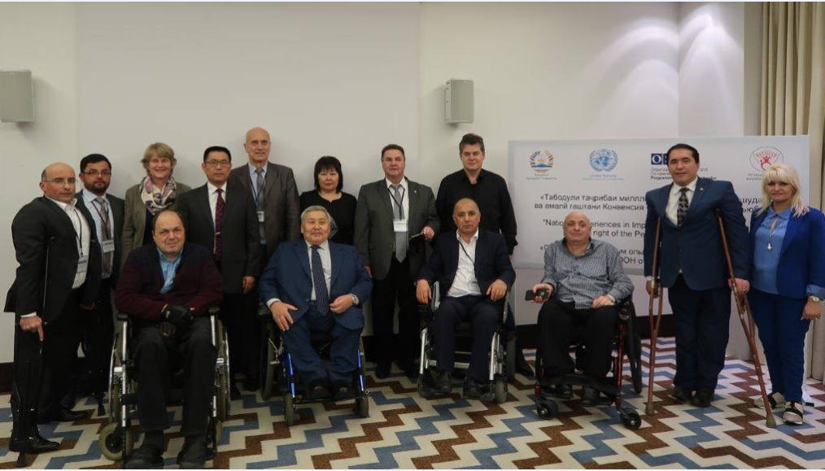
Photo 1 caption: A group photo at the workshop on disability organized by UN-DESA in Dushanbe, Tajikistan

29 January to 7 February 2018: The fifty-sixth session of the Commission for Social Development (CSocD56), the UN Headquarters in New York. The priority theme for the 2018 policy cycle is “Strategies for eradicating poverty to achieve sustainable development for all”. A multi-stakeholder panel discussion on disability will be held on 31 January 2018, with a focus on the evidence-based approach to the mainstreaming of disability in the implementation, monitoring and evaluation of the 2030 Agenda. More on CSocD56 can be found at: http://bit.ly/2iJixzV

Call for inputs: Accessibility Survey
Accessibility Survey is being conducted by the United Nations Inter-Departmental Task Force on Accessibility (IDTFA). This survey seeks to collect information about barriers in terms of accessibility you have encountered, or if you have witnessed/heard others experience any accessibility barriers to full and equal participation of persons with disabilities in activities at the United Nations Headquarters. The results are processed in three months intervals and the information gathered will assist in enhancing accessibilities of facilities and services at the UN Headquarters. Links to the survey are as follows:
English http://icts-surveys.unog.ch/index.php/271441?lang=en
French http://icts-surveys.unog.ch/index.php/271441?lang=fr

NEWS FROM OTHER UN ENTITIES

UN OHCHR: The report of the UN Special Rapporteur on the rights of persons with disabilities presented her report at the UNGA72
At the 72nd session of the UN General Assembly, Ms. Catalina Devandas, UN Special Rapporteur on the rights of persons with disabilities, presented a report dedicated to the sexual and reproductive health and rights of girls and young women with disabilities. The report explores the systemic abuse and violence faced by young women and girls with disabilities around the world, and calls for ending practices such as forced abortions, sterilization and other forms of contraception, among other non-consensual practices. It also calls for states to change legal capacity laws that limit the right for persons to decide over their lives and bodies. More can be found at: http://bit.ly/2BbNUM9
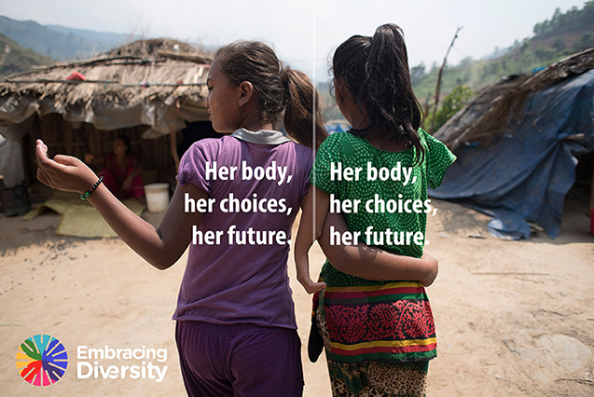
Photo 2 caption: Cover of the report. Two girls standing facing back with message “Her body, her choices, her future”.

UN WOMEN: In the words of Jana Mustafa: “Disability should not stop anyone from starting over”
Jana Mustafa is a former employee of a local NGO and a survivor of violence. She lost her job due to an abusive marriage and experienced years of physical and psychological violence. She got a divorce with the legal help of the Hayat Centre in the Gaza Strip. The Centre is supported by the UN Women programme, “A Holistic Approach to Sheltering Services for Women Victims and Survivors”, funded by the Italian Agency for Development Cooperation (AICS). As she hopes to begin a new life, Mustafa wants to open a small business to support her six-year-old son Jamal and prove that her disability is not an issue. More information on the story can be found at: http://bit.ly/2Be6pPN

UN WOMEN: UN Trust Fund to End Violence against Women: Call for Proposals: 31 October – 5 December 2017
The UN Trust Fund to End Violence against Women (UN Trust Fund) awards grants to initiatives that demonstrate that violence against women and girls can be systematically addressed, reduced and, with persistence, eliminated. The UN Trust Fund is currently accepting applications for multi-year grants up to USD 1 million. This year, the UN Trust Fund has a special window addressing violence against women and girls with disabilities. Applications from women’s rights, women-led, and small women’s organizations will be prioritized, in recognition of them being the driving force of the ending violence against women agenda, as well as being at the forefront of reaching women and girl survivors at the grassroots level. The online application will be available from 31 October until 5 December 2017 on the UN Trust Fund website. For more information on the Trust Fund, see: http://bit.ly/1gg85YS

UNDP: ‘Leave no one behind,’ UNDP aims to champion the rights of visually impaired people in Indonesia
Indonesia has the second highest rate of people with blindness in the world. This and other eye-opening facts were discussed during a UNDP workshop in Jakarta which aimed to champion the rights of people who are blind, visually impaired, or print disabled. Most importantly the workshop discussed ways to implement the Marrakesh Treaty, which went into force last year. The Treaty is designed to improve access to knowledge among people with some form of visual impairment. Indonesia was one of the first countries in Asia that signed the Marrakesh Treaty. The South-East Asia country is now moving towards ratifying the Treaty for the benefit of its millions visually impaired people. Detail of the workshop is available at: http://bit.ly/2xNO3ni ; http://bit.ly/2ykVu7J

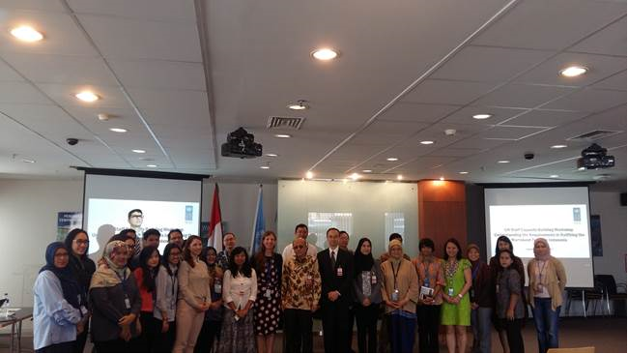
Photo 3 caption: A group photo at the workshop on Marrakesh Treaty in Jakarta. Photo credit: Agus Soetianto, UNDP

UNDP: National briefing on Marrakesh Treaty in Cambodia:
Over 230 government officials, representatives of disabled people’s organizations and national and international non-governmental agencies in Cambodia have received a briefing on the Marrakesh Treaty for blind, visually impaired and otherwise print disabled people. The briefing - the first presentation of the Marrakesh Treaty at a national meeting of key stakeholders in Cambodia - aimed to raise awareness about the Treaty, to set the stage for further discussion, and to encourage ratification. It took place during a plenary session of the National Workshop on Monitoring Implementation of the National Disability Strategy Plans 2014 -2018, held on 23 - 24 August 2017 in Phnom Penh, Cambodia. Further information on the briefing can be found at (an article by the Electronic Information for Libraries, EIFL): http://bit.ly/2xCyyhF and the Issue Brief on the Marrakesh Treaty can be found at: http://bit.ly/2zsL5cr (for the audio, please contact Amara Bou at amara.bou@undp.org)
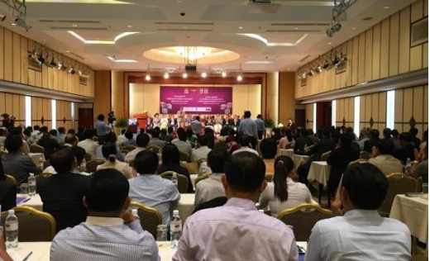
Photo 4 caption: A photo of the participants and speakers at the National Workshop on Monitoring Implementation of the National Disability Strategy Plans 2014-2018 in Cambodia, where the Marrakesh Treaty briefing was presented. Photo credit: Amara Bou, UNDP

ILO: What companies should do to support the rights of persons with disabilities
This easy-to-read version of the UN Global Compact/ILO "Guide for business on the rights of persons with disabilities - How business can respect and support the rights of persons with disabilities and benefit from inclusion" is published. The guide suggests concrete actions and measures companies can take to implement good practices that are inclusive of persons with disabilities in the workplace, marketplace and in the community - in alignment with relevant UN conventions and frameworks. The document can be found here: http://bit.ly/2BjHlXZ

CALENDAR OF INTERNATIONAL DISABILITY EVENTS
Please send us information on major international disability events, for possible inclusion in the list below, to enable@un.org. Now also available on the UN Enable website at: http://bit.ly/1syHQs2

27 November to 1 December, 2017: High-Level Intergovernmental Meeting on the Midpoint Review of the Asian and Pacific Decade of Persons with Disabilities, 2013-2022, in Beijing, China. More detail can be found at: http://www.unescap.org/disabilityhighlevelmeeting2017/

5 December 2017: Hearing on 'Ending forced sterilisation of women and girls with disabilities' in the European Parliament in Brussels
Women and girls with disabilities in Europe continue to be deprived of many of their human rights, including being sterilised against their consent or knowledge, depriving them from their dignity and power over their sexual and reproductive rights. On 5 December 2017, European Disability Forum (EDF) will hold a hearing to raise awareness on ending forced sterilisation of women and girls with disabilities and to call for the prohibition of all forms of violence against women. Women with disabilities from all over Europe, women's rights organisations, civil society, human rights stakeholders, representatives of the United Nations, and EU institutions will gather at this important event. (For more information, contact: Lucia D’Arino lucia.darino@edf-feph.org) More detail of the event can also be found at: http://bit.ly/2zZdFAX

6 December, 2017: Seminar: Leave no one behind, Oslo, Norway.
The Atlas-Alliance, the Norwegian Center for Human Rights and Plan International Norway invites to a one-day seminar on inclusive development. “Leaving no one behind" is a human rights principle, embedded in both CRPD and the SDGs. Development cooperation must be monitored to know whether we are reaching the disabled. The objective of the seminar is to increase the knowledge on how to implement and monitor disability inclusive development strategies. Speakers include Ms. Rosangela Berman-Bieler, UNICEF Senior Advisor on Children with Disability and Mr. Mitch Loeb, the Washington Group on Disability Statistics. More on the seminar can be found at: http://bit.ly/2iIT9uY

7 December, 2017: Seminar on SDGs and Inclusive Society: Dyslexia, Tokyo, Japan. Japanese Society for Rehabilitation of Persons with Disabilities will organize a seminar on SDGs and Inclusive Society with focus on dyslexia. The seminar will invite speakers from the government, academia, and civil society organizations to share knowledge, best practices, and challenges in pursuing inclusive society while ensuring ‘leaving no one behind’. More information on the seminar can be found at (Japanese only): http://bit.ly/2zyNJgH ; Contact: soumu@dinf.ne.jp

12 – 15 December 2017: Regional workshop on the Implementation of the CRPD, Windhoek, Namibia. UN-DESA, in collaboration with the Government of Namibia and African Union will convene a regional capacity building workshop on the ratification and implementation of the CRPD.

7 to 13 February 2018: The Ninth session of the World Urban Forum, Kuala Lumpur Convention Center, Malaysia. The Ninth Session of the World Urban Forum will be the first session to focus on the implementation of the New Urban Agenda adopted in Habitat III. Details can be found at: http://wuf9.org/

30 May to 1 June 2018: Inclusion International’s 17th World Congress themed Learn, Inspire, Lead, in Birmingham, U.K. The World Congress 2018 is a chance for us to learn, inspire and share experiences on issues that matter to us all, and lead the way in making the world more inclusive for people with intellectual disabilities. The World Congress will bring together self-advocates, families and professionals as part of the global movement for change. Registration is now open at: www.worldcongress2018.com
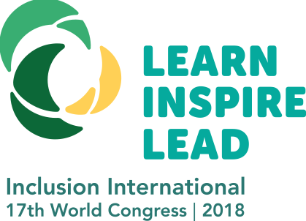
Photo 5 caption: Logo of the 17th World Congress 2018 on Inclusion International with a message “Learn Inspire Lead”.

OTHER NEWS
(DISCLAIMER: The information below is provided by other stakeholders for informational purposes only. This does not constitute endorsement of, or an approval by, the United Nations of any of the products, services, or opinions of the organization or individual. The United Nations bears no responsibility for the accuracy, legality or content of their statements and opinions.)

The Belt and Road High-level Event on Disability Cooperation adopts the declaration
The Belt and Road High-level Event on Disability Cooperation was organized by China Disabled Persons’ Federation in cooperation with World Health Organization, International Telecommunication Union and Rehabilitation International from 13-15 September 2017 at China National Convention Center, with an aim to further promote exchange and cooperation in the field of assistive technology industry. As one of the key events, the Global Conference on Assistive Technology 2017 was convened on 14 September, with the theme of “strengthening connectivity for inclusive development of assistive technology industry”. The declaration, adopted at the high-level event, states that the Belt and Road, promoting inclusive development, has provided countries connected by the initiative with an opportunity to enhance the exchange and cooperation for persons with disabilities. The declaration called for further advancement of rights of persons with disabilities in line with the CRPD and the 2030 Agenda for Sustainable Development, with a focus on the cooperation in data and statistics, public services, rehabilitation and assistive technology, vocational training and employment, cultural and sports. Detail of the conference can be found at: http://www.cdpf.org.cn/ztzl/2017zt/2686/

Innovate, collaborate and accelerate: The 2018 Harkin Summit on Global Disability Employment
The Second Harkin Summit on Global Disability Employment began on the 2nd of November in Washington D.C. 260 invitees from companies, civil society, Disabled People’s Organizations, NGO, government, foundations, microfinance institutions, universities and research centers from more than 40 countries came to exchange ideas about the solutions and innovations for disability-inclusive employment. To share best practices for the summit, Handicap International, member of the planning committee, co-wrote with the NGO Leonard Cheshire a white paper called “Good for Business, promoting partnership to employ people with disability,” to share their experiences and best practices in developing countries about the employment for people with disabilities (please find this document at: http://bit.ly/Good4Biz). Detail of the Summit can be found at: http://www.harkinsummit.org/

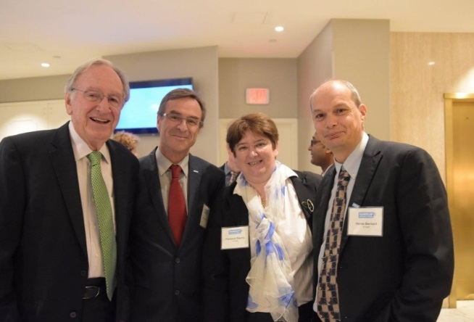
Photo 6 caption: A photo at the Harkin International Disability Employment Summit (from left to right): Senator Harkin (retired), Xavier du Crest, Florence Daunis, Hervé Bernard

Leonard Cheshire Disability’s contribution to “Transformation towards sustainable and resilient society”
Leonard Cheshire Disability (LCD) works to ensure the United Nations Convention on the Rights of Persons with Disabilities is implemented, as well as the Sustainable Development Goals for inclusive education and livelihoods, and support the transformation towards sustainable and resilient society. Research by LCD in Kenya, Zambia, Sierra Leone and Bangladesh shows that persons with disabilities and their representative organisations are not engaged in the monitoring and implementation of the SDGs and that more needs to be done to ensure that they are included in the global development agenda. LCD is committed to working with Disabled Persons’ Organisations to ensure that they can support the implementation of the SDGs. LCD’s flagship programme with Accenture, the ‘Access to Livelihoods’ (A2L) programme, was showcased in ‘Good for Business’, a report by LCD and Handicap International which focussed on how NGO-private sector partnerships can support more inclusive employment practices.

G3ict: Smart Cities for All
The Global Initiative for Inclusive ICTs (G3ict) and World Enabled announced that their Smart Cities for All (SC4A) global initiative will develop a new tool to assess and benchmark digital inclusion and ICT accessibility in smart cities. The Smart Cities for All Digital Inclusion Maturity Model will become the first maturity model targeted specifically at digital accessibility and inclusion in Smart City programs worldwide. The new SC4A Maturity Model is being developed to help cities clearly evaluate their progress towards achieving ICT accessibility and digital inclusion across a broad range of functions that are important to all cities, e.g. communications, procurement, training, and standards. It will define key performance indicators and metrics that support advancing accessibility and digital inclusion. The maturity model will define 5 levels of digital inclusion and accessibility progress, or maturity, dealing with smart city technology, data, culture, and strategy. Press release of the launch can be found at: http://bit.ly/2A3BBkQ

Handicapped International: Addressing violence against women and girls with disabilities in Africa
The Making It Work Gender and Disability Technical Advisory Committee (TAC) has just finalized its selection of 9 good practices implemented by 7 DPOs and 2 Women’s Organizations in 6 countries: Cameroon, Kenya, Malawi, Nigeria, Rwanda and Uganda. The good practices include successful community-based prevention of violence, national advocacy, increased access to justice and to health services, amongst others. Selected practices respect criteria of leadership of women with disabilities, diversity and gender equity. Next step will bring the TAC members, Good Practice Holders, and Handicapped International project team to the 2nd Gender and Disability Forum in Kenya, March 2018. More on Making it Work can be found at: https://www.makingitwork-crpd.org/

Addressing Challenges in Disability & Inclusion in Africa – Rehabilitation International’s Call to Action
Regional Conference for Africa was held on 14 November 2017 at the United Nations Economic Commission for Africa Conference Center with the theme: Addressing Challenges in Disability & Inclusion in Africa – Rehabilitation International’s Call to Action. Representatives from thirty-seven countries including disability leaders, those from the African Union and government officials of Ethiopia, gathered in Addis Ababa for Rehabilitation International (RI)’s Regional Conference for Africa to discuss how RI can assist in addressing the challenges in disability and rehabilitation in the region. This was the first and single biggest gathering of RI members and partners to exchange views and chart a way forward for a collaborative work on disability in the region. The regional meeting also helped jumpstart the regional projects on disability. Press releases of the regional conference can be found at: http://bit.ly/2zni3Xh ; http://bit.ly/2n3sMEW ; For more information, contact: info@riglobal.org

Japanese Society for Rehabilitation of Persons with Disabilities (JSRPD): Awareness Raising on SDGs among DPOs and Cooperation with other Sectors
JSRPD has been working on raising awareness on SDGs among DPOs since the beginning of this year, 2017. Without greater and more direct involvements of the DPOs, persons with disabilities will continue to be left behind. In 2017, JSRPD have organized two major events. On 28th June, they held a large-scale workshop where the participants were divided into three groups of International Issue, Domestic Work and Networking. The second event was a symposium for the realization of inclusive society held on 31st October, where we invited speakers from different fields including private companies. Students, researchers, NPO staff members, business people and persons with disabilities were among the participants in the event. More information of JSRPD can be found at: http://www.jsrpd.jp/static/index_e.html

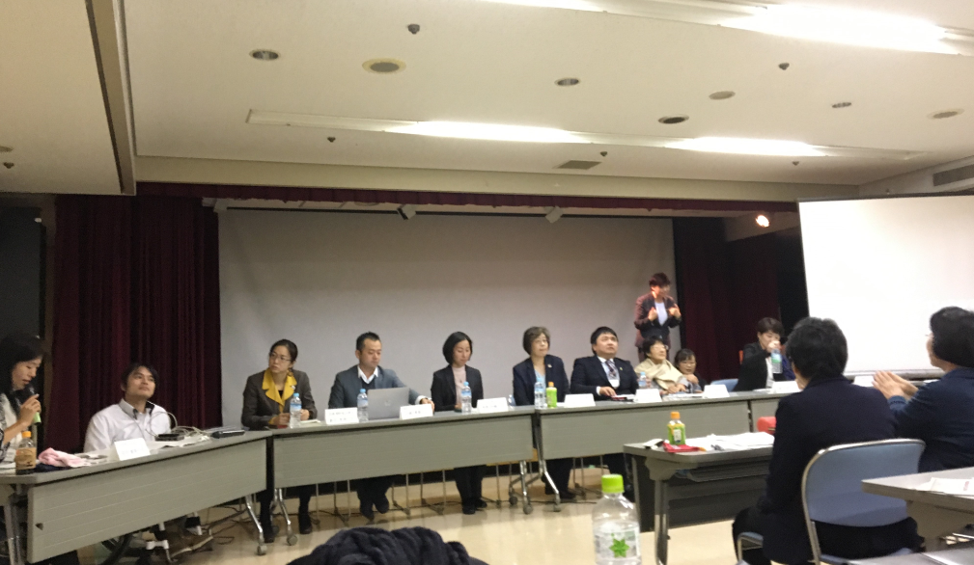
Photo 7 caption: Speakers at the symposium for the realization of inclusive society held on 31st October in Japan

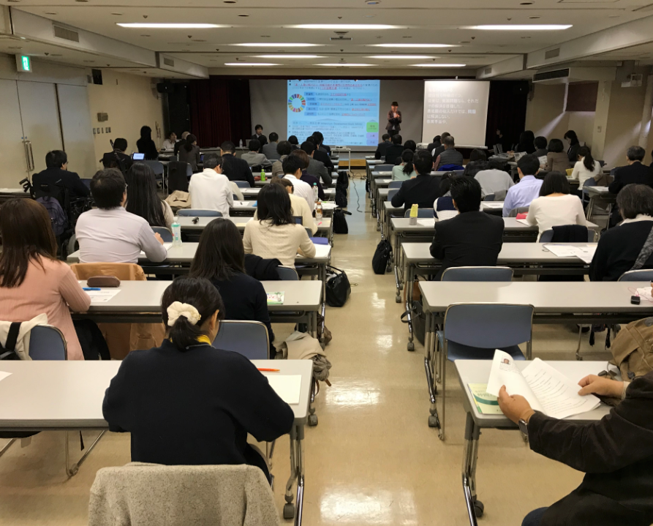
Photo 8 caption: Participants at the symposium for the realization of inclusive society held on 31st October in Japan

Mental Health Europe-Santé Mentale Europe
The French-speaking Collective of the Absolute Prohibition campaign (https://absoluteprohibition.org/) announced that persons with psychosocial disabilities, twelve of their representative organisations, and UN Special Rapporteur for the rights of persons with disabilities, Ms. Catalina Devandas-Aguilar had fruitful discussions during the Special Rapporteur’s recent country visit to France in early October, in both Paris and Marseilles. In December, there will be an Empowerment Seminar on the CRPD and French law, showcasing good practices, which is being organised by and for organisations of (ex)users and survivors of psychiatry with support of Mental Health Europe (http://www.mhe-sme.org/), Advocacy-France (http://www.advocacy.fr/) and the Pairadvocacy network (http://www.pairadvocacy.eu). For detail on the event, contact: Stephanie Wooley at <s.wooley@wanadoo.fr>

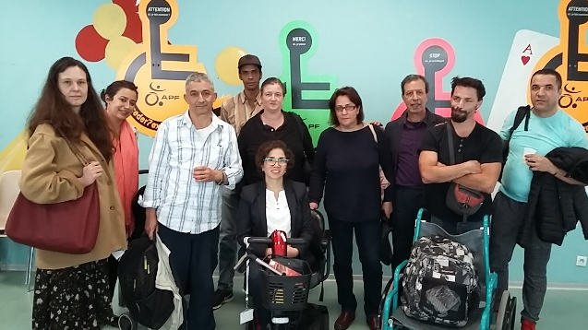
Photo 9 caption: A group photo, UN Special Rapporteur Ms. Catalina Devandas-Aguilar meets with persons with psychosocial disabilities, 8 October, Marseilles, France

The Festival of Universal Design
The Festival of Universal Design, organized by the Russian disability organization Perspekitva, was held in Moscow at the design center ARTPLAY from 2-4 October 2017.

CONTACT INFORMATION
Secretariat for the Convention on the Rights of Persons with Disabilities
Division for Social Policy and Development (DSPD)
Department of Economic and Social Affairs (DESA)
United Nations Headquarters, New York, NY 10017, USA

BE INFORMED! GET INVOLVED!
Facebook: www.facebook.com/pages/United-Nations-Enable/196545623691523
Twitter: http://twitter.com/UN_Enable
Website: www.un.org/disabilities
Email: enable@un.org

Call for volunteers to translate the UN Enable newsletter in other languages
Volunteer your time to translate the UN Enable newsletter in an official UN language or your own local language. We are looking for volunteers to translate the newsletter in to the UN official languages of Chinese and Russian.
(http://bit.ly/enablenewslettervolunteer)

Call for photos for future inputs
We will continue working to improve the design of our newsletter while ensuring the accessibility. We welcome your feedback.
---

To subscribe: http://bit.ly/unenablenewsletter

