UN Enable Newsletter

August-December2018
The UN Enable Newsletter is prepared by the Programme on Disability / Secretariat for the Convention on the Rights of Persons with Disabilities, Division for Inclusive Social Development, the United Nations Department of Economic and Social Affairs with inputs from UN entities and civil society organizations, including organizations of persons with disabilities.

In this issue:
- The Convention on the Rights of Persons with Disabilities (CRPD)
- News from UN Headquarters
- News from other UN entities
- Other news
- Calendar of international disability events

The Convention on the Rights of Persons with Disabilities (CRPD)
[Status of the CRPD]
177 ratifications/accessions and 161 signatories to the CRPD
92 ratifications/accessions and 92 signatories to its Optional Protocol (OP)
More on the CRPD can be found by clicking the following link: http://bit.ly/UN_crpd

News from UN Headquarters

International Day of Persons with Disabilities

The Commemoration of the International Day of Persons took place on 3 December at UN Headquarters in New York. This year, the focus was on “Empowering persons with disabilities and ensuring inclusiveness and equality”. This theme focused on the empowering persons with disabilities for the inclusive, equitable and sustainable development envisaged in the 2030 Agenda for Sustainable Development.
The Secretary-General issued a message for the Day emphasizing that in its pledge to leave no one behind, the 2030 Agenda for Sustainable Development represents a commitment to reducing inequality and promoting the social, economic and political inclusion of all, including people with disabilities. The Secretary-General also emphasized that there is a need to integrate the voices and concerns of people with disabilities into national agendas and policies.
The event was co-sponsored by the Office of the President of the United Nations General Assembly, Ecuador, Republic of Korea, Brazil, Bulgaria, Italy, Philippines, United Kingdom, Japan, Singapore, ITU, UN Women and the UN Department of Management.
In the morning, the commemoration featured the launch of the first UN Flagship Report on Disability and Development on the “Realization of the Sustainable Development Goals by, for and with persons with disabilities”. The publication was launched by Mr. Elliott Harris, ASG DESA. The report showed that persons with disabilities are at a disadvantage regarding most SDGs, but also highlighted the growing number of good practices that can create a more inclusive society in which they can live independently. The report demonstrated how disability-based discrimination has severe effects on transport, cultural life, and access to public places and services, and the need to make urban environments more accessible. In the afternoon, the commemoration focused on “Accessible Cities for All: Smart and Inclusive Urban Planning” as key elements to reduce inequalities and empower people to live in accessible, usable and friendly healthy environments. For more information, please visit: https://www.un.org/development/desa/disabilities/international-day-of-persons-with-disabilities-3-december/idpd18.htm
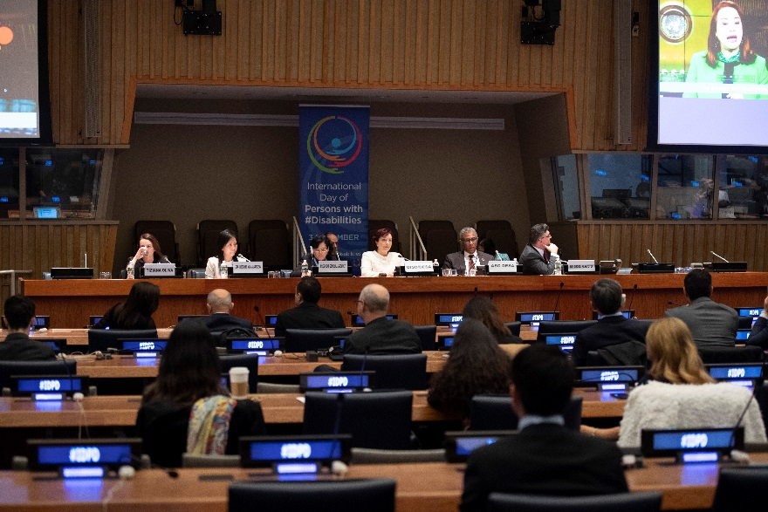

Photo 1: A photo of the International Day of Persons with Disabilities, 20 December 2018

Launch of the First UN Report on Disability and Sustainable Development Goals
The “The UN Flagship Report on Disability and Development 2018 – Realizing the SDGs by, for and with persons with disabilities shows that people with disabilities are at a disadvantage regarding most Sustainable Development Goals, but also highlights the growing number of good practices that can create a more inclusive society in which they can live independently.” UN Secretary-General António Guterres’ message on the International Day of Persons with Disabilities, observed on 3 December 2018.
Twelve years after the adoption of the Convention on the Rights of Persons with Disabilities, the international community continue to champion the commitments of the Convention at this year’s International Day of Persons with Disabilities on 3 December, by affirming the fundamental role this group plays in building inclusive societies for all. Under the theme “Empowering persons with disabilities and ensuring inclusiveness and equality”, the International Day looked at ways in which persons with disabilities contribute to eradicate all forms of discrimination and intolerances against them and to promote an equitable and sustainable development envisaged in the 2030 Agenda for Sustainable Development. During the International Day, the United Nations Department of Economic and Social Affairs (UN DESA) launched the first UN Flagship Report on Disability and Development on the “Realization of the Sustainable Development Goals by, for and with persons with disabilities”. The report demonstrates that persons with disabilities are at a disadvantage regarding most Sustainable Development Goals. Concrete action is needed to make their situations visible in policymaking. We need to recognize the potential of persons with disabilities as contributors to society. For more information, please visit:
https://www.un.org/development/desa/disabilities/publication-disability-sdgs.html

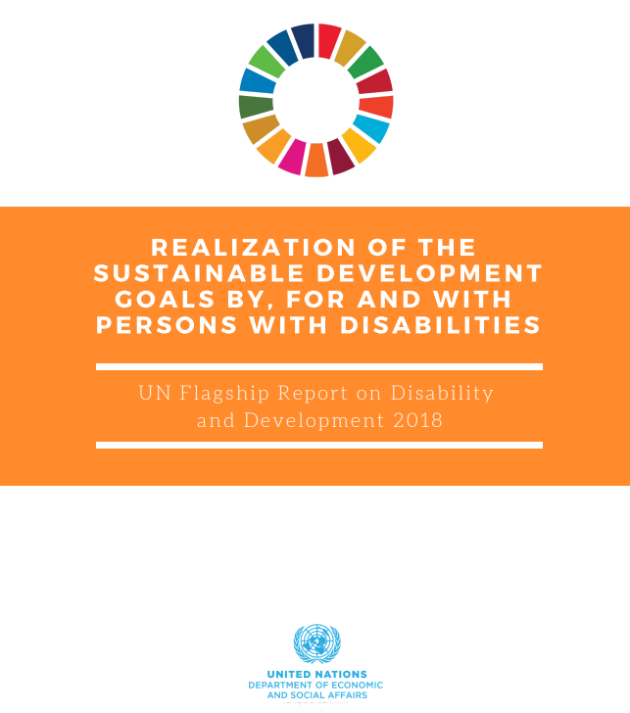

Photo 2: During the International Day, the United Nations Department of Economic and Social Affairs (UN DESA) launched the first UN Flagship Report on Disability and Development on the “Realization of the Sustainable Development Goals by, for and with persons with disabilities”.

First-ever World Braille Day fosters more accessible and disability-inclusive societies
To raise awareness of the importance of Braille for approximately 1.3 billion people living with some form of distance or near vision impairment, on Friday the United Nations is observing the first official World Braille Day.
Recognized henceforth each 4 January, the Day was proclaimed by the General Assembly last November, as a means of realizing fully the human rights of visually-impaired and partially-sighted people and bringing written language to the forefront as a critical prerequisite for promoting fundamental freedoms.
The World Health Organization(WHO) reports that people who are visually impaired are more likely than those with full sight to experience higher rates of poverty and disadvantages which can amount to a lifetime of inequality. For more information, please visit:

https://www.un.org/development/desa/disabilities/news/news/first-ever-world-braille-day.html

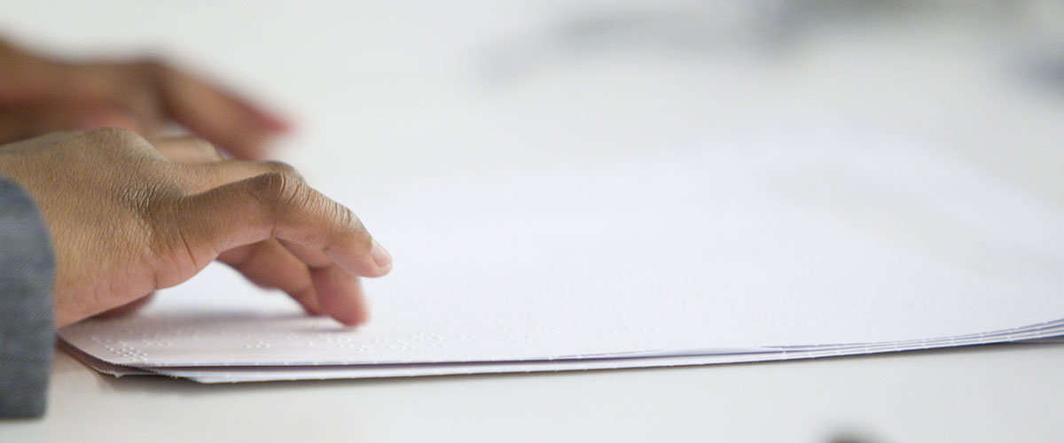

Photo 3: World Braille Day is observed to raise awareness of the importance of braille as a means of communication in the full realization of the human rights for blind and partially sighted people. The first official World Braille Day is celebrated on 4 January 2019.

United Nations Portal on disability statistics
The United Nations Statics Division of the Department of Economic and Social Affairs, the focal point dealing with official statistics in the UN, launched a portal on disability statistics. Visit the following link and learn key facts about the situation of persons with disabilities in different countries of the world: http://bit.ly/2NkXtOj

News from other UN entities

UN Women: The empowerment of women and girls with disabilities: Towards full and effective participation and gender equality
Women and girls with disabilities face systemic marginalization and attitudinal and environmental barriers that lead to lower economic and social status; increased risk of violence and abuse, including sexual violence; discrimination as well as harmful gender-based discriminatory practices; and barriers to access education, health care, including sexual and reproductive health, information and services, and justice as well as civic and political participation. This hinders their participation on an equal basis with others.
This strategy document was developed to ensure a more systematic approach to strengthen the inclusion of the rights of women and girls with disabilities in UN Women’s efforts to achieve gender equality, empowerment of all women and girls, and the realization of their rights. The strategy aligns with UN Women’s Strategic Plan 2018–2021 and commitments made in the common chapter to the Strategic Plans of UNDP, UNFPA, UNICEF, and UN Women, and further builds upon UN Women’s work in the area of empowerment of women and girls with disabilities. For more information, please visit the UN Women's website:
http://www.unwomen.org/en/digital-library/publications/2018/12/the-empowerment-of-women-and-girls-with-disabilities

Calendar of international disability events
(DISCLAIMER: This section includes the information provided by other stakeholders and for informational purposes only. This does not constitute endorsement of, or an approval by, the United Nations of any of the products, services, or opinions of the organization or individual. The United Nations bears no responsibility for the accuracy, legality or content of their statements and opinions.)

4 January 2019
World Braille Day is observed in order to raise awareness of the importance of braille as a means of communication in the full realization of the human rights for blind and partially sighted people. The first official World Braille Day is celebrated on 4 January 2019.” For more information, please visit the following link: http://www.un.org/development/desa/disabilities/news/news/first-ever-world-braille-day.html

11-21 February 2019, 57th session of the Commission for Social Development – CsocD57
The fifty-seventh session of the Commission for Social Development (CSocD57) will take place from 11 to 21 February 2019, at the United Nations Headquarters in New York. The Commission is the advisory body responsible for the social development pillar of global development. The Priority Theme for the 2019 Session is “Addressing inequalities and challenges to social inclusion through fiscal, wage and social protection policies”. For more detail on the Commission, please visit the following link: http://bit.ly/un-csocd57

CONTACT:
Programme on Disability/Secretariat for the Convention on the Rights of Persons with Disabilities
Division for Inclusive Social Development (DISD)
Department of Economic and Social Affairs (DESA)
United Nations Headquarters, New York, NY 10017, USA
Facebook: http://bit.ly/2MSBukV
Twitter: http://twitter.com/UN_Enable
Website: www.un.org/disabilities
Email: enable@un.org

Call for volunteers to translate the UN Enable newsletter in other languages:
Volunteer your time to translate the UN Enable newsletter in an official UN language or your own local language. We are looking for volunteers to translate the newsletter into the UN official languages of Chinese and Russian. Detail can be found in the following link: http://bit.ly/enablenewslettervolunteer

Call for photos for future inputs:
We will continue working to improve the design of our newsletter while ensuring the accessibility. We welcome your feedback.
To subscribe, click the following link: http://bit.ly/unenablenewsletter

