PFII/2004/WS.1/3
Original: English
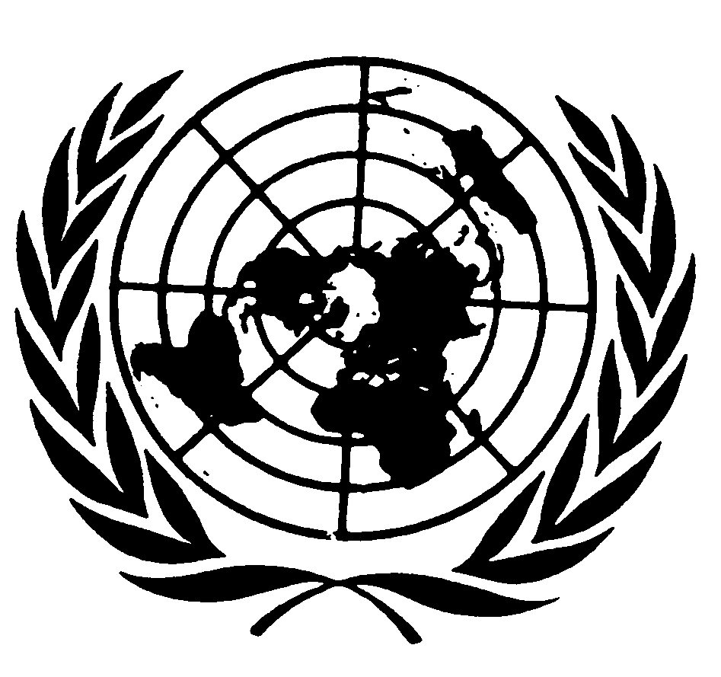
UNITED NATIONS NATIONS UNIES

DEPARTMENT OF ECONOMIC AND SOCIAL AFFAIRS
Division for Social Policy and Development
Secretariat of the Permanent Forum on Indigenous Issues

WORKSHOP ON DATA COLLECTION
AND DISAGGREGATION
FOR INDIGENOUS PEOPLES
(New York, 19-21 January 2004)

THE CONCEPT OF INDIGENOUS PEOPLES

Background paper prepared
by the Secretariat of the Permanent Forum
on Indigenous Issues

Introduction

1. In the thirty-year history of indigenous issues at the United Nations, and the longer history in the ILO on this question, considerable thinking and debate have been devoted to the question of definition of “indigenous peoples”, but no such definition has ever been adopted by any UN-system body. One of the most cited descriptions of the concept of the indigenous was given by Jose R. Martinez Cobo, the Special Rapporteur of the Sub-Commission on Prevention of Discrimination and Protection of Minorities, in his famous Study on the Problem of Discrimination against Indigenous Populations. Significant discussions on the subject have been held within the context of the preparation of a Draft Declaration on the Rights of Indigenous Peoples by the Working Group on Indigenous Populations since 1982. An understanding of the concept of “indigenous and tribal peoples” is contained in article 1 of the 1989 Convention concerning Indigenous and Tribal Peoples in Independent Countries, No. 169, adopted by the International Labour Organization.

Study on the Problem of Discrimination against Indigenous Populations

2. After long consideration of the issues involved, the Special Rapporteur who prepared the above-mentioned study offered a working definition of “indigenous communities, peoples and nations”. In doing so he expressed a number of basic ideas to provide the intellectual framework for this effort, which included the right of indigenous peoples themselves to define what and who is indigenous. The working definition reads as follows:
“Indigenous communities, peoples and nations are those which, having a historical continuity with pre-invasion and pre-colonial societies that developed on their territories, consider themselves distinct from other sectors of the societies now prevailing on those territories, or parts of them. They form at present non-dominant sectors of society and are determined to preserve, develop and transmit to future generations their ancestral territories, and their ethnic identity, as the basis of their continued existence as peoples, in accordance with their own cultural patterns, social institutions and legal system.
“This historical continuity may consist of the continuation, for an extended period reaching into the present of one or more of the following factors:
- Occupation of ancestral lands, or at least of part of them;
- Common ancestry with the original occupants of these lands;
- Culture in general, or in specific manifestations (such as religion, living under a tribal system, membership of an indigenous community, dress, means of livelihood, lifestyle, etc.);
- Language (whether used as the only language, as mother-tongue, as the habitual means of communication at home or in the family, or as the main, preferred, habitual, general or normal language);
- Residence on certain parts of the country, or in certain regions of the world;
- Other relevant factors.
“On an individual basis, an indigenous person is one who belongs to these indigenous populations through self-identification as indigenous (group consciousness) and is recognized and accepted by these populations as one of its members (acceptance by the group).
“This preserves for these communities the sovereign right and power to decide who belongs to them, without external interference”.

Working Group on Indigenous Populations

3. During the many years of debate at the Working Group, the observers from indigenous organizations developed a common position and rejected the idea of a formal definition of indigenous peoples that would be adopted by States. Similarly governmental delegations expressed the view that it was neither desirable nor necessary to elaborate a universal definition of indigenous peoples. Finally, at its fifteenth session, in 1997, the Working Group concluded that a definition of indigenous peoples at the global level was not possible at that time, and certainly not necessary for the adoption of the Draft Declaration on the Rights of Indigenous Peoples. Article 8 of the Draft Declaration, states that
“Indigenous peoples have a collective and individual right to maintain and develop their distinct identities and characteristics, including the right to identify themselves as indigenous and to be recognized as such.”

International Labour Organization Convention No. 169

4. Article 1 of ILO Convention No. 169 contains a statement of coverage rather than a definition, indicating that the Convention applies to:
“a) tribal peoples in independent countries whose social, cultural and economic conditions distinguish them from other sections of the national community and whose status is regulated wholly or partially by their own customs or traditions or by special laws or regulations;
“b) peoples in independent countries who are regarded as indigenous on account of their descent from the populations which inhabited the country, or a geographical region to which the country belongs, at the time of conquest or colonization or the establishment of present state boundaries and who irrespective of their legal status, retain some or all of their own social, economic, cultural and political institutions.”

5. Article 1 also indicates that self-identification as indigenous or tribal shall be regarded as a fundamental criterion for determining the groups to which the provisions of this Convention apply.

6. The two terms “indigenous peoples” and “tribal peoples” are used by the ILO because there are tribal peoples who are not “indigenous” in the literal sense in the countries in which they live, but who nevertheless live in a similar situation – an example would be Afro-descended tribal peoples in Central America; or tribal peoples in Africa such as the San or Maasai who may not have lived in the region they inhabit longer than other population groups. Nevertheless, many of these peoples refer to themselves as “indigenous” in order to fall under discussions taking place at the United Nations. For practical purposes the terms “indigenous” and “tribal” are used as synonyms in the UN system when the peoples concerned identify themselves under the indigenous agenda.

Conclusion

7. In the sixty-year history of developing International Law within the United Nations system, various terms have not been formally defined, the most vivid examples being the notions of “peoples” and of “minorities”. Yet, the United Nations has recognized the right of peoples to self-determination and has adopted the Declaration on the Rights of Persons Belonging to National or Ethnic, Religious and Linguistic Minorities. The lack of formal definition of “peoples” or “minorities” has not been crucial to the Organization’s successes or failures in those domains nor to the promotion, protection or monitoring of the rights recognized for these entities.

8. Similarly, in the case of the concept of “indigenous peoples”, the prevailing view today is that no formal universal definition of the term is necessary. For practical purposes the understanding of the term commonly accepted is the one provided in the Martinez Cobo study mentioned above.

UN Doc. E/CN.4/Sub.2/1986/7 and Add. 1-4. The conclusions and recommendations of the study, in Addendum 4, are also available as a United Nations sales publication (U.N. Sales No. E.86.XIV.3). The study was launched in 1972 and was completed in 1986, thus making it the most voluminous study of its kind, based on 37 monographs.
The Draft Declaration is contained in UN Doc. E/CN.4/Sub.2/1994/2/Add.1 and is currently under consideration by a Working Group of the Commission on Human Rights.
Supra 1, paragraphs 379-382.
An example of the position of indigenous representatives is listed in the 1996 report of the Working Group (UN Doc. E/CN.4/Sub.2/1996/21) as follows: “We, the Indigenous Peoples present at the Indigenous Peoples Preparatory Meeting on Saturday, 27 July 1996, at the World Council of Churches, have reached a consensus on the issue of defining Indigenous Peoples and have unanimously endorsed Sub-Commission resolution 1995/32. We categorically reject any attempts that Governments define Indigenous Peoples. We further endorse the Martinez Cobo report (E/CN.4/Sub.2/1986/Add.4) in regard to the concept of “indigenous”. Also, we acknowledge the conclusions and recommendations by Chairperson-Rapporteur Madame Erica Daes in her working paper on the concept of indigenous peoples (E/CN.4/Sub.2/AC.4/1996/2).”
UN Doc. E/CN.4/Sub.2/1997/14, para.129. See also UN Doc. E/CN.4/Sub.2/1996/21, paras. 153-154.
Supra 2.
The right of peoples to self-determination is recognized in article 1 common to the International Covenant on Economic, Social and Cultural Rights and the International Covenant on Civil and Political Rights, both adopted by the General Assembly in 1966 and ratified by the overwhelming majority of States.
Adopted by the General Assembly in 1992.
In some parts of Asia and Africa the term “ethnic groups” or “ethnic minorities” is used by governments, although some of these groups have identified themselves as “indigenous”.

