PFII/2006/WS.3/6
Original: English

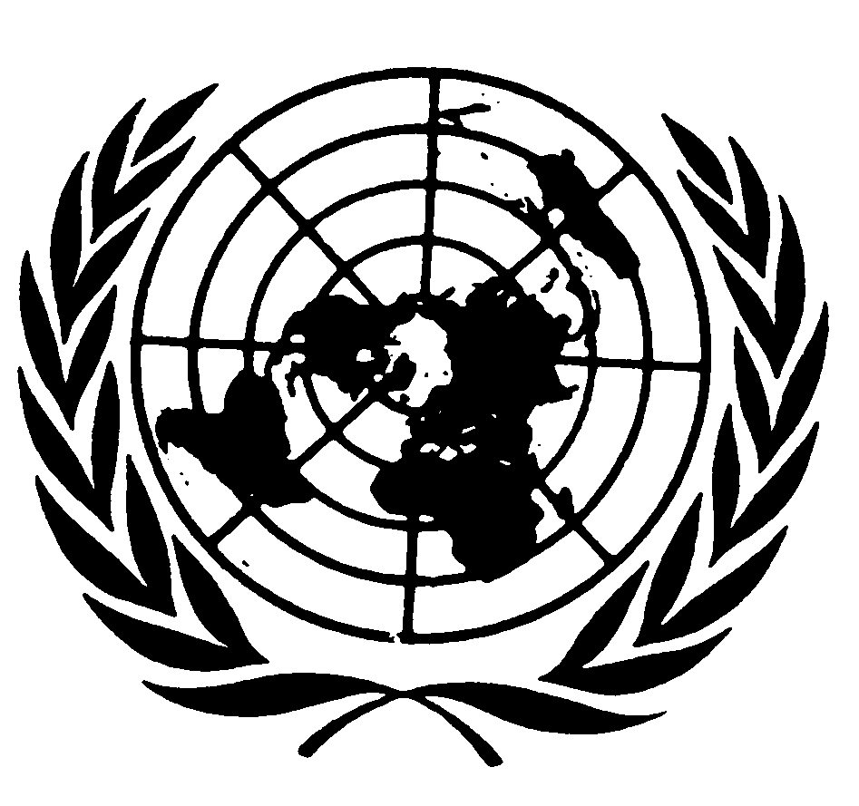
UNITED NATIONS NATIONS UNIES

DEPARTMENT OF ECONOMIC AND SOCIAL AFFAIRS
Division for Social Policy and Development
Secretariat of the Permanent Forum on Indigenous Issues

INTERNATIONAL EXPERT GROUP MEETING
ON THE MILLENNIUM DEVELOPMENT GOALS, INDIGENOUS PARTICIPATION AND GOOD GOVERNANCE
(New York, 11-13 January 2006)

UNESCO Contribution

Prepared by
UNESCO Intersectoral Team on Indigenous Issues
Directed by
Mrs Katérina Stenou
Division for Cultural Policies and Intercultural Dialogue
Introduction

Within UNESCO, the Millennium Development Goals are being taken into account in all current work and figure prominently in the Organization’s major programming framework, the Medium-Term Strategy for 2002-2007. UNESCO contributes to the achievement of each of the MDGs through its fields of competence – education, the sciences, culture, communication and information – with a special focus on the urgent needs of disadvantaged and excluded groups or geographic regions, countries or groups of countries.

The eradication of poverty is pursued in all fields of UNESCO’s competence as an integrated, cross-sectoral concern. In addition, the Medium Term Strategy has identified the “Eradication of poverty, especially extreme poverty” as a cross-cutting theme, which must be intrinsic to all programmes that the organization undertakes. The collaboration of all sectors enhances efforts to understand and address the multidimensional nature of poverty and promote innovation and efficacy in fighting it.

The following contribution will highlight how UNESCO addresses some key concerns regarding the MDGs and indigenous peoples. It will then illustrate in particular how UNESCO considers indigenous world views and aspirations in contributing to the achievement of the goals 2 (universal primary education) and 7 (environmental sustainability), since they are of particular relevance to UNESCO’s fields of competence. The conclusion presents some challenges for the future.

I. Key concerns and UNESCO’s response

UNESCO fully recognises the concerns raised in the IASG Report from the Fourth Session of the Permanent Forum on Indigenous Issues regarding the Millennium Development Goals as vehicles for addressing the needs and aspirations of indigenous peoples. These concerns are multiple, multifaceted and interconnected and must be addressed in a unified manner in order for the current state of affairs to be turned around. Here three major challenges will be discussed; (1) the absence of indigenous peoples from the MDG process, (2) the lack of disaggregated data and indicators and (3) mainstream development approaches and their potential contradiction to the holistic worldviews of indigenous peoples. For each of them the chapter discusses UNESCO’s view and how the organization is working to address these concerns.

1. The absence of indigenous peoples from the MDG process:

From the beginning of the MDG process, indigenous peoples have been left on the sidelines. They were not adequately consulted during the formulation of the MDGs and have been largely absent from their implementation as well as from the monitoring and reporting process. Therefore, indigenous people’s awareness of the MDGs is very low, further reinforcing their exclusion. This situation has persisted despite the fact that available data makes it clear that indigenous peoples figure among the world’s most impoverished and vulnerable groups.

The IASG Report points to the double challenge posed to the MDGs by indigenous peoples. “On the one hand they have the right to be fully included and to benefit from the global efforts to achieve the MDGs, while on the other hand, their rights to define their own development path and priorities, must be respected, in order to ensure that the MDGs contribute to the full realisation and strengthening of the potential of these peoples.” It is therefore important that mechanisms be established that ensure that communities are able to give their free, prior and informed consent (FPIC) on all policies, strategies and activities affecting them.

UNESCO’s Medium-term Strategy outlines the objectives regarding the organizations contribution to the implementation of the International Decade on the World’s Indigenous People. It emphasizes that efforts will be made to ensure the “full participation of minorities and marginalized and vulnerable groups in devising, implementing and monitoring policies and actions which directly affect them”. This is done through an interdisciplinary approach, concentrating on issues such as cultural diversity and heritage, the promotion of multilingual and multicultural education and the enhancement of indigenous knowledge systems and intergenerational transmission.

While UNESCO has not formulated an official definition on the principle of FPIC regarding indigenous peoples, its strategy and action in promoting cultural diversity and the integration of cultural diversity principles in the development of indigenous peoples has always been based on the commitment to ensure their full participation in the development of all policies affecting them.

During the International Decade on the World’s Indigenous People, UNESCO has worked closely with indigenous peoples and more recently with the UN Permanent Forum on Indigenous Issues, to facilitate the enhancement of indigenous cultural identity and encourage intercultural dialogue, which since the Johannesburg Summit in 2002, has been recognized as the indispensable basis for any initiative of sustainable development. Indigenous cultural input is crucial to sound sustainable development that is coherent to the people concerned. UNESCO moreover is an active member of the Inter-Agency Support Group on Indigenous Issues and established close working relations with the Special Rapporteur on the Situation of Human Rights and Fundamental Freedoms of Indigenous Peoples, especially regarding cultural rights and the right to education of indigenous peoples. Indigenous perspectives on the Millennium Development Goals are increasingly part of joint reflection.

UNESCO has developed a number of standard setting instruments for the promotion of cultural diversity which provide tools and spaces to build mutual consent with indigenous peoples about policies and actions concerning their cultural expression and future development. The most recent of those instruments is the Convention on the Protection and Promotion of the Diversity of Cultural Expressions which was adopted at the 2005 General Conference. It is based on the principles of the UNESCO Universal Declaration on Cultural Diversity which recognizes indigenous cultures as part of the common heritage of humanity and emphasizes their protection and defence as “an ethical imperative, inseparable from respect for human dignity.” The challenge will now be to explore how the principles of the Convention can best be applied for the benefit and promotion of indigenous cultural expression.

UNESCO’s commitment to the principle of participation is also reflected in a new initiative for 2006-2007 on constructing mutual consent with indigenous peoples on policies and actions concerning their development. Activities will be carried out in partnership with the UN Permanent Forum on Indigenous Issues and other agencies and associations representing indigenous peoples and a special focus will be on indigenous women and youth.

A noteworthy example of UNESCO’s direct collaboration with indigenous communities is the Indigenous Fellowship Programme, organised in concert with the Office of the United Nations High Commissioner for Human Rights. Every year 10 representatives of indigenous communities stay at UNESCO for two weeks to learn about the organization and engage in dialogue with programme specialists on issues of mutual concern. So far MDGs have not been explicitly discussed, but this could be envisaged for the future.

2. The lack of disaggregated data and indicators regarding indigenous peoples

Another major concern regarding the MDGs and indigenous peoples is that the goals and their related indicators do not allow for disaggregated monitoring of progress concerning indigenous peoples. There is a serious need for data on indigenous peoples and indicators must be developed that reflect the needs and concerns of these groups. All too often the situation of indigenous peoples remains hidden in national averages and therefore their concerns are less likely to be taken into account in the MDG implementation strategies as well as in development strategies in general.

One of UNESCO’s main contributions to the MDGs is the collection and use of quality and timely data in education, science and technology, communications and culture. The UNESCO Institute for Statistics (UIS) is the focal point for UNESCO’s data collection efforts and is the lead agency for the collection of data and indicators for MDGs 2 and 3. It is continually working towards the development of appropriate methodology for new indicators and the improvement of existing indicators, including the identification of inequalities within nations and disaggregation by gender. The Institute is aware of the acute problem of the lack of data available on indigenous and minority communities and is in the process of developing a strategy for including the needs of these groups in the development of its statistics.

3. Mainstream development approaches ignoring indigenous perspectives and aspirations

As stated in the IASG Report, there is “a potentially serious contradiction between indigenous peoples’ holistic vision of development and the compartmentalized and quantified approach of the MDGs”. Indigenous peoples have specific perceptions of development and poverty, which are not included in the narrow economic formulations contained in the MDGs.

UNESCO defends the case of the indivisibility of culture and development, understood not simply in terms of economic growth, but also as a means of achieving a satisfactory intellectual, emotional, moral and spiritual existence. This development may be defined as that set of capacities that allows groups, communities and nations to define their futures in an integrated manner. The new challenges arising from globalization are making it increasingly important to redefine the relationship between culture and development or, to be more precise, between diversity, dialogue and development: the “Three Ds”.

As Arjun Appadurai, a key speaker at the UNESCO Roundtable on Cultural Diversity and Biodiversity for Sustainable Development at the World Summit on Sustainable Development in Johannesburg (2002), noted: “Many development projects have failed because they have failed to make the link between intangible and tangible dimensions of development, or have tried to impose a single vision of human betterment and material well-being.” He then affirmed that “Being an open archive of development visions and a natural resource of motivation and commitment, cultural diversity is more than ornamental. It is a renewable resource linking cultural values and material well-being.”

Providing a new anchor and entry point for approaching the issue of sustainability from the viewpoint of cultural diversity is the Universal Declaration on Cultural Diversity, adopted by the UNESCO General Conference in late 2001. The Declaration is predicated on the consideration of culture as a full-fledged resource for development. Explicit in the declaration is that cultural diversity is as important a factor for development as biological diversity. It is regarded as one of the roots of development, “understood not simply in terms of economic growth but also as a means to achieve a more satisfactory intellectual, emotional, moral and spiritual existence” (Article 3 of the Declaration). Cultural diversity presupposes the existence of a process of exchanges, open to renewal and innovation but also committed to tradition, and does not aim at the preservation of a static set of behaviors, values and expressions.

In the case of the MDG 1 and its targets and indicators, it is the inadequacy of the definition of poverty solely in economic terms that has been increasingly debated and criticized. UNESCO participates actively in these reflections, notably through its Social and Human Sciences Sector and its project entitled ‘Poverty as a Human Rights Violation: Developing a New Paradigm’. This project postulates that situations of poverty derive from the responsibility of particular individuals, collective agents or governments and that this responsibility can be understood as a violation of human rights.

But even from a strictly economic viewpoint, the MDG targets and indicators are inadequate for indigenous peoples. They focus solely on monetary income and ignore the informal, subsistence economies that are so important for the fulfillment of many of the basic needs of indigenous peoples. As presently defined, the MDGs, do not take account alternative life ways and their importance to indigenous peoples, not only in the economic sense, but also as the underpinnings for social solidarity and cultural identity. They guide development action towards an increasing involvement of indigenous peoples in wage labour and market economies, where there is no use for their sophisticated traditional knowledge and know-how.

UNESCO therefore joins in calling for a careful and comprehensive refinement of the MDGs to take into account indigenous people’s perceptions of well-being and poverty, and their own formulations of development pathways to sustainability. There is a need for realignment that adheres to a cultural approach to development, and that mobilises culture as a mainspring to social well-being. A realignment that recognises the great diversity and continuing dynamism of indigenous peoples’ cultures, contexts and aspirations, and one that directly involves indigenous peoples from the local level upwards to national and international levels.

UNESCO’s actions in this field are focused towards advocacy, research, capacity building, policy formulation and implementation. The aim is to assist Member States in designing multidimensional poverty eradication policies based on participatory and inclusive processes at national and local levels. The organization has developed a number of innovative field projects to demonstrate feasibility and potential results as a basis for mainstreaming them nationally or in other countries.
Some of these field projects directly address the needs of indigenous peoples. For example, UNESCO’s cross-cutting LINKS project on Local and Indigenous Knowledge Systems seeks to empower indigenous communities in natural resource governance, by demonstrating that their indigenous knowledge makes them essential partners in decision-making on resource use, access and management. The experience of this project is an interesting case study on applying the principles of free prior and informed consent regarding indigenous peoples’ cultural and natural resources, since it explicitly addresses the key issues of empowering indigenous communities to engage in dialogue between indigenous peoples and a third party regarding the future development of indigenous communities and their resources.
The project on Cultural Resource Mapping with Indigenous Communities is part of the UNESCO Programme on Cultural Policies and Intercultural Dialogue and its efforts to stabilize and revitalize the cultural identity of displaced, fragmented and stigmatized indigenous communities. The lessons learned through various cases studies have shown that cultural mapping can be a viable process and tool for the empowerment of indigenous peoples as long as some ethical principles are respected. This initiative reflects the spirit of FPIC, since it has some success stories to tell of how indigenous peoples influenced the decision-making about their own land, resources and development paths. They engaged in negotiation with third parties fully equipped with tools and arguments to put forward, developed through cultural resource mapping.
II. Specific goals in the context of UNESCO’s partnership with indigenous peoples
UNESCO’s contribution to integrating indigenous perspectives into achieving goal 1 on poverty reduction, goal 2 on universal primary education and goal 7 on the environment and sustainability shall be further discussed below in the context of UNESCO’s partnership with indigenous peoples.

Goal 2: Achieve Universal Primary Education.

UNESCO serves as the Secretariat for the Education for All initiative and is in charge of coordinating EFA partners and maintaining their collaborative momentum. As such, it fully supports the view expressed at the 11 April 2002 Retreat of the CEB that “In pursuing a multisectoral approach to the achievement of the MDGs, and mobilizing the entire system in this effort, care must be taken to draw on existing mechanisms, rather than creating new ones … The proposed MDG Campaign, particularly the Millennium Project, should complement rather than supersede the mechanisms already in place, by facilitating a systematic exchange of information and experience and the over-all assessment of progress in the implementation of the Millennium Declaration.” UNESCO’s contribution to the achievement of education-related MDGs will therefore substantially draw on the mechanisms and instruments set in place for EFA.

Regarding the right to education of indigenous peoples, UNESCO has emphasized the need for culturally and linguistically pertinent curricula in which indigenous peoples’ history, values, languages, oral traditions and spirituality are recognized, respected and promoted. UNESCO further supports intercultural bilingual and multilingual education as a means of promoting respect for cultural and linguistic diversity, encouraging understanding between different population groups, including indigenous children, and eliminating discrimination.

The organization takes an active part in indigenous education through the preparation of publications, information materials, regional conferences and the organization of expert group meetings and seminars. The recent publication: “The Challenge of Indigenous Education: Practice and Perspectives” (2004) provides a succinct overview of current thinking and practice in the area of indigenous education. In addition, UNESCO has continued its collaboration with Ministries at country level to promote education policy reform in favor of indigenous peoples.

In 2004, UNESCO co-organized the expert seminar “Indigenous Education in the 21st Century” jointly with the Office of the United Nations High Commissioner for Human Rights. The seminar brought together sixty participants from ministries of education, indigenous peoples organizations, and experts who have direct involvement in indigenous education issues. Representatives of indigenous people from Brazil, Canada, Australia, India, Guatemala, Chile, Norway, Thailand, New-Zealand, Mexico, Kenya, Greenland, Russia and Ecuador together with experts on indigenous education, made presentations under four different themes:
• Indigenous Peoples and access to quality education at all levels
• Culturally appropriate quality education (bilingual education, mother tongue literacy, national and local curricula, textbooks and learning materials and teacher training)
• Participatory approaches
• Higher education for indigenous peoples

As a contribution to the implementation of the last UN Permanent Forum's recommendation addressed to UNESCO on indigenous education in the context of MDGs 2, UNESCO and the UN organized a panel on mother tongue education for indigenous children during the 5th World Indigenous Peoples Conference on Education (WIPCE) held in New-Zealand from 27th November to 1 December 2005.

It is UNESCO’s view that education that is adapted to indigenous peoples’ cultures and values is the best way of ensuring their right to education. In recent years, more and more countries have recognized the need for bilingual and intercultural education. However, intercultural bilingual education faces many hurdles, from the small number of inadequately trained bilingual teachers to problems in developing appropriate teaching materials and methods, and the need to involve indigenous communities in the designing and running of their own education centers at all levels. Therefore, concerted efforts will be needed to ensure that indigenous peoples fully benefit from the right to education and MDG 1.

Goal 7: Ensure Environmental Sustainability

UNESCO contributes to environmental sustainability through education for sustainable development, the promotion and application of science for sustainable development, the development of ethical principles and guidelines for sustainable development; developing and sustaining the world’s freshwater and marine resources and their supporting ecosystems and ensuring sustainable development through cultural diversity.

Despite the evident linkages and complementarities between the United Nations Decade of Education for Sustainable Development (DESD), of which UNESCO is the lead agency, and the MDGs, there are also a number of important differences. Most importantly, DESD adds an ethical and cultural approach to development issues that the MDGs seek to address. The MDGs tend to disconnect environmental issues from larger social, economic and cultural issues, while DESD emphasises the interdependence between all these issues.

UNESCO has underlined that the three pillars of sustainable development—economic, social, and environmental, are all underpinned by culture, which is an area of the Decade to which UNESCO will make major contributions. These will be particularly linked to methods of intercultural dialogue and indigenous learning approaches as ways to foster sustainability. The Culture Sector will contribute through a major mapping exercise on diverse contemporary practices of intercultural dialogue and learning outside formal institutions, giving attention to issues such as conflict prevention, cultural regeneration and identity building, in particular regarding indigenous peoples and indigenous youth.

III. Conclusion

To summarise, UNESCO recommends that the targets and indicators of the MDG goals be re-visited, realigned and expanded upon in order to take into account the needs and aspirations of indigenous peoples. They should not only allow but also encourage indigenous peoples to formulate and establish, in a stepwise and iterative manner, their own development pathways in order to maintain or achieve satisfying and sustainable livelihoods. Indigenous peoples must be fully involved in these processes, which should be driven and continually guided from the local level upwards to national and international levels.

UNESCO believes that the MDGs need to be considered and approached holistically and must be understood in the context of the Millennium Declaration which sets out a much broader framework for human development, focusing on democracy, human rights and the protection of vulnerable and minority groups.
The organization further sees the need for greater efforts to strengthen mechanisms for consultation and participation of indigenous peoples in the implementation of the MDGs and particularly within the framework of the Poverty Reduction Strategies (PRSs), the Common Country Assessments (CCA) and the United Nations Development Frameworks (UNDAF). As articulated in the technical position paper of the IASG, this should be understood and implemented as a process rather than as ad-hoc events. Development policies must be culturally sensitive and indigenous peoples must be free to choose their own paths of development.
The participation of indigenous peoples and the inclusion of their concerns is a major challenge for the MDGs and it is crucial for their achievement that they be developed and applied at a local level in a culturally sensitive manner. In this way indigenous peoples, and other minority groups, would develop a sense of ownership in the process, thereby contributing to its long term sustainability.
At the eve of developing a new Medium-Term Strategy to orient the organization’s work for seven years as of 2008, UNESCO has an opportunity and challenge to articulate the linkages between UNESCO’s major strategic objectives, the MDGs and the perspectives, rights and aspirations of indigenous peoples in the context of UNESCO’s fields of competence. The outcomes of this workshop may inspire UNESCO in this regard.

The workshop was mandated by the Permanent Forum on Indigenous Issues at its fourth session in May 2005 and confirmed by the Economic and Social Council in its decision 2005/252.
See also: “Cultural Diversity and Principles of Free, Prior and Informed Consent Regarding Indigenous Peoples - The work of UNESCO.” Prepared by UNESCO’s Division of Cultural Policies and Intercultural Dialogue for the International Workshop on Methodologies Regarding Free, Prior and Informed Consent and Indigenous Peoples. Department of Economic and Social Affairs / Secretariat of the Permanent Forum on Indigenous Issues, New York, 17-19 January 2005

