PFII/2006/WS.3/11
Original: English

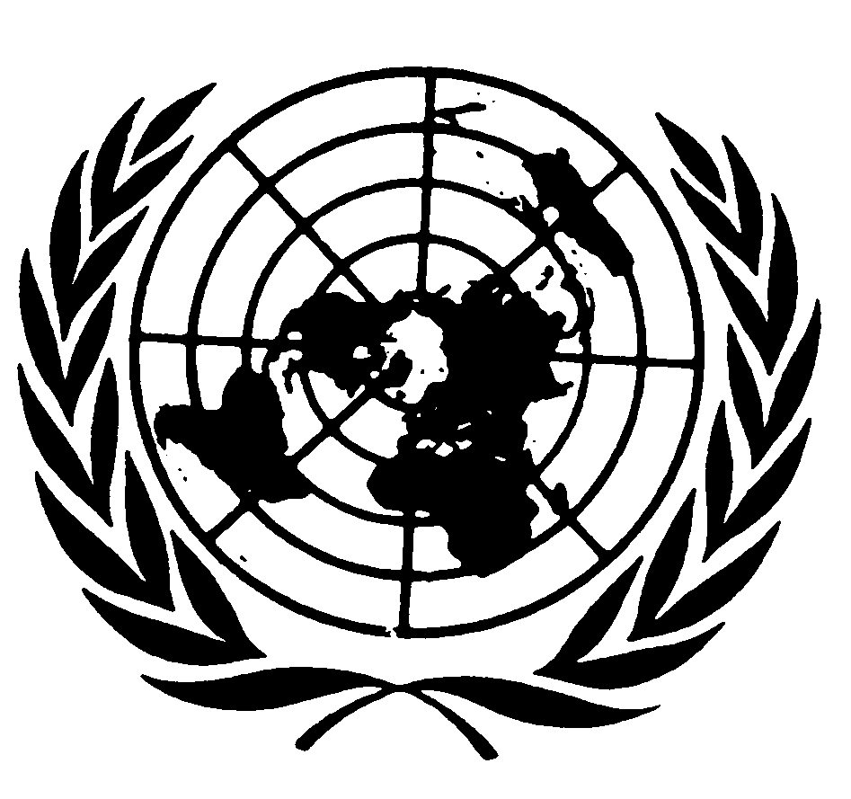
UNITED NATIONS NATIONS UNIES

DEPARTMENT OF ECONOMIC AND SOCIAL AFFAIRS
Division for Social Policy and Development
Secretariat of the Permanent Forum on Indigenous Issues

INTERNATIONAL EXPERT GROUP MEETING
ON THE MILLENNIUM DEVELOPMENT GOALS, INDIGENOUS PARTICIPATION AND GOOD GOVERNANCE
(New York, 11-13 January 2006)

UNDP Background Paper

This paper highlights a select number of UNDP initiatives and activities addressing issues related to the MDGs, indigenous participation and good governance.

Policy Framework
The UNDP corporate mandate, development cooperation processes and agreements, and the aspirations of indigenous peoples guide UNDP engagement with indigenous peoples and their organizations. In the context of the International Decade of the World’s Indigenous People (1995-2004), and building on previous initiatives, UNDP issued a policy guidance note in August 2001 entitled: UNDP and Indigenous Peoples: A policy of engagement. The objective of the policy note is to provide UNDP staff with a framework to guide their work in building sustainable partnerships with indigenous peoples. Rooted in the goals and targets set by world leaders at the UN Millennium Summit in September 2000, it is underpinned by the international human rights framework and a full recognition of indigenous peoples’ vital role in, and contribution to, development.

In May 2000, UNDP established a Civil Society Organizations Advisory Committee composed of 14 civil society leaders who provide strategic advice to the Administrator and senior management on key policy advocacy initiatives. The committee, which includes the chair of the Permanent Forum, has been a vehicle to bring indigenous peoples’ concerns to the attention of the UNDP Administrator and senior management.

MDGs: Over the last three years UNDP has engaged in raising awareness of the MDGs among indigenous peoples and their organizations at various international fora, such as WSSD, the Permanent Forum on Indigenous Issues, regional workshops, and within UNDP headquarters.

UNDP seeks to collaborate with indigenous peoples and their organizations in achieving the MDGs and recognizes greater efforts are needed to include the participation of indigenous peoples’ organizations in the development of the MDG Country Reports that monitor the progress of the goals. Greater coordination between indigenous peoples’ organizations and the Millennium Campaign is also needed, nevertheless the first steps have been taken.

In September 2004 UNDP hosted and coordinated the yearly meeting of the Interagency Support Group on Indigenous Issues. Two key outputs of this meeting were a joint statement and a technical position paper on indigenous peoples and the MDGs. The meeting also served to raise awareness internally among UNDP senior management on indigenous concerns vis-à-vis the MDGs.

UNDP builds the capacity of communities to “localize the MDGs” by providing small grants to community oriented sustainable development projects as well as through community to community learning exchange facilities that encourage the sharing of knowledge and best practices among community-based organizations. In addition, community dialogue spaces profile communities during global conferences and highlight the contribution of communities and especially indigenous peoples in achieving the MDGs. These dialogue spaces bring together representatives of communities and indigenous peoples with international government and CSO leaders for a frank exchange on how to develop an enabling environment for community participation in regional development.

Co-organized with Equator Initiative and Community Action 2015, the Community Commons, a CSO forum, held from 16-18 June 2005 in New York brought together 150 representatives from community based organizations and indigenous peoples’ organizations to prepare a community position to the issues raised in the Secretary General’s Larger Freedom report and ensure a CSO/CBO collective agenda could be presented at the June General Assembly hearings with civil society.

Publications, Toolkits, and Reports

CSO Perspectives on the MDGs (2005): A compilation that features the viewpoints of some of the CSO Advisory Committee members and focuses on issues of gender, environment trade and indigenous peoples.

MDGs and Ethnicity (2005): In response to the Secretary General’s visit to the Andean region in Latin America (2003) and his call of alarm that the MDGs will not be achieved if indigenous peoples are not targeted, UNDP in partnership with the Inter-American Development Bank, the World Bank, and ECLAC, commissioned a study entitled, MDGs and Ethnicity (2005) aimed at highlighting key issues of concern within goals one to three on poverty, gender and education.

The Regional Initiative to Strengthen Policy Dialogue on Indigenous Peoples (RIPP) in the Asia-Pacific region is conducting research on ‘Monitoring the progress of Millennium Development Goals for indigenous peoples in the Asia-Pacific region’. The report will help the initiative identify strategic interventions in making the MDGs relevant to the vulnerable groups in the region by bringing this issue to the fore at the regional level, and by placing the issue in the forefront of any discussion on the MDGs and Poverty Reduction Strategy Papers.

Human Development Reports: With its focus on exploring issues related to building inclusive societies and managing diversity, the global 2004 HDR “Cultural Liberty in Today’s Diverse World”, provided a key platform for debate on indigenous peoples’ concerns. The HDR was instrumental in stimulating national debates on issues related to cultural diversity and policy-making. In June 2004, the Guatemala country office organized a workshop to discuss issues raised in the HDR related to multiculturalism, indigenous peoples and governance.

National Human Development Reports are also an important tool for generating debate on issues of concern to indigenous peoples. Chapter Three of Bolivia’s 2004 NHDR “Interculturalismo y globalización. La Bolivia posible.” specifically addresses issues of identities, multiculturalism, democratic pluralism and nation building.

In 2003 UNDP Chile in partnership with the support of the Government developed the Human Development Index for the Mapuche population in southern Chile, El Índice de Desarrollo Humano en la población Mapuche de la Región de la Araucanía: Una aproximación a la equidad interétnica e intraétnica.

In Mexico UNDP has been working with the Comisión Nacional para el Desarrollo de los Pueblos Indígenas in the development of a human development index for indigenous peoples.

Toolkits: A number of toolkits and how-to guides on enhancing local ownership and broadening participation in the MDG process were also produced in 2005.

Global programming

HURIST is a joint programme with UNDP and the Office of the High Commissioner for Human Rights (OHCHR) aimed at integrating human rights in development by building the capacity of UN country offices, preparing methodologies and toolkits on human rights and through documenting and disseminating good practices. In 2002 Hurist incorporated an indigenous peoples’ component in its overall programme, with the objective of promoting the full participation of indigenous peoples in the planning, implementation and evaluation of the projects that may affect them.

In 2004, HURIST launched two pilot projects in Ecuador (March) and Kenya (June-July). The initial programming meeting in Ecuador has since led to consultations with indigenous peoples on several programming issues as identified through the HURIST initiative, such as bilingual education, policy dialogue mechanisms and strengthening the role of the national Ombudsman’s office.

Among the key outputs of the Hurist initiative in Kenya was the facilitation of a frank dialogue between members of parliament and indigenous representatives and the establishment of an advisory mechanism on indigenous issues known as the United Nations Indigenous Peoples’ Advisory Committee of Kenya (UNIPACK).

Additional projects will be initiated in 2006 in Guatemala and Bolivia.

Global Environment Facility (GEF) Small Grants Programme (SGP)

Since 1992, the Global Environment Facility (GEF) Small Grants Programme (SGP) has promoted grassroots action to address global environmental concerns. GEF SGP allocates grants of up to $50,000 – with an average grant size of between US$20,000 – directly to non-governmental, community-based organizations (CBOs) and indigenous peoples’ organizations to support their efforts to protect the environment while generating sustainable livelihoods. The programme is a corporate initiative of the GEF, and is implemented by UNDP on behalf of the three implementing agencies of the GEF, which include UNDP, UNEP and the World Bank. The programme currently operates through a decentralized management system in 95 developing countries in Africa, Arab States, Asia and the Pacific, CIS, Latin America and the Caribbean. Specific criteria established by a global strategic framework guide the approval of grants at the national level enabling GEF/SGP to be demand rather than supply driven. Country level activities are guided by National Steering Committees (NSCs) made up of a non-governmental majority of representatives from national NGOs, academia, co-funding donors, UN agencies, the private sector, as well as indigenous peoples’ representatives.

Following on from a joint CSO-SGP workshop held during the UN Permanent Forum on indigenous issues in May 2005, SGP has been assisting the GEF Secretariat to facilitate the representation of NGOs from different regions in the GEF NGO network including key indigenous partner NGOs in touch with the programme.

In addition, SGP has been continuing its efforts to develop new approaches to increase access to funding for IPs from SGP, in particular through video proposal development. To this end, SGP has partnered with both the HURIST and the CSO Division of UNDP to co-sponsor a handbook on participatory video for development, which is currently in the final stages of preparation and will be available in both English as well as Spanish by the end of March 2006.

GEF/SGP Guatemala

Since its beginning in 1997, the GEF/SGP National Steering Committee, which approves all grants in Guatemala has sought to work in the south-western region of the country as priority geographic area owing to high levels of human threats to globally significant biodiversity and international watersheds. The committee noted that “traditional” funding sources and donors had not allowed participation of indigenous Mayan peoples in the south-west in development projects, largely due to education barriers and high levels of ethnic and linguistic diversity (k’iché, mam, cakchiquel, sipakapense and tzutuhil Mayan groups). The GEF/SGP country programme also observed that local intermediaries often followed their own agendas on project development whilst working with indigenous peoples. As a result, there were few opportunities for indigenous peoples to express their own needs and environmental interests. As a result, the national strategic framework for the GEF/SGP was reviewed and priorities placed on the following aspects:

Priority funding to be targeted at communities in extreme poverty and exclusion (indigenous peoples and women’s groups)

Specific procedures and proposal formats should be developed to facilitate access for these groups

GEF/SGP Philippines

In the Philippines, the GEF/SGP Community Management of Protected Areas Conservation (COMPACT) programme completed a comprehensive baseline assessment and site strategy in 2001 for the Puerto Princesa Subterranean River National Park on the island of Palawan in order to include all concerned stakeholders, including indigenous tagbanua and bataks, in the management arrangements for the protected area. An exhaustive socio-economic and demographic survey of the 741 households residing in the park revealed that resource-based livelihoods like farming, fishing and forest extraction were the main sources of family income for 96 per cent of households surveyed. An analysis of the status and threats on the biodiversity in the park also revealed extensive habitat destruction and uncontrolled forest extraction relating to land use conflicts with the indigenous tagbanua and bataks.

As a result of the survey work, COMPACT addressed several management issues over the course of project implementation including: (i) overlapping jurisdictions following the expansion of the park’s area from 3,901 to 22,202 hectares in 1999; (ii) environmental, biological and physical concerns in the ‘Certificate of Ancestral Domain Claim’ (indigenous territories) within the park; and (iii) conflict resolution techniques to bring stakeholders together to resolve issues of jurisdiction. In 2004, following a range of project interventions, the participatory site strategy developed by COMPACT was incorporated by the government as the “favoured management approach” for the expanded WH site.

Regional programming

UNDP is currently implementing a $2m Regional Initiative on Strengthening Policy Dialogue on Indigenous, Highland and Tribal Peoples’ Rights and Development (RIPP) in the Asia-Pacific region. The project aims to enhance inter-country sharing of experiences on priority issues, particularly with regard to reducing the incidence of poverty among indigenous peoples. It aims to build capacity among all stakeholders, strengthen information networks and knowledge management systems particularly among indigenous peoples, to support their full and effective participation in policy dialogue at all levels. The project is led from Thailand and the core participating countries include Cambodia, Philippines, Thailand and Vietnam. Some of the intended outputs include needs assessments, capacity-building initiatives such as trainings and materials for indigenous peoples and government at the national level, indigenous advisory mechanisms, pilot projects, and learning networks at the national and regional level. The regional initiative also pays particular attention to the concerns and needs of indigenous women, especially in the area of indigenous knowledge and sustainable resource management.

The following describes a number of related activities under RIPP.

Equal access to the administration of justice services:

Case studies are now underway on indigenous peoples’ access to justice systems in Thailand, Bangladesh, Nepal, India, Indonesia and the Philippines (to be completed in March 2006.)

In Cambodia, RIPP is working with the UNDP country office to develop and provide support for a comprehensive access to justice programme. The programme designed to target a range of vulnerable groups within Cambodian society, has a specific set of activities such as community legal support services, emergency legal support funds and legal education.

In the Philippines, there are three on-going activities under the RIPP:

A data disaggregation project, implemented by Tebtebba Foundation, seeks to address the problem of lack of accurate information gathering vis-à-vis indigenous peoples.

A case study on access to justice in two areas in the Philippines in which indigenous peoples are recognized as ancestral domain holders, is being carried out by the UNDP country office in cooperation with the University of the Philippines.

Working with the National Statistics Office of the Philippines to determine ways in which disaggregation of data can be institutionalized, and preliminary surveying is taking place in three provinces.

Country programming: Guatemala example

Much of UNDP support at the country level to indigenous peoples is channelled through small grants programmes. In Guatemala, a civil society participation programme (PASOC) focuses on strengthening the recognition of indigenous peoples’ rights. Activities include: raising awareness and strengthening legislation; establishing institutions for the promotion and protection of indigenous women’s rights; and awareness raising on human rights treaties and norms.

Support to the Permanent Forum on Indigenous Issues

UNDP contributions to the Voluntary Fund of the Permanent Forum (2003 and 2004) aimed to support initiatives focusing on data collection and disaggregation and the MDGs.

